**PREDICTING ENERGY OUTPUT OF A WND TURBINE BASED ON WEATHER CONDITIONS**

**1.INTRODUCTION:**

**1.1 Overview:**

Wind energy is the use of wind to provide the mechanical power through wind-turbines to turn electric generators. In simple terms, wind energy describes process by which wind is used to generate mechanical power. Wind Energy is a clean alternative to fossil fuels driving the climate crisis. Whether it’s wind farm on a hillside or along a coastline, wind turbine technology offers a vastly more efficient way to generate useable electricity than non-renewable traditional sources.

Wind power generation involves converting wind energy into electricity by means of wind turbines. Wind turbine consists of three rotor blades, nacelle which contains set of gears, generator, and a tower on which the blades and nacelle are mounted. The wind makes the rotor spin and as the rotor spins, the movement of the rotor blades drives the generator and creates energy. In scientific terms, the kinetic energy created by air motion is transformed into electric energy using wind turbines. This movement of rotor blades not just depends on wind, but it also depends on air density. Air density have a key role to play in movement of rotor blades. Air density is a function of altitude, pressure, temperature. Dense air exerts more pressure on the rotors, which in turn results in higher power output. Even higher wind speeds result in higher power output, as stronger winds allow the rotor blades to rotate faster. Ultimately faster rotation leads to more mechanical power and more electrical power. The power output will increase cubically the wind speed. This cubic relationship is that makes wind speed such an important factor for wind power.

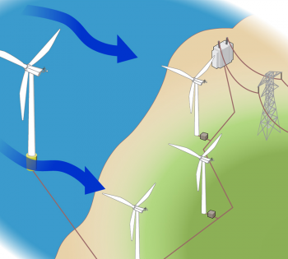

Being a form of solar energy, wind energy has a similar drawback to that of solar energy, it is not constant. To bring complete usage and benefits of wind turbine, the weather needs to be predictable. We can’t eliminate the variability of the wind, but we can use machine learning to make wind power sufficiently more predictable and valuable. This approach also helps bring greater data rigor to wind farm operations, as machine learning can help wind farm operators make smarter, faster and more data-driven assessments of how their power output can meet electricity demand.

**1.2 Purpose:**

Any country’s development is based on amount of power generated by the country. In-order to reduce pollution, energy sector is making a transition into renewable energy generation. Wind energy is one of the major sources of renewable energy. Wind energy plays an increasing role in the supply of energy world-wide. The energy output of a wind turbine is highly dependent on the weather conditions present at its site. If the output can be predicted more accurately, energy suppliers can coordinate the collaborative production of different energy sources more efficiently to avoid costly overproduction. Thus reducing pollution and meeting energy demand simultaneously.

**2.LITERATURE SURVEY:**

**2.1 Existing Problem:**

Energy generated by a country is the key indicator for its development. Every developing and under-developed countries need to boost their economy for better survival. In order to develop they need to have more industries and IT sectors to boost their economy. To establish an industry enough energy has to be supplied to the industry by the Government. So to meet energy demand Government has to increase power production by setting up various power plants. One of the best and most reliable power plant is Thermal Power Plant. It is a moderate efficiency ,reliable output and can generate the required power continuously without any disturbance. But one the most important drawback for this power plant is ,It creates lot pollution because it uses coal as its fuel and burning coal emits lot of pollutants into the atmosphere. Moreover coal which is a fossil fuel cannot last long forever. Due to these drawbacks Government plans on investing in renewable energy to meet the Power demands.

In renewable energy sources like wind ,water and solar they depend on sun which is a non-exhaustive resource. Solar energy is one of the most reliable energy source but its efficiency of conversion is very low and can’t generate if there is non proper amount of sunlight and even during nights it cant generate any power. When coming to water as a source, it need heavy infrastructure like dams and reservoirs which may create disturbance to the environment and also water has to be set free after using its potential energy. Which is a waste of water.

Coming to Wind energy it is a reliable and most efficient form of renewable energy. Erecting wind mills in wind farm and During the wind flow they rotate ,converting kinetic energy into electrical energy. But Wind energy is more dependent on weather conditions at the site. And there is a threshold wind speed value for which every turbine in wind farm can rotate and generate electricity. Due to uncertain wind flows , it is tough to predict the energy generated wind farm and also to completely rely on them.

**2.2 Proposed solution:**

Uncertainty in the wind flow and atmospheric conditions around the farm are major problems for relaying on wind energy. The wind energy equation is



Therefore power generated by wind turbine is dependent on air density, Area swept by the wind blades and velocity of the wind. Our solution is to find the correlation among the parameters air density and wind speed with power as they are dependent on weather conditions and design a machine learning model which can predict the energy output of wind turbine based on existing weather conditions. So if we have an idea of how much the wind farm is going to produce we can schedule the other power generating stations so that energy and fuel from other plants is not wasted.

**3.THEORITICAL ANALYSIS:**

**Software designing:**

Project is implemented on IBM Cloud , from loading data to displaying User interface . On IBM Cloud, we created various resources of it to establish all that are required for a project. Upon creating a Watson Studio resource, we then created an instance of it in the form of Jupyter notebook . We can load all the necessary data set onto IBM cloud before building a model . Utilising Jupyter notebook to the fullest, we completed building, training and testing our new model. For User Interface, we have created a resource of Node-red, with which we designed the frameworks for better and easier user interaction. On this interface, we have linked the machine learning code to nodes, so as to take wind speed and time from user, which in turn returns the plot representing the power generated for the next 72 hours. All these were done top of IBM cloud lite service**.**



Using these resources we trained our model using Watson assistant and deployed UI using node red.

**4.EXPERIMENTAL INVESTIGATION:**

In general, it is well known that the power generated by wind mill depends on rotor blades length, wind, air density. To decide the relativity of the parameters, we import a dataset with all the parameters and its values. Then we calculate the correlation coefficient to measure the dependency between the attributes. Correlation coefficient value ranges from -1 to 1, where negative values indicate that the respective attributes are inversely proportional. Positive values represent that the two attributes are directly proportional to each other. Zero value indicates that the attributes are not related at all. After applying the built-in method dataframe.corr(), we get output in the range of -1 to 1 . The correlation coefficient between power and air density was 0.0254 which is close to zero. Therefore, air density is least dependent, precisely, independent of power. And the correlation coefficient between power and wind speed is 0.95, that is, wind speed is directly proportional to power. From graphical representation, when the wind speed increases, power generated also increases. Beyond the cutoff wind speed, power generated decreases to the least and stays constant thereafter.

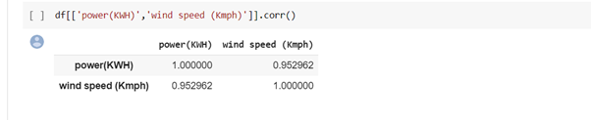

Correlation between wind speed and power is 95.2%

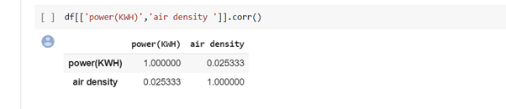

Correlation between power and air density is 2.5%

After training the model with both linear and polynomial regression with the data we found polynomial regression to be more accurate than the linear regression. So we used polynomial regression to the model.

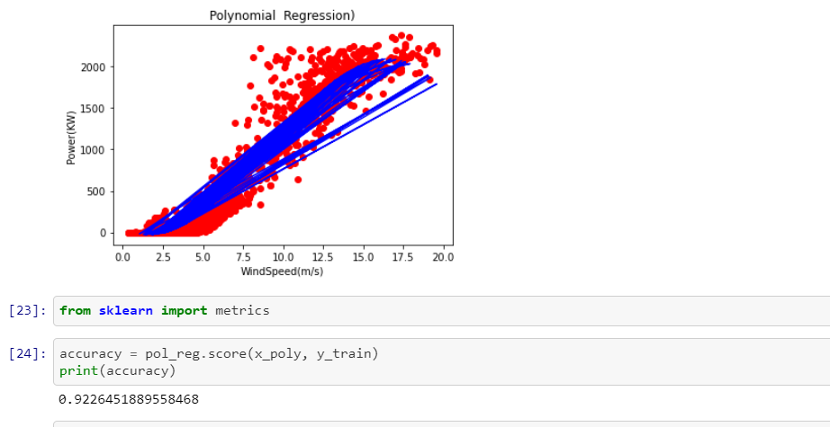

**5.FLOWCHART:**

start

Import Libraries

Data Pre-processing

Train and Test

Select required regression

Test and Train

Take inputs from user

Predict the values from model

Display output

End

**6.RESULT:**

In our model we considered time and windspeed as inputs of our data. The speed at a given time is regulated to different speeds for different time intervals and is fed into the model. The model thus generates an output for 72hrs which can be shown graphically as bellow.

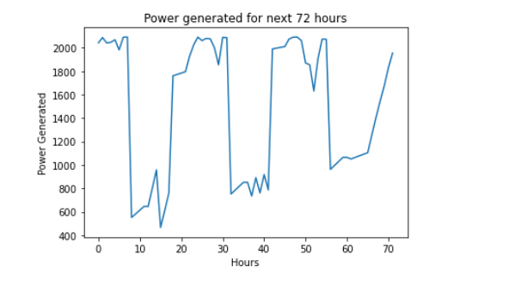

Predicted power output for next 72hrs taking probable wind speeds for next coming hours.

7.Advantages and Disadvantages:

**Advantages:**

* Our model predicts energy output for next 72hrs with 90% accuracy rate
* The Algorithm used isn’t complex and easily understandable
* The mean speeds of different hour intervals was considered for minimal or less errors.
* User friendly User interface

**Disadvantages:**

* Wind speed which is weather dependent, can’t be properly predicted
* The energy predicted is mean of different powers generated at different weather conditions with same wind speed. So can’t completely rely on it

**8.APPLICATIONS:**

1. All Wind Energy generating stations

This model can be used to predict energy for next 72hrs and slight modifications can help in predicting energy for the very next instant

1. For Thermal power plant to schedule their operations

This will help thermal power plants to schedule their operation and generate required amount thus helping in conservation of fuel.

1. Slight change in algorithm can help in predicting energy output of a solar panel

Solar energy which is dependent on sunlight , a proper prediction can help in scheduling other plants.

**9.CONCLUSION:**

* Wind isn’t always constant. It is dependent weather condition and temperature
* Predicting wind energy isn’t a simple task. The machine learning algorithm which we used in making the model predicts with an accuracy of 91%
* Even a greater accuracy doesn’t mean the output will be as real-time.
* Prediction gives us a nearest value of power that will be generated, so that we can schedule other power plants accordingly.
* This algorithm is very simple and UI is friendly for understanding.

**10.FUTURE SCOPE:**

Wind energy is clean, renewable way of generating electricity. In future provided costs are reined in, the primary focus will be offshore development. Wind power is rapidly developing in practically every part of the world, with growth rates ranging from 10 to 40% per year. Although the pace of growth slackened in 2013, installed global capacity reached an impressive 318GW, for an increase of 200GW inf five years. In 2019 it reached 651 GW. Europe is focusing heavily on offshore development. Three countries - The UK, Denmark and Germany are spearheading this drive. At present, wind turbines are anchored to sea-beds in water depths not exceeding 30meters. Studies and tests are being conducted on artificial islands and wind turbines on floating foundations anchor at depths up to 60 meters.

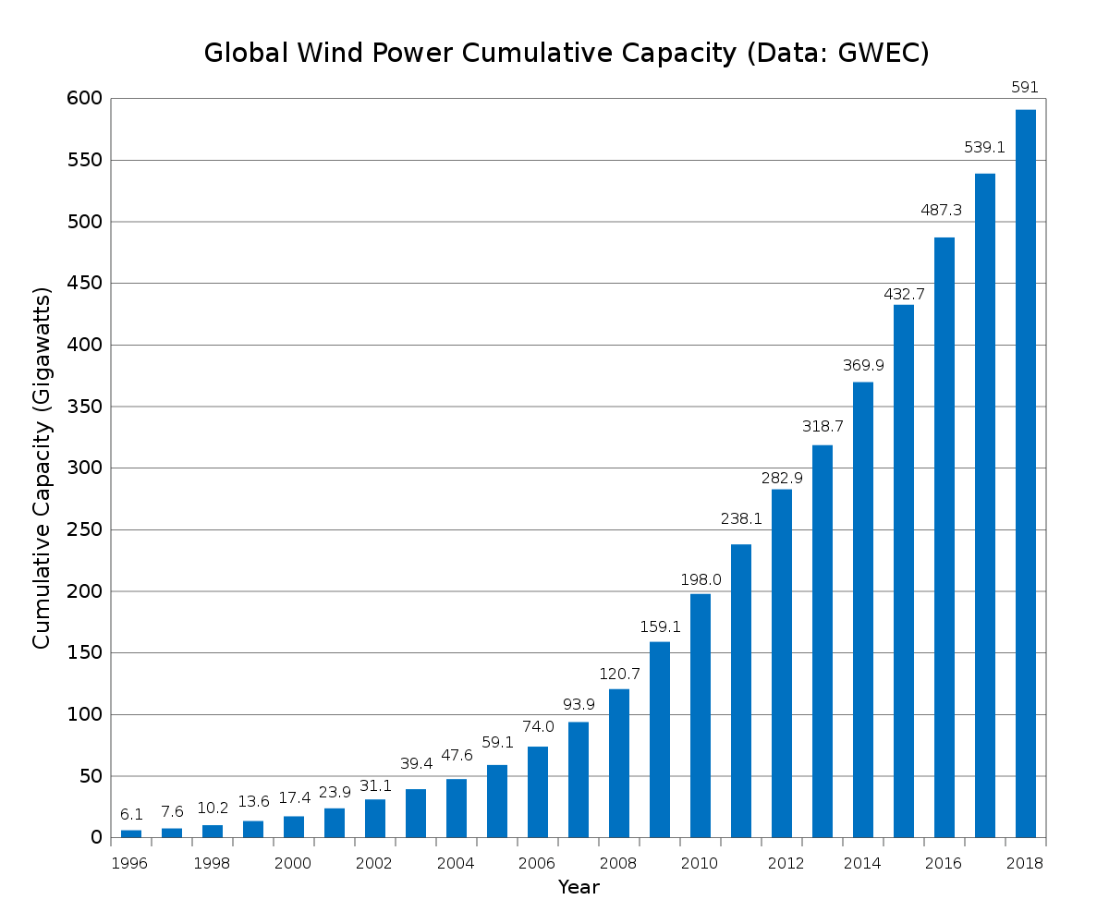

source: Wikipedia, Growth of wind energy globally.

If there is proper prediction of wind energy usage can be increased even more exponentially. Our prediction model can further developed using LSTM to have more accuracy. At present we included only time and speed of wind at that moment. A proper training with all weather parameters can be more useful even though correlation among them with power generated is very less. A continuous data from wind turbines with all necessary sensors can help more in training the model for better accuracy.

**11.BIBLIOGRAPHY:**

**Sites referred:**

* <https://en.wikipedia.org/wiki/Wind_power>
* <https://www.researchgate.net/publication/297736979_Issues_and_challenges_of_wind_energy>
* <http://www.sotaventogalicia.com/en/technical-area/real-time-data/historical/>
* <https://www.geeksforgeeks.org/python-implementation-of-polynomial-regression/>
* <https://www.youtube.com/channel/UCvB8PgOZdb2y7lgToPE-Dfw>
* [www.cloud.ibm.com](http://www.cloud.ibm.com)

**Books referred:**

* Power systems by J.Nagarath and P.Kothari
* Wind energy explained by J.F Manwell

**Apendix**

**source code:**

**from sklearn.preprocessing import PolynomialFeatures**

**poly_reg = PolynomialFeatures(degree=3)**

**x_poly = poly_reg.fit_transform(x_train)**

**pol_reg = LinearRegression()**

**pol_reg.fit(x_poly, y_train)**

**def viz_polymonial():**

**plt.scatter(x, y, color='red')**

**plt.plot(x_test, pol_reg.predict(poly_reg.fit_transform(x_test)), color='blue')**

**plt.title('Polynomial Regression)')**

**plt.xlabel('WindSpeed(m/s)')**

**plt.ylabel('Power(KW)')**

**plt.show()**

**return**

**viz_polymonial()**

**from sklearn import metrics**

**accuracy = pol_reg.score(x_poly, y_train)**

**print(accuracy)**

**speed1=int(input("enter the wind speed"))**

**time=int(input("enter time"))**

**from numpy import array**

**from numpy import reshape**

**pred_list=[]**

**k=speed1**

**i=1**

**for i in range(72):**

**if((time>=1)and(time<6)):**

**if((speed1>4) and (speed1<8)):**

**speed1+=0.75**

**else:**

**speed1=5.36+(i/24)*1.5**

**elif((time>=6)and(time<10)):**

**if((speed1>8) and (speed1<12)):**

**speed1+=0.72**

**else:**

**speed1=11.5+(i/24)*1.75**

**elif((time>=10)and(time<14)):**

**if((speed1>12) and (speed1<16)):**

**speed1+=0.96**

**else:**

**speed1=14.48+(i%24)**

**elif((time>=14)and(time<16)):**

**if((speed1>13)and (speed1<15)):**

**speed1+=0.5**

**else:**

**speed1=15+(i/24)*2**

**elif((time>=16)and(time<18)):**

**if((speed1>16) and (speed1<20)):**

**speed1+=1**

**else:**

**speed1=17.29+(i/24)*0.75**

**elif((time>=18)and(time<20)):**

**if((speed1>14) and (speed1<17)):**

**speed1+=0.16**

**else:**

**speed1=16.18+(i/24)*0.5**

**elif((time>=20)and(time<=23)):**

**if((speed1>6) and (speed1<10)):**

**speed1+=0.16**

**else:**

**speed1=6.42+(i/24)*1**

**if(i==24) or(i==48) or(i==72):**

**speed1=k+1.26+(i%24)**

**speed1=array([speed1])**

**speed1=speed1.reshape(speed1.shape[0],1)**

**b=poly_reg.fit_transform(speed1,0)**

**a=pol_reg.predict(b)**

**if(a>2300):**

**a=2300+i%24**

**pred_list.append(abs(a))**

**time=(time)+1**

**if(time>24):**

**time=time%24**

**a = []**

**for i in pred_list:**

**a.append(i[0][0])**

**pred_list = array(a)**