**Scope Of Project:**

To Build a machine learning model to predict the results accurately.for bulding machine learning model we need to follow following steps

1.Data Preparation

2.Data visualisaton

3.Data Preprocessing

4.Building model

5.Evaluating the results

**Undestanding Botson Dataset:**

1. import numpy as np
2. import pandas as pd
3. import seaborn as sns
4. import matplotlib.pyplot as plt
5. from sklearn.linear_model import LinearRegression
6. from sklearn.model_selection import train_test_split
7. from sklearn.metrics import mean_absolute_error
8. dataset=pd.read_csv('boston_data.csv')
9. dataset.head()

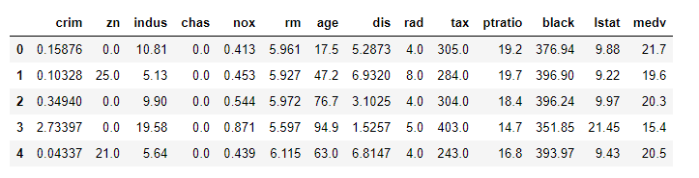

1. dataset.shape



1. dataset.info()

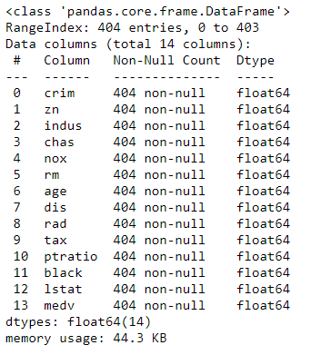

1. dataset.dtypes

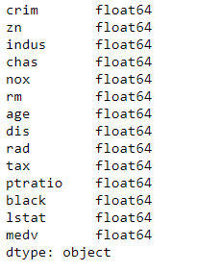

1. dataset.describe()

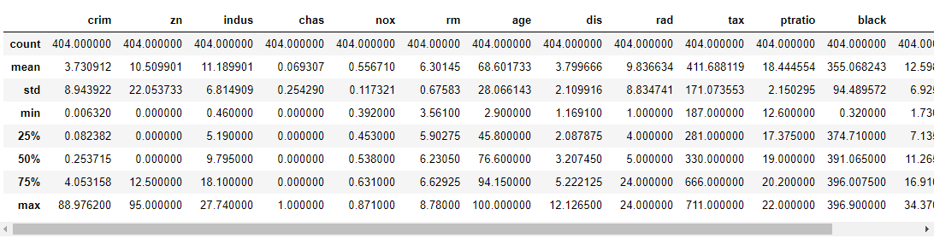

1. dataset.isnull().sum()

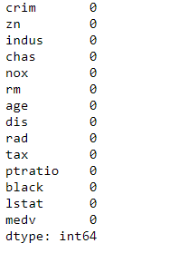

1. dataset.isnull().any()

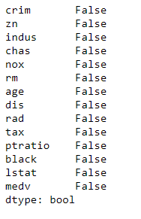

1. dataset.plot(subplots=True)

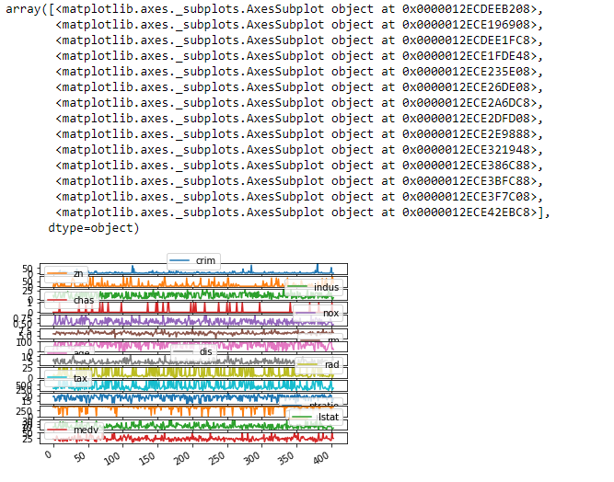

1. sns.heatmap(dataset.isnull())

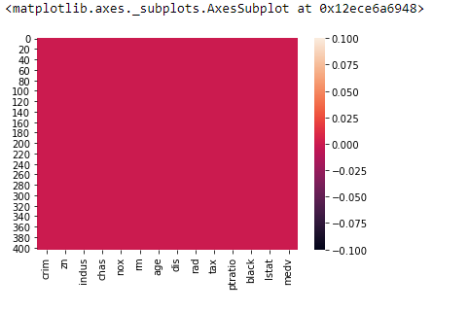

1. x_train=dataset[['crim','zn','indus','chas','nox','rm','age','dis','rad','tax','ptratio','black','lstat']]
2. x_train=np.array(x_train)
3. y_train=dataset[['medv']]
4. y_train=np.array(y_train)
5. X_train,X_test,Y_train,Y_test=train_test_split(x_train,y_train,test_size=0.2)
6. print(X_train.shape)
7. print(Y_train.shape)
8. print(Y_test.shape)
9. print(X_test.shape)

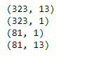

1. model=LinearRegression()
2. model.fit(X_train,Y_train)



1. score=model.score(X_test,Y_test)
2. print(score)



1. predictions=model.predict(X_test)
2. error=mean_absolute_error(Y_test,predictions)
3. error



1. plt.plot(Y_test,label='True Predictions',color='r')
2. plt.plot(predictions,label='Predicted',color='b')
3. plt.title('Model Results')
4. plt.legend()
5. plt.show()

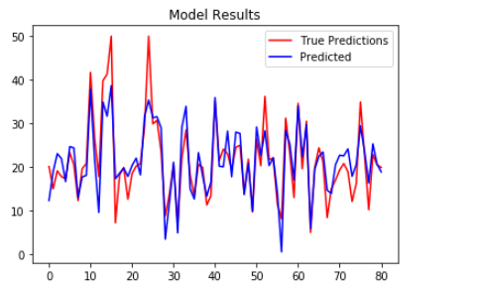

**Understanding Diabetic Dataset:**

**Undersatanding Diabetic Dataset:**

1. import numpy as np
2. import pandas as pd
3. import seaborn as sns
4. import matplotlib.pyplot as plt
5. from sklearn.linear_model import LogisticRegression
6. from sklearn.model_selection import train_test_split
7. from sklearn.metrics import accuracy_score,confusion_matrix,plot_confusion_matrix,classification_report

1. dataset=pd.read_csv('diabetes.csv')
2. dataset.head()

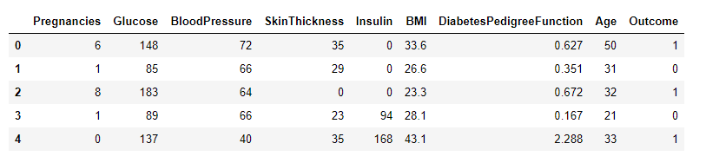

1. dataset.info()

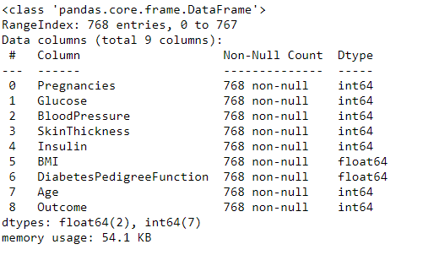

1. dataset.describe()

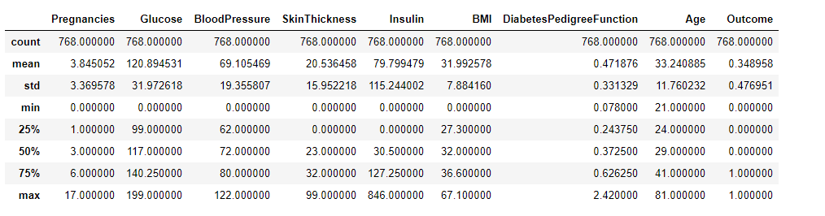

1. dataset.isnull().sum()

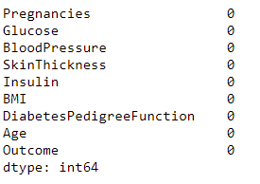

1. dataset.isnull().any()

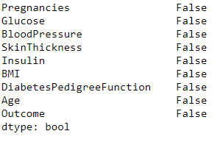

1. dataset.plot(subplots=True)

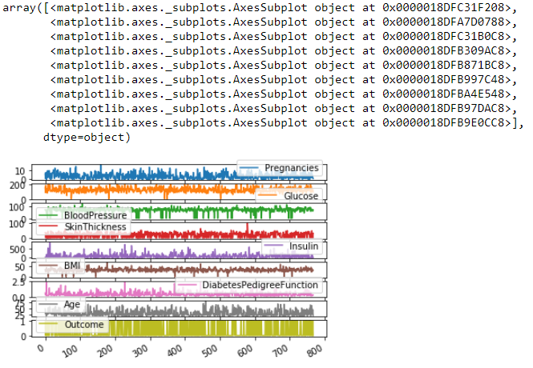

1. sns.heatmap(dataset.isnull())

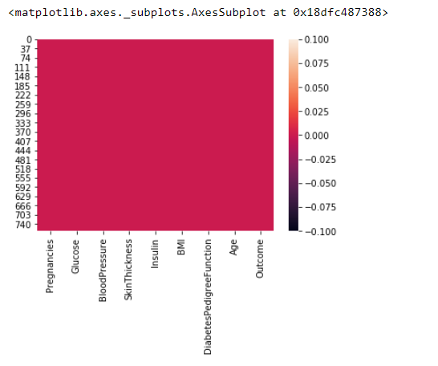

1. data_in=dataset[['Pregnancies','Glucose','BloodPressure','SkinThickness','Insulin','BMI','DiabetesPedigreeFunction','Age']]
2. data_out=dataset[['Outcome']]
3. data_in=np.array(data_in)
4. data_out=np.array(data_out)
5. print(data_in.shape)
6. print(data_out.shape)



1. X_train,X_test,Y_train,Y_test=train_test_split(data_in,data_out,test_size=0.2)
2. print(X_train.shape)
3. print(X_test.shape)
4. print(Y_train.shape)
5. print(Y_test.shape)

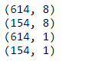

1. model=LogisticRegression()
2. model.fit(X_train,Y_train)

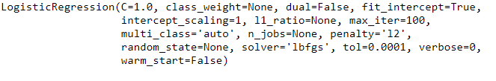

1. score=model.score(X_test,Y_test)
2. print(score)



1. predictions=model.predict(X_test)
2. predictions

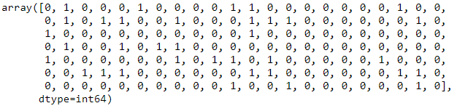

1. conf=confusion_matrix(Y_test,predictions)
2. conf



1. acc=accuracy_score(Y_test,predictions)
2. acc



1. plot_confusion_matrix(model,X_test,Y_test)

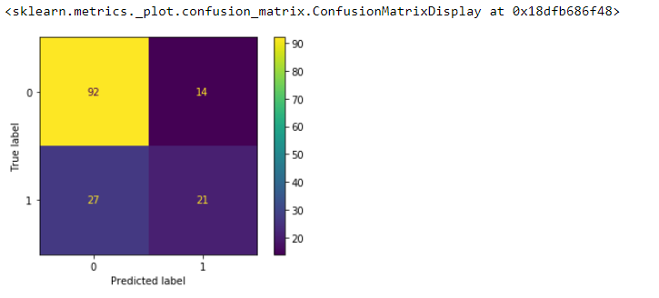

1. report=classification_report(Y_test,predictions)
2. print(report)

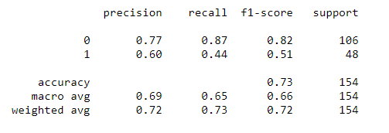

**UnderStanding BikeSharing Dataset:**

1. import numpy as np
2. import pandas as pd
3. import seaborn as sns
4. from sklearn.metrics import
5. accuracy_score,confusion_matrix,plot_confusion_matrix,classification_report
6. from sklearn.tree import DecisionTreeClassifier
7. from sklearn.model_selection import train_test_split
8. from sklearn.preprocessing import LabelEncoder

1. dataset=pd.read_csv('202006-capitalbikeshare-tripdata.csv')
2. dataset.head()

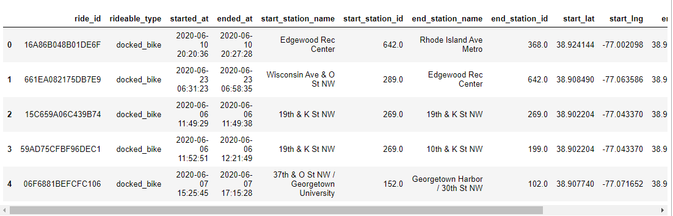

1. dataset.count()

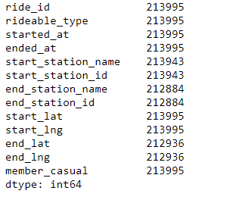

1. dataset['rideable_type'].unique()



1. dataset['member_casual'].unique()



1. dataset.isnull().sum()

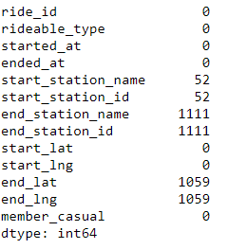

1. dataset=dataset.drop(['start_station_name','end_station_name','ride_id'],axis=1)
2. dataset.head()

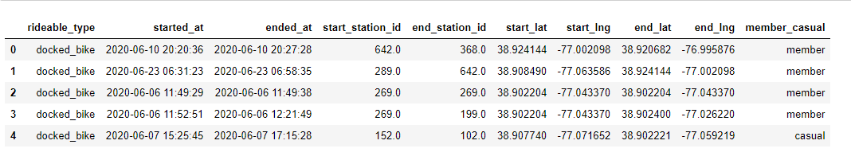

1. sns.heatmap(dataset.isnull())

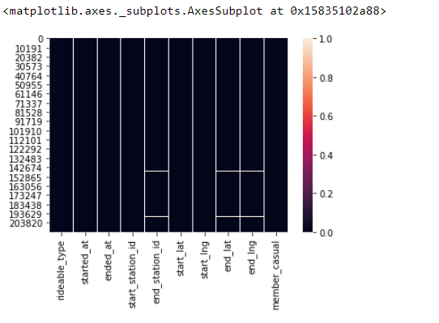

1. dataset.describe()

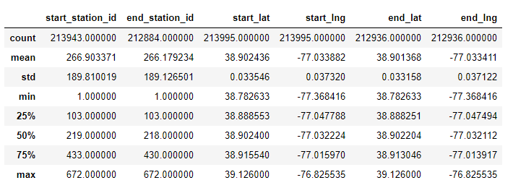

1. dataset=dataset.drop(['started_at','ended_at'],axis=1)
2. dataset.head()

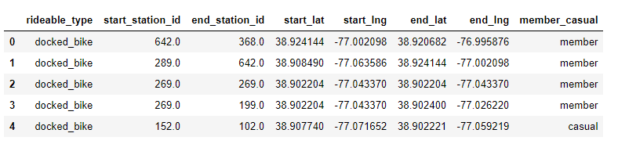

1. dataset.isnull().sum()

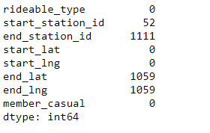

1. dataset['end_lat']=dataset['end_lat'].fillna(np.mean(dataset['end_lat']))
2. dataset['end_lng']=dataset['end_lng'].fillna(np.mean(dataset['end_lng']))
3. dataset.isnull().sum()

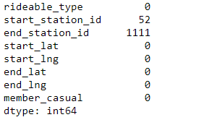

1. sns.heatmap(dataset.isnull())

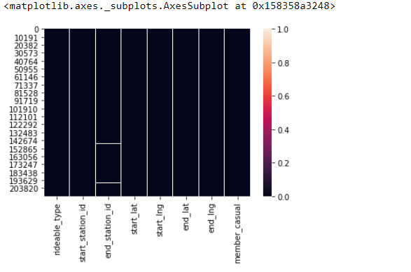

1. dataset['start_station_id']=dataset['start_station_id'].fillna(dataset['start_station_id'].value_counts().index[0])
2. dataset['end_station_id']=dataset['end_station_id'].fillna(dataset['end_station_id'].value_counts().index[0])
3. dataset.isnull().sum()

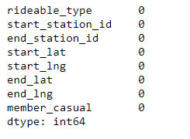

1. sns.heatmap(dataset.isnull())

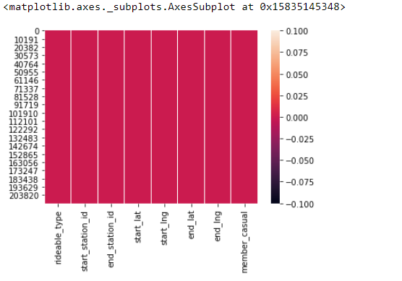

1. dataset.head()

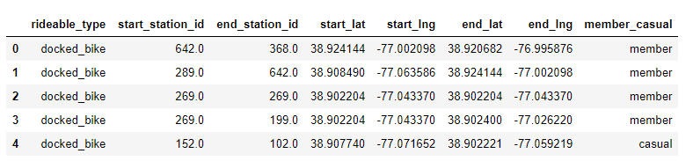

1. enc=LabelEncoder()
2. dataset['rideable_type']=enc.fit_transform(dataset['rideable_type'])
3. dataset['member_casual']=enc.fit_transform(dataset['member_casual'])
4. dataset.head()

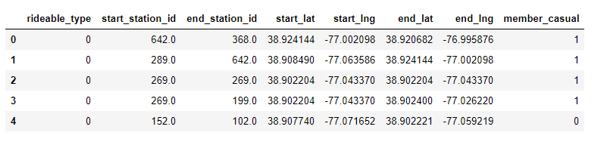

1. x_data=dataset[['rideable_type','start_station_id','end_station_id','start_lat','start_lng','end_lat','end_lng']]
2. y_data=dataset[['member_casual']]
3. x_data=np.array(x_data)
4. y_data=np.array(y_data)
5. print(x_data.shape)
6. print(y_data.shape)



1. X_train,X_test,Y_train,Y_test=train_test_split(x_data,y_data,test_size=0.2)
2. print(X_test.shape)
3. print(X_train.shape)
4. print(Y_test.shape)
5. print(Y_train.shape)

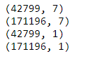

1. model=DecisionTreeClassifier(random_state=0)
2. model.fit(X_train,Y_train)

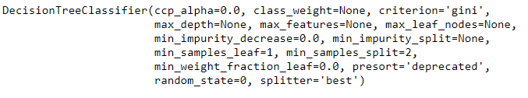

1. predictions=model.predict(X_test)
2. predictions



1. label_pred=enc.inverse_transform(predictions)
2. label_pred



1. score=model.score(X_test,Y_test)
2. print(score)



1. conf=confusion_matrix(Y_test,predictions)
2. conf



1. acc=accuracy_score(Y_test,predictions)
2. acc



1. plot_confusion_matrix(model,X_test,Y_test)

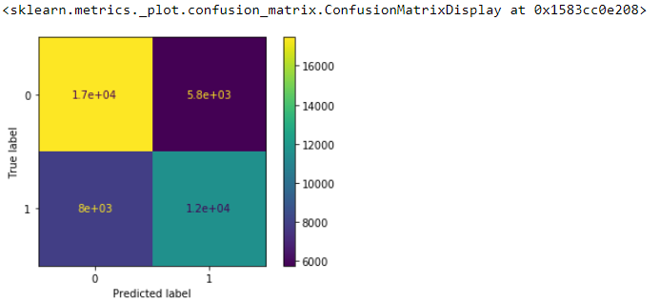

1. report=classification_report(Y_test,predictions)
2. print(report)

