* **PROJECT TITLE – People Counting And Tracking System**
* **INTRODUCTION**

People Counting And Tracking System System uses existing IP cameras and CCTV cameras combined with Computer Vision to detect how many people are there.

* **Overview**

People Counting And Tracking System AI platform uses existing IP cameras to identify how many people are there. E.g – Shop

**2.2 Purpose**

People Counting and Tracking Computer Vision system finds the how many peoples there detected in the camera. The platform generates notifications and calls an external alarm (via speaker) to warn if anyone is found violating laws.

**3. RESULT**

**3.1 Screenshots of output**

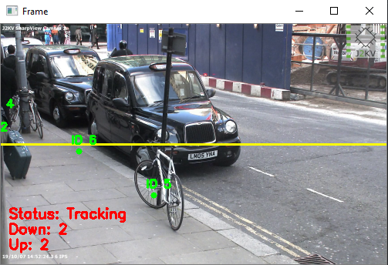

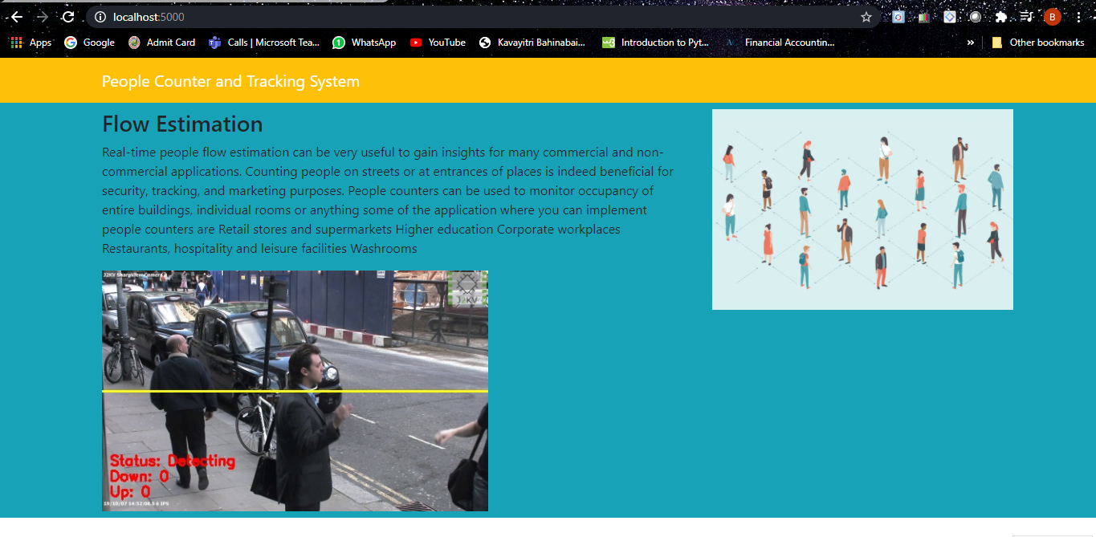

* **APPLICATIONS**
* **No new hardware required**

You don’t need new cameras to enable the platform. Instead, it can work on the existing RTSP camera and connect to your existing smart speakers.

Real-time people flow estimation can be very useful to gain insights for many commercial and non-commercial applications. Counting people on streets or at entrances of places is indeed beneficial for security, tracking, and marketing purposes. People counters can be used to monitor occupancy of entire buildings, individual rooms or anything some of the application where you can implement people counters are

Retail stores and supermarkets

Higher education

Corporate workplaces

Restaurants, hospitality and leisure facilities

Washrooms

* **CONCLUSION**
* People Counting And Tracking System System uses existing IP cameras and CCTV cameras combined with Computer Vision to detect how many people are there.
* **FUTURE SCOPE**

People Counting And Tracking System can be used at airports, hospitals, offices, retail shops, metro stations, public libraries, schools, religious places to identify how many people are there. If there is a crowd, the system will trigger an alarm and alert people to contain the risk of COVID-19. The risk of COVID-19 will be not be ending soon; therefore, airports, hospitals, offices, retail shops, metro stations, public libraries, schools, religious places after the lockdown can use this system to ensure that people counting and tracking is maintained until the risk of COVID-19 does not go away.