PROJECT REPORT

People Counting And Tracking

SMART BRIDGE

By:

B.Sai Seravan

Contents:

1.Introduction

1.1 Overview

1.2 Purpose

2.Result

2.1 screenshots of output

3. Applications

4.Conclusions

5.Future Scope

**1.Introduction:**

1.1 Over view: A people counting system provides tools to save money, gain valuable analytics, improve the visitor experience and optimise operations.

Of all people counting methods, video-based people counting is the most accurate at over 98%.

Many different types of businesses and activities find it useful to count people: smart centres, shopping centres, retail shops, musems, other public buildings, sporting venues, exhibition centres, theme parks, banks, hotels, buses,trains, restaurants and so on. The video people count data lets them make informed decisions about their business.

Counting software correctly detects people indoors and outdoors. You can configure each counting area according to the situation: optimising for crowds, compensating for reflections, monitoring queues ,etc…

This project uses the concepts of opencv,numpy,imutils,dlib and deep learning object detector for people counting.

While dealing with an object that is to be detected in the video , we have to detect the object, track it , register it, count it and then de register the object.

While dealing with an object that is to be detected in the video , we have to detect the object, track it , register it, count it and then de register the object.

For object detection , we use deep learning base “single shot detectors”(SSD) and R-CNN’s . We accept the input co-ordinates of the object say ,(x,y) . Now we assign an unique ID to the object and track the object in the frame.

Now we combine the detection and tracking aspects of the project . We need to detect if any new objects have entered the frame . Find objects that were lost during tracking phase and update the bounding box parameters and then we trace it until the specified N-th frame is reached. If the object is not found after the Nth frame , then we need to consider the object as disappeared . For this process , we make use of MobileNET, SSD and Cafee.

We create a centroid algorithm through which, we can calculate the Euclidean distance , assign object ID’s , Register new objects , De register lost objects

MobileNet is a CNN architecture model for Image Classification and Mobile Vision.There are other models as well but what makes MobileNet special that it very less computation power to run or apply transfer learning to.This makes it a perfect fit for Mobile devices,embedded systems and computers without GPU or low computational efficiency with compromising significantly with the accuracy of the results.It is also best suited for web browsers as browsers have limitation over computation,graphic processing and storage.

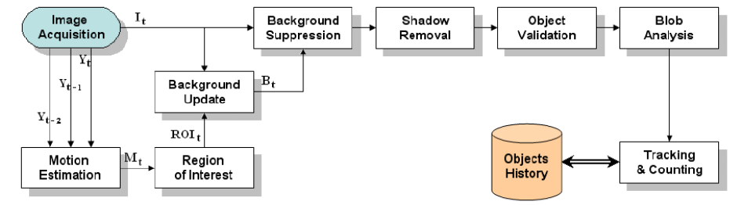

MobileNet Architecture:

MobileNets for mobile and embedded vision applications is proposed, which are based on a streamlined architecture that uses depthwise separable convolutions to build light weight deep neural networks.

Two simple global hyper-parameters that efficiently trade off between latency and accuracy are introduced.

The core layer of MobileNet is depthwise separable filters, named as Depthwise Separable Convolution. The network structure is another factor to boost the performance. Finally, the width and resolution can be tuned to trade off between latency and accuracy.

Depthwise Separable Convolution

Depthwise separable convolutions which is a form of factorized convolutions which factorize a standard convolution into a depthwise convolution and a 1×11×1 convolution called a pointwise convolution. In MobileNet, the depthwise convolution applies a single filter to each input channel. The pointwise convolution then applies a 1×11×1 convolution to combine the outputs the depthwise convolution. The following figure illustrates the difference between standard convolution and depthwise separable convolution.

**Caffe:**

Caffe is a deep learning framework made with expression, speed, and modularity in mind. It is developed by Berkeley AI Research (BAIR) and by community contributors.

Expressive architecture encourages application and innovation. Models and optimization are defined by configuration without hard-coding. Switch between CPU and GPU by setting a single flag to train on a GPU machine then deploy to commodity clusters or mobile devices.

Extensible code fosters active development. In Caffe’s first year, it has been forked by over 1,000 developers and had many significant changes contributed back. Thanks to these contributors the framework tracks the state-of-the-art in both code and models.

Speed makes Caffe perfect for research experiments and industry deployment. Caffe can process over 60M images per day with a single NVIDIA K40 GPU*. That’s 1 ms/image for inference and 4 ms/image for learning and more recent library versions and hardware are faster still. We believe that Caffe is among the fastest convnet implementations available.

**SSD :**

 Single-Shot Multibox Detector (SSD) was the first one-stage detector to achieve an accuracy reasonably close to the two-stage detectors while still retaining the ability to work in real-time. There have been a lot of efforts towards making one-stage detectors surpass the accuracy of two-stage detectors by tackling several issues with SSD and adding an additional stage of refinement in the one-stage pipeline, but most of them use SSD as the starting point.

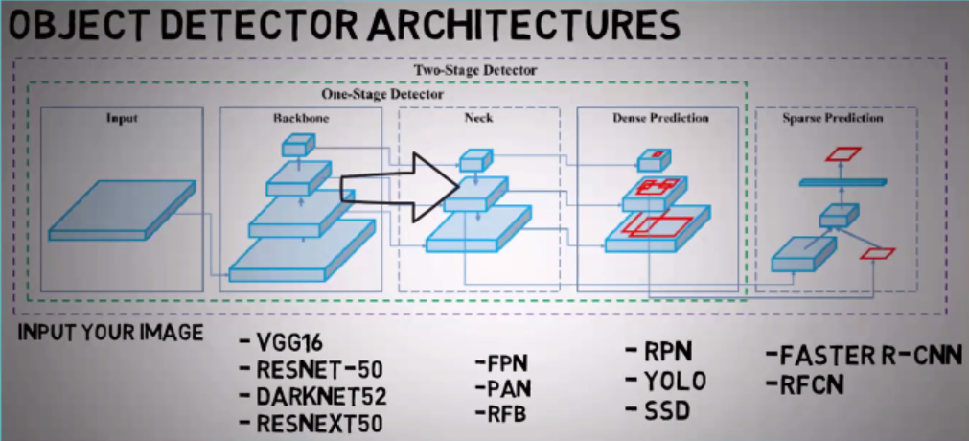

**1.2 Purpose:**

This project focuses on creating a people counting and tracking system using python and dependencies such as numpy,cmake,dlib and deep learning neural networks like the faster R-CNN’s and employing alogrithms like mobilenet, ssd , caffe in order to detect the people in video footage , count them and track them.

**2. Result :**

**2.2 Screen Shots:**

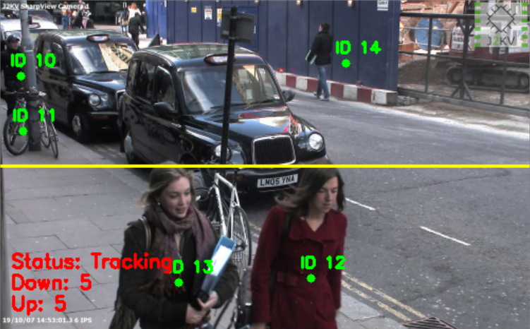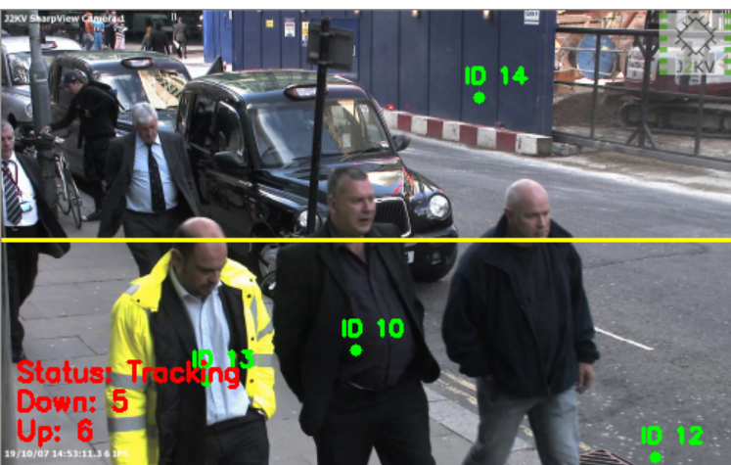

**3. Applications:**

Retail analytics - data driven intelligence:

Irisys door counters can be used to measure people through different entrances, across or into different areas of a building. Retailers can use this to measure and optimise conversion rates, staff scheduling and the success of marketing campaigns.

Get a consistent measure of customer engagement

Delivering real-time information on customer numbers and movement throughout the store, Irisys people counting systems can give you an accurate assessment of the footfall across your whole store portfolio, and show which stores are making the most of their opportunities.

Assign staff deployment to demand

By measuring the footfall in your stores at different locations and times of day, you can find the best places for in-store displays, and make sure that staff schedules accurately reflect the demand by customers. By reducing the time your staff spend where they aren’t required and re-deploying them where they are, you can make cost savings and create a better experience for customers and staff.

Monitor passenger traffic flow

Queues are the bane of travellers' lives. In an increasingly competitive industry, people will often choose one airport or train station over another because of a better customer experience.

With large-scale movements of people in your facility throughout the day, it is vital you can identify areas of congestion to ensure passenger flow is not disrupted. With privacy protecting sensors that preserve anonymity for everyone that passes by them, you can implement Irisys’ systems discretely and effectively.

Improve space planning

Understanding how people are moving through your city and how they make use of the space gives you an opportunity to look at the way you manage that space, and make improvements.

Public transport, community facilities and route planning are all areas where a thorough understanding of how people are currently using your city centre can inform your decisions, helping you create a better environment for shoppers and other visitors.

Attract investment using actual footfall data

Having an objective measure of the popularity of your city centre, is a strong piece of evidence to take to potential investors or businesses interested in relocating to your area - something that people counting technology can deliver consistently and accurately.

Monitor effectiveness of campaigns and events

Without data on the response to your campaigns, measuring your return on investment and the success of your campaigns is very difficult. With Irisys people counters you can measure the footfall across your entire city centre, splitting it into different zones for comparison, and using the data to improve your promotions campaigns and marketing activity.

**4.Conclusion:**

The project has been completed using deep learning neural networks, and the required output was deployed and tested on both the local machine and the internal server using flask application.

**5.Future scope:**

It is imperative to study the evolution of **in-store analytics** to understand where it is headed and be prepared for what is yet to come. Retailers have come a long way in tracking their visitors’ behavior and interpreting what it means and what it should mean to them. In a similar manner, technological innovations have matured to catch up. Long gone are the days of beam sensors and thermal **people counters, technology has set the standards high with the launch of new camera-based people counters that have reached its current peak to provide over 98% accuracy**. It has not stopped there, of course, thanks to Wi-Fi and Bluetooth technologies, it is now possible to follow the footprints of the customers and know where their legs take them.

Gartner, a leading information technology research and advisory company, published an insightful study, back in 2012, on the **past, present and the future of the retail and new BI tools**. It suggests that it all started with “**descriptive analytics**” which enabled retailers to understand what happened in their stores. The next step followed was “**diagnostic analytics**” through which why it happened became a common question to ask. In this evolutionary process, by collecting and analyzing what and why information which delivered a useful foresight, retailers started to think about what might happen, also known as “**predictive analytics**”. While these insights are paramount to retailers’ knowledge base, predictive analysis lacked in encouraging to take in-store actions at the moment of a sales-producing activity. Thus, in 2016, a new era started with “**prescriptive analytics**” which led people ask what should be done with comprehensive insight to entirely optimize the transaction.

**Why is prescriptive analysis gaining such a high importance?** It is seen as the missing piece of the big retail business analytics puzzle. Executives are now encouraged to think more boldly about their data and potential. According to the November, 2015 report released by IDC Research on Big Data analytics, number 2 prediction was **“By 2020, 50% of all business analytics software will incorporate prescriptive analytics built on cognitive computing functionality**”. Global Industry Analysts, a world leader in market research, claimed that global market potential for prescriptive analytics is forecasted to reach $1.6 billion by 2022 in business intelligence and analytics. This trend is explained as assembling, interpreting and acting on data as it happens.

People counting business is stepping up by offering more advanced technology coupled with various BI tools to catch up with the new prescriptive analytics era. It is becoming more personalized than ever with gender recognition and **in-store notification technologies** in addition to people counters, furnished with software applications to provide ever-advanced reporting. Gender recognition technology allows retailers to understand their customer portfolio, what percentage is male/female, to optimize their operations accordingly. Push notification, on the other hand, will provide a stronger drive to purchase and encourage them to feel more special by touching on their customized needs. For the ease of use and a wider-reach, mobile world has emerged as to-go-to and dominant platform for this communication.

**Having said all these, the main question here is who will adapt to these innovations and be the real game changer?** On the retail side, however, the gap between data driven companies and those who rely on their gut feeling in their decision-making process will be the main determinant in who the winner becomes and who becomes the sore loser of this rapidly-evolving game.