**Project Report on Intelligent Water Distribution System**

**==============================================**

 CONTENTS

   1. Introduction

1.1. Overview 01

1.2. Purpose 02

2. Literature Survey

2.1. Existing Problem 03

2.2. Proposed Solution 04

3. Theoretical Analysis

3.1. Block Diagram 05

4. Flow Chart 06

5. Result 07

6. Advantages and Disadvantages 08

7. Application 08

8. Conclusion 09

9. Future Scope 10

10. References 11

**Appendix**

**INTRODUCTION**

Overview The project Intelligent water distribution system, as the name says it is all about management of water supply throughout the scale, right from small societies, townships to entire urban infrastructure and also for irrigation for irrigation water supply management. The main task of the water distribution system is to maintain the water in the tank and also generate the water bills to the individual households which involve human efforts. This system can be automated using the Internet of things.This project deals with the water management using the AWS IoT core and cloud services for the automation. Water is one of the most important natural resources essential for survival and it is supplied to cities through pipelines from water sources such has rivers and lakes. So it become necessary to determine the water usage of each household and then charging them in accordance to the usage.

**Purpose**

The main aim of this proposed project is reduce the human efforts in the management of the water distribution and management system. The purpose of this project is to automate the many manual tasks in the area of the water monitoring and distribution system by introducing the Internet of Things (IoT) technology to this present system. As per the surveys conducted by many researchers that a proper water management system can solve water problems to many areas in the city.This brings the transparency in billing to both the customer and the provider and also helps in the proper maintenance of the water distribution system. It also helps in getting the insights of the areas where water is consumed at a high rate and low rate which in turn helps the water monitoring authority in planning the water pipelines to those areas. The bills produced can be paid online via internet banking or any digital wallet to make the work of the customer and the provider easy.

**LITERATURE SURVEY**

**Existing Problem**

The problem presented in this project is about wastage of lots of human efforts in the water monitoring and the distribution system.2018 saw the fourth year of drought and the worst in recorded history for the city of Cape Town, South Africa. “Day zero” was a term coined by the city for the day when they would have to turn the water off for citizens. Fortunately, “day zero” was never realized, and Cape Town didn’t go down in history as the first major city to run out of water. Water restrictions and augmentation plans alleviated the crisis until rainfall returned to the city, however, the city remains sensitive to water crises. Citizen behaviour must permanently change in order to use water in a sustainable manner.Water is always a crucial part of everyday life. Due to global environmental situation, water management and conservation is vital for human survival. In recent times, there were huge needs of consumer based humanitarian projects that could be rapidly developed using Internet of Things (IoT) technology.

**Proposed Solution**

The Solution proposed in this project is using AWS IoT and other AWS services (Amazon Web Services) for the real time monitoring of the water level of the tank and alerting the user via an mobile app and also via text message. The proposed solution is there will a microcontroller present in the tank along with a water level sensor and that will be publishing the details of water level,flow rate, device ID and also the counter value to the thing registered in the AWS IoT via MQTT protocol(Message Query Telementary Transport). The counter used here is used to count the number of times the tank got emptied and based on that we can calculate the billing amount in the mobile app by multiplying with amount for water for one complete fill tank. This published values from the microcontroller will be then stored in a table in the database service offered by AWS called DynamoDB. And also a SNS subscription is attached as an action rule to the IoT thing in the AWS IoT console to send a message to the user mobile via mobile number as a normal text message. This data stored in the DynamoDB must be retrieved for the information of the user so we create a Lambda service offered by AWS it is a service to execute a code based user preferred environment like python,javascript and many more remotely over the AWS servers. This lambda function will retrieve the data of a particular id when ever it is called. So to integrate this function with the built app we create a REST api for the data retrieval . The URL for the data retrieving is created using API gate way service of the AWS services.

**BLOCK DIAGRAM**

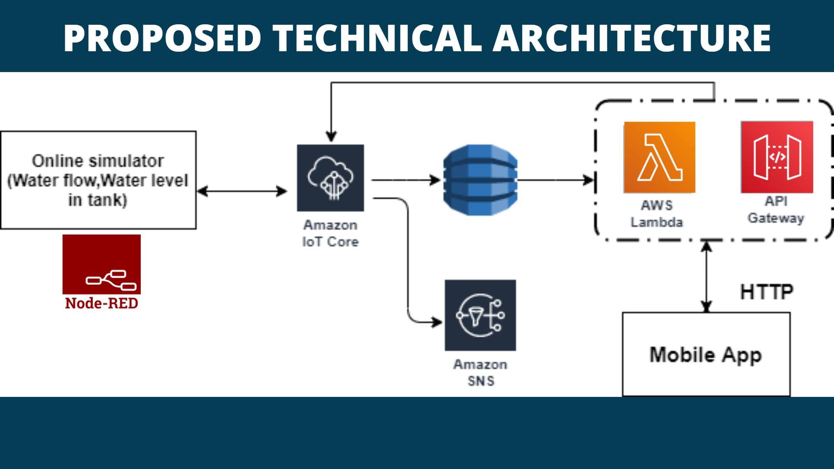

## FLOW CHART



Microcontroller



AWS

IoT

core



SNS

Service



DynamoDB



Lambda

function

+

API

Gateway



Mobile

APP



Text

message

to

mobile



**RESULT**

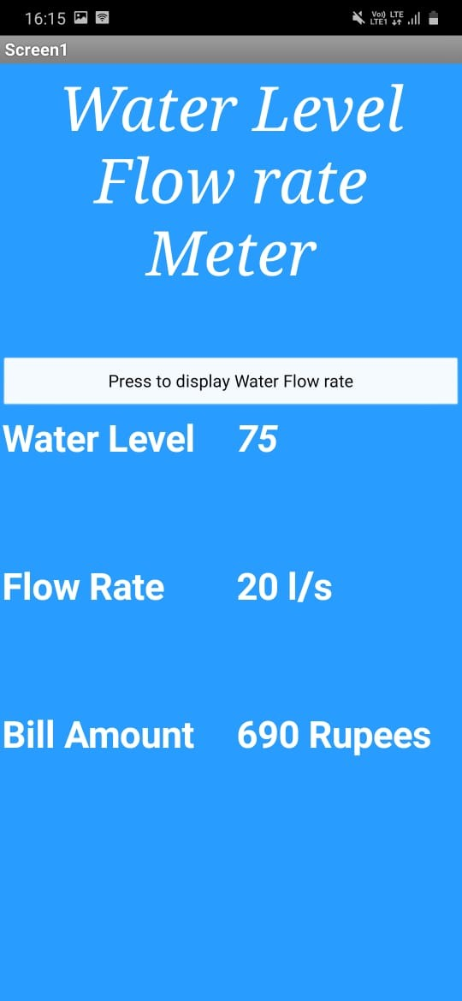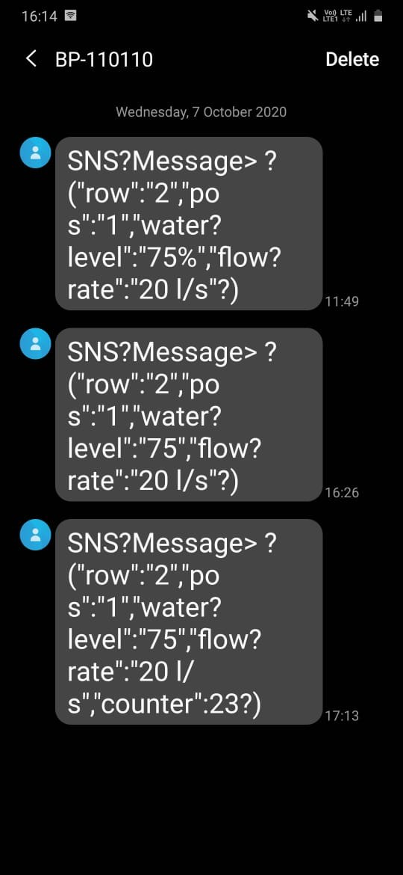

SNS Message On Mobile App Showing The Data From Dynamodb

**ADVANTAGES AND DISADVANTAGES**

**Advantages**

1. Easy monitoring.

2. Less human effort.

3. Transparency in billing.

4. Accurate billing.

5. It can be attached to auto payment systems.

**Disadvantages**

1. Costly.

2. System can be tampered.

3. Inaccurate if the system looses connection to server.

4. Vulnerable to cyber attacks.

**APPLICATIONS**

● Can be used in smart cities.

● In maintaining water supply of an apartment, building or colony.

● In Muncipalities to manage water distribution.

● It can be a part of home automation systems.

**CONCLUSION**

We can say that this proposed methodology for the water level management and distrubution system can be usefull and implemented in the real life. This implementation will decrease a lot of human effort and increase the effciency of the work done in calculating the water usage. This system sets the transperncy in billing for both the user and the provider.

**FUTURE SCOPE**

A lot of work can be done in this project by adding the UI for the water provider to interpret the usage of water in the zone wise. It can also be used to calculate the leakages by calculating the total Inflow and Outflow to a particular zone. We can also attach an automated payment system for paying the bills which reduces the human efforts to as minimum as possible. We need to work on various devices that increases the efficiency of this system leading to the GREEN IoT.

**REFERENCES**

1. IoT Badge,AWS educate. awsedcate.com/IoTBadge.
2. <https://data4water.pub.ro/pluginfile.php/730/mod_resource/content/0/42.pdf>
3. <https://www.ijeat.org/wp-content/uploads/papers/v8i6/D6295048419.pdf>
4. <https://www.ijrte.org/wp-content/uploads/papers/v7i4s/E1897017519.pdf>
5. https://www.researchgate.net/publication/331655540_IoT_based_model_for_monitoring_and_controlling_water_distribution

**APPENDIX**

Lambda Function code

//python 3.7 code

import boto3

import json

from boto3.dynamodb.conditions import Key

dynamo = boto3.resource("dynamodb")

table = dynamo.Table("Water_level_table")

def lambda_handler(event,context):

response = table.query(KeyConditionExpression=Key('Row').eq(str(event['Row'])))

for i in response['Items']:

pay = (i['payload'])

 return pay

//test using parameter "Row":2

**By**

**Sairam Mandapaka**

[**mandapaka.sairam@gmail.com**](mailto:mandapaka.sairam@gmail.com)

**SBID :** SB20200075672