**1. PROJECT TITLE – HIGH QUALITY FACIAL RECOGNITION**

**2. INTRODUCTION**

A facial recognition system is a technology capable of [identifying](https://en.wikipedia.org/wiki/Identification_of_human_individuals) or [verifying](https://en.wikipedia.org/wiki/Authentication) a person from a [digital image](https://en.wikipedia.org/wiki/Digital_image) or a [video frame](https://en.wikipedia.org/wiki/Film_frame) from a video source. There are multiple methods in which facial recognition systems work, but in general, they work by comparing selected [facial features](https://en.wikipedia.org/wiki/Face) from given image with faces within a [database](https://en.wikipedia.org/wiki/Database_management_system). It is also described as a [Biometric](https://en.wikipedia.org/wiki/Biometrics) [Artificial Intelligence](https://en.wikipedia.org/wiki/Artificial_intelligence) based application that can uniquely identify a person by analyzing patterns based on the person's facial textures and shape

**2.1 Overview**

While initially a form of computer [application](https://en.wikipedia.org/wiki/Application_software), it has seen wider uses in recent times on mobile platforms and in other forms of technology, such as robotics. It is typically used as access control in [security systems](https://en.wikipedia.org/wiki/Burglar_alarm) and can be compared to other [biometrics](https://en.wikipedia.org/wiki/Biometrics) such as [fingerprint](https://en.wikipedia.org/wiki/Fingerprint) or eye [iris recognition](https://en.wikipedia.org/wiki/Iris_recognition) systems

**2.2 Purpose**

A facial recognition system uses biometrics to map facial features from a photograph or video. It compares the information with a database of known faces to find a match. Facial recognition can help verify personal identity, but it also raises privacy issues.

**3. RESULT**

**3.1 Screenshots of output**

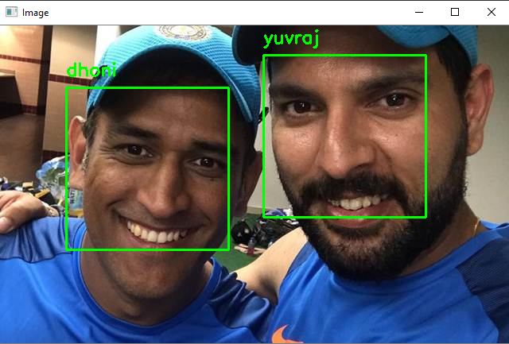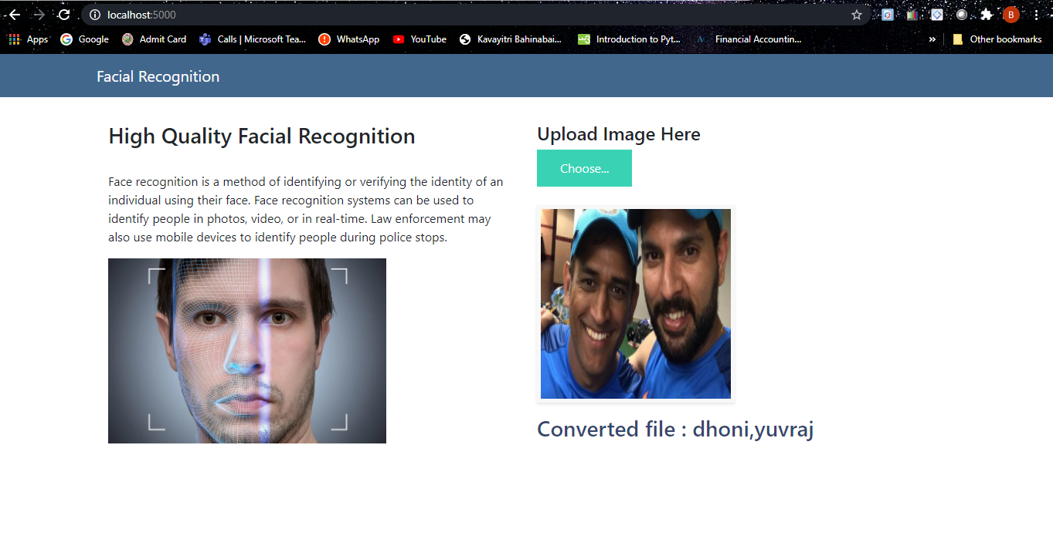

* **APPLICATIONS**

**Social media**

[Social media](https://en.wikipedia.org/wiki/Social_media) platforms have adopted facial recognition capabilities to diversify their functionalities in order to attract a wider user base amidst stiff competition from different applications.

#### ID verification

#### The emerging use of facial recognition is in the use of ID verification services. Many companies and others are working in the market now to provide these services to banks, ICOs, and other e-businesses

#### Face ID

#### The technology learns from changes in a user's appearance, and therefore works with hats, scarves, glasses, and many sunglasses, beard and makeup.[[](https://en.wikipedia.org/wiki/Facial_recognition_system#cite_note-35)

* **CONCLUSION**
  + - 1. A facial recognition system is a technology capable of [identifying](https://en.wikipedia.org/wiki/Identification_of_human_individuals) or [verifying](https://en.wikipedia.org/wiki/Authentication) a person from a [digital image](https://en.wikipedia.org/wiki/Digital_image) or a [video frame](https://en.wikipedia.org/wiki/Film_frame) from a video source.
* **FUTURE SCOPE**

Some face recognition [algorithms](https://en.wikipedia.org/wiki/Algorithms) identify facial features by extracting landmarks, or features, from an image of the subject's face. For example, an algorithm may analyze the relative position, size, and/or shape of the eyes, nose, cheekbones, and jaw.[[14]](https://en.wikipedia.org/wiki/Facial_recognition_system#cite_note-14) These features are then used to search for other images with matching features.[[](https://en.wikipedia.org/wiki/Facial_recognition_system#cite_note-Bonsor2-15)