**PROJECT DOCUMENTATION**

**PROJECT TITLE:**High Quality Facial Recognition System

**INTRODUCTION:**

Overview: In this project I have build a web application for face recognition for images using:

•  Open CV

•  Python

•  Deep learning

In this project  you will learn how to perform facial recognition using OpenCV, Python,and deep learning.We’ll start with a brief discussion of how deep learningbased facialrecognition works, including the concept of “deep metric learning”.Finally we'll implement face recognition for images.

**PURPOSE**:

Purpose: Facial recognition is a way of recognizing a human face through

technology. A facial recognition system uses biometrics to map facial features from a photograph . It compares the information with a database of known faces to find a match. Facial recognition can help verify personal identity.

**RESULT:**

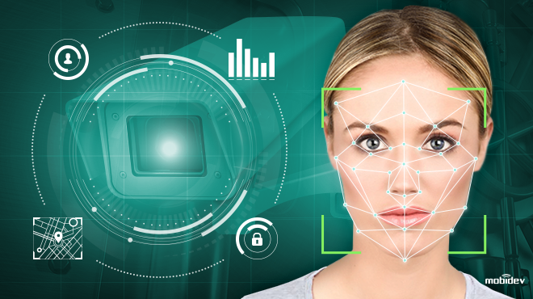

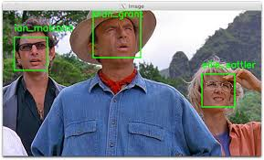

**APPLICATIONS:**

Beyond just unlocking phones or laptops, the biometric software behind facial recognition applications can accurately identify faces today, better than other people can. Various industries are using facial recognition technologies. For the following purposes:

* security companies are using facial recognition to secure their premises.
* Immigration checkpoints use facial recognition to enforce smarter border control.
* Ride-sharing companies can use facial recognition to ensure the right passengers are picked up by the right drivers.
* Academic institutuions can use facial recognition to take daily attendance of their students.

**CONCLUSION:**

This is a basic project probably it cant be used in real time but it helps to learn the skills required to built a real time application.In this we also usedHisto gram Oriented Gradient(HOG) for better and fast recognition.This facialrecognition is being used in many areas like commercial and non-commercial places.

**FUTURE SCOPE:**

Today, one of the fields that uses facial recognition the most is security. Facial recognition is a very effective tool that can help law enforcers recognize criminals and software companies are leveraging the technology to help users access their technology. This technology can be further developed to be used in other avenues such as ATMs, accessing confidential files, or other sensitive materials. This can make other security measures such as passwords and keys obsolete.

Another way that innovators are looking to implement facial recognition is within subways and other transportation outlets. They are looking to leverage this technology to use faces as credit cards to pay for your transportation fee. Instead of having to go to a booth to buy a ticket for a fare, the face recognition would take your face, run it through a system, and charge the account that you’ve previously created. This could potentially streamline the process and optimize the flow of traffic drastically.