**Intelligent "Best safety/Max safety" Rating Generator for**

**Restaurant**

**Introduction:**

During this covid-19 pandemic, safety plays a major role and food safety can never be compermised. The reviews given in the food app are feedbacks of people, but nobody knows whether the restaurant is taking up and following all the safety measures. With the help of aws , the api created and stored in the cloud database. AWS also known as Amazon web service, which provides on-demand cloud computing platforms and APIs to individuals, companies and governments.

**Overview:**

The project is created using AWS Rekognition , open cv, lamda functions and flask using python .

**Purpose:** The aws rekognition is used the recognizes people with mask and without mask and upload the data and rates the safety of the restaurant. If the employes in the restaurant wears mask and follows the covid measures, their restaurant is rated as max safety or best safety , meanwhile if the employees are found without wearing mask , it automatically reduces the rating of the restaurant.

**Result:**

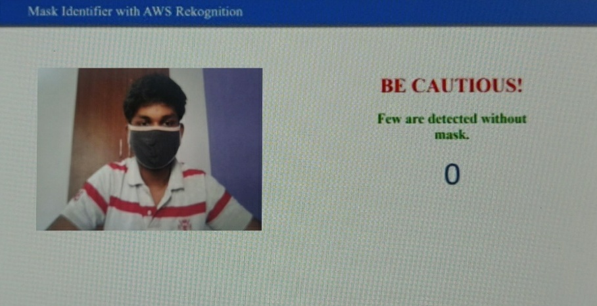

**Application:**

The application of aws rekognition,dynamodb,opencv and lamda are:-

* To identify persons with mask and without mask.
* To give the no. of people without mask
* To rate the restaurant based on the no. of persons wearing the mask.

**Conclusion:**

Thus the aws rekognition is used to identify the persons with or withoout mask and rate the restaurants based on the recognition.

**Future scope:**

The future of AI recognition is comparably huge for both security and safety purposes. This project has a major role to play in covid-19 safety purpose and also it is useful even after pandemic to ensure the safety of the people buying the food .