**I. PROJECT TITLE:**

INTELLIGENT “BEST SAFETY/MAX SAFETY RATING

GENERATOR FOR RESTAURANT”

**II. INTRODUCTION:**

Safety became an important factor during the pandemic situation and gaining the trust of customers became more difficult. The restaurant’s business completely depends on the rating. Nowadays the food delivery apps are rating the restaurants with “Best Safety” or “Max Safety” based on the COVID-19 safety guidelines followed by the restaurant staff. This rating would help customers in choosing the safest restaurants. Safety in terms mean, sanitizing the kitchen, chefs equipped with gloves and masks, etc. And in this project it will also find the number of unmasked customers in the restaurant as well as in the kitchen staff so that the safety will be maintained and no further transmission of COVID-19 can be stopped.

In regard to the problem faced, an application is to be built which would scan the chefs and check if they are working with all the safety measures. The methodology which this lab follows is using the AWS Cloud. Using the Rekognition, Lambda, S3 and API Gateway services of the AWS Cloud, this application will be built. Continuous and effective monitoring of safety violations is a difficult process. In this project you can learn and build an AI powered monitoring system to capture the safety violations and generate dynamic rating for the restaurants.

**II(a).OVERVIEW:**

Now-a-days all the food delivery apps are rating the restaurants with the “Best /Max Safety” of the customers as well as the staff Members so that the customers will come to the respective restaurants where the safety and all the guidelines are followed .In this application ,it scan the chefs /all the staff members and check if they are working with all the safety measures and it recognise all the faces with mask as well as without mask by using the OpenCV Software .And the model is trained by using the AWS cloud for training the data and providing the interface with the human and the model .In this it uses the Rekognition ,Lambda, S3 and API Gateway services of the AWS Cloud. Firstly it contain all the unlabelled data then it will convert the unlabelled data/images into the labelled data/images by using the model training, so that the model gets the best accuracy. After the model gets trained the Lambda function is used ,it will find the people who doesn’t wear the masks, and in this it will automatically count the unmasked people. Then the API Gateway service is used for the interface with the lambda function. And DynamoDB is used for storing the database ,in this it will automatically changed without given any queries.

**AWS CLOUD**:

Amazon Web Services provides a highly reliable, scalable, low-cost infrastructure platform in the cloud that powers hundreds of thousands of businesses in 190 countries around the world. With data center locations in the U.S., Europe, Brazil, Singapore, Japan, and Australia, customers across all industries .

Amazon Web Services (AWS) began offering IT infrastructure services to businesses in the form of web services -- now commonly known as cloud computing. One of the key benefits of cloud computing is the opportunity to replace up-front capital infrastructure expenses with low variable costs that scale with your business. With the Cloud, businesses no longer need to plan for and procure servers and other IT infrastructure weeks or months in advance. Instead, they can instantly spin up hundreds or thousands of servers in minutes and deliver results faster.

**II(b). PURPOSE**:

The main aim of this application is to provide the “Best safety And Max Safety” for the customers as well as the staff members for the restaurants or any other crowded areas.

**III. RESULT:**

F1 Score =0.722

Status = Running

Date=2020-09-04

Project Name=mask-detection

**III(a). OUTPUT:**

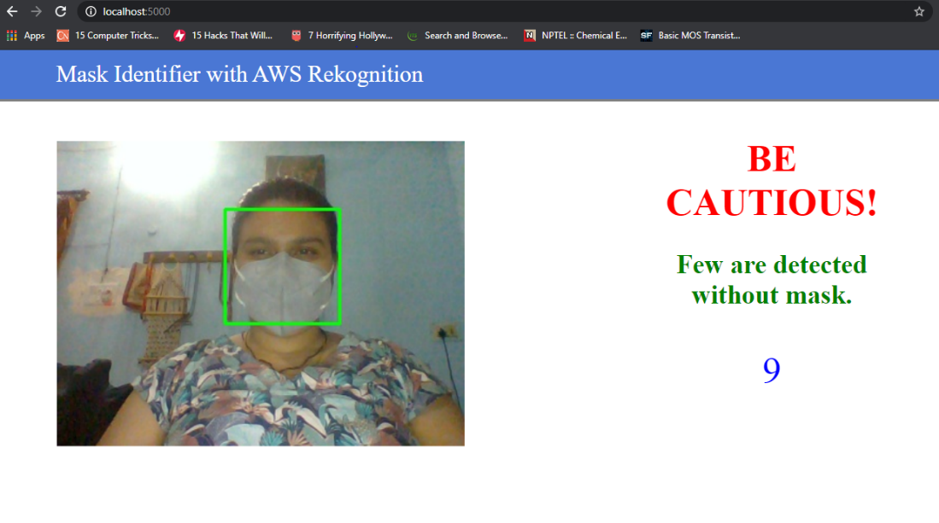

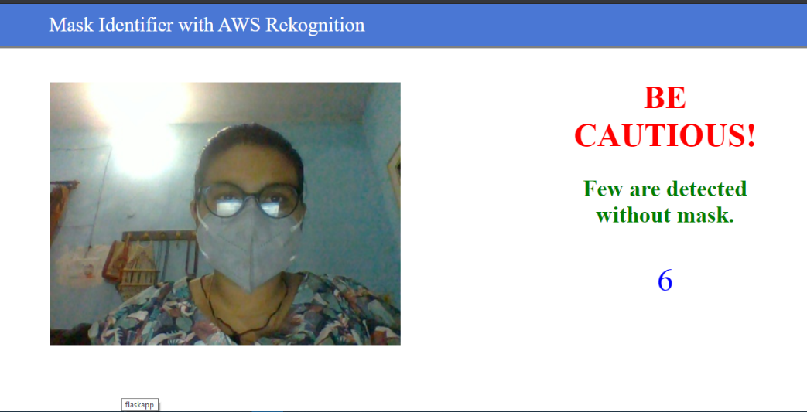

**IV. APPLICATIONS:**

* This application is used for monitor the people whether they are following all the guidelines regard of COVID-19.
* It can be used mostly in crowded areas like restaurants, hospitals, shops, markets ,etc.
* It is also used as the detector at medical areas like hospitals ,chemist shops ,etc which would help the workers and all other working staff to stay aware about the virus.

**V. CONCLUSION:**

This application “Best Safety /max safety “provides the safety for the people in these pandemic situation (COVID-19) and may used in future also for the precautions purposes.

**VI. FUTURE SCOPE:**

* It helps in monitoring transmission .
* It will used in future for precautions purposes or legal advice for the safety.
* It contain the measure guidelines to prevent something dangerous happens.