**Develop Alexa Skill for Covid-19 Recommendation**

**Introduction:**

Alexa is a virtual assistant AI technology developed by Amazon. It is capapble of voice interaction, music playback, making to-do list, setting alarms, sreaming podcasts, playing audiobooks and much more. Alexa controls several smart devices using itself as a home automation system. Now in 2020, Covid-19 pandemic created a serious cause, where the mental illness is becomes a major problem due to quarantine.

**Overview:**

This project is about creating a skill for Alexa to interact with people for covid-19 queries. The skill is developed using lamda functions, dynamodb, python coding using aws management system and Alexa skill set.

**Purpose:**

The skill created for Alexa interacts with the person speaking to it and analzes the information and gives the person covid-19 recommendations such as whether the person has normal alleries or severe infection or covid-19 and suggests the person to stay safe and provides the information to check up with the doctor.

**Result:**

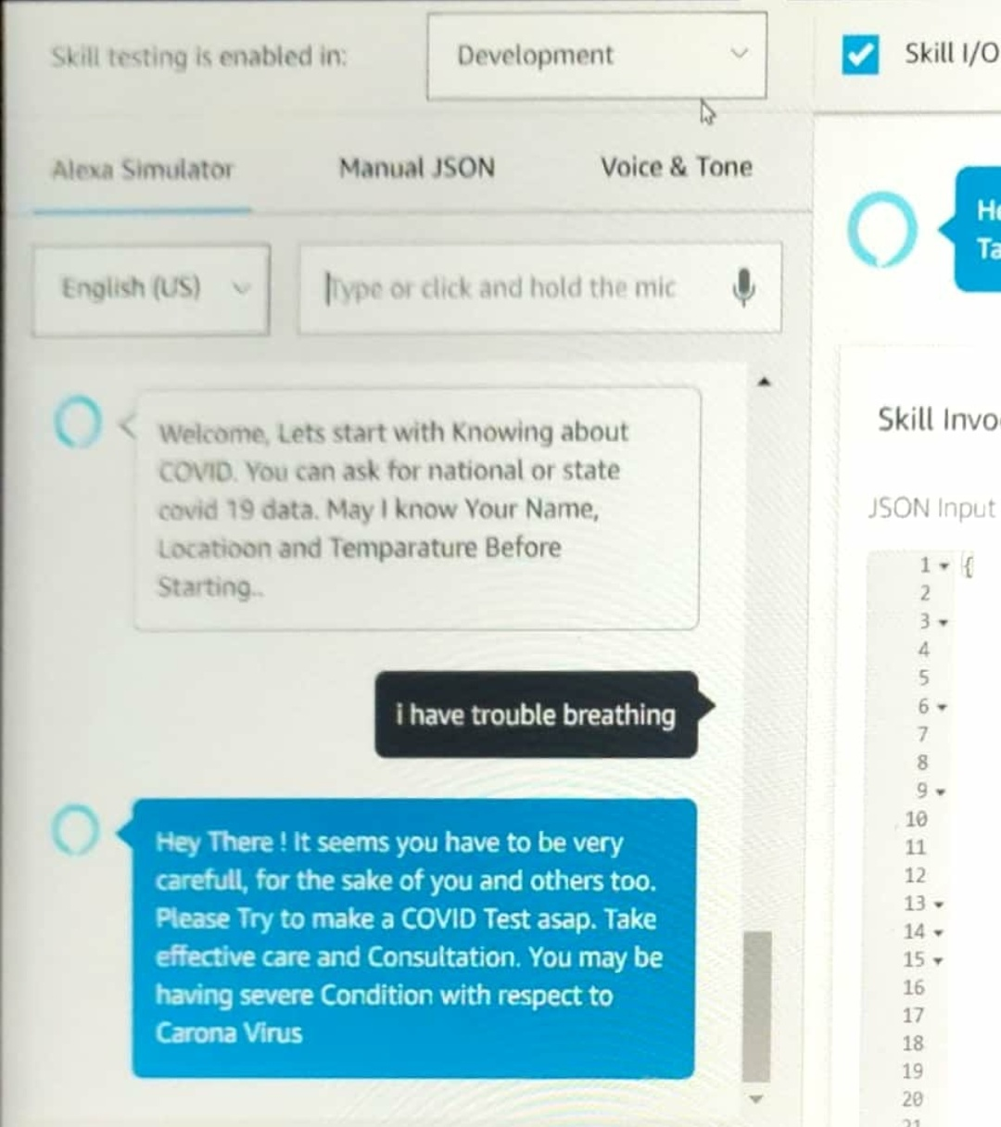

**Applications:**

The application of Alexa covid-19 skills are:-

* To analyze the person whether he/she has normal allergy or covid-19.
* To recommend the person with covid-19 symptoms to check with the doctor
* To give the necessary details about current no. of cases.

**Conclusion:**

Thus Alexa skill is one of the best way to cope up the mental illness during this covid-19 pandemic.

**Future scope:**

The future scope of AI interaction is huge, it can create new career pths in the field of Machine learning,Data mining and Analysis,AI software development , Program management, and testing.