**1.PROJECT TITLE:**

**Build a Plasma Donar App with AWS serverless computing**

**2.INTRODUCTION**

**2.1 OVERVIEW**

As the pandemic is going on, we know that plasma placing an immense role. This app is will register the people who can donate their plasma, including details and people login and check whether there is a blood group matching to there required one. They can also request for the required blood group. Thus, a message will be sent to the donar that they need to donate plasma to someone.

**2.2 PURPOSE**

People who are infected can be Cured easily by getting plasma through this app easily.

**3.RESULT**

**3.1 SCREENSHOTS OF OUTPUT**

Request

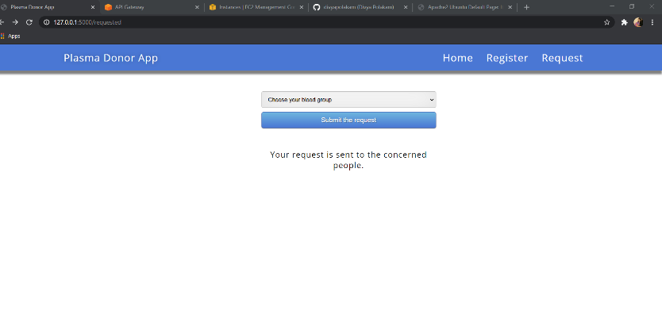

Login

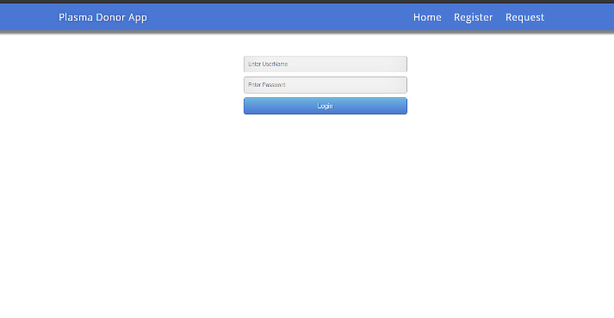

**4.APPLICATIONS**

* Everyone all over the world can access it and get plasma to cure from Covid-19.
* Easy access.
* Free source

**5.CONCLUSION**

People can easily get access to this application and get there required bllod group as it is user friendly.

**6.FUTURE SCOPE**

As the pandemic is getting worse day-by-day it will help people a lot.