**Scope Of Project:**

After building Machine learning model we need to evaluate the model Results .In this Project we evaluate models by using different metrics that are there for both classification and regression algorithms.

**Regression:**

1. import numpy as np
2. import pandas as pd
3. import matplotlib.pyplot as plt
4. from sklearn.linear_model import LinearRegression
5. from sklearn.model_selection import train_test_split
6. from sklearn.metrics import mean_absolute_error,r2_score,mean_squared_error

1. dataset=pd.read_csv('diabetes.csv')
2. dataset.head()

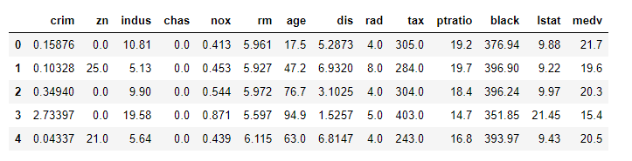

1. dataset.describe()

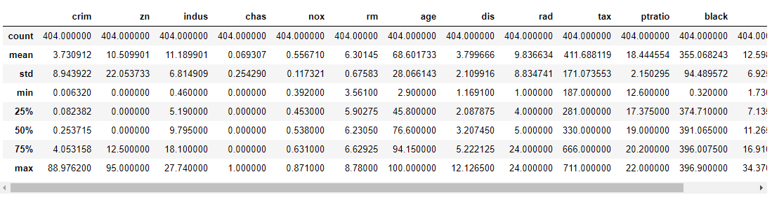

1. dataset.isnull().sum()

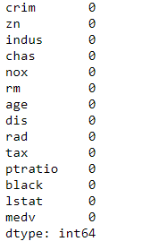

1. x_train=dataset[['crim','zn','indus','chas','nox','rm','age','dis','rad','tax','ptratio','black','lstat']]
2. y_train=dataset[['medv']]
3. x_train=np.array(x_train)
4. y_train=np.array(y_train)
5. X_train,X_test,Y_train,Y_test=train_test_split(x_train,y_train,test_size=0.2)
6. print(X_train.shape)
7. print(Y_train.shape)
8. print(Y_test.shape)
9. print(X_test.shape)

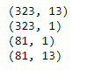

1. model=LinearRegression()
2. model.fit(X_train,Y_train)



1. predictions=model.predict(X_test)
2. error_sq=mean_absolute_error(Y_test,predictions)
3. error_sq



1. error_sqr=mean_squared_error(Y_test,predictions)
2. error_sqr



1. error_nsqr=mean_squared_error(Y_test,predictions,squared=False)
2. error_nsqr



1. r2=r2_score(Y_test,predictions)
2. r2



1. plt.plot(Y_test,label='True Predictions',color='r')
2. plt.plot(predictions,label='Predicted',color='b')
3. plt.title('Model Results')
4. plt.legend()
5. plt.show()

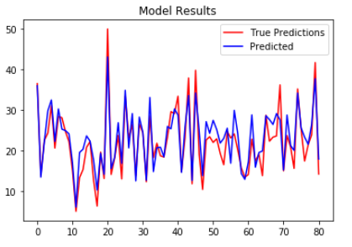

**Classification:**

1. import numpy as np
2. import pandas as pd
3. import matplotlib.pyplot as plt
4. from sklearn.preprocessing import LabelEncoder
5. from sklearn.preprocessing import StandardScaler
6. from sklearn.model_selection import train_test_split
7. from sklearn.linear_model import LogisticRegression
8. from sklearn.metrics import plot_confusion_matrix
9. from sklearn.metrics import accuracy_score,confusion_matrix,roc_curve,auc

1. dataset=pd.read_csv('diabetes.csv')
2. dataset.head()

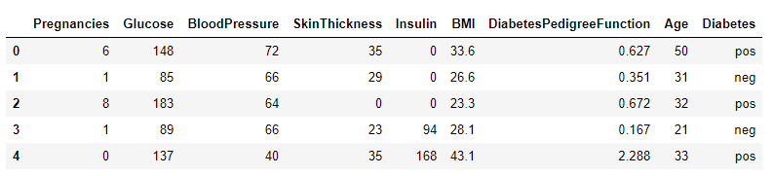

1. dataset.isnull().sum()

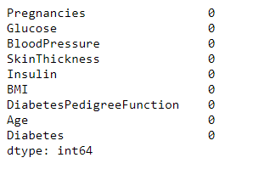

1. dataset.describe()

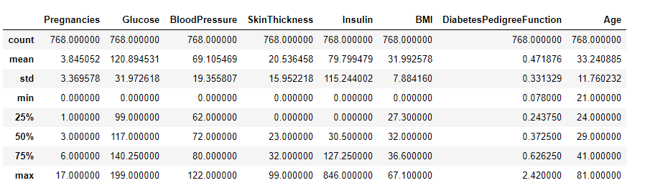

1. x=dataset.iloc[:,0:-1].values
2. y=dataset.iloc[:,-1].values
3. le=LabelEncoder()
4. y=le.fit_transform(y)
5. sc=StandardScaler()
6. x=sc.fit_transform(x)
7. x_train,x_test,y_train,y_test=train_test_split(x,y,test_size=0.2)
8. print(x_train.shape)
9. print(y_train.shape)
10. print(x_test.shape)
11. print(y_test.shape)

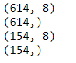

1. model1=LogisticRegression()
2. model1.fit(x_train,y_train)

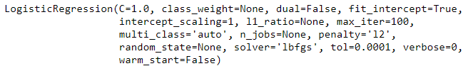

1. pred1=model1.predict(x_test)
2. pr1=le.inverse_transform(pred1)
3. pr1

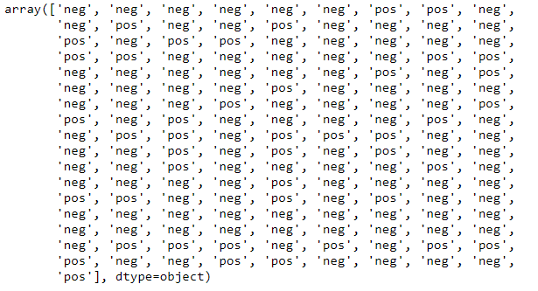

1. accuracy_score(y_test,pred1)



1. confusion_matrix(y_test,pred1)



1. fpr,tpr,threshold=roc_curve(y_test,pred1)
2. roc_auc=auc(fpr,tpr)
3. roc_auc



1. plt.title('Recursive Operating Characetstics')
2. plt.plot(fpr,tpr,'b',label='AUC %f'%roc_auc)
3. plt.legend()
4. plt.show()

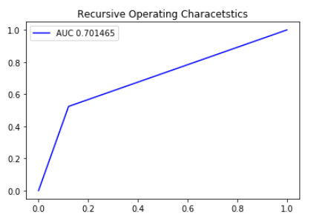

1. plot_confusion_matrix(model1,x_test,y_test)

