**Report on Chatbot (Covida)**

**Aim: To design a Chatbot facilitating the customer to purchase grocery, vegetables and fruits.**

**Components:**

1. Watson Assistant for building the Chatbot.
2. Node-red for building the GUI.

**Description: The Chatbot was designed in two phases:**

**Phase 1:**

Building the skill: A basic Chatbot skill comprises of the following three elements:

1. Intents: The interaction which the user will have with the system
2. Entities: The action words which will be used to interact with the system
3. Dialogues: The conversation which will take place between the user and the bot.

The system which has been designed comprises of the following:

1. Intents: The bot has been designed using 5 entities namely: #enquiry, #Goodbye, #Greetings, #name, #order. Each entity has been provided with sufficient number of examples to understand the user intent.
2. Entities: The intents have been modelled using entities which will be further used for building the dialogues. The entities created are: @email, @enquiry, @fruits, @goodbye, @greetings, @groceries, @name, @order, @payment, @phonenumber, @response, @vegetables. The system entity @sys-number has been used for creating the context variable for the quantity that user wants to buy.
3. Dialogues: The dialogues have been modelled as per the flowgraph shown below:

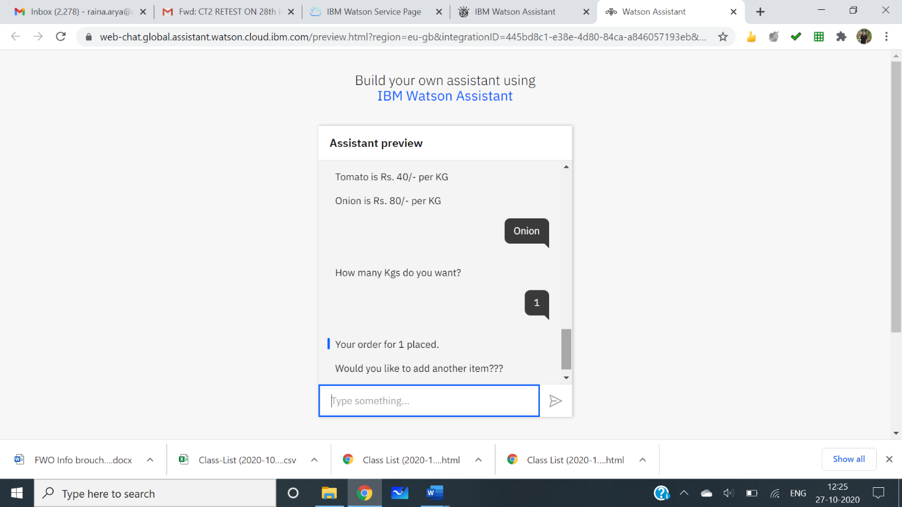**Snapshots of the Assistant Preview**

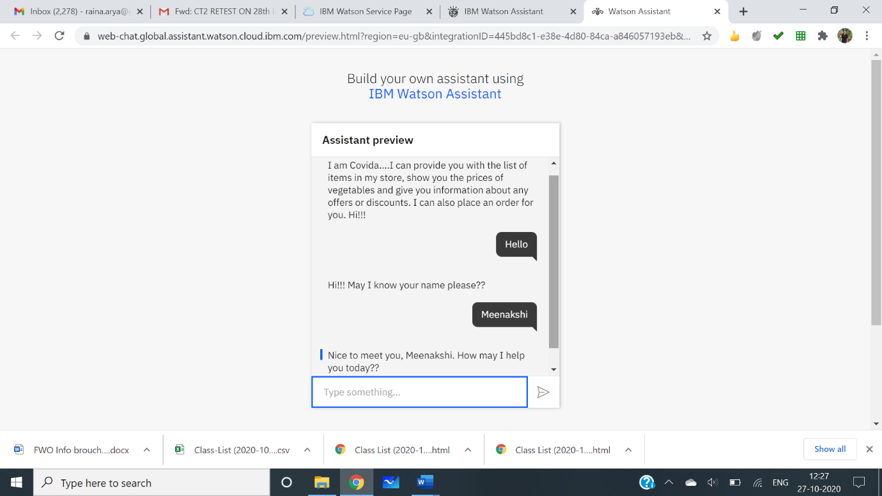

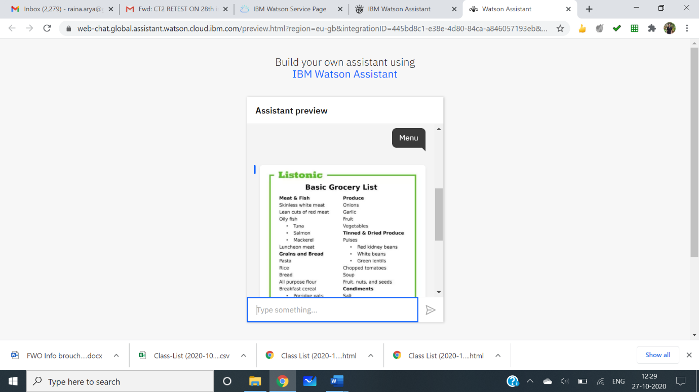 Step 1

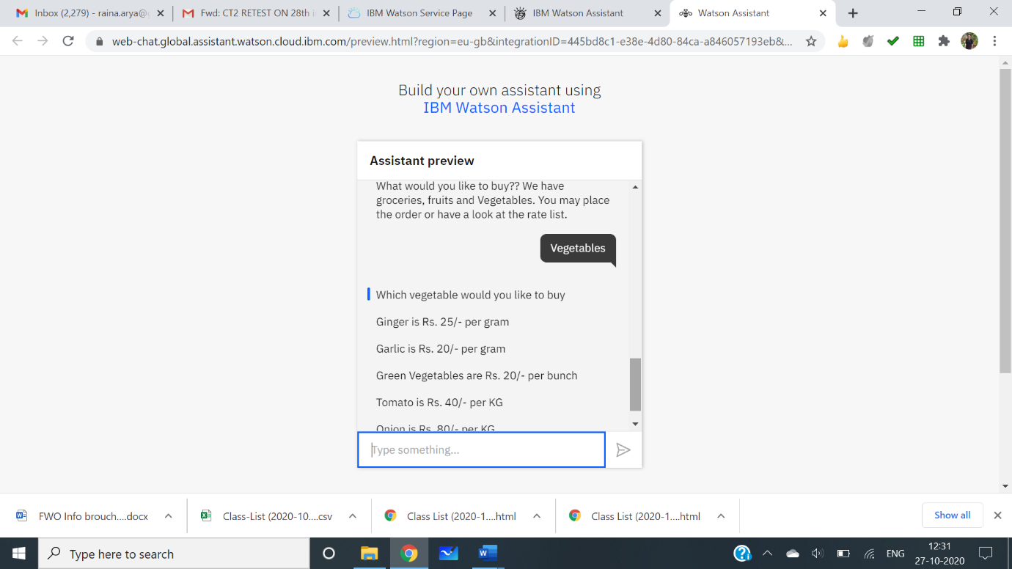 Step 2

Step 4

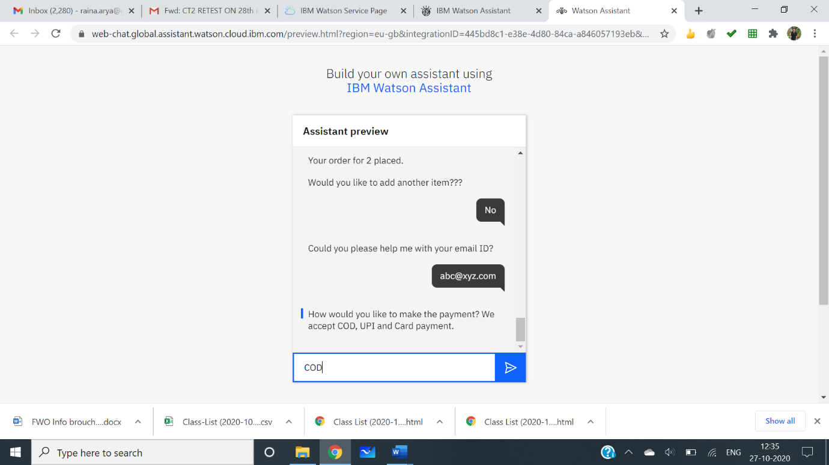

Step 5

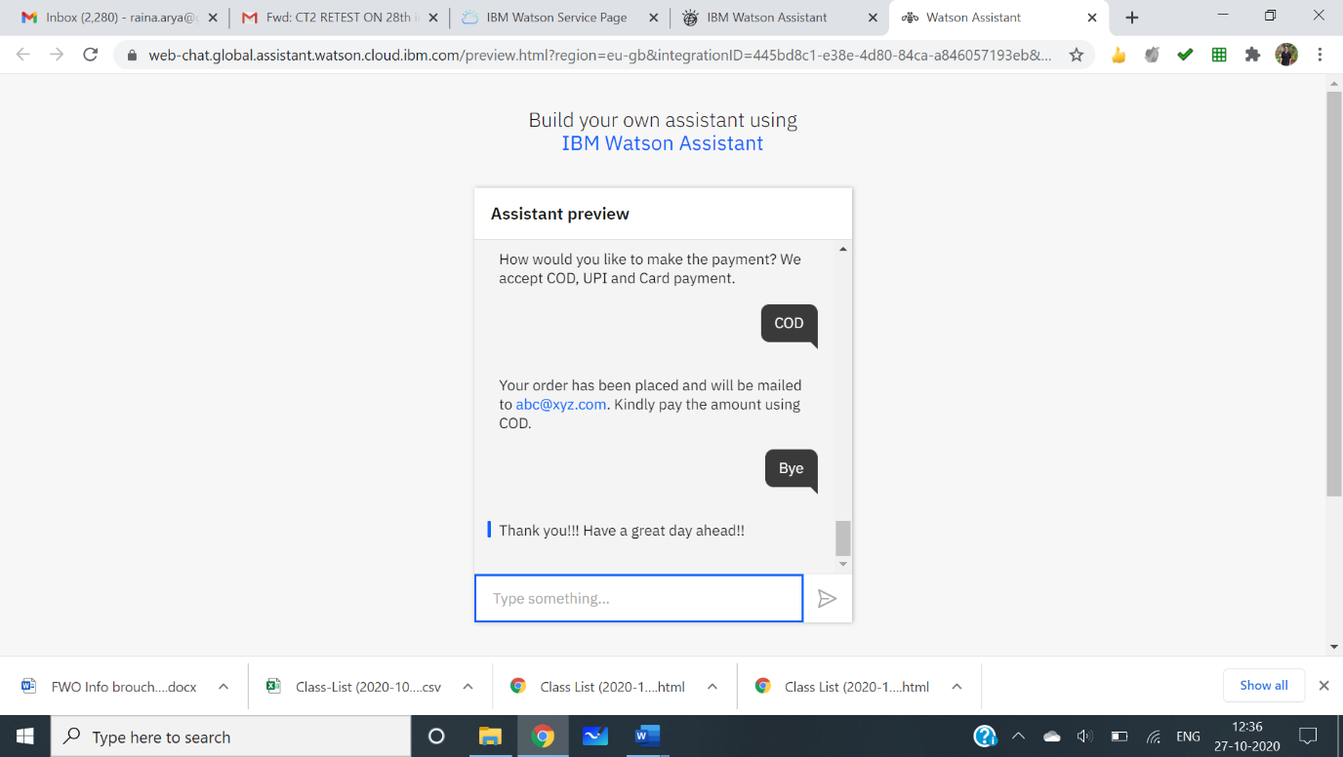

Step 7

Step 3 Step 6

Phase 2: Designing the interface and the UI

The GUI has been built using Node-Red, the following node red components were used for designing the GUI:

1. Assistant node: The API key of the assistant node alongwith the workspace ID is set to the API key of Watson studio and the Bot skill created.
2. Form Node: Part of node-red-dashboard palette, this node has been used to create the form for accepting the response through “You” text node and reply with the parsed input through the “Covida” Text field.
3. Function Node: Two function nodes namely “Input Parsing” and “Parsing” have been used to parse the user input and send the parsed output to the “Covida” text node.
4. Inject Node: It is used for testing whether the bot is responding to the input “Hi”.
5. 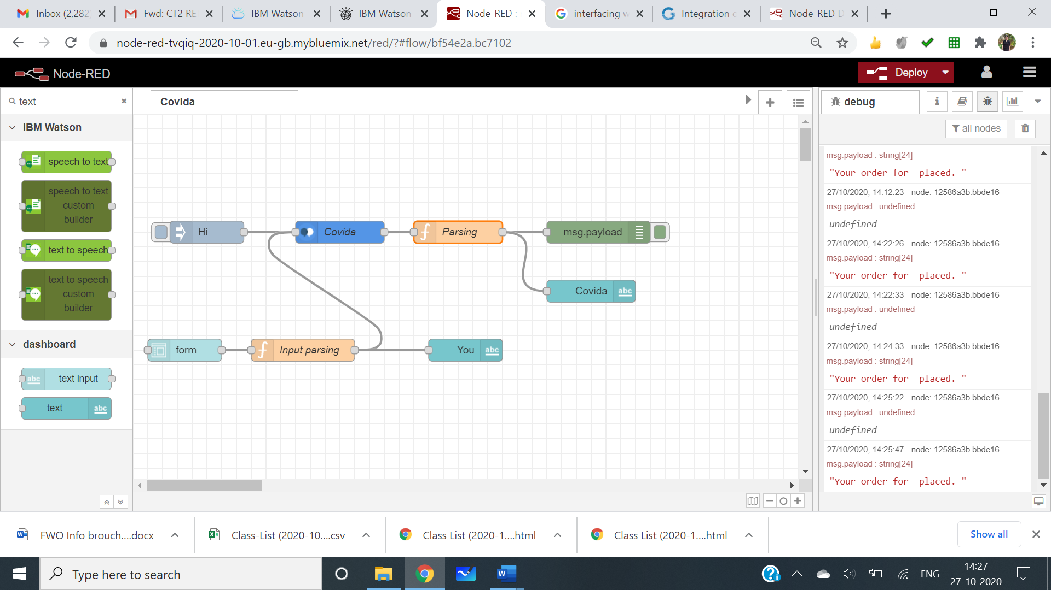Debug Node: It is used to test whether the input from the inject node is being processed by the assistant node to give the correct output.

**Screenshot of the Node- Red Flow**

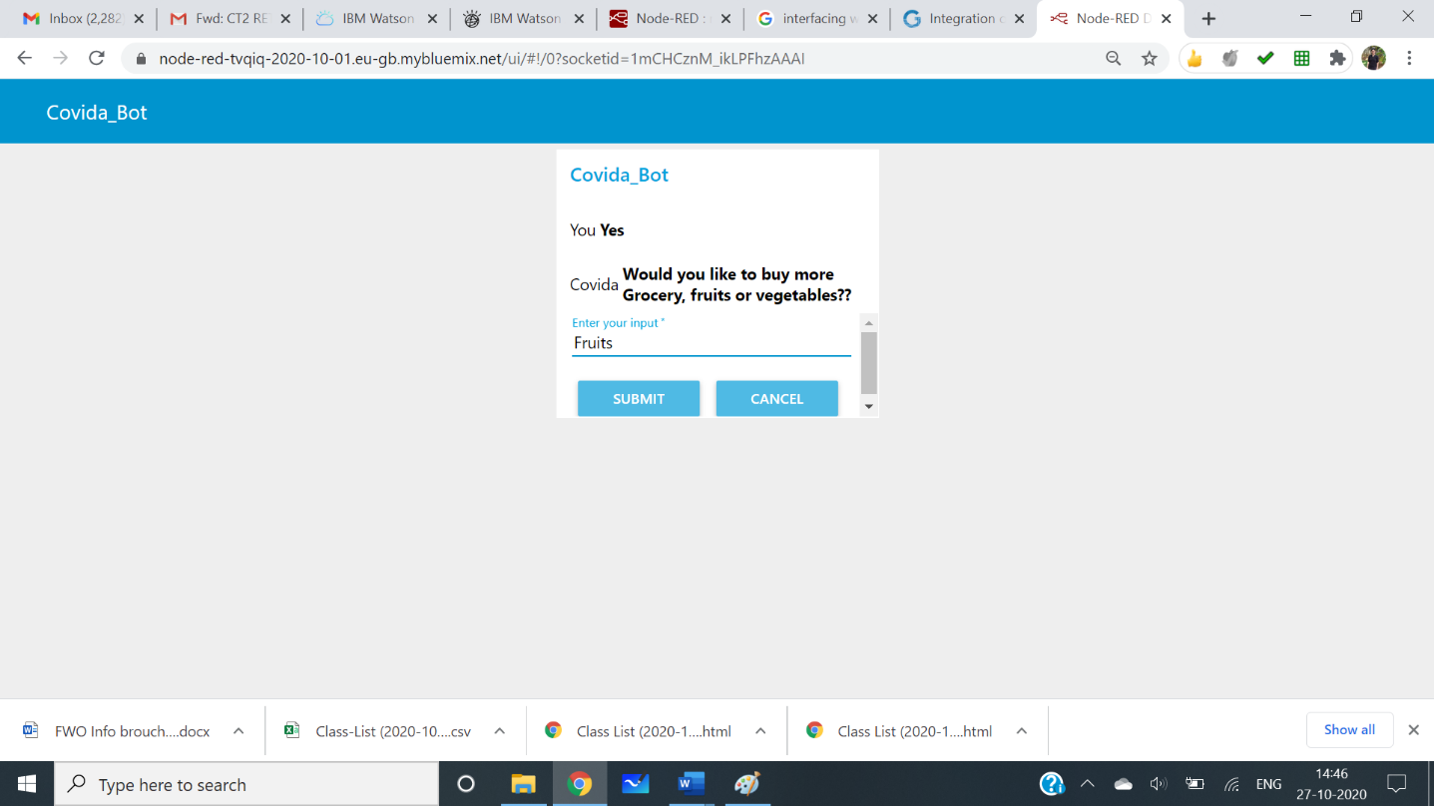

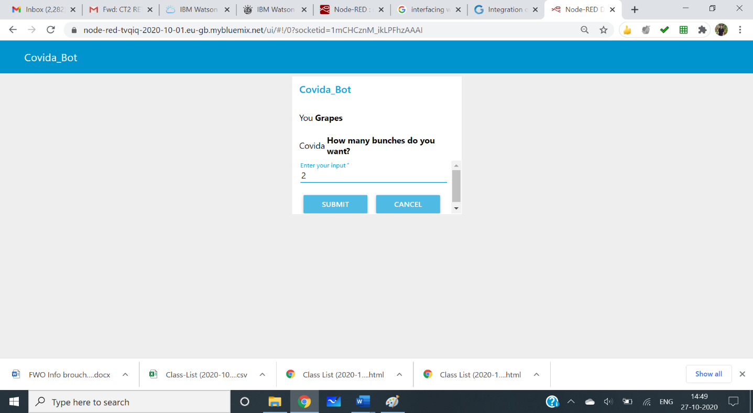

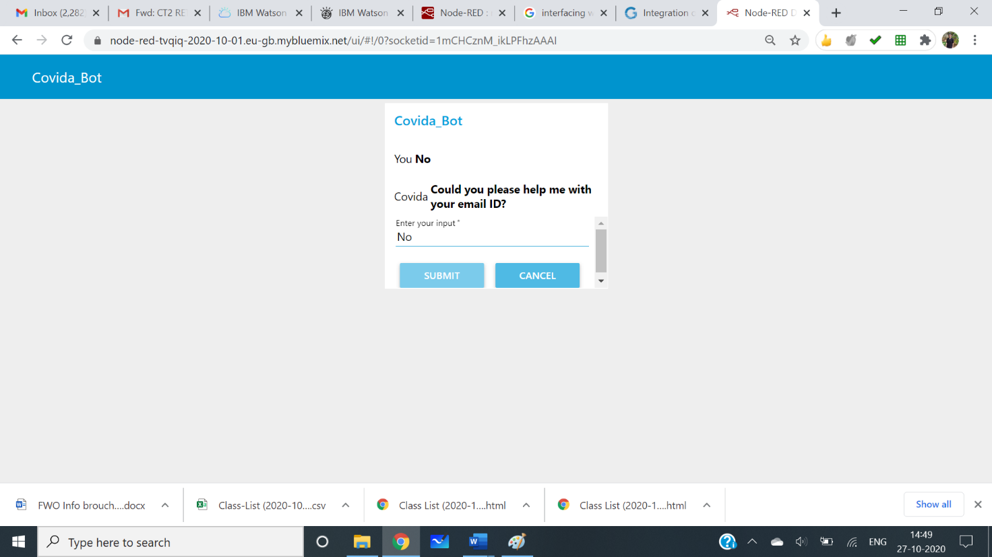

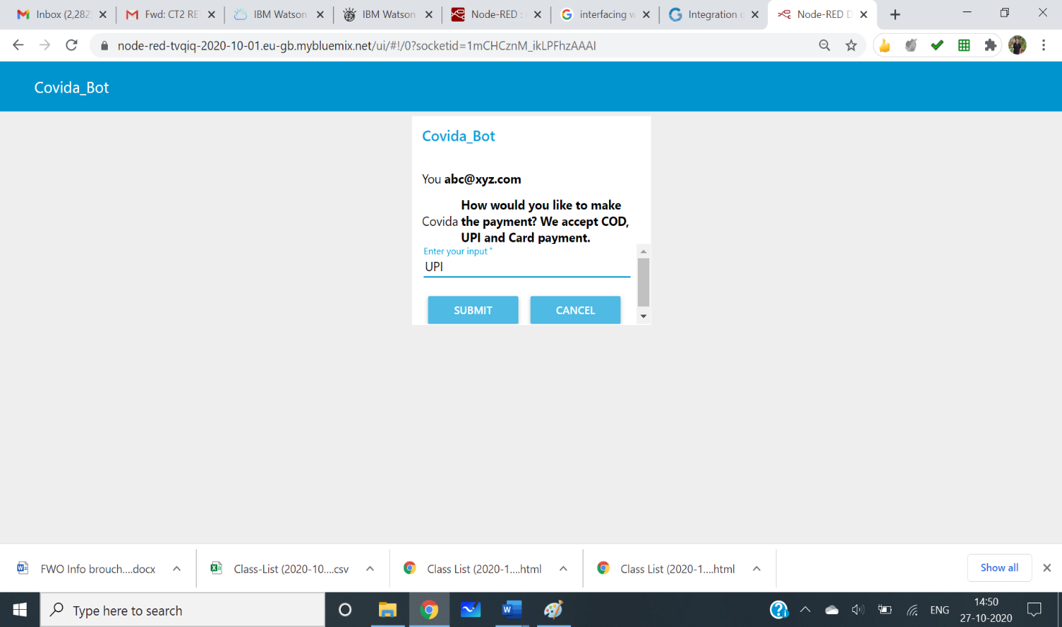

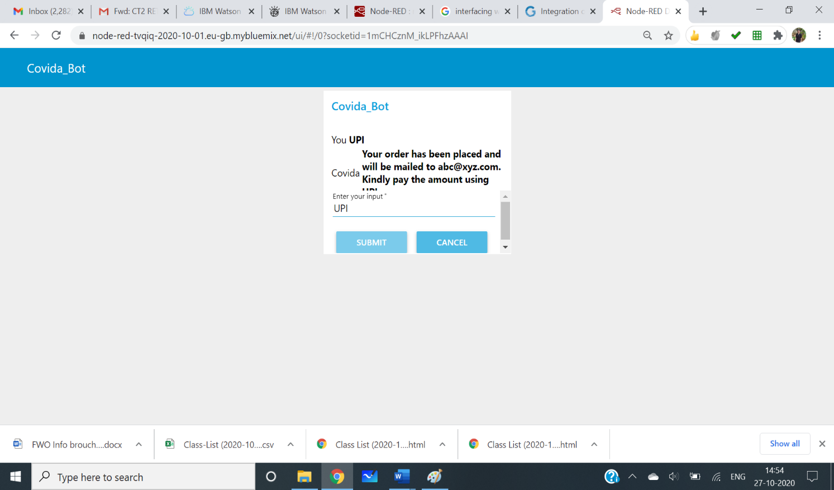

**Screenshots of UI**