**Project Report on Covid-19 Essentials Chatbot to shop Vegetables**

|  |  |  |  |  |  |  |  |
| --- | --- | --- | --- | --- | --- | --- | --- |
| **1** | |  | **INTRODUCTION** | |  |  |  |
|  | |  | 1.1  Overview | |  |  |  |
|  | |  | 1.2  Purpose | |  |  |  |
| **2** | |  | **LITERATURE SURVEY** | |  |  |  |
|  | |  | 2.1  Existing problem | | |  |  |
|  | |  | 2.2  Proposed solution | | |  |  |
| **3** | |  | **THEORITICAL ANALYSIS** | |  |  |  |
|  | |  | 3.1  Block diagram | |  |  |  |
|  | |  | 3.2  Hardware / Software designing | | |  |  |
| **4** | |  | **EXPERIMENTAL INVESTIGATIONS** | | |  |  |
| **5** | |  | **FLOWCHART** | |  |  |  |
| **6** | |  | **RESULT** |  |  |  |  |
| **7** | |  | **ADVANTAGES & DISADVANTAGES** | | |  |  |
| **8** | |  | **APPLICATIONS** | |  |  |  |
| **9** | |  | **CONCLUSION** | |  |  |  |
| **10** | |  | **FUTURE SCOPE** | | **`** |  |  |
| **11** | |  | **BIBILOGRAPHY** | |  |  |  |
|  | |  | **APPENDIX** | |  |  |  |
|  |  | | A. Source code | |  |  |  |

|  |
| --- |
| 1. **INTRODUCTION** |
| 1.1  Overview |

Whole world is facing a pandaemic threat posed by Corona virus.Due to Covid-19 pandaemic lockdown situations, people are not able to go out to buy the essentials required. Inorder to maintain social distancing, all are forced to use online shopping to shop the essentials. Retail business people are also experiencing difficulties with respect to handling many customers simultaneously or assisting them as quickly as possible.

1.2  Purpose

Customers shopping for essentials without coming into physical contact of any persons and items, being an ideal solution in near future. Finding a Digital solution which is user friendly to be used by all category of people, which will help in online shopping is necessary to overcome the difficult times of Pandaemic situation. On the other side, business of many retail stores led to stand still due to pandemic. To help both the customers and the retail business people, an AI feature, the chatbot which helps in shopping will be a complete digital solution.

|  |  |
| --- | --- |
| **2. LITERATURE SURVEY** |  |
| 2.1 Existing problem  Many grocery shopping platforms in India rely on shop keepers / retailers who are local to area and provide delivery.As current pandaemic situation has restrictions in selling and buying,the local vendors may not have delivery boys, quick reply to available essentials, measures to resolve issues, provide updated detailed list of everyday available essentials. And also many more such difficult cases are to be handled efficiently. Top companies delivering groceries to home are Denzo,Big Basket, Fresh Direct and many more. Developing an application in e-commerce or UI for mobile platforms would not be an easy and quick solution.    2.2 Proposed solution  An appropriate solution to overcome the above mentioned customer related issues would be to develop a chatbot for shopping essentials. This chatbot would be a replacement for human interaction. The issues related to shopping and delivering can be resolved much easily.  The proposed chatbot is for buying the essentials i.e vegetables which at any time would be an everyday essential to any one in any situation. The chatbot is designed to list the available vegetables mentioning the price with the other offers available. A complete solution for a customer to enquire, order and buy the vegetables without any hindrance. Also, implemented the chatbot to answer few queries related to covid-19 such as symptoms and precautions. | |

1. THEORITICAL ANALYSIS

3.1 Block diagram

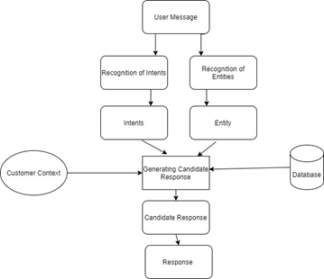

Fig 1: Block diagram for Covid-19 Essentials Chatbot

As shown in Fig. 1, User messages are prompted initially which matches the intents and entities created. The responses to the relevant intent, entity or for the context are generated by searching the response database. Finally, the response to the customer or candidate is posted in the chatbox by the bot.

3.2. Hardware / Software designing

IBM Cloud platform

Watson Assistant to create a chatbot

Node-red for UI integration with chatbot

1. **EXPERIMENTAL INVESTIGATIONS**
2. Vegetable list to be displayed on everyday basis
3. To display the current offers for the day
4. To allow customers to add vegetables and buy vegetables.
5. Save the name and email for future reference.
6. Personal touch to each customer to stay connected till the order is billed
7. **FLOWCHART**

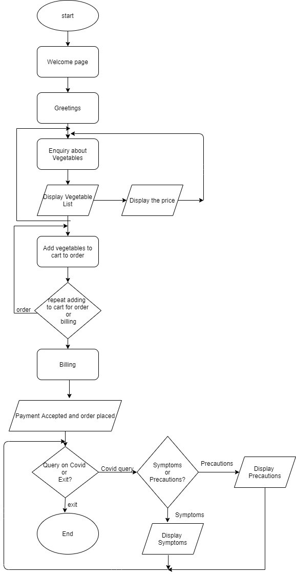

Fig 2: Chatbot flow chart

RESULT:

The Fig 3 shows the screenshots of the Covid-19 Essentials Chatbot.

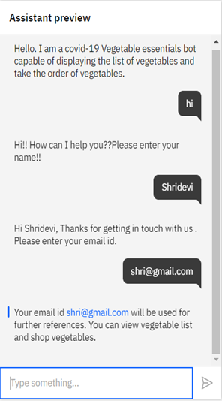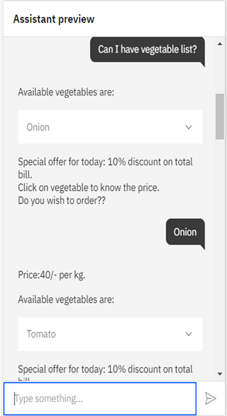

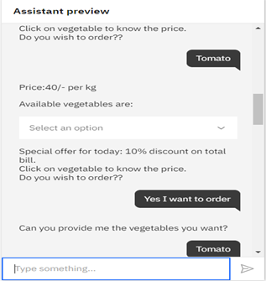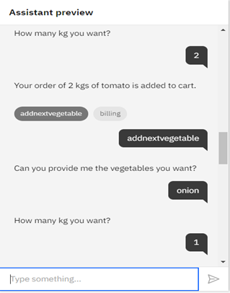

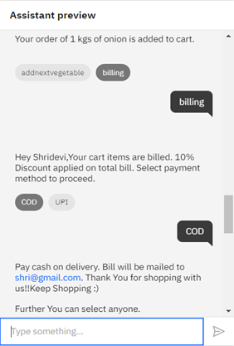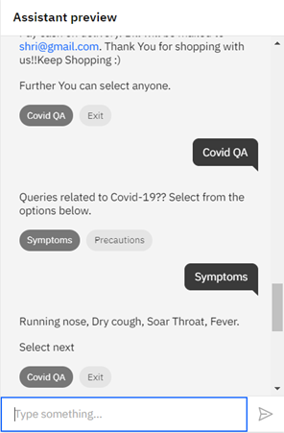

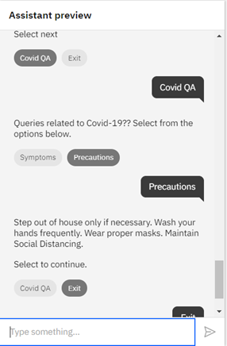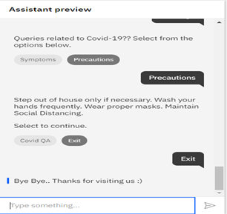

Fig 3: Screenshots of working Chatbot

**ADVANTAGES & DISADVANTAGES**

Advantages:

1. Convenient customer support and gather customer insights

2. Will cause increase in sales

3. Available 24/7 and save money for retail owners

4. Handled enquiry, order and billing

Disadvantages:

1. No view of cart

2. Billing module to be implemented

**APPLICATIONS**

This chatbot can be integrated with online shopping webiste for shopping essentials like vegetables.

**CONCLUSION**

The Shop for Essentials chat bot is a basic virtual assistant for shopping the essential such as vegetables. The custom messages are featured for customer support, instant response to the queries of the customer in the bot. The above few characteristics of the bot developed for essentials is basic bot application suitable to run on windows platform. Aim is to simulate human responses.

**FUTURE SCOPE**

The few additional features to be added are the more essentials and billing module.