**Movie Ticket Booking Chat Bot**

|  |  |  |  |  |  |  |  |
| --- | --- | --- | --- | --- | --- | --- | --- |
| **1** | |  | **INTRODUCTION** | |  |  | **Page NO** |
|  | |  | 1.1 Overview | |  |  | 2 |
|  | |  | 1.2 Purpose | |  |  | 2 |
| **2** | |  | **LITERATURE SURVEY** | |  |  | **2** |
|  | |  | 2.1 Existing problem | | |  | 2 |
|  | |  | 2.2 Proposed solution | | |  | 2 |
| **3** | |  | **THEORITICAL ANALYSIS** | |  |  | **3** |
|  | |  | 3.1 Block diagram | |  |  | 3 |
|  | |  | 3.2 Hardware / Software designing | | |  | 3 |
| **4** | |  | **FLOWCHART** | |  |  | **4** |
| **5** | |  | **RESULT** |  |  |  | **5-7** |
| **6** | |  | **ADVANTAGES & DISADVANTAGES** | | |  | **7** |
| **7** | |  | **APPLICATIONS** | |  |  | **7** |
| **8** | |  | **CONCLUSION** | |  |  | **7** |
| **9** | |  | **FUTURE SCOPE** | | **`** |  | **7** |
| **10** | |  | **BIBILOGRAPHY** | |  |  | **7** |
|  | |  | **APPENDIX** | |  |  |  |
|  |  | | A. Source code | |  |  | 7-82 |
|  |  | |  |  |  |  |  |

**Movie Ticket Booking Chat Bot**

1. Introduction
   1. Overview

A Chabot is a system implemented by many researchers to support various types of platforms. Most of them are customized for a particular platform.

* 1. Purpose

There are many apps to book movie tickets online but for naïve users it is not possible to do ticket booking online easily. To help naïve user to book movie tickets chat bots are very helpful as it is very user friendly to operate.

1. Literature Survey
   1. Existing Problem

There is a an existing Odeon’s chatbot, developed by social technology company Gruvi, requires a user to like the brand’s Facebook page and then either click “Message” or type “Odeon” into a chat search. After a greeting from the bot Users are asked for their location or what film they are interested in seeing. The bot then informs the customer of nearby cinemas or where, and what time, their selected film is showing. Once a decision has been made, the customer is sent a link to a booking page. This is developed in “EUROPE” for Odeon’s Cinemas. Chatbots are emerging technology that leverage messaging habits to help business communicate more efficiently to their clients. Chatbots intermediate and help users with a specific task. The future scope is limitless. First, there was traditional ticket booking i.e. Window Booking then came to a Smart Application i.e. BOOK MY SHOW now came to an Automated Chatbot.

* 1. Proposed Solution

There only few chatbots based on movie ticket booking in INDIA. There is an application in INDIA BookMyShow” which has a booking of a movie ticket but there is no chatbot in it to chat with the user. Bot informs the customer of cinemas or where, and what time, their selected film is showing. Once a decision has been made, the customer is sent a link to a booking.

The Proposed System Is called “Movie booking Chatbot” which helps Indian users to book movie tickets based on the language of the movie they wish to watch with the help to IBM Watson assistant.

1. Theoretical analysis
   1. Block Diagram

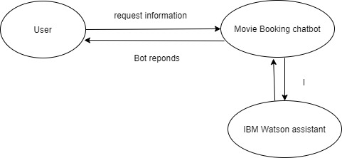

* 1. Hardware and Software design

IBM Watson assistant and IBM Cloud storage(for data set)

1. Flowchart

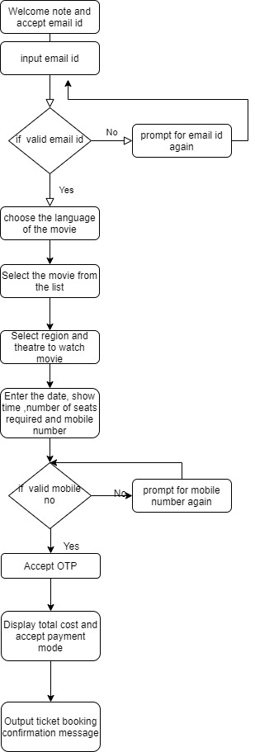

1. Result

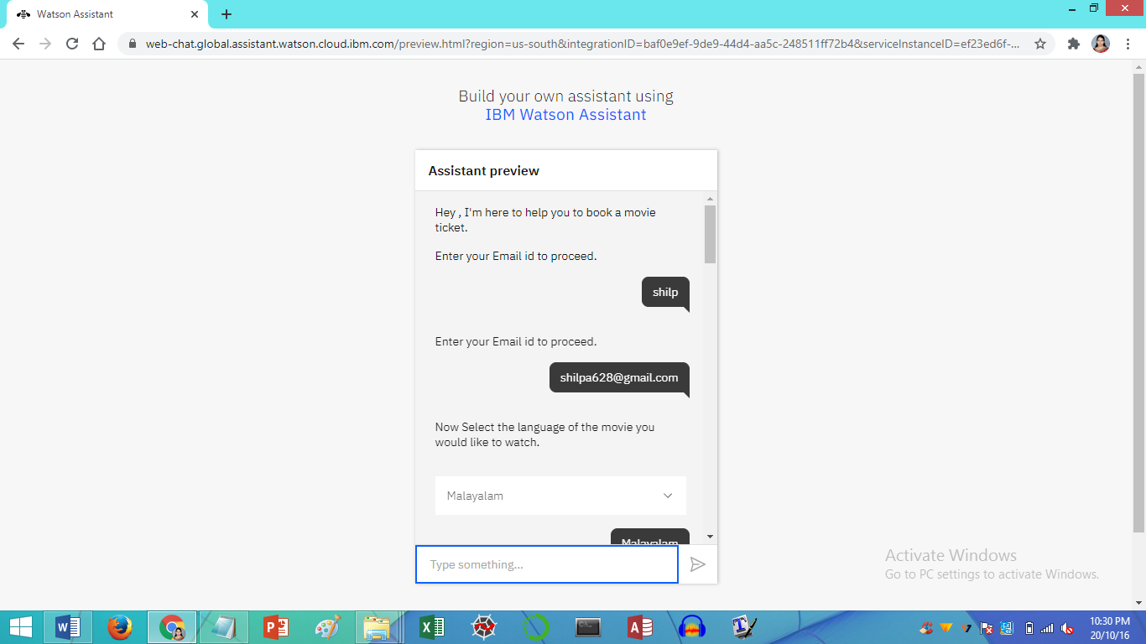

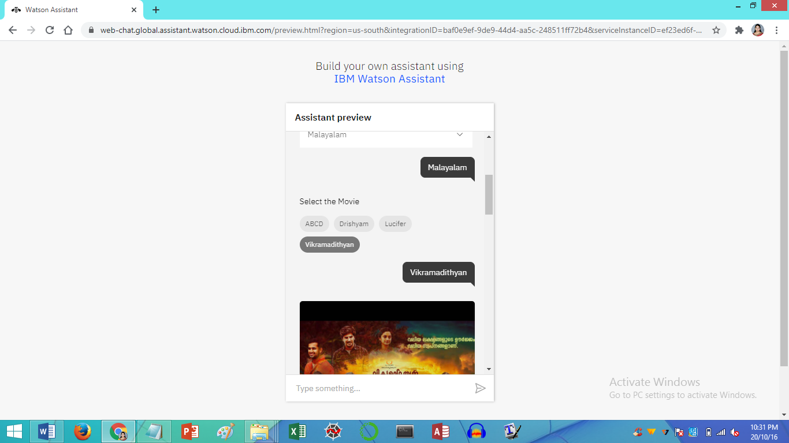

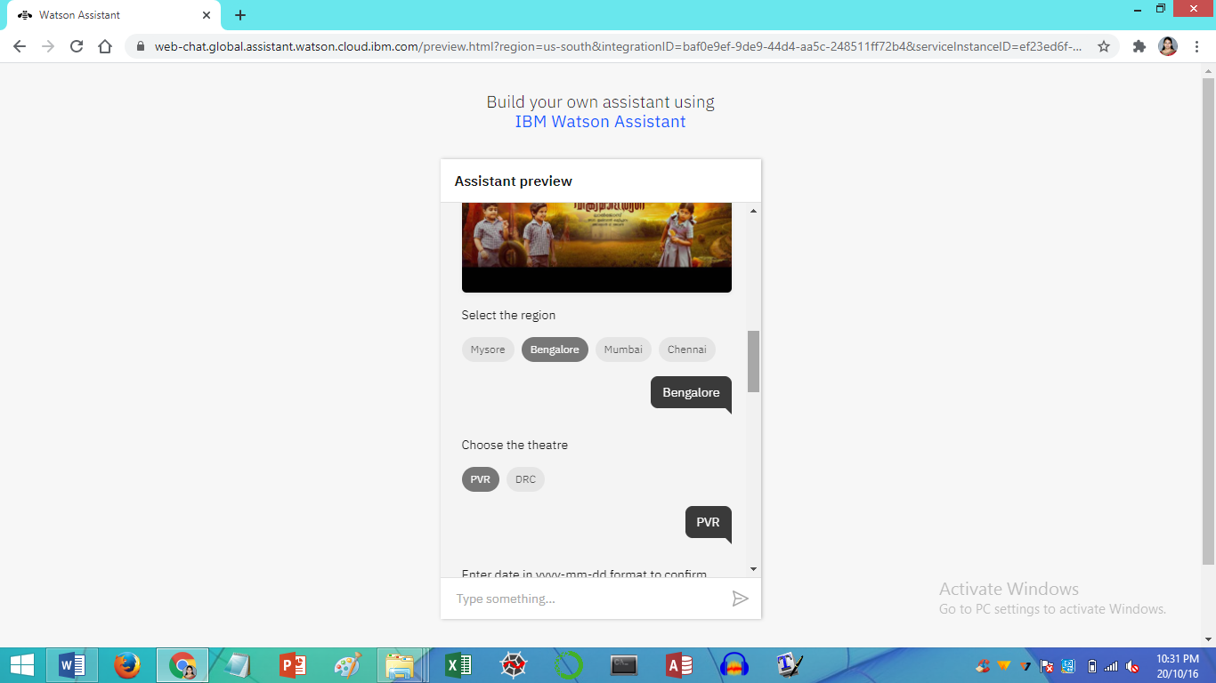

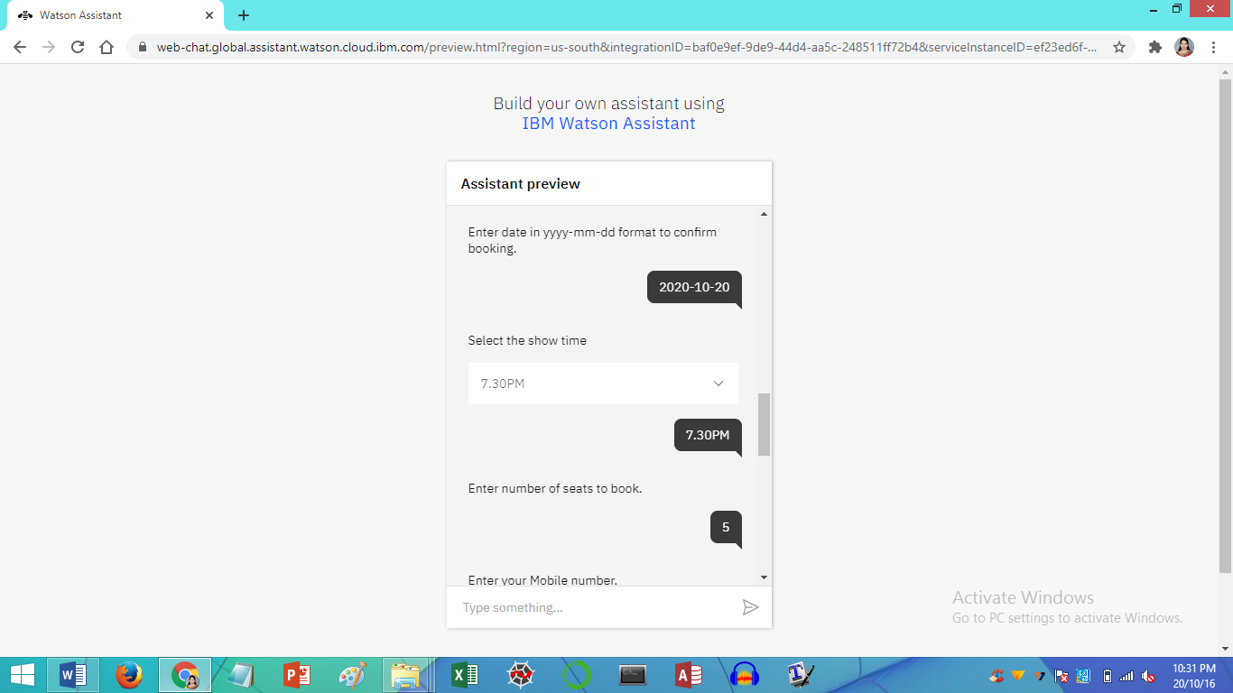

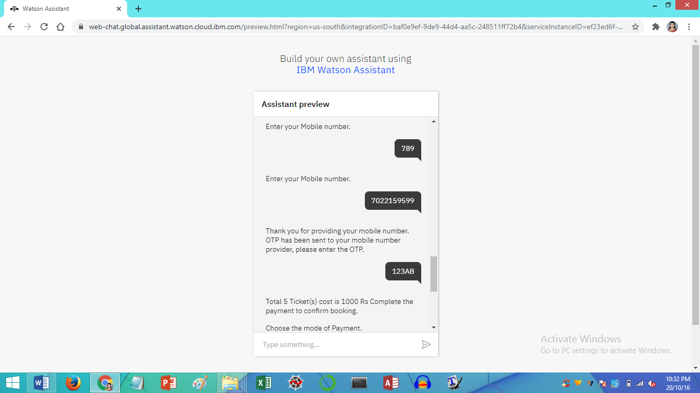

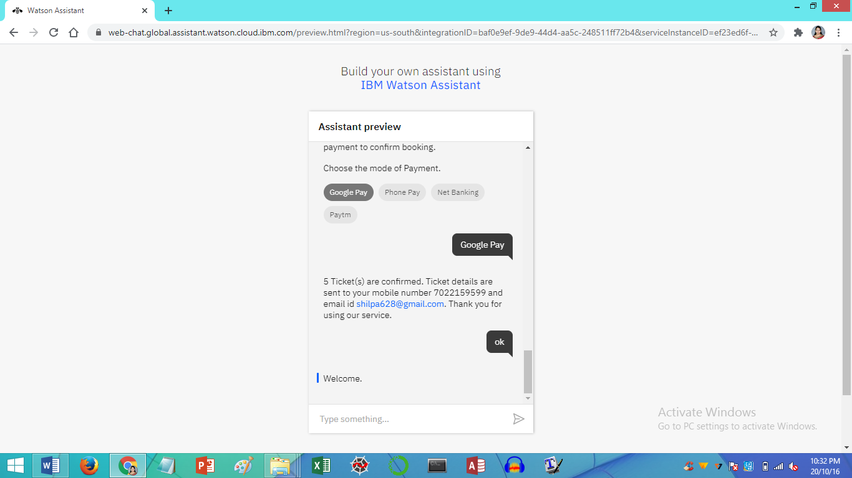

1. Advantages

1. Bots are a lot easier to install than mobile apps and they can save users the much needed storage space on their smart phones.

2. Mobile app can be expensive to build, maintain, and display.

3. Messaging apps are already dominating engagement so no need to start your efforts from the scratch.

4. Bots interact with customers in natural conversational language.

5. Context Awareness

6. Free of cost.

7. Company can achieve good marketing.

Disadvantages

1.Chatbots does not have answer for all user queries, it requires constant training.

1. Applications
2. Movie tickets booking online.
3. Conclusion

Chatbot in apps are basically an upgrade to a mobile user interface, as they bring the most basic type of human interaction into the digital environment. A simpler, faster and more intuitive user interface results in an overall better user experience, which is one of the key factors for mobile growth. The future scope is limitless. First there was traditional ticket booking i.e. Window Booking then came a Smart Application now an integrated application with chatbot. This movie ticket booking chatbot help the user to book a movie based on the language of their choice in popular cities.

1. Future scope

* This “Movie booking chatbot” can be upgraded to find user location, time and shows in nearby theatres with available tickets.
* This Movie booking chatbot is static it could be converted into dynamic chatbot.

1. Bibliography

[1] Regex pattern available at: <https://www.ibm.com/support/knowledgecenter/SSY2V3_5.3.0/lr/lsh-regex.html>

1. Appendix

Source code:

{

"intents": [

{

"intent": "MovieEnquiry",

"examples": [

{

"text": "Movies names"

},

{

"text": "Suggest me some movies."

},

{

"text": "what are the movies for the day?"

}

],

"description": ""

},

{

"intent": "otp",

"examples": [

{

"text": "100090"

},

{

"text": "123AB"

},

{

"text": "345Bc"

},

{

"text": "46890"

},

{

"text": "87654"

}

],

"description": ""

},

{

"intent": "Seats",

"examples": [

{

"text": "1"

},

{

"text": "2"

},

{

"text": "3"

},

{

"text": "4"

},

{

"text": "5"

},

{

"text": "6"

}

],

"description": ""

},

{

"intent": "ShowTimings",

"examples": [

{

"text": "10.30AM"

},

{

"text": "11PM"

},

{

"text": "1PM"

},

{

"text": "4PM"

},

{

"text": "7.30AM"

},

{

"text": "7.30PM"

}

],

"description": ""

},

{

"intent": "ThankYou",

"examples": [

{

"text": "k"

},

{

"text": "ok"

},

{

"text": "okay"

},

{

"text": "Thanks"

},

{

"text": "Thank You"

}

],

"description": ""

}

],

"entities": [

{

"entity": "email",

"values": [

{

"type": "patterns",

"value": "email",

"patterns": [

"^(\\\\([a-z] {30}\\\\))?[a-z]{30}@[.]$",

"^[a-zA-Z0-9+_.-]+@[a-zA-Z0-9.-]+$"

]

}

],

"fuzzy_match": true

},

{

"entity": "Hindi",

"values": [

{

"type": "synonyms",

"value": "Baaghi3",

"synonyms": []

},

{

"type": "synonyms",

"value": "Gunjan Saxena",

"synonyms": []

},

{

"type": "synonyms",

"value": "Hindi",

"synonyms": []

},

{

"type": "synonyms",

"value": "Raat Akeli Hai",

"synonyms": []

},

{

"type": "synonyms",

"value": "War",

"synonyms": []

}

],

"fuzzy_match": true

},

{

"entity": "Kannada",

"values": [

{

"type": "synonyms",

"value": "Dia",

"synonyms": []

},

{

"type": "synonyms",

"value": "Kannada",

"synonyms": []

},

{

"type": "synonyms",

"value": "Love Moctail",

"synonyms": []

},

{

"type": "synonyms",

"value": "Pogaru",

"synonyms": []

},

{

"type": "synonyms",

"value": "Robert",

"synonyms": []

}

],

"fuzzy_match": true

},

{

"entity": "Malayalam",

"values": [

{

"type": "synonyms",

"value": "ABCD",

"synonyms": []

},

{

"type": "synonyms",

"value": "Drishyam",

"synonyms": []

},

{

"type": "synonyms",

"value": "Lucifer",

"synonyms": []

},

{

"type": "synonyms",

"value": "Malayalam",

"synonyms": []

},

{

"type": "synonyms",

"value": "Vikramadithyan",

"synonyms": []

}

],

"fuzzy_match": true

},

{

"entity": "mobileno",

"values": [

{

"type": "patterns",

"value": "mobileno",

"patterns": [

"^[789]\\d{9}$"

]

}

],

"fuzzy_match": true

},

{

"entity": "Paymentmode",

"values": [

{

"type": "synonyms",

"value": "Google Pay",

"synonyms": [

"GPay"

]

},

{

"type": "synonyms",

"value": "Net Banking",

"synonyms": [

"Online Banking"

]

},

{

"type": "synonyms",

"value": "Paytm",

"synonyms": []

},

{

"type": "synonyms",

"value": "Phone Pay",

"synonyms": []

}

],

"fuzzy_match": true

},

{

"entity": "regions",

"values": [

{

"type": "synonyms",

"value": "Bengalore",

"synonyms": []

},

{

"type": "synonyms",

"value": "chennai",

"synonyms": []

},

{

"type": "synonyms",

"value": "Mumbai",

"synonyms": []

},

{

"type": "synonyms",

"value": "Mysore",

"synonyms": []

}

],

"fuzzy_match": true

},

{

"entity": "sys-date",

"values": [],

"fuzzy_match": true

},

{

"entity": "sys-number",

"values": [],

"fuzzy_match": true

},

{

"entity": "sys-time",

"values": [],

"fuzzy_match": true

},

{

"entity": "Tamil",

"values": [

{

"type": "synonyms",

"value": "Bigil",

"synonyms": []

},

{

"type": "synonyms",

"value": "Petta",

"synonyms": []

},

{

"type": "synonyms",

"value": "Saaho",

"synonyms": []

},

{

"type": "synonyms",

"value": "Tamil",

"synonyms": []

},

{

"type": "synonyms",

"value": "Vishwasam",

"synonyms": []

}

],

"fuzzy_match": true

},

{

"entity": "Telugu",

"values": [

{

"type": "synonyms",

"value": "Geeta Govindam",

"synonyms": []

},

{

"type": "synonyms",

"value": "Hit",

"synonyms": []

},

{

"type": "synonyms",

"value": "Mahanati",

"synonyms": []

},

{

"type": "synonyms",

"value": "Maharshi",

"synonyms": []

},

{

"type": "synonyms",

"value": "Telugu",

"synonyms": []

}

],

"fuzzy_match": true

},

{

"entity": "theatre",

"values": [

{

"type": "synonyms",

"value": "DRC",

"synonyms": []

},

{

"type": "synonyms",

"value": "PVR",

"synonyms": []

}

],

"fuzzy_match": true

}

],

"metadata": {

"api_version": {

"major_version": "v2",

"minor_version": "2018-11-08"

},

"from-sample": true

},

"dialog_nodes": [

{

"type": "standard",

"title": "Anything else",

"output": {

"generic": [

{

"values": [

{

"text": "I didn't understand. You can try rephrasing."

},

{

"text": "Can you reword your statement? I'm not understanding."

},

{

"text": "I didn't get your meaning."

},

{

"text": "something went wrong. Try again."

}

],

"response_type": "text",

"selection_policy": "sequential"

}

]

},

"conditions": "anything_else",

"dialog_node": "Anything else",

"previous_sibling": "node_9_1602659958199",

"disambiguation_opt_out": true

},

{

"type": "event_handler",

"output": {},

"parent": "slot_1_1602786601503",

"event_name": "focus",

"dialog_node": "handler_10_1602786601961",

"previous_sibling": "handler_9_1602786601961"

},

{

"type": "event_handler",

"parent": "node_9_1602659354845",

"event_name": "focus",

"dialog_node": "handler_1_1602674534564"

},

{

"type": "event_handler",

"output": {},

"parent": "node_16_1602667832835",

"event_name": "focus",

"dialog_node": "handler_17_1602667832844",

"previous_sibling": "node_4_1602659256754"

},

{

"type": "event_handler",

"output": {

"generic": []

},

"parent": "node_9_1602659958199",

"event_name": "focus",

"dialog_node": "handler_2_1602675529527",

"previous_sibling": "node_1_1602786897755"

},

{

"type": "event_handler",

"output": {},

"parent": "slot_5_1602784798441",

"context": {

"number": "@sys-number"

},

"conditions": "@sys-number",

"event_name": "input",

"dialog_node": "handler_2_1602784798514"

},

{

"type": "event_handler",

"output": {

"text": {

"values": [

"Enter your Mobile number."

],

"selection_policy": "sequential"

}

},

"parent": "slot_1_1602833915601",

"event_name": "focus",

"dialog_node": "handler_2_1602833915685",

"previous_sibling": "handler_8_1602833915685"

},

{

"type": "event_handler",

"output": {},

"parent": "node_23_1602668337041",

"event_name": "focus",

"dialog_node": "handler_24_1602668337055",

"previous_sibling": "node_11_1602660910708"

},

{

"type": "event_handler",

"output": {},

"parent": "node_30_1602668383619",

"event_name": "focus",

"dialog_node": "handler_31_1602668383630",

"previous_sibling": "node_15_1602661028514"

},

{

"type": "event_handler",

"output": {},

"parent": "node_2_1602506151098",

"event_name": "focus",

"dialog_node": "handler_3_1602506151103",

"previous_sibling": "node_5_1602660780556"

},

{

"type": "event_handler",

"parent": "node_1_1602660156251",

"event_name": "focus",

"dialog_node": "handler_3_1602680643561",

"previous_sibling": "node_3_1602660462859"

},

{

"type": "event_handler",

"output": {},

"parent": "node_44_1602669991258",

"event_name": "focus",

"dialog_node": "handler_45_1602669991272",

"previous_sibling": "node_18_1602661197808"

},

{

"type": "event_handler",

"output": {},

"parent": "slot_7_1602834032850",

"context": {

"emailid": "@email:email"

},

"conditions": "@email:email",

"event_name": "input",

"dialog_node": "handler_5_1602834032941"

},

{

"type": "event_handler",

"output": {

"generic": [

{

"values": [],

"response_type": "text",

"selection_policy": "sequential"

}

]

},

"parent": "node_2_1602830963146",

"event_name": "focus",

"dialog_node": "handler_6_1602830963167"

},

{

"type": "event_handler",

"output": {

"text": {

"values": [

"Enter your Email id to proceed."

],

"selection_policy": "sequential"

}

},

"parent": "slot_7_1602834032850",

"event_name": "focus",

"dialog_node": "handler_7_1602834032941",

"previous_sibling": "handler_5_1602834032941"

},

{

"type": "event_handler",

"output": {},

"parent": "slot_1_1602833915601",

"context": {

"mobileno": "@mobileno:mobileno"

},

"conditions": "@mobileno:mobileno",

"event_name": "input",

"dialog_node": "handler_8_1602833915685"

},

{

"type": "event_handler",

"output": {

"text": {

"values": [

"Enter number of seats to book."

],

"selection_policy": "sequential"

}

},

"parent": "slot_5_1602784798441",

"event_name": "focus",

"dialog_node": "handler_9_1602784798514",

"previous_sibling": "handler_2_1602784798514"

},

{

"type": "event_handler",

"parent": "slot_1_1602786601503",

"event_name": "input",

"dialog_node": "handler_9_1602786601961"

},

{

"type": "event_handler",

"output": {

"generic": []

},

"parent": "node_1_1602786897755",

"event_name": "focus",

"dialog_node": "handler_9_1602786897774",

"previous_sibling": "node_1_1602660156251"

},

{

"type": "standard",

"output": {

"generic": [

{

"source": "https://ahseeit.com/tamil/king-include/uploads/2019/06/d9ldtomu0acktpj-6404750519.jpeg",

"response_type": "image"

},

{

"title": "Select the region",

"options": [

{

"label": "Mysore",

"value": {

"input": {

"text": "Mysore"

}

}

},

{

"label": "Bengalore",

"value": {

"input": {

"text": "Bengalore"

}

}

},

{

"label": "Mumbai",

"value": {

"input": {

"text": "Mumbai"

}

}

},

{

"label": "Chennai",

"value": {

"input": {

"text": "Chennai"

}

}

}

],

"response_type": "option"

}

]

},

"parent": "node_23_1602668337041",

"conditions": "@Tamil:Bigil",

"dialog_node": "node_10_1602660907814",

"previous_sibling": "node_12_1602660913094"

},

{

"type": "standard",

"output": {

"generic": [

{

"source": "https://www.india-forums.com/bollywood/images/uploads/49D_petta-4.jpeg",

"response_type": "image"

},

{

"title": "Select the region",

"options": [

{

"label": "Mysore",

"value": {

"input": {

"text": "Mysore"

}

}

},

{

"label": "Bengalore",

"value": {

"input": {

"text": "Bengalore"

}

}

},

{

"label": "Mumbai",

"value": {

"input": {

"text": "Mumbai"

}

}

},

{

"label": "Chennai",

"value": {

"input": {

"text": "Chennai"

}

}

}

],

"response_type": "option"

}

]

},

"parent": "node_23_1602668337041",

"conditions": "@Tamil:Petta",

"dialog_node": "node_11_1602660910708",

"previous_sibling": "node_10_1602660907814"

},

{

"type": "standard",

"output": {

"generic": [

{

"values": [

{

"text": "Total $number Ticket(s) cost is <? $number*200 ?> Rs Complete the payment to confirm booking."

}

],

"response_type": "text",

"selection_policy": "sequential"

},

{

"title": "Choose the mode of Payment.",

"options": [

{

"label": "Google Pay",

"value": {

"input": {

"text": "Google Pay"

}

}

},

{

"label": "Phone Pay",

"value": {

"input": {

"text": "Phone Pay"

}

}

},

{

"label": "Net Banking",

"value": {

"input": {

"text": "Net Banking"

}

}

},

{

"label": "Paytm",

"value": {

"input": {

"text": "Paytm"

}

}

}

],

"response_type": "option"

}

]

},

"parent": "node_1_1602786897755",

"context": {},

"metadata": {

"_customization": {

"mcr": false

}

},

"next_step": {

"behavior": "jump_to",

"selector": "user_input",

"dialog_node": "node_3_1602660462859"

},

"conditions": "#otp",

"dialog_node": "node_1_1602660156251"

},

{

"type": "frame",

"output": {

"generic": [

{

"values": [

{

"text": "Thank you for providing your mobile number. OTP has been sent to your mobile number provider, please enter the OTP."

}

],

"response_type": "text",

"selection_policy": "sequential"

}

]

},

"parent": "node_9_1602659958199",

"context": {

"phn": "@mobileno.literal"

},

"next_step": {

"behavior": "jump_to",

"selector": "user_input",

"dialog_node": "node_1_1602660156251"

},

"conditions": "@sys-number",

"dialog_node": "node_1_1602786897755"

},

{

"type": "standard",

"output": {

"generic": [

{

"source": "https://ticketspi.com/upload/event/orig/project_42505.jpeg",

"response_type": "image"

},

{

"title": "Select the region",

"options": [

{

"label": "Mysore",

"value": {

"input": {

"text": "Mysore"

}

}

},

{

"label": "Bengalore",

"value": {

"input": {

"text": "Bengalore"

}

}

},

{

"label": "Mumbai",

"value": {

"input": {

"text": "Mumbai"

}

}

},

{

"label": "Chennai",

"value": {

"input": {

"text": "Chennai"

}

}

}

],

"response_type": "option"

}

]

},

"parent": "node_23_1602668337041",

"conditions": "@Tamil:Vishwasam",

"dialog_node": "node_12_1602660913094",

"previous_sibling": "node_9_1602660880416"

},

{

"type": "standard",

"output": {

"generic": [

{

"source": "https://www.seelatest.com/images/hit%20day%201%20(2).jpg",

"response_type": "image"

},

{

"title": "Select the region",

"options": [

{

"label": "Mysore",

"value": {

"input": {

"text": "Mysore"

}

}

},

{

"label": "Bengalore",

"value": {

"input": {

"text": "Bengalore"

}

}

},

{

"label": "Mumbai",

"value": {

"input": {

"text": "Mumbai"

}

}

},

{

"label": "Chennai",

"value": {

"input": {

"text": "Chennai"

}

}

}

],

"response_type": "option"

}

]

},

"parent": "node_30_1602668383619",

"conditions": "@Telugu:Hit",

"dialog_node": "node_13_1602660984135"

},

{

"type": "standard",

"output": {

"generic": [

{

"source": "https://miro.medium.com/max/700/1*ktWgbLTXTM02Fdiz2bm_Vw.jpeg",

"response_type": "image"

},

{

"title": "Select the region",

"options": [

{

"label": "Mysore",

"value": {

"input": {

"text": "Mysore"

}

}

},

{

"label": "Bengalore",

"value": {

"input": {

"text": "Bengalore"

}

}

},

{

"label": "Mumbai",

"value": {

"input": {

"text": "Mumbai"

}

}

},

{

"label": "Chennai",

"value": {

"input": {

"text": "Chennai"

}

}

}

],

"response_type": "option"

}

]

},

"parent": "node_30_1602668383619",

"conditions": "@Telugu:Maharshi",

"dialog_node": "node_14_1602661025528",

"previous_sibling": "node_13_1602660984135"

},

{

"type": "standard",

"output": {

"generic": [

{

"source": "https://www.filmibeat.com/fanimg/movie/16114/mahanati-photos-images-61143.jpg",

"response_type": "image"

},

{

"title": "Select the region",

"options": [

{

"label": "Mysore",

"value": {

"input": {

"text": "Mysore"

}

}

},

{

"label": "Bengalore",

"value": {

"input": {

"text": "Bengalore"

}

}

},

{

"label": "Mumbai",

"value": {

"input": {

"text": "Mumbai"

}

}

},

{

"label": "Chennai",

"value": {

"input": {

"text": "Chennai"

}

}

}

],

"response_type": "option"

}

]

},

"parent": "node_30_1602668383619",

"conditions": "@Telugu:Mahanati",

"dialog_node": "node_15_1602661028514",

"previous_sibling": "node_16_1602661031353"

},

{

"type": "standard",

"output": {

"generic": [

{

"source": "https://naasongs.com.co/wp-content/uploads/2018/08/Geetha-Govindam-jpeg-1.jpg",

"response_type": "image"

},

{

"title": "Select the region",

"options": [

{

"label": "Mysore",

"value": {

"input": {

"text": "Mysore"

}

}

},

{

"label": "Bengalore",

"value": {

"input": {

"text": "Bengalore"

}

}

},

{

"label": "Mumbai",

"value": {

"input": {

"text": "Mumbai"

}

}

},

{

"label": "Chennai",

"value": {

"input": {

"text": "Chennai"

}

}

}

],

"response_type": "option"

}

]

},

"parent": "node_30_1602668383619",

"conditions": "@Telugu:(Geeta Govindam)",

"dialog_node": "node_16_1602661031353",

"previous_sibling": "node_14_1602661025528"

},

{

"type": "standard",

"title": "language-kannada",

"output": {},

"metadata": {

"_customization": {

"mcr": true

}

},

"conditions": "@Kannada",

"dialog_node": "node_16_1602667832835",

"previous_sibling": "node_23_1602668337041"

},

{

"type": "standard",

"output": {

"generic": [

{

"source": "https://www.satiitv.com/wp-content/uploads/2019/10/war.jpeg",

"response_type": "image"

},

{

"title": "Select the region",

"options": [

{

"label": "Mysore",

"value": {

"input": {

"text": "Mysore"

}

}

},

{

"label": "Bengalore",

"value": {

"input": {

"text": "Bengalore"

}

}

},

{

"label": "Mumbai",

"value": {

"input": {

"text": "Mumbai"

}

}

},

{

"label": "Chennai",

"value": {

"input": {

"text": "Chennai"

}

}

}

],

"response_type": "option"

}

]

},

"parent": "node_44_1602669991258",

"conditions": "@Hindi:War",

"dialog_node": "node_17_1602661092146"

},

{

"type": "standard",

"output": {

"generic": [

{

"source": "https://www.sify.com/uploads/Raat_Akeli_Hai_Review_uh5mGWedhbgef.jpeg",

"response_type": "image"

},

{

"title": "Select the region",

"options": [

{

"label": "Mysore",

"value": {

"input": {

"text": "Mysore"

}

}

},

{

"label": "Bengalore",

"value": {

"input": {

"text": "Bengalore"

}

}

},

{

"label": "Mumbai",

"value": {

"input": {

"text": "Mumbai"

}

}

},

{

"label": "Chennai",

"value": {

"input": {

"text": "Chennai"

}

}

}

],

"response_type": "option"

}

]

},

"parent": "node_44_1602669991258",

"conditions": "@Hindi:(Raat Akeli Hai)",

"dialog_node": "node_18_1602661197808",

"previous_sibling": "node_20_1602661202103"

},

{

"type": "standard",

"output": {

"generic": [

{

"source": "https://planetbollywood.com/wp/wp-content/uploads/2020/03/98C0DD7D-F75D-4D23-BA20-977675993512-800x1039.jpeg",

"response_type": "image"

},

{

"title": "Select the region",

"options": [

{

"label": "Mysore",

"value": {

"input": {

"text": "Mysore"

}

}

},

{

"label": "Bengalore",

"value": {

"input": {

"text": "Bengalore"

}

}

},

{

"label": "Mumbai",

"value": {

"input": {

"text": "Mumbai"

}

}

},

{

"label": "Chennai",

"value": {

"input": {

"text": "Chennai"

}

}

}

],

"response_type": "option"

}

]

},

"parent": "node_44_1602669991258",

"conditions": "@Hindi:Baaghi3",

"dialog_node": "node_19_1602661199900",

"previous_sibling": "node_17_1602661092146"

},

{

"type": "standard",

"output": {

"generic": [

{

"source": "https://images.indulgexpress.com/uploads/user/imagelibrary/2019/8/29/original/Gunjan-Saxena.jpeg",

"response_type": "image"

},

{

"title": "Select the region",

"options": [

{

"label": "Mysore",

"value": {

"input": {

"text": "Mysore"

}

}

},

{

"label": "Bengalore",

"value": {

"input": {

"text": "Bengalore"

}

}

},

{

"label": "Mumbai",

"value": {

"input": {

"text": "Mumbai"

}

}

},

{

"label": "Chennai",

"value": {

"input": {

"text": "Chennai"

}

}

}

],

"response_type": "option"

}

]

},

"parent": "node_44_1602669991258",

"conditions": "@Hindi:(Gunjan Saxena)",

"dialog_node": "node_20_1602661202103",

"previous_sibling": "node_19_1602661199900"

},

{

"type": "standard",

"title": "language-Malayalam",

"output": {},

"metadata": {

"_customization": {

"mcr": true

}

},

"conditions": "@Malayalam",

"digress_in": "does_not_return",

"dialog_node": "node_2_1602506151098",

"previous_sibling": "node_2_1602830963146"

},

{

"type": "frame",

"title": "email",

"output": {

"generic": [

{

"values": [

{

"text": "Now Select the language of the movie you would like to watch."

}

],

"response_type": "text",

"selection_policy": "sequential"

},

{

"title": "",

"options": [

{

"label": "Kannada",

"value": {

"input": {

"text": "Kannada"

}

}

},

{

"label": "Hindi",

"value": {

"input": {

"text": "Hindi"

}

}

},

{

"label": "Malayalam",

"value": {

"input": {

"text": "Malayalam"

}

}

},

{

"label": "Telugu",

"value": {

"input": {

"text": "Telugu"

}

}

},

{

"label": "Tamil",

"value": {

"input": {

"text": "Tamil"

}

}

}

],

"response_type": "option"

}

]

},

"context": {

"eid": "@email.literal"

},

"metadata": {

"_customization": {

"mcr": false

}

},

"conditions": "",

"digress_in": "does_not_return",

"dialog_node": "node_2_1602830963146",

"previous_sibling": "Welcome"

},

{

"type": "standard",

"title": "language-Tamil",

"output": {},

"metadata": {

"_customization": {

"mcr": true

}

},

"conditions": "@Tamil",

"dialog_node": "node_23_1602668337041",

"previous_sibling": "node_44_1602669991258"

},

{

"type": "standard",

"title": "language-Telugu",

"output": {},

"metadata": {

"_customization": {

"mcr": true

}

},

"conditions": "@Telugu",

"dialog_node": "node_30_1602668383619",

"previous_sibling": "node_2_1602506151098"

},

{

"type": "standard",

"output": {

"generic": [

{

"source": "https://m.media-amazon.com/images/M/MV5BNDEwODVjYWQtYTVhNC00YzU0LWFjYTQtZmVlNDk0YmQ1YTY4XkEyXkFqcGdeQXVyNjIwNzA2NzY@._V1_QL50_.jpg",

"response_type": "image"

},

{

"title": "Select the region",

"options": [

{

"label": "Mysore",

"value": {

"input": {

"text": "Mysore"

}

}

},

{

"label": "Bengalore",

"value": {

"input": {

"text": "Bengalore"

}

}

},

{

"label": "Mumbai",

"value": {

"input": {

"text": "Mumbai"

}

}

},

{

"label": "Chennai",

"value": {

"input": {

"text": "Chennai"

}

}

}

],

"response_type": "option"

}

]

},

"parent": "node_16_1602667832835",

"conditions": "@Kannada:(Love Moctail)",

"dialog_node": "node_3_1602659222018",

"previous_sibling": "node_6_1602655434099"

},

{

"type": "standard",

"output": {

"generic": [

{

"values": [

{

"text": "$number Ticket(s) are confirmed. Ticket details are sent to your mobile number $phn and email id $eid. Thank you for using our service."

}

],

"response_type": "text",

"selection_policy": "sequential"

}

]

},

"parent": "node_1_1602660156251",

"next_step": {

"behavior": "jump_to",

"selector": "user_input",

"dialog_node": "node_9_1602660572568"

},

"conditions": "@Paymentmode",

"dialog_node": "node_3_1602660462859"

},

{

"type": "standard",

"output": {

"generic": [

{

"source": "https://kannada.filmibeat.com/fanimg/movie/963/pogaru-photos-images-722.jpg",

"response_type": "image"

},

{

"title": "Select the region",

"options": [

{

"label": "Mysore",

"value": {

"input": {

"text": "Mysore"

}

}

},

{

"label": "Bengalore",

"value": {

"input": {

"text": "Bengalore"

}

}

},

{

"label": "Mumbai",

"value": {

"input": {

"text": "Mumbai"

}

}

},

{

"label": "Chennai",

"value": {

"input": {

"text": "Chennai"

}

}

}

],

"response_type": "option"

}

]

},

"parent": "node_16_1602667832835",

"conditions": "@Kannada:Pogaru",

"dialog_node": "node_4_1602659256754",

"previous_sibling": "node_3_1602659222018"

},

{

"type": "standard",

"title": "language-Hindi",

"output": {},

"metadata": {

"_customization": {

"mcr": true

}

},

"conditions": "@Hindi",

"dialog_node": "node_44_1602669991258",

"previous_sibling": "node_30_1602668383619"

},

{

"type": "standard",

"output": {

"generic": [

{

"source": "https://static.moviecrow.com/gallery/20150603/62801-abcd_american_born_confused_desi_xlg.jpg",

"response_type": "image"

},

{

"title": "Select the region",

"options": [

{

"label": "Mysore",

"value": {

"input": {

"text": "Mysore"

}

}

},

{

"label": "Bengalore",

"value": {

"input": {

"text": "Bengalore"

}

}

},

{

"label": "Mumbai",

"value": {

"input": {

"text": "Mumbai"

}

}

},

{

"label": "Chennai",

"value": {

"input": {

"text": "Chennai"

}

}

}

],

"response_type": "option"

}

]

},

"parent": "node_2_1602506151098",

"conditions": "@Malayalam:ABCD",

"dialog_node": "node_5_1602660780556",

"previous_sibling": "node_6_1602660811904"

},

{

"type": "standard",

"output": {

"generic": [

{

"source": "https://images.cinemaexpress.com/uploads/user/imagelibrary/2019/6/29/original/DIA.jpeg",

"response_type": "image"

},

{

"title": "Select the Region",

"options": [

{

"label": "Mysore",

"value": {

"input": {

"text": "Mysore"

}

}

},

{

"label": "Bengalore",

"value": {

"input": {

"text": "Bengalore"

}

}

},

{

"label": "Mumbai",

"value": {

"input": {

"text": "Mumbai"

}

}

},

{

"label": "Chennai",

"value": {

"input": {

"text": "Chennai"

}

}

}

],

"response_type": "option"

}

]

},

"parent": "node_16_1602667832835",

"conditions": "@Kannada:Dia",

"dialog_node": "node_6_1602504572042"

},

{

"type": "standard",

"output": {

"generic": [

{

"source": "https://www.filmibeat.com/fanimg/movie/17724/roberrt-photos-images-67364.jpg",

"response_type": "image"

},

{

"title": "Select the region",

"options": [

{

"label": "Mysore",

"value": {

"input": {

"text": "Mysore"

}

}

},

{

"label": "Bengalore",

"value": {

"input": {

"text": "Bengalore"

}

}

},

{

"label": "Mumbai",

"value": {

"input": {

"text": "Mumbai"

}

}

},

{

"label": "Chennai",

"value": {

"input": {

"text": "Chennai"

}

}

}

],

"response_type": "option"

}

]

},

"parent": "node_16_1602667832835",

"conditions": "@Kannada:Robert",

"dialog_node": "node_6_1602655434099",

"previous_sibling": "node_6_1602504572042"

},

{

"type": "standard",

"output": {

"generic": [

{

"source": "https://malayalam.filmibeat.com/img/2015/02/11-1423625054-vikramadithyan.jpg",

"response_type": "image"

},

{

"title": "Select the region",

"options": [

{

"label": "Mysore",

"value": {

"input": {

"text": "Mysore"

}

}

},

{

"label": "Bengalore",

"value": {

"input": {

"text": "Bengalore"

}

}

},

{

"label": "Mumbai",

"value": {

"input": {

"text": "Mumbai"

}

}

},

{

"label": "Chennai",

"value": {

"input": {

"text": "Chennai"

}

}

}

],

"response_type": "option"

}

]

},

"parent": "node_2_1602506151098",

"conditions": "@Malayalam:Vikramadithyan",

"dialog_node": "node_6_1602660811904",

"previous_sibling": "node_7_1602660815635"

},

{

"type": "standard",

"output": {

"generic": [

{

"title": "Select the show time",

"options": [

{

"label": "7.30AM",

"value": {

"input": {

"text": "7.30AM"

}

}

},

{

"label": "10.30AM",

"value": {

"input": {

"text": "10.30AM"

}

}

},

{

"label": "1PM",

"value": {

"input": {

"text": "1PM"

}

}

},

{

"label": "4PM",

"value": {

"input": {

"text": "4PM"

}

}

},

{

"label": "7.30PM",

"value": {

"input": {

"text": "7.30PM"

}

}

},

{

"label": "11PM",

"value": {

"input": {

"text": "11PM"

}

}

}

],

"response_type": "option"

}

]

},

"conditions": "@sys-date",

"dialog_node": "node_7_1602659820639",

"previous_sibling": "node_7_1602679580938"

},

{

"type": "standard",

"output": {

"generic": [

{

"source": "https://images-na.ssl-images-amazon.com/images/I/51nJR9TBs2L._SY445_.jpg",

"response_type": "image"

},

{

"title": "Select the region",

"options": [

{

"label": "Mysore",

"value": {

"input": {

"text": "Mysore"

}

}

},

{

"label": "Bengalore",

"value": {

"input": {

"text": "Bengalore"

}

}

},

{

"label": "Mumbai",

"value": {

"input": {

"text": "Mumbai"

}

}

},

{

"label": "Chennai",

"value": {

"input": {

"text": "Chennai"

}

}

}

],

"response_type": "option"

}

]

},

"parent": "node_2_1602506151098",

"conditions": "@Malayalam:Lucifer",

"dialog_node": "node_7_1602660815635",

"previous_sibling": "node_8_1602660818896"

},

{

"type": "standard",

"output": {

"generic": [

{

"values": [

{

"text": "Enter date in yyyy-mm-dd format to confirm booking."

}

],

"response_type": "text",

"selection_policy": "sequential"

}

]

},

"conditions": "@theatre",

"digress_in": "does_not_return",

"dialog_node": "node_7_1602679580938",

"previous_sibling": "node_9_1602659354845"

},

{

"type": "standard",

"output": {

"generic": [

{

"source": "https://www.filmibeat.com/img/2014/02/03-mohanlal-movie-drishyam-releasing-today-133-theaters.jpg",

"response_type": "image"

},

{

"title": "Select the region",

"options": [

{

"label": "Mysore",

"value": {

"input": {

"text": "Mysore"

}

}

},

{

"label": "Bengalore",

"value": {

"input": {

"text": "Bengalore"

}

}

},

{

"label": "Mumbai",

"value": {

"input": {

"text": "Mumbai"

}

}

},

{

"label": "Chennai",

"value": {

"input": {

"text": "Chennai"

}

}

}

],

"response_type": "option"

}

]

},

"parent": "node_2_1602506151098",

"conditions": "@Malayalam:Drishyam",

"dialog_node": "node_8_1602660818896"

},

{

"type": "standard",

"output": {

"generic": [

{

"title": "Choose the theatre",

"options": [

{

"label": "PVR",

"value": {

"input": {

"text": "PVR"

}

}

},

{

"label": "DRC",

"value": {

"input": {

"text": "DRC"

}

}

}

],

"response_type": "option"

}

]

},

"conditions": "@regions",

"dialog_node": "node_9_1602659354845",

"previous_sibling": "node_16_1602667832835"

},

{

"type": "frame",

"output": {

"generic": [

{

"values": [],

"response_type": "text",

"selection_policy": "sequential"

}

]

},

"context": {},

"next_step": {

"behavior": "jump_to",

"selector": "body",

"dialog_node": "node_1_1602786897755"

},

"conditions": "#ShowTimings",

"digress_in": "does_not_return",

"dialog_node": "node_9_1602659958199",

"previous_sibling": "node_7_1602659820639"

},

{

"type": "standard",

"output": {

"generic": [

{

"values": [

{

"text": "Welcome."

},

{

"text": "Thank You. Visit again."

},

{

"text": "Thank You"

}

],

"response_type": "text",

"selection_policy": "sequential"

}

]

},

"parent": "node_3_1602660462859",

"conditions": "#ThankYou",

"dialog_node": "node_9_1602660572568"

},

{

"type": "standard",

"output": {

"generic": [

{

"source": "https://images.news18.com/tamil/uploads/2019/08/203470-prabhas.jpg",

"response_type": "image"

},

{

"title": "Select the region",

"options": [

{

"label": "Mysore",

"value": {

"input": {

"text": "Mysore"

}

}

},

{

"label": "Bengalore",

"value": {

"input": {

"text": "Bengalore"

}

}

},

{

"label": "Mumbai",

"value": {

"input": {

"text": "Mumbai"

}

}

},

{

"label": "Chennai",

"value": {

"input": {

"text": "Chennai"

}

}

}

],

"response_type": "option"

}

]

},

"parent": "node_23_1602668337041",

"conditions": "@Tamil:Saaho",

"dialog_node": "node_9_1602660880416"

},

{

"type": "response_condition",

"output": {

"generic": [

{

"title": "Select the Movie",

"options": [

{

"label": "Dia",

"value": {

"input": {

"text": "Dia"

}

}

},

{

"label": "Love Mocktail",

"value": {

"input": {

"text": "Love Mocktail"

}

}

},

{

"label": "Pogaru",

"value": {

"input": {

"text": "Pogaru"

}

}

},

{

"label": "Robert",

"value": {

"input": {

"text": "Robert"

}

}

}

],

"response_type": "option"

}

]

},

"parent": "node_16_1602667832835",

"conditions": "@Kannada:Kannada",

"dialog_node": "response_18_1602667832844",

"previous_sibling": "handler_17_1602667832844"

},

{

"type": "response_condition",

"output": {

"generic": [

{

"title": "Select the Movie",

"options": [

{

"label": "Bigil",

"value": {

"input": {

"text": "Bigil"

}

}

},

{

"label": "Petta",

"value": {

"input": {

"text": "Petta"

}

}

},

{

"label": "Saaho",

"value": {

"input": {

"text": "Saaho"

}

}

},

{

"label": "Vishwasam",

"value": {

"input": {

"text": "Vishwasam"

}

}

}

],

"response_type": "option"

}

]

},

"parent": "node_23_1602668337041",

"conditions": "@Tamil:Tamil",

"dialog_node": "response_27_1602668337055",

"previous_sibling": "handler_24_1602668337055"

},

{

"type": "response_condition",

"output": {

"generic": [

{

"title": "Select the Movie",

"options": [

{

"label": "Geeta Govindam",

"value": {

"input": {

"text": "Geeta Govindam"

}

}

},

{

"label": "Hit",

"value": {

"input": {

"text": "Hit"

}

}

},

{

"label": "Mahanati",

"value": {

"input": {

"text": "Mahanati"

}

}

},

{

"label": "Maharshi",

"value": {

"input": {

"text": "Maharshi"

}

}

}

],

"response_type": "option"

}

]

},

"parent": "node_30_1602668383619",

"conditions": "@Telugu:Telugu",

"dialog_node": "response_35_1602668383630",

"previous_sibling": "handler_31_1602668383630"

},

{

"type": "response_condition",

"output": {

"generic": [

{

"title": "Select the Movie",

"options": [

{

"label": "Baaghi3",

"value": {

"input": {

"text": "Baaghi3"

}

}

},

{

"label": "Gunjan Saxena",

"value": {

"input": {

"text": "Gunjan Saxena"

}

}

},

{

"label": "Raat Akeli Hai",

"value": {

"input": {

"text": "Raat Akeli Hai"

}

}

},

{

"label": "War",

"value": {

"input": {

"text": "War"

}

}

}

],

"response_type": "option"

}

]

},

"parent": "node_44_1602669991258",

"conditions": "@Hindi:Hindi",

"dialog_node": "response_50_1602669991272",

"previous_sibling": "handler_45_1602669991272"

},

{

"type": "response_condition",

"output": {

"generic": [

{

"title": "Select the Movie",

"options": [

{

"label": "ABCD",

"value": {

"input": {

"text": "ABCD"

}

}

},

{

"label": "Drishyam",

"value": {

"input": {

"text": "Drishyam"

}

}

},

{

"label": "Lucifer",

"value": {

"input": {

"text": "Lucifer"

}

}

},

{

"label": "Vikramadithyan",

"value": {

"input": {

"text": "Vikramadithyan"

}

}

}

],

"response_type": "option"

}

]

},

"parent": "node_2_1602506151098",

"conditions": "@Malayalam:Malayalam",

"dialog_node": "response_7_1602506151103",

"previous_sibling": "handler_3_1602506151103"

},

{

"type": "slot",

"parent": "node_7_1602659820639",

"dialog_node": "slot_1_1602786601503"

},

{

"type": "slot",

"parent": "node_1_1602786897755",

"variable": "$mobileno",

"dialog_node": "slot_1_1602833915601",

"previous_sibling": "handler_9_1602786897774"

},

{

"type": "slot",

"parent": "node_9_1602659958199",

"variable": "$number",

"dialog_node": "slot_5_1602784798441",

"previous_sibling": "handler_2_1602675529527"

},

{

"type": "slot",

"parent": "node_2_1602830963146",

"variable": "$emailid",

"dialog_node": "slot_7_1602834032850",

"previous_sibling": "handler_6_1602830963167"

},

{

"type": "standard",

"title": "Welcome",

"output": {

"generic": [

{

"values": [

{

"text": "Hey , I'm here to help you to book a movie ticket. "

}

],

"response_type": "text",

"selection_policy": "sequential"

}

]

},

"context": {},

"metadata": {

"_customization": {

"mcr": false

}

},

"next_step": {

"behavior": "jump_to",

"selector": "body",

"dialog_node": "node_2_1602830963146"

},

"conditions": "welcome",

"dialog_node": "Welcome"

}

],

"counterexamples": [],

"system_settings": {

"off_topic": {

"enabled": true

},

"disambiguation": {

"prompt": "Did you mean:",

"enabled": true,

"randomize": true,

"max_suggestions": 5,

"suggestion_text_policy": "title",

"none_of_the_above_prompt": "None of the above"

},

"system_entities": {

"enabled": true

},

"human_agent_assist": {

"prompt": "Did you mean:"

},

"spelling_auto_correct": true

},

"learning_opt_out": false,

"name": "Movie chatbot",

"language": "en",

"description": "I'm a Movie bot capable of helping you in booking movie ticket by showing movies list, Show Timings and cost details."

}