Screenshots of Results:

6.1 Dataset and data refinery flow

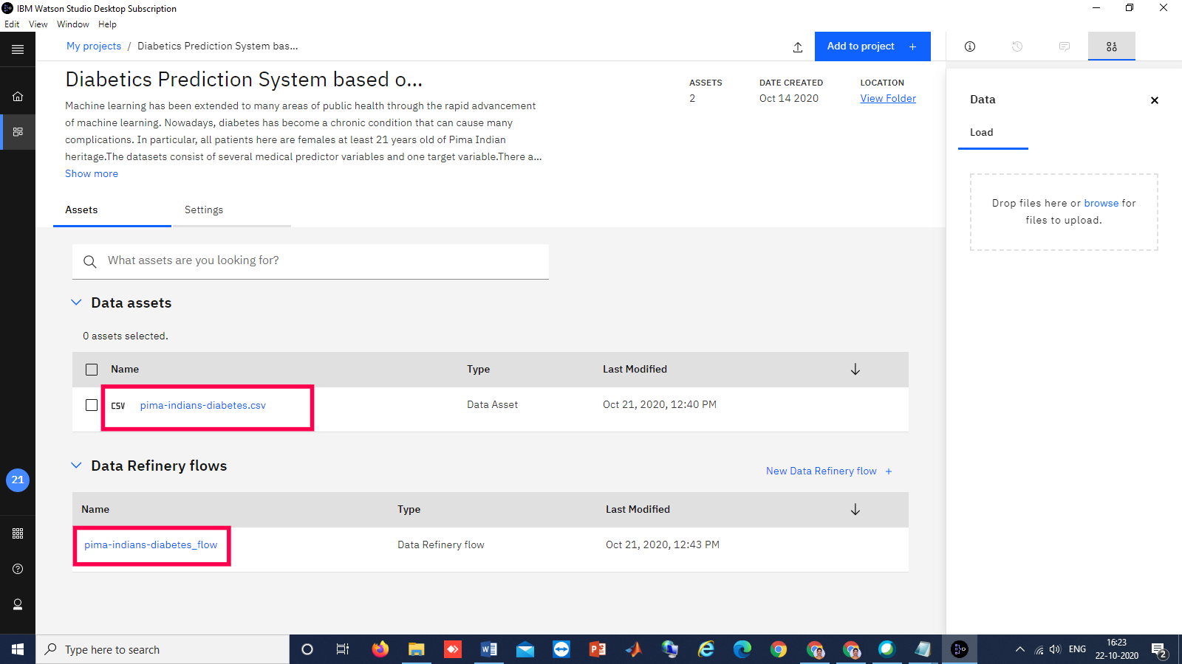

6.2 Auto_AI_OUTPUT

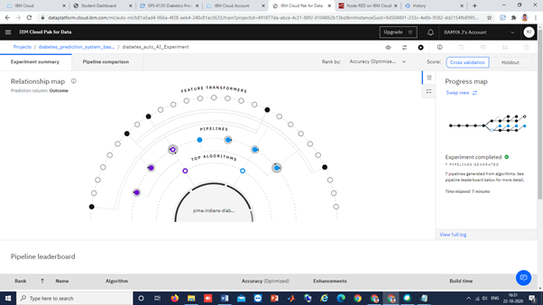

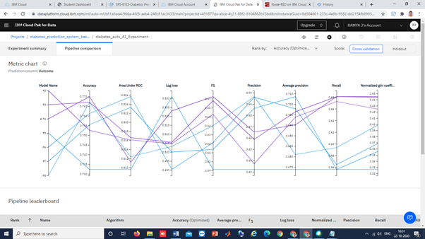

6.3 prediction results using various evaluation metrics

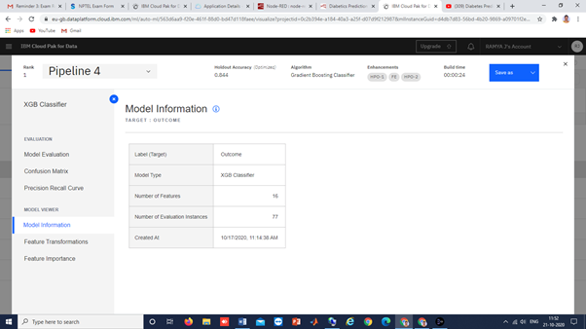

6.4 ROC Curve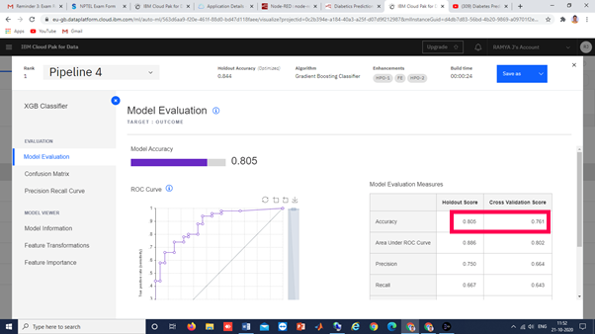

6.5 Precision recall Curve

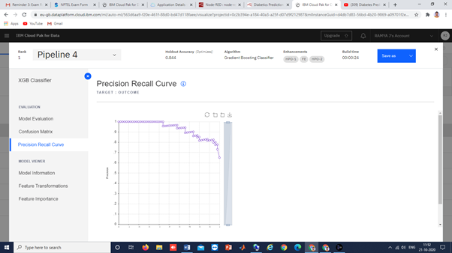

6.6 Feature importance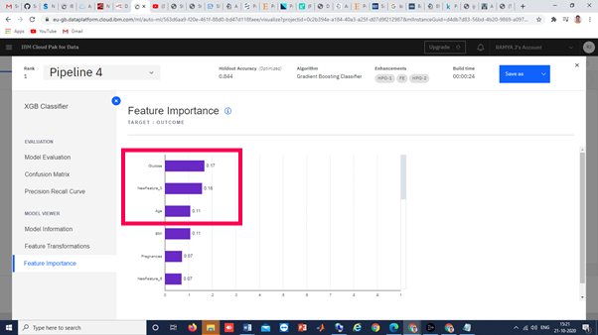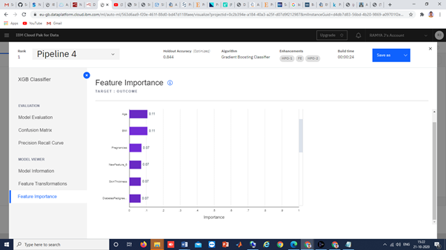

6.7 Confusion Matrix- It gives us gives us a matrix as output and describes the complete performance of the model.

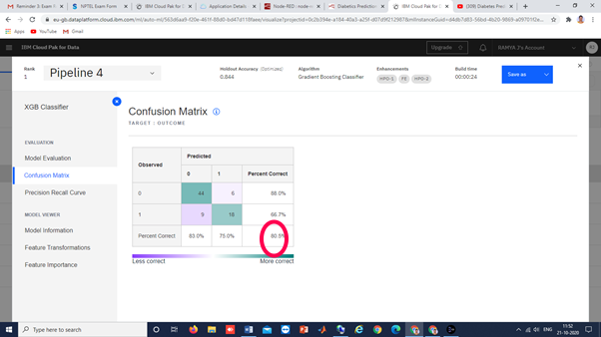

6.8 Classification Accuracy- It is the ratio of number of correct predictions to the total number of input samples.

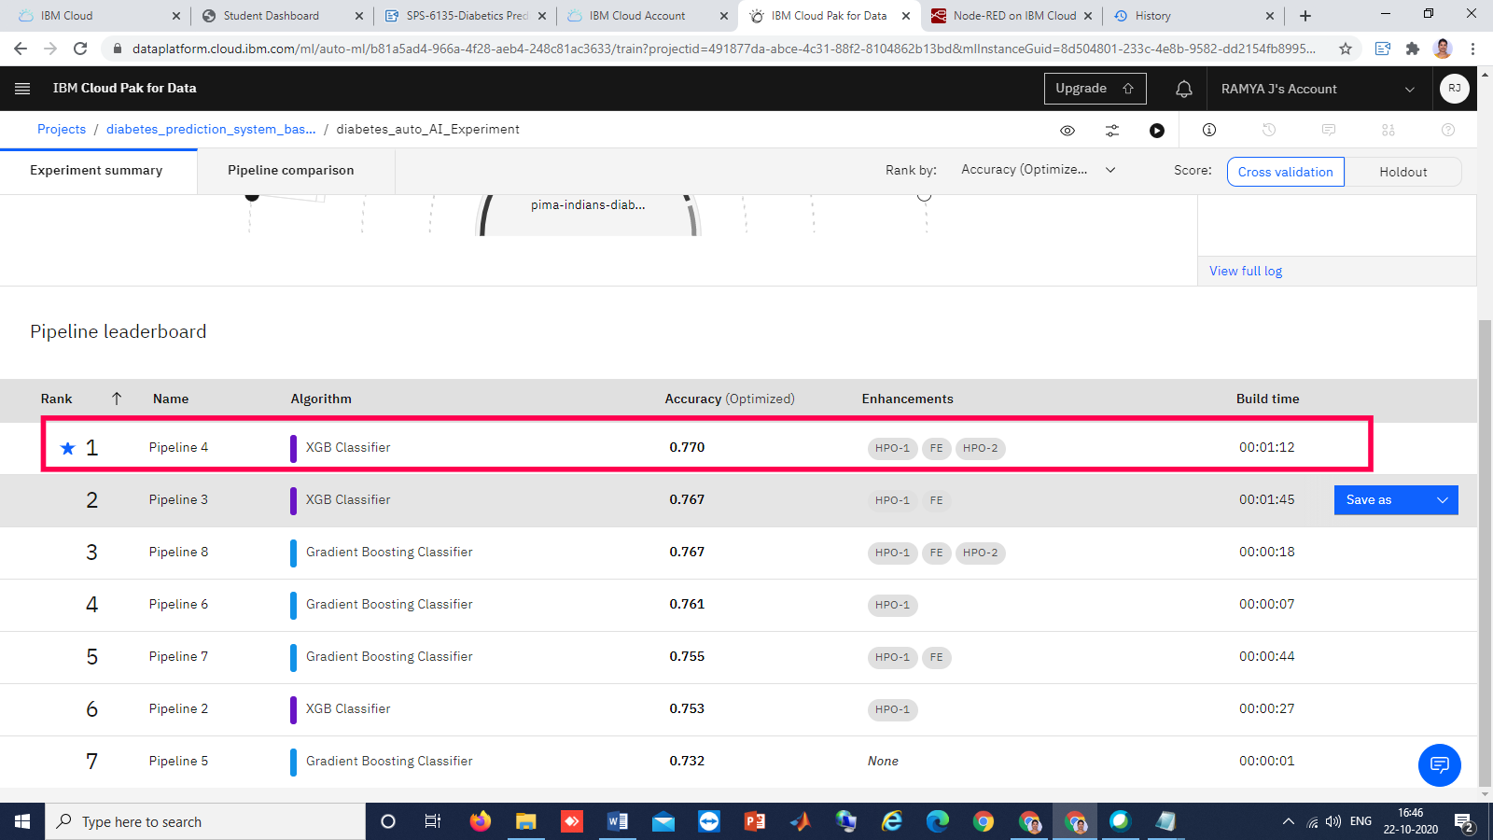6.9 a)Building the web application using node_red after deployment

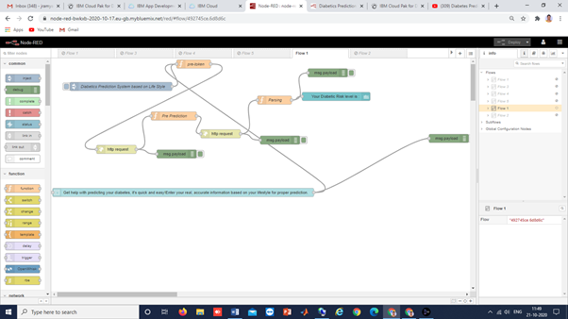

6.9 b) final output_UI_ after launching

