Diabetes Mellitus Prediction Using IBM Auto AI Service

Category: IBM Cloud Application Skills Required:

IBM Nodered,IBM Watson Studio,IBM Machine Learning

1. INTRODUCTION

Diabetes is one of the terrible diseases in the world which is not only a disease but a root cause for varieties of diseases like heart strokes, blindness, kidney related diseases, etc. The normal procedure is regularly visiting hospitals or labs for testing whether it is normal or not and eagerly waiting for the reports with tension because the report brings lot of changes in our life style .This process is not only mental stress but also waste of money for paying for diagnostic centres.The solution is modern approach which uses auto AI and machine learning models for prediction.The bigger advantage is early prediction saves the risc from being critical. The main aim of the project is to develop an auto AI IBM model for prediction of diabetes Mellitus accurately.

Artificial Intelligence is a wide domain which contains wide spectrum of methods for modelling variety of solutions to problems. It h applications in healthcare domain, very effectively used in prediction of diseases.Various life style and other parameters have an impa progression of this disease. These parameters and the outcome for number of patients already available in the domain can be used to m from and predict with good amount of accuracy when new/unseen data points are posed to it. This would open new avenues for mach of healthcare that would assist the healthcare stakeholders to make informed decisions by studying large number of patient data. This them to strategize customized treatment methods to better meet the varying disease symptoms in case of chronic diseases like diabete.

Diabetes mellitus is one of the most common chronic diseases. The number of cases of diabetes in the world is likely to increase m the next 30 years; from 115 million in 2000 to 284 million in 2030. In type I diabetes, the disease is caused by the failure of the pancr sufficient amount of insulin which leads to an uncontrolled increase in blood glucose unless the patient administers insulin, typically b injection. This work is concerned with managing diabetic patients by trying to predict their glucose levels in the near future (30 minut current levels. The goal of this paper is to determine the future blood glucose value of a diabetic patient using an artificial neural netw approaches, which involve questioning the patients, feature extraction procedures were implemented (diabetic dynamic model) on dia time series, in order to extract a knowledge (how patient blood glucose level will change a according to the external food intake and a activities). An artificial neural network was then trained using these features in order to predict the future value of blood glucose level accuracy.

* 1. Overview

This Diabetes prediction application is built by using IBM Watson Studio associated with Machine Learning service to perform the prediction task and Node-Red is used to build the web application.

* 1. Purpose

The purpose of building this application is to predict whether or not a patient acquires diabetes based on some diagnostic features. Though this application would not substitute a doctor or professional medical advice, it serves as a preliminary investigator the symptoms a person has w.r.t. diabetes.

1. LITERATURE SURVEY
   1. Existing problem

Diabetes disease prediction is one of the progressive research area in the healthcare fields.

Although many data mining techniques have been employed to assess the main causes of diabetes, but only few sets of clinical risk factors are considered. Due to this, some important factors like pre-diabetes health conditions are not considered in their analysis. So the results produced by such techniques may not represent appropriate diabetes pattern and risk factors appropriately.

* 1. Proposed solution

The proposed system uses 8 vital parameters that can predict the chances of acquiring the diabetes which uses machine learning techniques to learn from hundreds of patient data, fit the best performing model consistent with the training examples given and it is tested/validated with unseen data also. It is found to perform with about good accuracy in its predictions. So, an application built on this will be highly reliable with good prediction accuracy.

1. . THEORITICAL ANALYSIS

Diabetes mellitus is a chronic disease characterized by hyperglycemia. It may cause many complications. According to the growing morbidity in recent years, in 2040, the world’s diabetic patients will reach 642 million, which means that one of the ten adults in the future is suffering from diabetes.

In this project, you need to build a machine learning model that can efficiently discover the rules to predict diabetes

mellitus of patients based on the given parameter about their health. The model needs to be deployed in the IBM cloud to get scoring endpoint which can be used as API in web app building. . The model prediction needs to be showcased on User Interface.

**Services Used:**

1. IBM Watson Studio
2. IBM Watson Machine Learning
3. Node-RED
4. IBM Cloud Object Storage
5. EXPERIMENTAL INVESTIGATIONS
   1. Block diagram

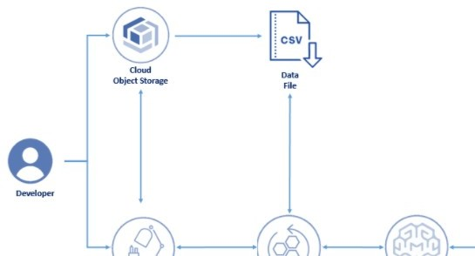

fig3.1: Proposed Architecture for diabetes mellitus prediction model

* 1. Hardware/ Software designing:
  2. IBM Watson Studio
  3. AI/Machine Learning Service
  4. IBM Cloud Object Storage
  5. Node Red flow-based development tool

1. **Dataset collection :**

Pima Indians Diabetes dataset was collected from Kaggle.

All data is from females atleast 21 years old of Pima Indian heritage. Dataset description

* 1. 1. No. of Pregnancies - Number of times pregnant

1. Random Glucose - Plasma glucose concentration a 2 hours in an oral glucose tolerance test
2. Blood Pressure - Diastolic blood pressure (mm Hg)
3. Skin Thickness - Triceps skin fold thickness (mm)
4. Insulin - 2-Hour serum insulin (mu U/ml)
5. Body Mass Index - Body mass index (weight in kg/(height in m)^2)
6. Diabetes Pedigree Function - A function which scores the likelihood of diabetes based on family history. It provided some data on diabetes mellitus history in relatives and the genetic relationship of those relatives to the patient
7. Age - Age (in years)
8. Outcome - The outcome label 1 for Yes (for chances of acquiring diabetes and 0 for No (for no chances of acquiring diabetes)
9. FLOW CHART

6. Steps followed to build the project

1. Create a project in Watson Studio – Diabetes Prediction
2. Add Auto AI experiment
3. Create a Machine Learning instance
4. Associate ML instance to the project
5. Load the dataset to cloud object storage
6. Select the target variable (prediction parameter) in the dataset
7. Train the model
8. Deploy
9. Build web application using Node-Red

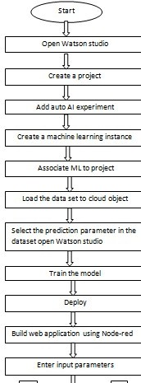

Fig 6.1 :Flowchart for diabetes mellitus prediction process using IBM Auto AI

7.Auto AI Experiment Results

**Grading Boosting Classifier** is selected by the Auto AI experiment as the best performing model after fine tuning all the hyper-parameters. It is found to give about 77.1% accuracy with 90% training set size and 10% test set size. The Area Under the Curve (AUC) is also satisfactory which depicts the TPR (sensitivity) and FPR (specificity). The models having higher AUC are said to perform better.

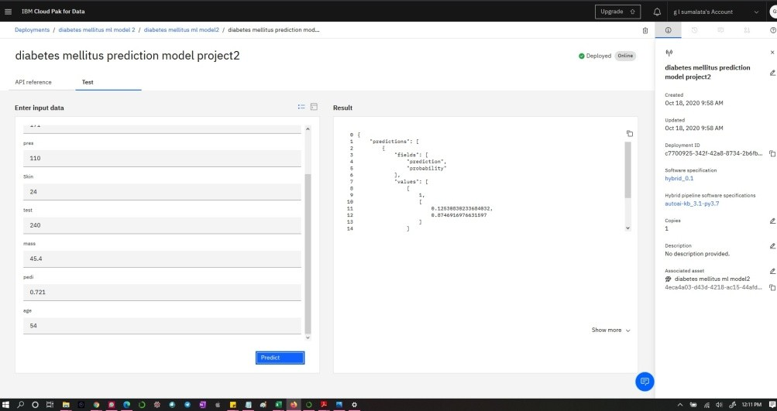

Fig7.1:Deployement and test

1. Node Red Flow

Node-RED is a flow-based development tool for visual programming developed originally by IBM for wiring together hardware devices, APIs and online services. The flows created in Node-RED are stored using JSON.

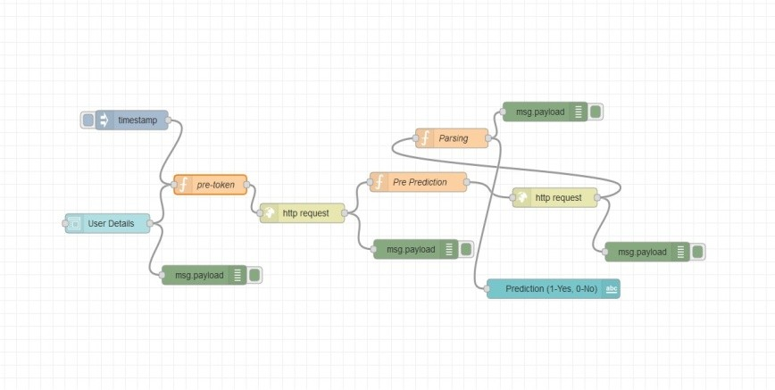

Fig. 8.1 Node-Red Flow

1. Demonstration of the application with the screenshots This application predicts the chance of acquiring diabetes based on the features/information the user enters through the user interface
   1. Home page of the application

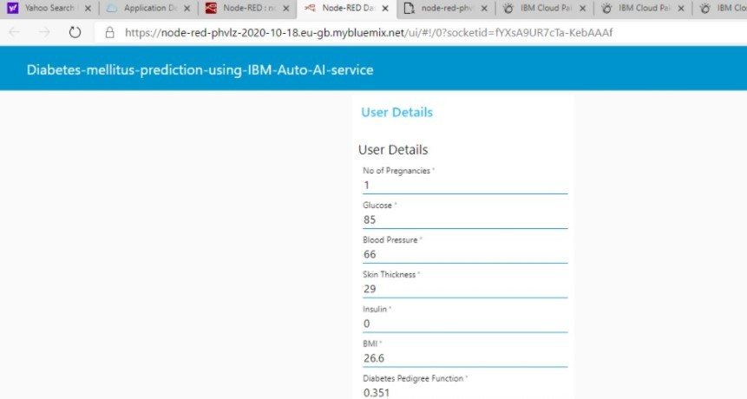

Fig. 9.1 Home page

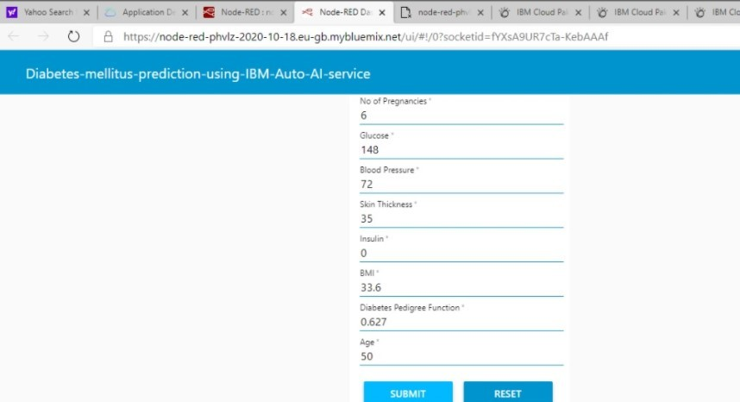

* 1. Reset button can be pressed to clear the previous input and enter fresh details

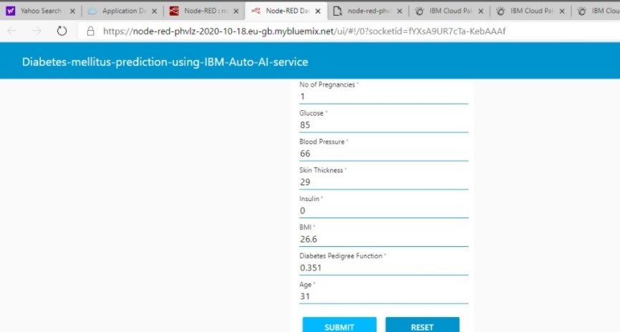

Fig. 9.2 The data can be Reset for entering new data

* 1. New user details entry and submit

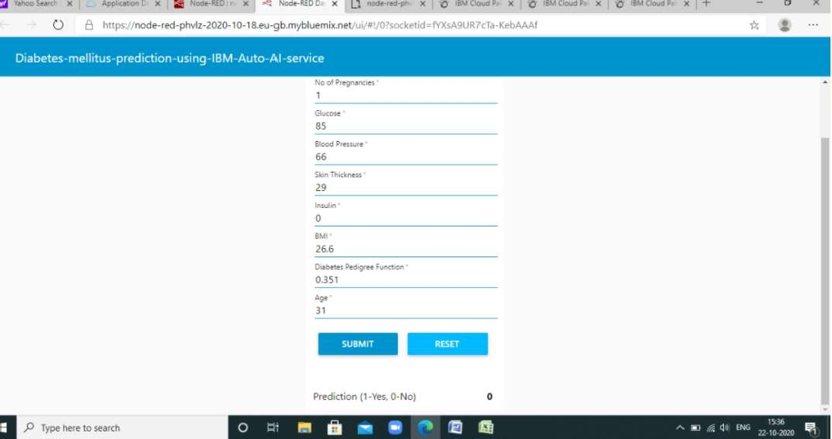

Fig. 9.3 Node-RED App Output for 0

* 1. Prediction display

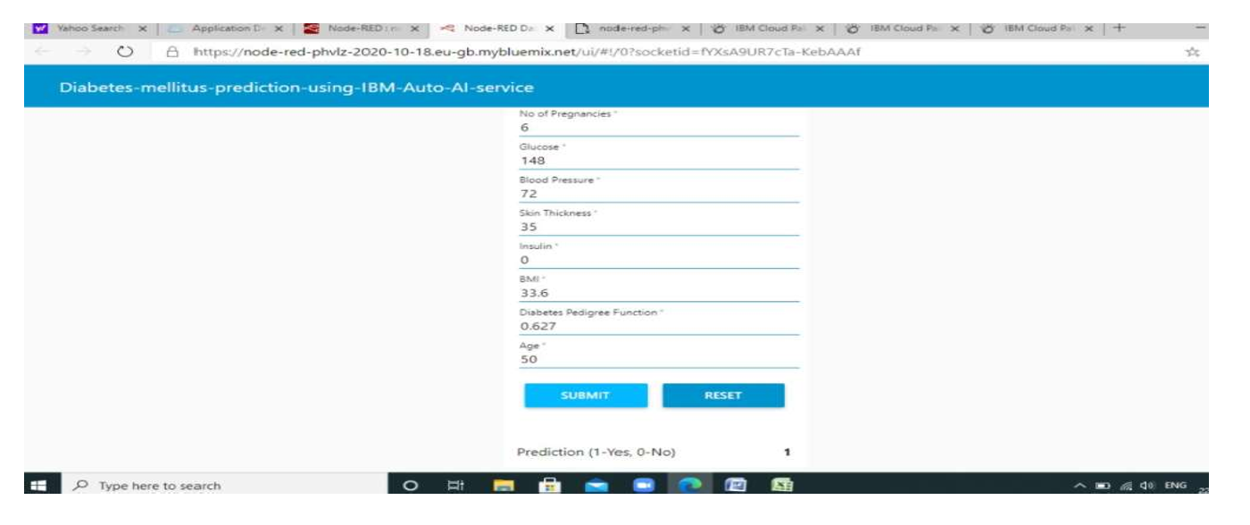

Fig. 9.4 Node-RED App Output for 1

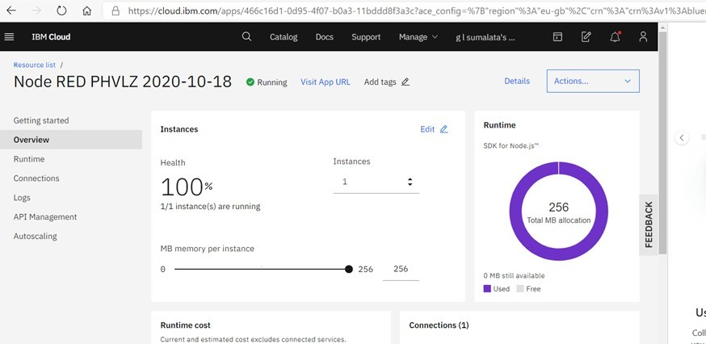

Fig. 9.5 Node-RED App

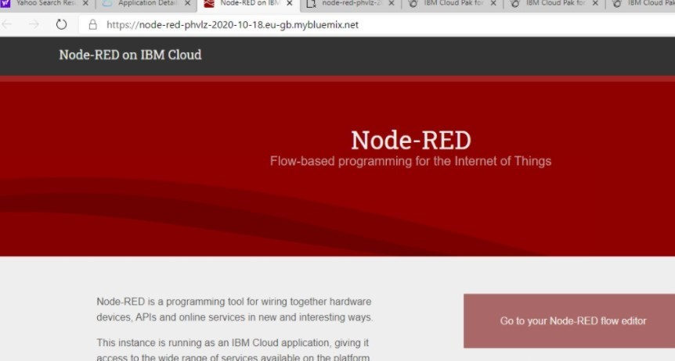

Fig: 9.6 Node-Red on IBM cloud

Node-Red is a programming tool for wiring the hardware devices.It also connects APIs and online services.It is used for building user interface for users to enter data so that the status of diabetic can be predicted.

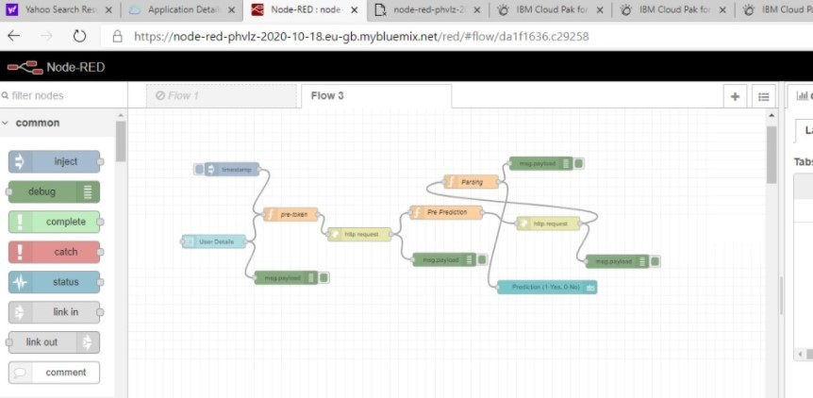

Fig. 9.7 Node-RED App Flow

1. ADVANTAGES & DISADVANTAGES ADVANTAGES:
   1. Identification without going to Diagnostic centers 2.No need to waste money for tests
2. No waiting time and anxiety for reports
3. can Identify at early stage so that care can be taken DISADVANTAGES:
   1. Prediction can be wrong sometimes according to confusion matrix which may create worst consequencies
   2. Accuracy can be less sometimes
   3. Some more parameters can be needed sometimes for predicting accurately
4. APPLICATIONS
   1. Diabetes Mellitus prediction for kidney patients 2.Diabetes Mellitus prediction for heart diseased patients
5. CONCLUSION

Most of the population all around the world has diabetes. Predicting this disease at earlier stages plays vital role for treatment of patient. The Pima Indian diabetes dataset has been used in this model. The algorithm is best among others and got 77% accuracy. The obtained results appear to be very important for predicting diabetes accurately. The main theme is to prevent and cure diabetes and to improve the lives of all people affected by diabetes at faster rate and to help the doctors to start the treatments early.

1. FUTURE SCOPE `

The Accuracy obtained is 77%.It can be increased by following different methods either by considering more parameters or huge data set can be used to train the model. The confusion matrix clearly states that there can be false positive, false negative cases which can cause to serious consequences and to be overcome in future researches.

ACKNOWLEDGEMENT:

I thank all the faculty members, IBM Team ,Gurucool Program and mentors who provided the excellent training and support for the knowledge shared and for completing the project. .

1. BIBILOGRAPHY APPENDIX
2. Source code

**IBM AutoAI-SDK Auto-Generated Notebook v1.14.1**

**Note:** Notebook code generated using AutoAI will execute successfully. If code is modified or reordered,  
there is no guarantee it will successfully execute. This pipeline is optimized for the original dataset.  
The pipeline may fail or produce sub-optimium results if used with different data. For different data,  
please consider returning to AutoAI Experiments to generate a new pipeline. Please read our documentation  
for more information:  
[Cloud Platform](https://dataplatform.cloud.ibm.com/docs/content/wsj/analyze-data/autoai-notebook.html)

Before modifying the pipeline or trying to re-fit the pipeline, consider:  
The notebook converts dataframes to numpy arrays before fitting the pipeline  
(a current restriction of the preprocessor pipeline). The known\_values\_list is passed by reference  
and populated with categorical values during fit of the preprocessing pipeline. Delete its members before re-fitting.

**Notebook content**

This notebook contains steps and code to demonstrate AutoAI pipeline. This notebook introduces commands for getting data,  
pipeline model, model inspection and testing.

Some familiarity with Python is helpful. This notebook uses Python 3.

**Notebook goals**

* inspection of trained pipeline via graphical vizualization and source code preview
* pipeline evaluation
* pipeline deployment and webservice scoring.

**Contents**

This notebook contains the following parts:

1. [Setup](https://dataplatform.cloud.ibm.com/data/notebooks/converter/assets/5b46ebc0-5fd1-4c73-a357-0161668b18ab?project=dc710200-9a27-4ecd-88ac-d027fc7b4875#setup)  
   a. [AutoAI experiment metadata](https://dataplatform.cloud.ibm.com/data/notebooks/converter/assets/5b46ebc0-5fd1-4c73-a357-0161668b18ab?project=dc710200-9a27-4ecd-88ac-d027fc7b4875" \l "variables_definition)
2. [Pipeline inspection](https://dataplatform.cloud.ibm.com/data/notebooks/converter/assets/5b46ebc0-5fd1-4c73-a357-0161668b18ab?project=dc710200-9a27-4ecd-88ac-d027fc7b4875#inspection)  
   a. [Get historical optimizer instance](https://dataplatform.cloud.ibm.com/data/notebooks/converter/assets/5b46ebc0-5fd1-4c73-a357-0161668b18ab?project=dc710200-9a27-4ecd-88ac-d027fc7b4875#get_hist_and_train)  
   b. [Get pipeline model](https://dataplatform.cloud.ibm.com/data/notebooks/converter/assets/5b46ebc0-5fd1-4c73-a357-0161668b18ab?project=dc710200-9a27-4ecd-88ac-d027fc7b4875#get_pipeline)  
   c. [Preview pipeline model as python code](https://dataplatform.cloud.ibm.com/data/notebooks/converter/assets/5b46ebc0-5fd1-4c73-a357-0161668b18ab?project=dc710200-9a27-4ecd-88ac-d027fc7b4875#preview_model_to_python_code)  
   d. [Visualize pipeline model](https://dataplatform.cloud.ibm.com/data/notebooks/converter/assets/5b46ebc0-5fd1-4c73-a357-0161668b18ab?project=dc710200-9a27-4ecd-88ac-d027fc7b4875#visualize_pipeline)  
   e. [Read training data](https://dataplatform.cloud.ibm.com/data/notebooks/converter/assets/5b46ebc0-5fd1-4c73-a357-0161668b18ab?project=dc710200-9a27-4ecd-88ac-d027fc7b4875#train_read)  
   f. [Test pipeline model locally](https://dataplatform.cloud.ibm.com/data/notebooks/converter/assets/5b46ebc0-5fd1-4c73-a357-0161668b18ab?project=dc710200-9a27-4ecd-88ac-d027fc7b4875#test_model)
3. [Pipeline refinery and testing (optional)](https://dataplatform.cloud.ibm.com/data/notebooks/converter/assets/5b46ebc0-5fd1-4c73-a357-0161668b18ab?project=dc710200-9a27-4ecd-88ac-d027fc7b4875#refinery)  
   a. [Pipeline definition source code](https://dataplatform.cloud.ibm.com/data/notebooks/converter/assets/5b46ebc0-5fd1-4c73-a357-0161668b18ab?project=dc710200-9a27-4ecd-88ac-d027fc7b4875#pipeline_definition)  
   b. [Lale library](https://dataplatform.cloud.ibm.com/data/notebooks/converter/assets/5b46ebc0-5fd1-4c73-a357-0161668b18ab?project=dc710200-9a27-4ecd-88ac-d027fc7b4875" \l "lale_library)
4. [Deploy and score](https://dataplatform.cloud.ibm.com/data/notebooks/converter/assets/5b46ebc0-5fd1-4c73-a357-0161668b18ab?project=dc710200-9a27-4ecd-88ac-d027fc7b4875#scoring)  
   a. [Insert WML credentials](https://dataplatform.cloud.ibm.com/data/notebooks/converter/assets/5b46ebc0-5fd1-4c73-a357-0161668b18ab?project=dc710200-9a27-4ecd-88ac-d027fc7b4875#wml_credentials)  
   b. [Create deployment](https://dataplatform.cloud.ibm.com/data/notebooks/converter/assets/5b46ebc0-5fd1-4c73-a357-0161668b18ab?project=dc710200-9a27-4ecd-88ac-d027fc7b4875#deployment)  
   c. [Score webservice](https://dataplatform.cloud.ibm.com/data/notebooks/converter/assets/5b46ebc0-5fd1-4c73-a357-0161668b18ab?project=dc710200-9a27-4ecd-88ac-d027fc7b4875#online_scoring)  
   d. [Delete deployment](https://dataplatform.cloud.ibm.com/data/notebooks/converter/assets/5b46ebc0-5fd1-4c73-a357-0161668b18ab?project=dc710200-9a27-4ecd-88ac-d027fc7b4875#delete_deployment)
5. [Authors](https://dataplatform.cloud.ibm.com/data/notebooks/converter/assets/5b46ebc0-5fd1-4c73-a357-0161668b18ab?project=dc710200-9a27-4ecd-88ac-d027fc7b4875#authors)

**Setup**

Before you use the sample code in this notebook, you must perform the following setup tasks:

* ibm\_watson\_machine\_learning installation
* autoai-libs installation/upgrade
* lightgbm or xgboost installation/downgrade if they are needed.

In [ ]:

!pip install -U ibm-watson-machine-learning

In [ ]:

!pip install -U autoai-libs

**AutoAI experiment metadata**

This cell defines COS credentials required to retrieve AutoAI pipeline.

In [ ]:

*# @hidden\_cell*

**from** **ibm\_watson\_machine\_learning.helpers** **import** DataConnection, S3Connection, S3Location

training\_data\_reference = [DataConnection(

connection=S3Connection(

api\_key='ZtDre\_BgetFAfRkC2GN8jA66ayld4p0wgWJ6cmGkZoYK',

auth\_endpoint='https://iam.bluemix.net/oidc/token/',

endpoint\_url='https://s3-api.us-geo.objectstorage.softlayer.net'

),

location=S3Location(

bucket='diabetesmellituspredictionusingib-donotdelete-pr-8ifczp1e9igaiw',

path='pima-indians-diabetes.data.csv'

))

]

training\_result\_reference = DataConnection(

connection=S3Connection(

api\_key='ZtDre\_BgetFAfRkC2GN8jA66ayld4p0wgWJ6cmGkZoYK',

auth\_endpoint='https://iam.bluemix.net/oidc/token/',

endpoint\_url='https://s3-api.us-geo.objectstorage.softlayer.net'

),

location=S3Location(

bucket='diabetesmellituspredictionusingib-donotdelete-pr-8ifczp1e9igaiw',

path='auto\_ml/a70aa112-5cb7-494b-8b6e-151da38ac9b2/wml\_data/4f55c607-5012-4b35-b854-00150a5befe2/data/automl',

model\_location='auto\_ml/a70aa112-5cb7-494b-8b6e-151da38ac9b2/wml\_data/4f55c607-5012-4b35-b854-00150a5befe2/data/automl/hpo\_c\_output/Pipeline1/model.pickle',

training\_status='auto\_ml/a70aa112-5cb7-494b-8b6e-151da38ac9b2/wml\_data/4f55c607-5012-4b35-b854-00150a5befe2/training-status.json'

))

Following cell contains input parameters provided to run the AutoAI experiment in Watson Studio

In [ ]:

experiment\_metadata = dict(

prediction\_type='classification',

prediction\_column='class',

test\_size=0.1,

scoring='accuracy',

project\_id='dc710200-9a27-4ecd-88ac-d027fc7b4875',

csv\_separator=',',

random\_state=33,

max\_number\_of\_estimators=2,

training\_data\_reference = training\_data\_reference,

training\_result\_reference = training\_result\_reference,

deployment\_url='https://us-south.ml.cloud.ibm.com')

pipeline\_name='Pipeline\_4'

**Pipeline inspection**

In this section you will get the trained pipeline model from the AutoAI experiment and inspect it.  
You will see pipeline as a pythone code, graphically visualized and at the end, you will perform a local test.

**Get historical optimizer instance**

The next cell contains code for retrieving fitted optimizer.

In [ ]:

**from** **ibm\_watson\_machine\_learning.experiment** **import** AutoAI

optimizer = AutoAI().runs.get\_optimizer(metadata=experiment\_metadata)

**Get pipeline model**

The following cell loads selected AutoAI pipeline model. If you want to get pure scikit-learn pipeline specify as\_type='sklearn' parameter. By default enriched scikit-learn pipeline is returned as\_type='lale'.

In [ ]:

pipeline\_model = optimizer.get\_pipeline(pipeline\_name=pipeline\_name)

**Preview pipeline model as python code**

In the next cell, downloaded pipeline model could be previewed as a python code.  
You will be able to see what exact steps are involved in model creation.

In [ ]:

pipeline\_model.pretty\_print(combinators=**False**, ipython\_display=**True**)

**Visualize pipeline model**

Preview pipeline model stages as graph. Each node's name links to detailed description of the stage.

In [ ]:

pipeline\_model.visualize()

**Read training data**

Retrieve training dataset from AutoAI experiment as pandas DataFrame.

In [ ]:

train\_df = optimizer.get\_data\_connections()[0].read()

test\_df = train\_df.sample(n=5).drop([experiment\_metadata['prediction\_column']], axis=1)

**Test pipeline model locally**

You can predict target value using trained AutoAI model by calling predict().

In [ ]:

y\_pred = pipeline\_model.predict(test\_df.values)

print(y\_pred)

**Pipeline refinery and testing (optional)**

In this section you will learn how to refine and retrain the best pipeline returned by AutoAI. It can be performed by:

* modifying pipeline definition source code
* using [lale](https://lale.readthedocs.io/en/latest/) library for semi-automated data science

**Note**: In order to run this section change following cells to 'code' cell.

**Pipeline definition source code**

Following cell lets you experiment with pipeline definition in python, e.g. change steps parameters.

It will inject pipeline definition to the next cell.

pipeline\_model.pretty\_print(combinators=False, ipython\_display='input')

**Lale library**

**Note**: This is only an exemplary usage of lale package. You can import more different estimators to refine downloaded pipeline model.

**Import estimators**

from sklearn.linear\_model import LogisticRegression as E1 from sklearn.tree import DecisionTreeClassifier as E2 from sklearn.neighbors import KNeighborsClassifier as E3 from lale.lib.lale import Hyperopt from lale.operators import TrainedPipeline from lale import wrap\_imported\_operators from lale.helpers import import\_from\_sklearn\_pipeline wrap\_imported\_operators()

**Pipeline decomposition and new definition**

In this step the last stage from pipeline is removed.

prefix = pipeline\_model.remove\_last().freeze\_trainable() prefix.visualize()new\_pipeline = prefix >> (E1 | E2 | E3) new\_pipeline.visualize()

**New optimizer hyperopt configuration and training**

This section can introduce other results than the original one and it should be used by more advanced users.

New pipeline is re-trained by passing train data to it and calling fit method.

Following cell performs dataset split for refined pipeline model.

from sklearn.model\_selection import train\_test\_split train\_X = train\_df.drop([experiment\_metadata['prediction\_column']], axis=1).values train\_y = train\_df[experiment\_metadata['prediction\_column']].values train\_X, test\_X, train\_y, test\_y = train\_test\_split(train\_X, train\_y, test\_size=experiment\_metadata['test\_size'], stratify=train\_y, random\_state=experiment\_metadata['random\_state'])hyperopt = Hyperopt(estimator=new\_pipeline, cv=3, max\_evals=20) fitted\_hyperopt = hyperopt.fit(train\_X, train\_y)hyperopt\_pipeline = fitted\_hyperopt.get\_pipeline() new\_pipeline = hyperopt\_pipeline.export\_to\_sklearn\_pipeline()prediction = new\_pipeline.predict(test\_X)from sklearn.metrics import accuracy\_score score = accuracy\_score(y\_true=test\_y, y\_pred=prediction) print('accuracy\_score: ', score)

**Deploy and Score**

In this section you will learn how to deploy and score pipeline model as webservice using WML instance.

**Connection to WML**

Authenticate the Watson Machine Learning service on IBM Cloud.

**Tip**: Your Cloud API key can be generated by going to the [**Users** section of the Cloud console](https://cloud.ibm.com/iam#/users). From that page, click your name, scroll down to the **API Keys** section, and click **Create an IBM Cloud API key**. Give your key a name and click **Create**, then copy the created key and paste it below.

**Note:** You can also get service specific apikey by going to the [**Service IDs** section of the Cloud Console](https://cloud.ibm.com/iam/serviceids). From that page, click **Create**, then copy the created key and paste it below.

**Action**: Enter your api\_key in the following cell.

In [ ]:

api\_key = "PUT\_YOUR\_API\_KEY\_HERE"

wml\_credentials = {

"apikey": api\_key,

"url": experiment\_metadata["deployment\_url"]

}

**Create deployment**

**Action**: If you want to deploy refined pipeline please change the pipeline\_name to new\_pipeline. If you prefer you can also change the deployment\_name.

**Action**: To perform deployment please specify target\_space\_id.

In [ ]:

target\_space\_id = "PUT\_YOUR\_TARGET\_SPACE\_ID\_HERE"

**from** **ibm\_watson\_machine\_learning.deployment** **import** WebService

service = WebService(source\_wml\_credentials=wml\_credentials,

target\_wml\_credentials=wml\_credentials,

source\_project\_id=experiment\_metadata['project\_id'],

target\_space\_id=target\_space\_id)

service.create(

model=pipeline\_name,

metadata=experiment\_metadata,

deployment\_name=f'**{**pipeline\_name**}**\_webservice'

)

Deployment object could be printed to show basic information:

In [ ]:

print(service)

To be able to show all available information about deployment use .get\_params() method:

In [ ]:

service.get\_params()

**Score webservice**

You can make scoring request by calling score() on deployed pipeline.

In [ ]:

predictions = service.score(payload=test\_df)

predictions

If you want to work with the webservice in external Python application you can retrieve the service object by:

* initialize service by:
* service = WebService(target\_wml\_credentials=wml\_credentials,

target\_space\_id=target\_space\_id)

* get deployment\_id by service.list() method
* get webservice object by service.get('deployment\_id') method

After that you can call service.score() method.

**Delete deployment**

You can delete an existing deployment by calling service.delete().

**Authors**

Licensed Materials - Copyright © 2020 IBM. This notebook and its source code are released under the terms of the ILAN License. Use, duplication disclosure restricted by GSA ADP Schedule Contract with IBM Corp.

**Note:** The auto-generated notebooks are subject to the International License Agreement for Non-Warranted Programs  
(or equivalent) and License Information document for Watson Studio Auto-generated Notebook (License Terms),  
such agreements located in the link below. Specifically, the Source Components and Sample Materials clause  
included in the License Information document for Watson Studio Auto-generated Notebook applies to the auto-generated notebooks.

By downloading, copying, accessing, or otherwise using the materials, you agree to the [License Terms](http://www14.software.ibm.com/cgi-bin/weblap/lap.pl?li_formnum=L-AMCU-BHU2B7&title=IBM%20Watson%20Studio%20Auto-generated%20Notebook%20V2.1)