**SPS-7220-Movie-ticketing-bot**

**Project-Build-A-Thon**

**Category**: IBM Cloud Application

IBM Watson Assistant Chatbot Web Preview link:   
<https://web-chat.global.assistant.watson.cloud.ibm.com/preview.html?region=eu-gb&integrationID=0976427f-3882-4b84-a74f-956ed65d059d&serviceInstanceID=6da51e7f-ecef-4ee6-940e-30f5eb1df500>

Node-Red UI link: <https://node-red-btnqr-2020-10-18.mybluemix.net/ui/>

**Submitted to**

**Smart-Internz, IBM**

**October 28, 2020**

**By**

**Karthic Annadurai**

**Project** **Description**:

In this project, built a chatbot using Watson assistant.

This ChatBot has the following capabilities:

1. Display the list of movies available.
2. The Bot shows different show timings.
3. When a movie is selected the bot shows the availability of tickets and their respective prices.
4. The bot is in a position to book tickets.

**Services Used**:

1. IBM Watson Assistant
2. Node-Red

**Architecture:**

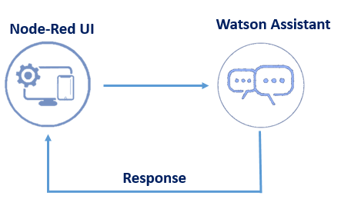

Adding the screenshots of Watson Assistant

**Intent**

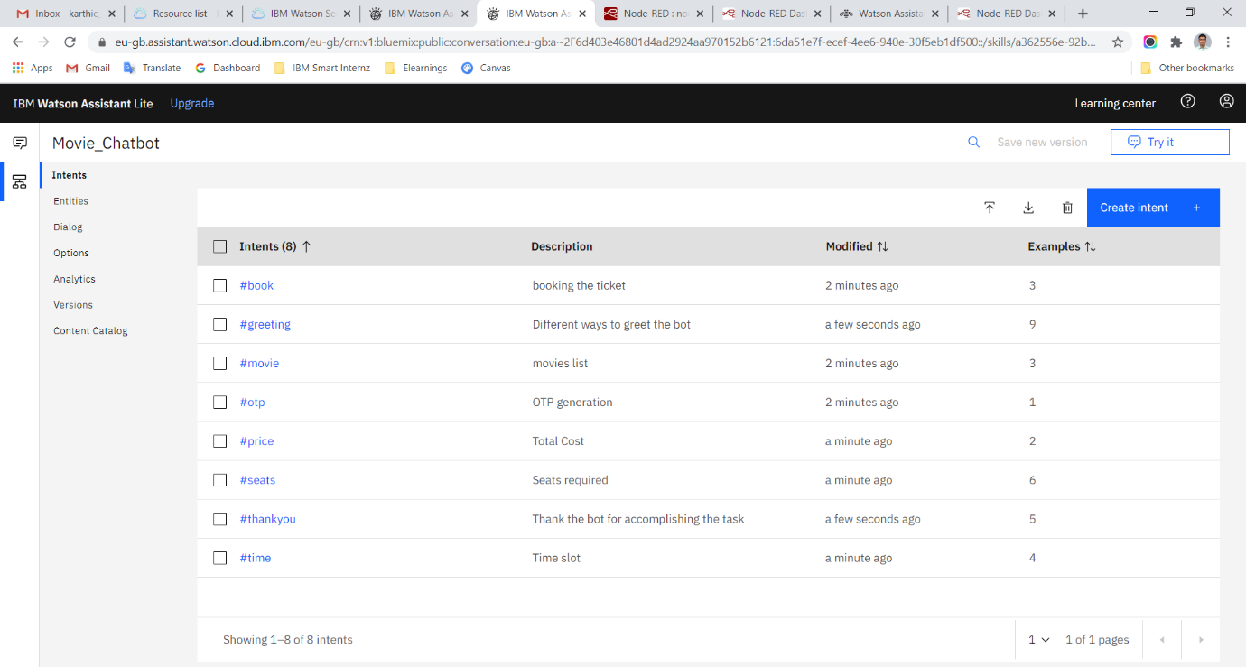

**Entities**

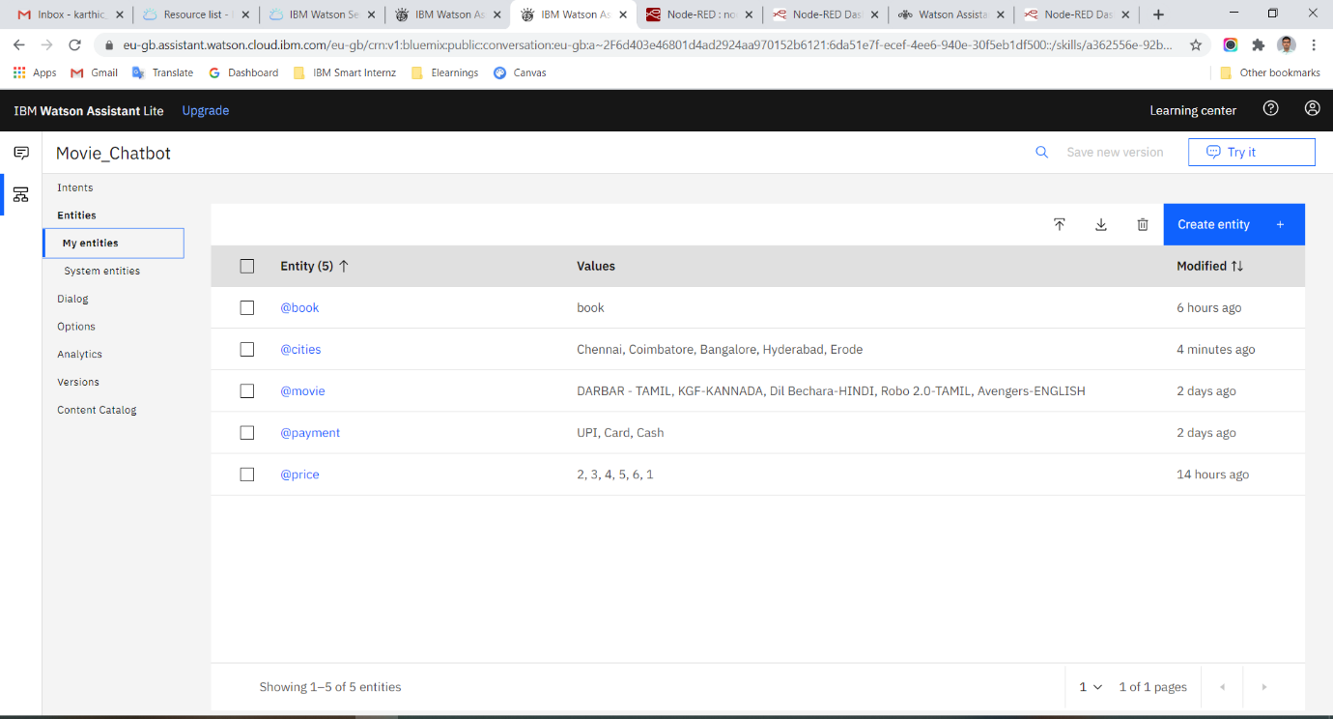

**System Entities**

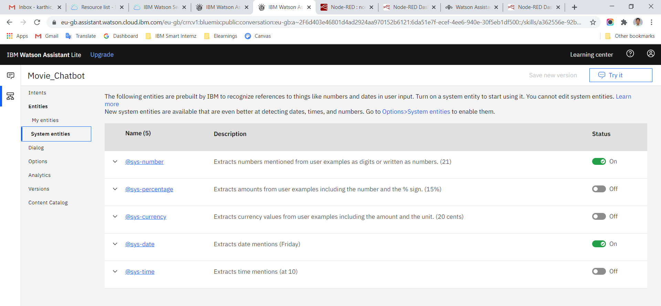

**Dialog Flows**

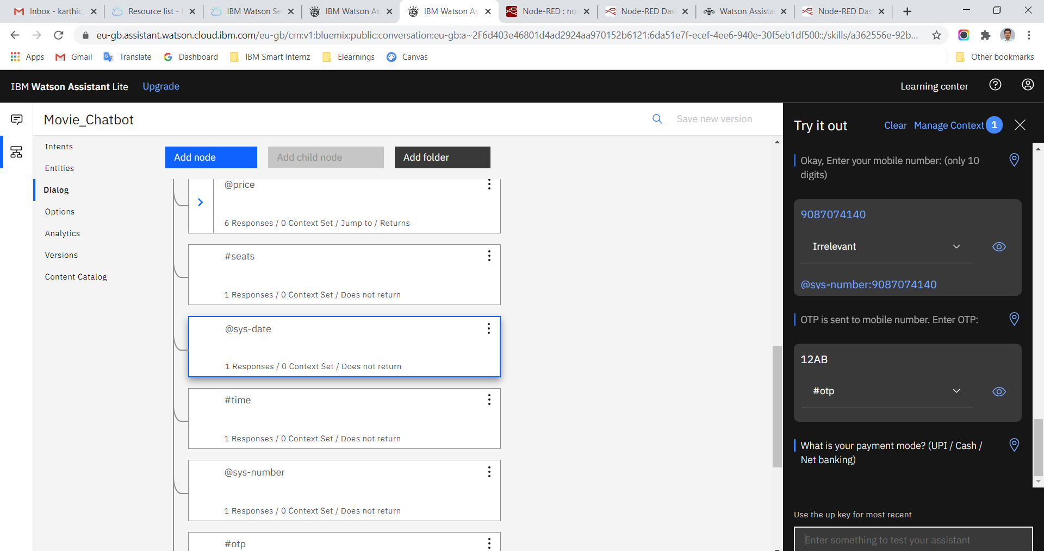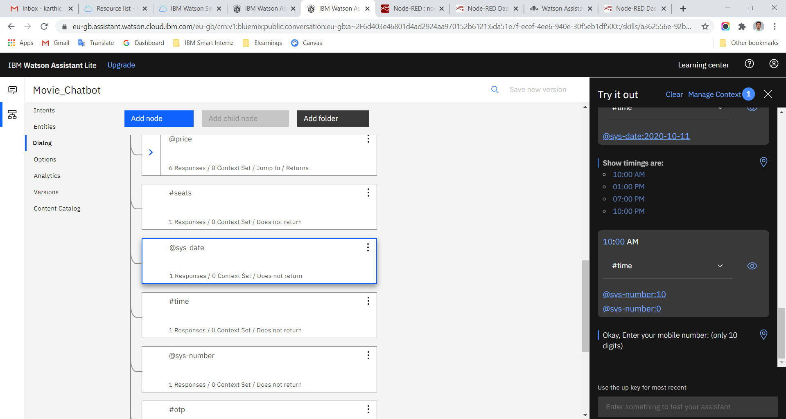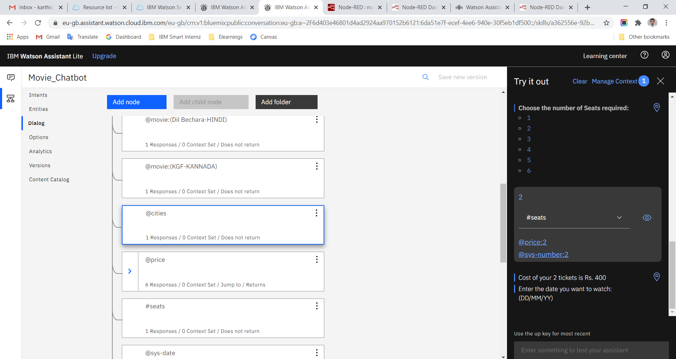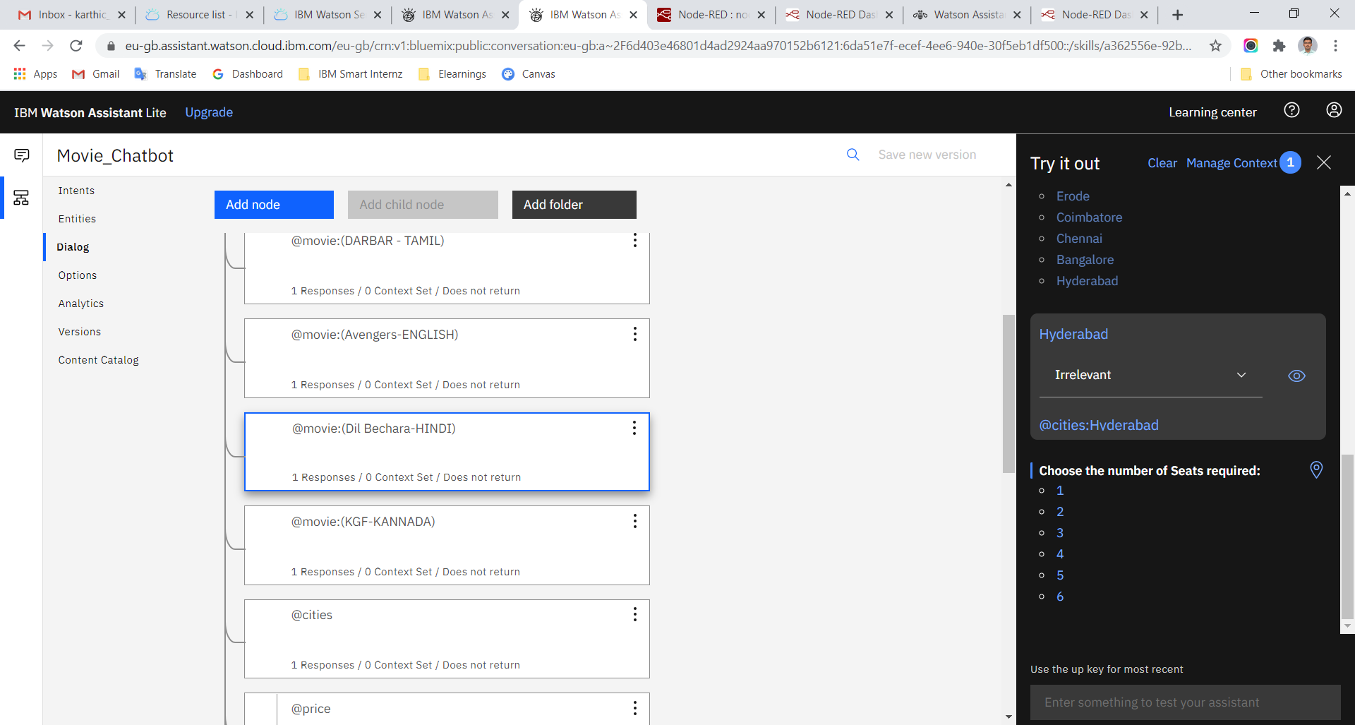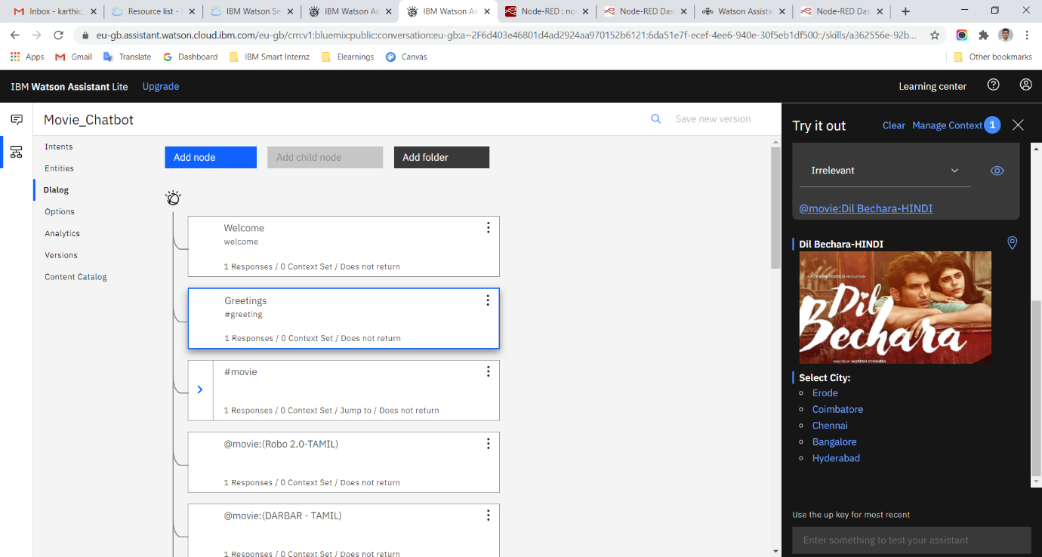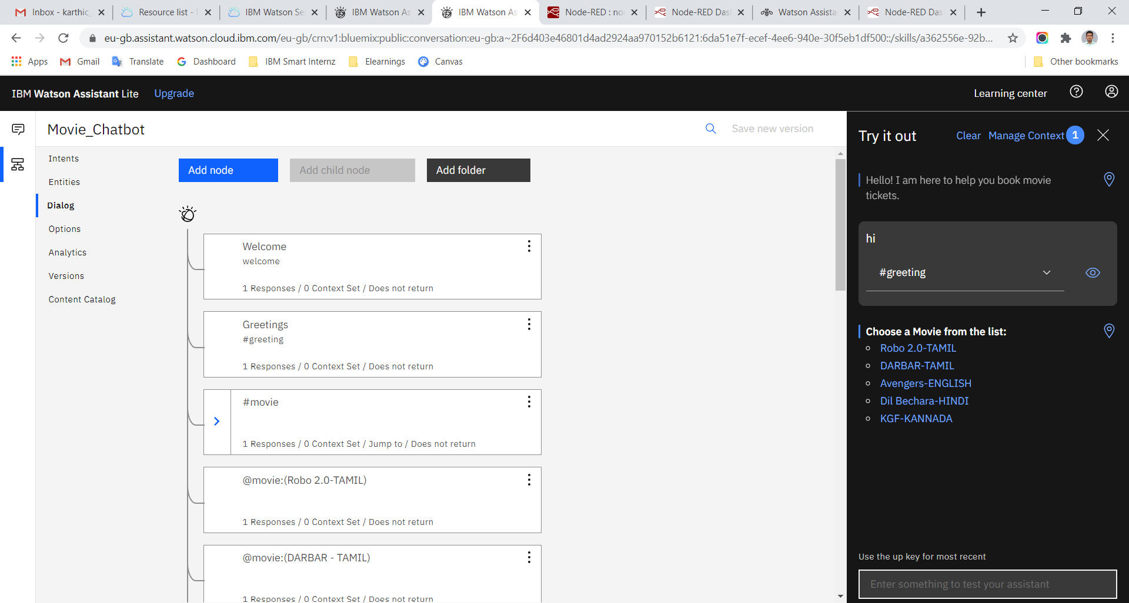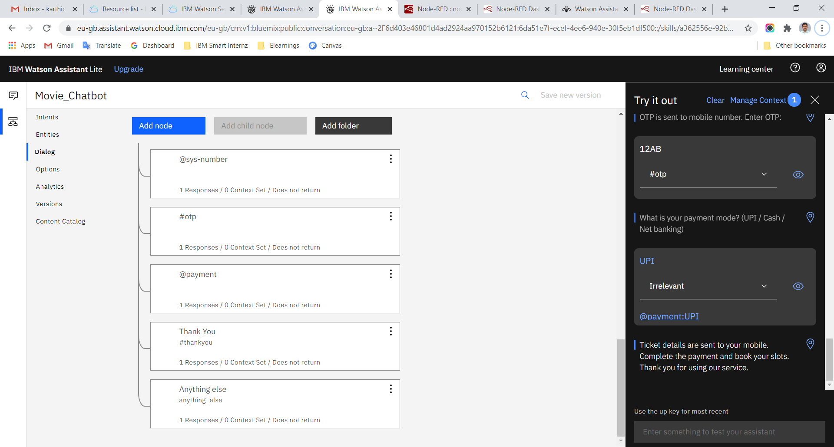

**Watson Assistant – Chat Previews**

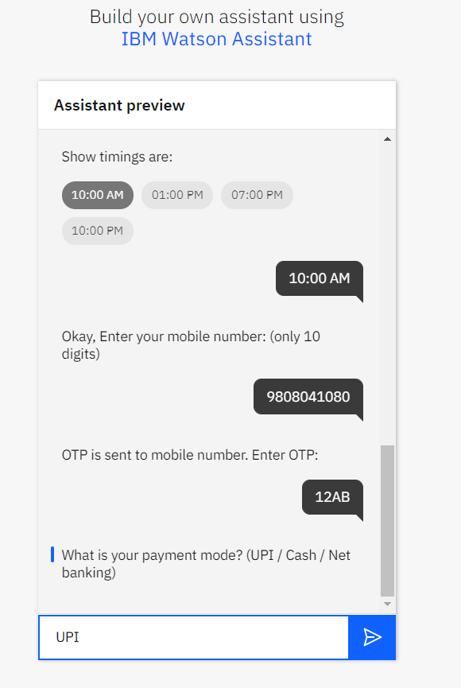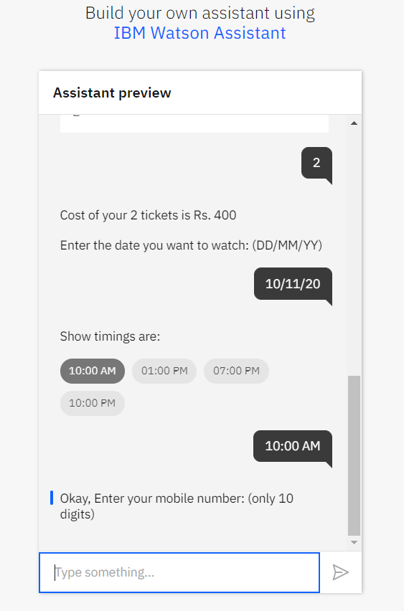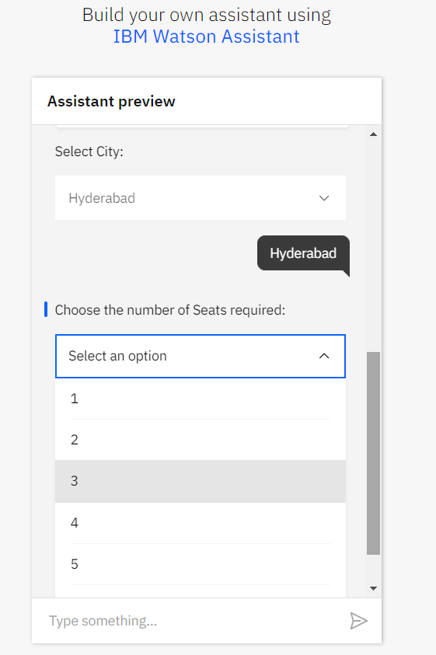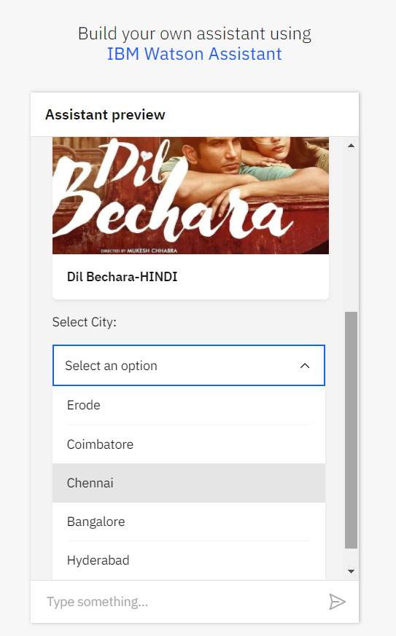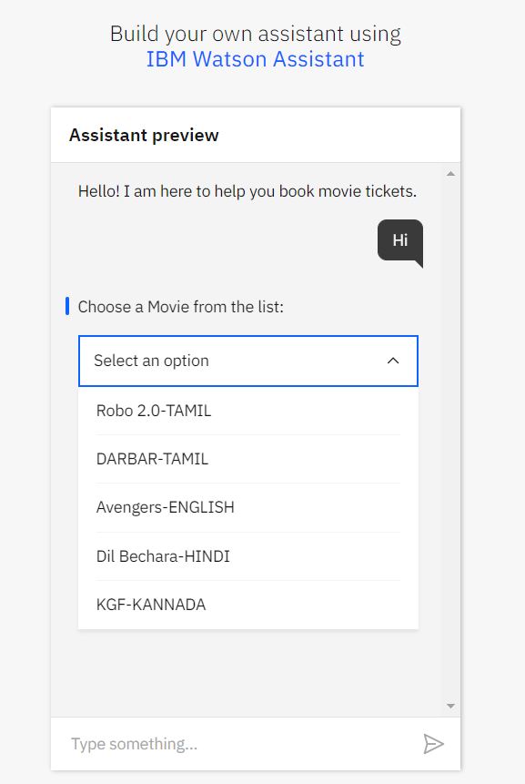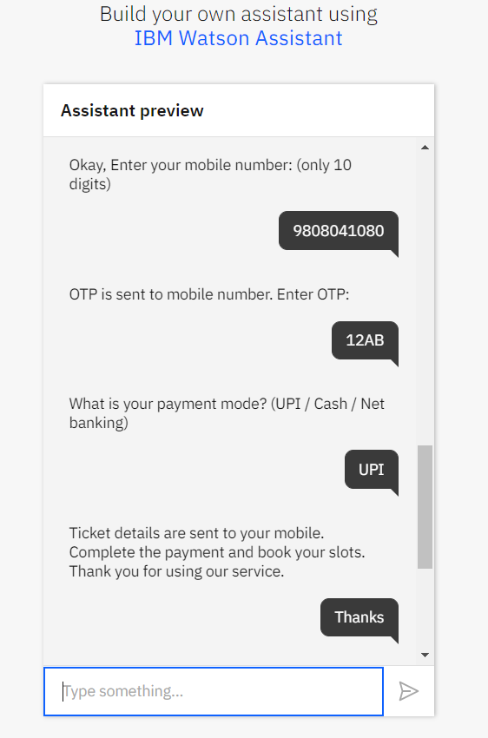

**Node Red Flow**

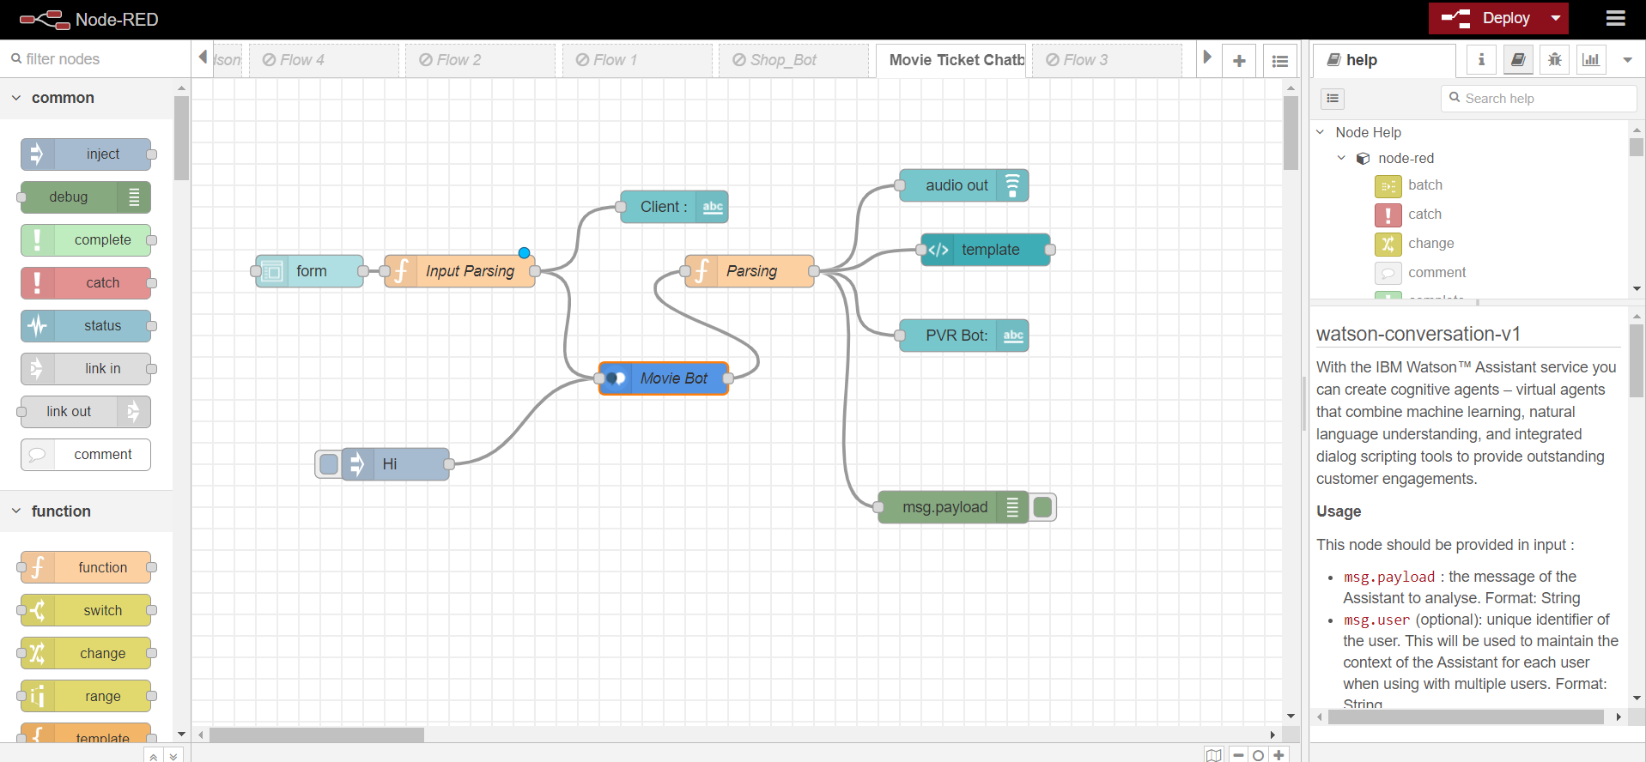

**Node -Red UI chats**

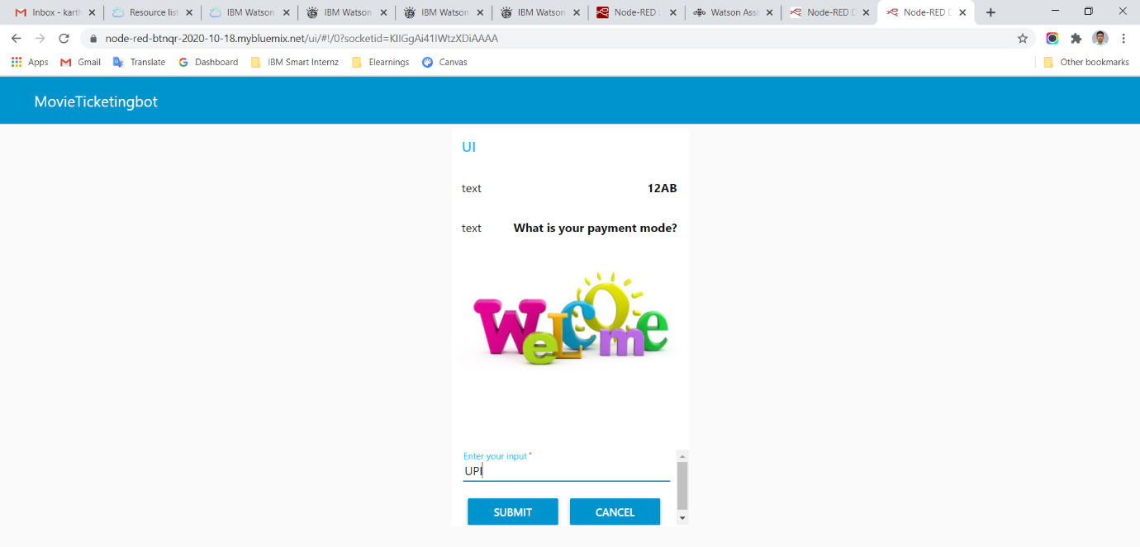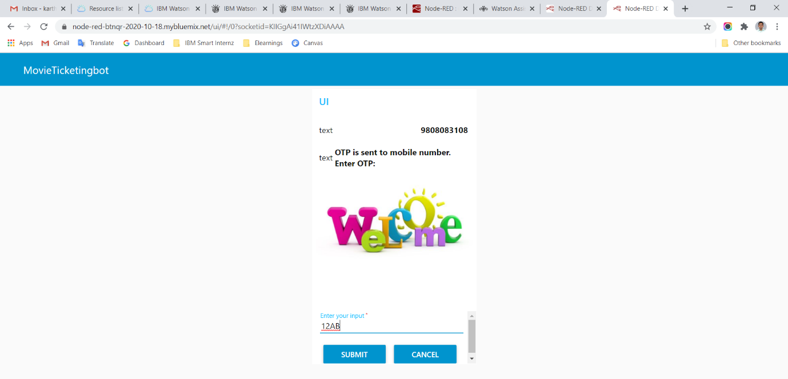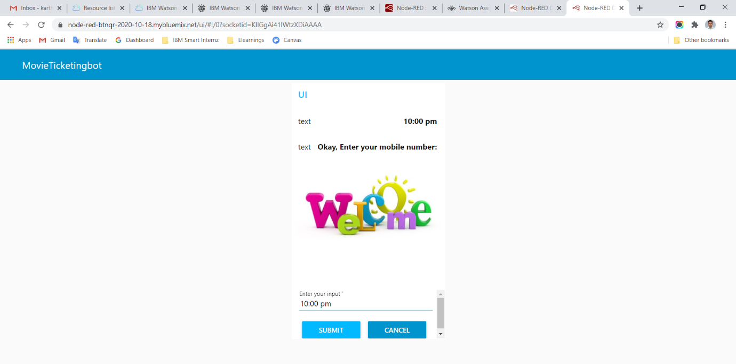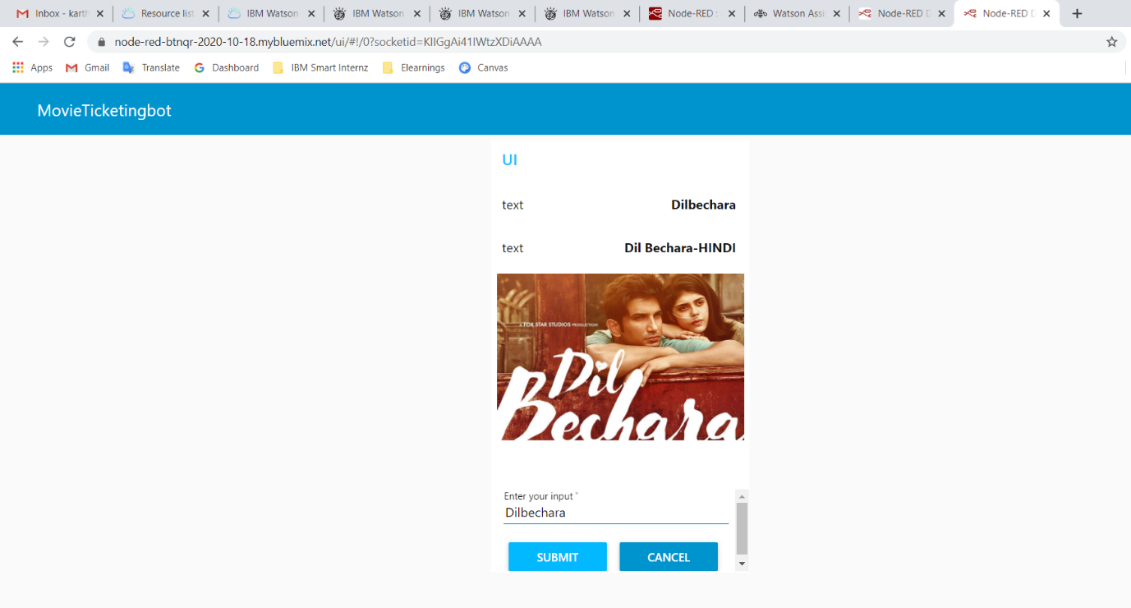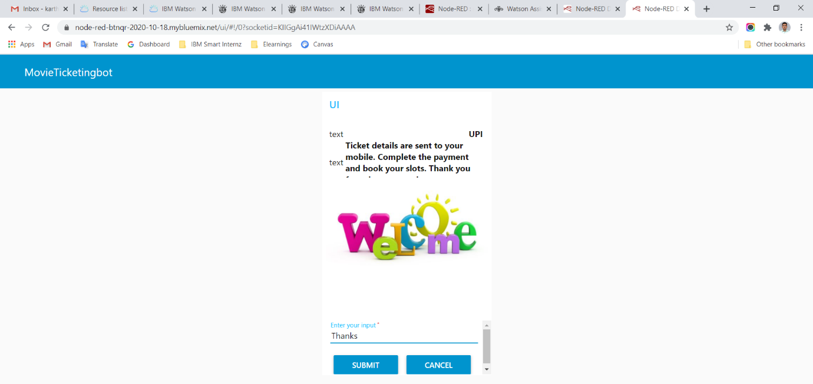

**Appendix:**

**skill-Movie_Chatbot.json**

{

"intents": [

{

"intent": "book",

"examples": [

{

"text": "book the movie"

},

{

"text": "can you book the ticket"

},

{

"text": "I want to book the movie"

}

],

"description": "booking the ticket"

},

{

"intent": "greeting",

"examples": [

{

"text": "GM"

},

{

"text": "Good Evening"

},

{

"text": "Good Morning"

},

{

"text": "Hello"

},

{

"text": "Hey"

},

{

"text": "Hi"

},

{

"text": "OK"

},

{

"text": "OKAY"

},

{

"text": "Welcome"

}

],

"description": "Different ways to greet the bot"

},

{

"intent": "movie",

"examples": [

{

"text": "can you show me the movies"

},

{

"text": "list of movies"

},

{

"text": "movies list"

}

],

"description": "movies list"

},

{

"intent": "otp",

"examples": [

{

"text": "12AB"

}

],

"description": "OTP generation"

},

{

"intent": "price",

"examples": [

{

"text": "Cost of the ticket"

},

{

"text": "Price of the seat"

}

],

"description": "Total Cost"

},

{

"intent": "seats",

"examples": [

{

"text": "1"

},

{

"text": "2"

},

{

"text": "3"

},

{

"text": "4"

},

{

"text": "5"

},

{

"text": "6"

}

],

"description": "Seats required"

},

{

"intent": "thankyou",

"examples": [

{

"text": "Great,Thanks"

},

{

"text": "Thanks!"

},

{

"text": "Thanks a lot"

},

{

"text": "Thanks to you so much"

},

{

"text": "Thank You"

}

],

"description": "Thank the bot for accomplishing the task"

},

{

"intent": "time",

"examples": [

{

"text": "01:00 PM"

},

{

"text": "07:00 PM"

},

{

"text": "10:00 AM"

},

{

"text": "10:00 PM"

}

],

"description": "Time slot"

}

],

"entities": [

{

"entity": "book",

"values": [

{

"type": "synonyms",

"value": "book",

"synonyms": []

}

],

"fuzzy_match": true

},

{

"entity": "cities",

"values": [

{

"type": "synonyms",

"value": "Bangalore",

"synonyms": []

},

{

"type": "synonyms",

"value": "Chennai",

"synonyms": []

},

{

"type": "synonyms",

"value": "Coimbatore",

"synonyms": []

},

{

"type": "synonyms",

"value": "Erode",

"synonyms": []

},

{

"type": "synonyms",

"value": "Hyderabad",

"synonyms": []

}

],

"fuzzy_match": true

},

{

"entity": "movie",

"values": [

{

"type": "synonyms",

"value": "Avengers-ENGLISH",

"synonyms": []

},

{

"type": "synonyms",

"value": "DARBAR - TAMIL",

"synonyms": []

},

{

"type": "synonyms",

"value": "Dil Bechara-HINDI",

"synonyms": []

},

{

"type": "synonyms",

"value": "KGF-KANNADA",

"synonyms": []

},

{

"type": "synonyms",

"value": "Robo 2.0-TAMIL",

"synonyms": []

}

],

"fuzzy_match": true

},

{

"entity": "payment",

"values": [

{

"type": "synonyms",

"value": "Card",

"synonyms": []

},

{

"type": "synonyms",

"value": "Cash",

"synonyms": []

},

{

"type": "synonyms",

"value": "UPI",

"synonyms": []

}

],

"fuzzy_match": true

},

{

"entity": "price",

"values": [

{

"type": "synonyms",

"value": "1",

"synonyms": [

"one"

]

},

{

"type": "synonyms",

"value": "2",

"synonyms": [

"two"

]

},

{

"type": "synonyms",

"value": "3",

"synonyms": [

"three"

]

},

{

"type": "synonyms",

"value": "4",

"synonyms": [

"four"

]

},

{

"type": "synonyms",

"value": "5",

"synonyms": [

"five"

]

},

{

"type": "synonyms",

"value": "6",

"synonyms": [

"six"

]

}

],

"fuzzy_match": true

},

{

"entity": "sys-date",

"values": []

},

{

"entity": "sys-number",

"values": []

}

],

"metadata": {

"api_version": {

"major_version": "v2",

"minor_version": "2018-11-08"

}

},

"dialog_nodes": [

{

"type": "standard",

"title": "Anything else",

"output": {

"generic": [

{

"values": [

{

"text": "I didn't understand. You can try rephrasing."

},

{

"text": "Can you reword your statement? I'm not understanding."

},

{

"text": "I didn't get your meaning."

}

],

"response_type": "text",

"selection_policy": "sequential"

}

]

},

"conditions": "anything_else",

"dialog_node": "Anything else",

"previous_sibling": "node_5_1602600013664",

"disambiguation_opt_out": true

},

{

"type": "standard",

"output": {

"generic": [

{

"title": "DARBAR - TAMIL",

"source": "https://i.pinimg.com/originals/43/1f/a5/431fa5ba5de1d7685d78a80be42e3054.png",

"response_type": "image"

},

{

"title": "Select City:",

"options": [

{

"label": "Erode",

"value": {

"input": {

"text": "Erode"

}

}

},

{

"label": "Chennai",

"value": {

"input": {

"text": "Chennai"

}

}

},

{

"label": "Bangalore",

"value": {

"input": {

"text": "Bangalore"

}

}

},

{

"label": "Coimbatore",

"value": {

"input": {

"text": "Coimbatore"

}

}

},

{

"label": "Hyderabad",

"value": {

"input": {

"text": "Hyderabad"

}

}

}

],

"response_type": "option"

}

]

},

"conditions": "@movie:(DARBAR - TAMIL)",

"digress_in": "does_not_return",

"dialog_node": "node_1_1603037525461",

"previous_sibling": "node_2_1603037636448"

},

{

"type": "standard",

"output": {

"generic": [

{

"values": [

{

"text": "Okay, Enter your mobile number: (only 10 digits)"

}

],

"response_type": "text",

"selection_policy": "sequential"

}

]

},

"conditions": "#time",

"dialog_node": "node_2_1602776943010",

"previous_sibling": "node_7_1602776770761"

},

{

"type": "standard",

"output": {

"generic": [

{

"title": "Robo 2.0-TAMIL",

"source": "https://www.cinejosh.com/newsimg/newsmainimg/20-box-office-collections-7-days_b_0612181048.jpg",

"response_type": "image"

},

{

"title": "Select City:",

"options": [

{

"label": "Erode",

"value": {

"input": {

"text": "Erode"

}

}

},

{

"label": "Chennai",

"value": {

"input": {

"text": "Chennai"

}

}

},

{

"label": "Coimbatore",

"value": {

"input": {

"text": "Coimbatore"

}

}

},

{

"label": "Bangalore",

"value": {

"input": {

"text": "Bangalore"

}

}

},

{

"label": "Hyderabad",

"value": {

"input": {

"text": "Hyderabad"

}

}

}

],

"response_type": "option"

}

]

},

"conditions": "@movie:(Robo 2.0-TAMIL)",

"digress_in": "does_not_return",

"dialog_node": "node_2_1603037636448",

"previous_sibling": "node_6_1603881310804"

},

{

"type": "standard",

"metadata": {

"_customization": {

"mcr": true

}

},

"next_step": {

"behavior": "jump_to",

"selector": "body",

"dialog_node": "node_9_1603038593418"

},

"conditions": "@price",

"digress_in": "returns",

"dialog_node": "node_2_1603038206940",

"digress_out": "allow_all",

"previous_sibling": "node_5_1602945732915"

},

{

"type": "standard",

"output": {

"generic": [

{

"title": "KGF-KANNADA",

"source": "https://www.deccanherald.com/sites/dh/files/articleimages/2020/07/01/Yash-1593586320.jpg",

"response_type": "image"

},

{

"title": "Select City:",

"options": [

{

"label": "Bangalore",

"value": {

"input": {

"text": "Bangalore"

}

}

},

{

"label": "Coimbatore",

"value": {

"input": {

"text": "Coimbatore"

}

}

},

{

"label": "Chennai",

"value": {

"input": {

"text": "Chennai"

}

}

},

{

"label": "Hyderabad",

"value": {

"input": {

"text": "Hyderabad"

}

}

}

],

"response_type": "option"

}

]

},

"conditions": "@movie:(KGF-KANNADA)",

"dialog_node": "node_3_1603037765559",

"previous_sibling": "node_4_1603037844243"

},

{

"type": "standard",

"output": {

"generic": [

{

"title": "Avengers-ENGLISH",

"source": "https://images-na.ssl-images-amazon.com/images/I/91e9898R7QL._RI_.jpg",

"response_type": "image"

},

{

"title": "Select City:",

"options": [

{

"label": "Erode",

"value": {

"input": {

"text": "Erode"

}

}

},

{

"label": "Coimbatore",

"value": {

"input": {

"text": "Coimbatore"

}

}

},

{

"label": "Chennai",

"value": {

"input": {

"text": "Chennai"

}

}

},

{

"label": "Bangalore",

"value": {

"input": {

"text": "Bangalore"

}

}

},

{

"label": "Hyderabad",

"value": {

"input": {

"text": "Hyderabad"

}

}

}

],

"response_type": "option"

}

]

},

"conditions": "@movie:(Avengers-ENGLISH)",

"digress_in": "does_not_return",

"dialog_node": "node_4_1602776508115",

"previous_sibling": "node_1_1603037525461"

},

{

"type": "standard",

"output": {

"generic": [

{

"title": "Dil Bechara-HINDI",

"source": "https://www.hindustantimes.com/rf/image_size_1200x900/HT/p2/2020/06/25/Pictures/_6b8984da-b6c7-11ea-9350-67a6fbf842e0.jpg",

"response_type": "image"

},

{

"title": "Select City:",

"options": [

{

"label": "Erode",

"value": {

"input": {

"text": "Erode"

}

}

},

{

"label": "Coimbatore",

"value": {

"input": {

"text": "Coimbatore"

}

}

},

{

"label": "Chennai",

"value": {

"input": {

"text": "Chennai"

}

}

},

{

"label": "Bangalore",

"value": {

"input": {

"text": "Bangalore"

}

}

},

{

"label": "Hyderabad",

"value": {

"input": {

"text": "Hyderabad"

}

}

}

],

"response_type": "option"

}

]

},

"conditions": "@movie:(Dil Bechara-HINDI)",

"digress_in": "does_not_return",

"dialog_node": "node_4_1603037844243",

"previous_sibling": "node_4_1602776508115"

},

{

"type": "standard",

"title": "Thank You",

"output": {

"generic": [

{

"title": "Welcome, Enjoy the Show!",

"source": "https://encrypted-tbn0.gstatic.com/images?q=tbn%3AANd9GcSte8o3d8fFCsrGOsdH6gQWhQCIhmS8yj9ziQ&usqp=CAU",

"response_type": "image"

}

]

},

"conditions": "#thankyou",

"dialog_node": "node_5_1602600013664",

"previous_sibling": "node_8_1603039409877"

},

{

"type": "standard",

"output": {

"generic": [

{

"values": [

{

"text": "What is your payment mode? (UPI / Cash / Net banking)"

}

],

"response_type": "text",

"selection_policy": "sequential"

}

]

},

"conditions": "#otp",

"dialog_node": "node_5_1602777052428",

"previous_sibling": "node_5_1603039248558"

},

{

"type": "standard",

"output": {

"generic": [

{

"title": "Choose the number of Seats required:",

"options": [

{

"label": "1",

"value": {

"input": {

"text": "1"

}

}

},

{

"label": "2",

"value": {

"input": {

"text": "2"

}

}

},

{

"label": "3",

"value": {

"input": {

"text": "3"

}

}

},

{

"label": "4",

"value": {

"input": {

"text": "4"

}

}

},

{

"label": "5",

"value": {

"input": {

"text": "5"

}

}

},

{

"label": "6",

"value": {

"input": {

"text": "6"

}

}

}

],

"description": "",

"response_type": "option"

}

]

},

"metadata": {

"_customization": {

"mcr": false

}

},

"conditions": "@cities",

"dialog_node": "node_5_1602945732915",

"previous_sibling": "node_3_1603037765559"

},

{

"type": "standard",

"output": {

"generic": [

{

"values": [

{

"text": "OTP is sent to mobile number. Enter OTP:"

}

],

"response_type": "text",

"selection_policy": "sequential"

}

]

},

"conditions": "@sys-number",

"dialog_node": "node_5_1603039248558",

"previous_sibling": "node_2_1602776943010"

},

{

"type": "standard",

"output": {

"generic": [

{

"values": [

{

"text": "Movies Available: Robo 2.0 (Tamil), Darbar (Tamil), Avengers (English), Dil Bechara (Hindi), KGF (Kannada)"

}

],

"response_type": "text",

"selection_policy": "sequential"

}

]

},

"next_step": {

"behavior": "jump_to",

"selector": "body",

"dialog_node": "node_9_1602599787216"

},

"conditions": "#movie",

"dialog_node": "node_6_1603881310804",

"previous_sibling": "node_9_1602599787216"

},

{

"type": "standard",

"output": {

"generic": [

{

"title": "Show timings are:",

"options": [

{

"label": "10:00 AM",

"value": {

"input": {

"text": "10:00 AM"

}

}

},

{

"label": "01:00 PM",

"value": {

"input": {

"text": "01:00 PM"

}

}

},

{

"label": "07:00 PM",

"value": {

"input": {

"text": "07:00 PM"

}

}

},

{

"label": "10:00 PM",

"value": {

"input": {

"text": "10:00 PM"

}

}

}

],

"response_type": "option"

}

]

},

"conditions": "@sys-date",

"dialog_node": "node_7_1602776770761",

"previous_sibling": "node_9_1603038593418"

},

{

"type": "standard",

"output": {

"generic": [

{

"values": [

{

"text": "Ticket details are sent to your mobile. Complete the payment and book your slots. Thank you for using our service. "

}

],

"response_type": "text",

"selection_policy": "sequential"

}

]

},

"conditions": "@payment",

"dialog_node": "node_8_1603039409877",

"previous_sibling": "node_5_1602777052428"

},

{

"type": "standard",

"title": "Greetings",

"output": {

"generic": [

{

"title": "Choose a Movie from the list:",

"options": [

{

"label": "Robo 2.0-TAMIL",

"value": {

"input": {

"text": "Robo 2.0-TAMIL"

}

}

},

{

"label": "DARBAR-TAMIL",

"value": {

"input": {

"text": "DARBAR-TAMIL"

}

}

},

{

"label": "Avengers-ENGLISH",

"value": {

"input": {

"text": "Avengers-ENGLISH"

}

}

},

{

"label": "Dil Bechara-HINDI",

"value": {

"input": {

"text": "Dil Bechara-HINDI"

}

}

},

{

"label": "KGF-KANNADA",

"value": {

"input": {

"text": "KGF-KANNADA"

}

}

}

],

"response_type": "option"

}

]

},

"conditions": "#greeting",

"dialog_node": "node_9_1602599787216",

"previous_sibling": "Welcome"

},

{

"type": "standard",

"output": {

"generic": [

{

"values": [

{

"text": "Enter the date you want to watch: (DD/MM/YY)"

}

],

"response_type": "text",

"selection_policy": "sequential"

}

]

},

"conditions": "#seats",

"dialog_node": "node_9_1603038593418",

"previous_sibling": "node_2_1603038206940"

},

{

"type": "response_condition",

"output": {

"generic": [

{

"values": [

{

"text": ""

}

],

"response_type": "text",

"selection_policy": "sequential"

}

]

},

"parent": "node_5_1602945732915",

"disabled": true,

"conditions": "",

"dialog_node": "response_4_1602945819693"

},

{

"type": "response_condition",

"output": {

"generic": [

{

"values": [

{

"text": "Cost of your 4 tickets is Rs. 800"

}

],

"response_type": "text",

"selection_policy": "sequential"

}

]

},

"parent": "node_2_1603038206940",

"conditions": "@price:(4)",

"dialog_node": "response_4_1603038420554",

"previous_sibling": "response_5_1603038387668"

},

{

"type": "response_condition",

"output": {

"generic": [

{

"values": [

{

"text": "Cost of your 2 tickets is Rs. 400"

}

],

"response_type": "text",

"selection_policy": "sequential"

}

]

},

"parent": "node_2_1603038206940",

"conditions": "@price:(2)",

"dialog_node": "response_5_1603038355236",

"previous_sibling": "response_7_1603038313173"

},

{

"type": "response_condition",

"output": {

"generic": [

{

"values": [

{

"text": "Cost of your 3 tickets is Rs. 600"

}

],

"response_type": "text",

"selection_policy": "sequential"

}

]

},

"parent": "node_2_1603038206940",

"conditions": "@price:(3)",

"dialog_node": "response_5_1603038387668",

"previous_sibling": "response_5_1603038355236"

},

{

"type": "response_condition",

"output": {

"generic": [

{

"values": [

{

"text": "Cost of your 6 tickets is Rs.1200"

}

],

"response_type": "text",

"selection_policy": "sequential"

}

]

},

"parent": "node_2_1603038206940",

"conditions": "@price:(6)",

"dialog_node": "response_5_1603038478450",

"previous_sibling": "response_8_1603038448498"

},

{

"type": "response_condition",

"output": {

"generic": [

{

"values": [

{

"text": "Cost of your ticket is Rs. 200"

}

],

"response_type": "text",

"selection_policy": "sequential"

}

]

},

"parent": "node_2_1603038206940",

"conditions": "@price:(1)",

"dialog_node": "response_7_1603038313173"

},

{

"type": "response_condition",

"output": {

"generic": [

{

"values": [

{

"text": "Cost of your 5 tickets is Rs. 1000"

}

],

"response_type": "text",

"selection_policy": "sequential"

}

]

},

"parent": "node_2_1603038206940",

"conditions": "@price:(5)",

"dialog_node": "response_8_1603038448498",

"previous_sibling": "response_4_1603038420554"

},

{

"type": "standard",

"title": "Welcome",

"output": {

"generic": [

{

"values": [

{

"text": "Hello! I am here to help you book movie tickets."

}

],

"response_type": "text",

"selection_policy": "random"

}

]

},

"conditions": "welcome",

"dialog_node": "Welcome"

}

],

"counterexamples": [],

"system_settings": {

"off_topic": {

"enabled": true

},

"disambiguation": {

"prompt": "Did you mean:",

"enabled": true,

"randomize": true,

"max_suggestions": 5,

"suggestion_text_policy": "title",

"none_of_the_above_prompt": "None of the above"

},

"system_entities": {

"enabled": true

},

"human_agent_assist": {

"prompt": "Did you mean:"

},

"spelling_auto_correct": true

},

"learning_opt_out": false,

"name": "Movie_Chatbot",

"language": "en",

"description": ""

}

**Movie_bot_Node_red_flows.json**

[{"id":"20b0d90b.133d96","type":"tab","label":"Movie Ticket Chatbot Flow","disabled":false,"info":""},{"id":"4d3deba5.55ca44","type":"watson-conversation-v1","z":"20b0d90b.133d96","name":"Movie Bot","workspaceid":"a362556e-92b5-4580-99df-69943dd53871","multiuser":false,"context":true,"empty-payload":false,"service-endpoint":"https://api.eu-gb.assistant.watson.cloud.ibm.com/instances/6da51e7f-ecef-4ee6-940e-30f5eb1df500","timeout":"","optout-learning":false,"x":440,"y":280,"wires":[["d8df471f.a63398"]]},{"id":"2fd815f3.618cca","type":"inject","z":"20b0d90b.133d96","name":"","props":[{"p":"payload"},{"p":"topic","vt":"str"}],"repeat":"","crontab":"","once":false,"onceDelay":0.1,"topic":"","payload":"Hi","payloadType":"str","x":190,"y":360,"wires":[["4d3deba5.55ca44"]]},{"id":"78b8f035.41c54","type":"debug","z":"20b0d90b.133d96","name":"","active":true,"tosidebar":true,"console":false,"tostatus":false,"complete":"payload","targetType":"msg","statusVal":"","statusType":"auto","x":710,"y":400,"wires":[]},{"id":"d8df471f.a63398","type":"function","z":"20b0d90b.133d96","name":"Parsing","func":"if(msg.payload.output.generic[0].response_type==\"message\"){\n msg.url = msg.payload.output.generic[0].source\n msg.payload = msg.payload.output.generic[0].title\n}\nelse{\n msg.url=\"https://upload.wikimedia.org/wikipedia/commons/d/dc/Pvrcinemas_logo.jpg\"\n } msg.payload = msg.payload.output.text[0];\nreturn msg;","outputs":1,"noerr":0,"initialize":"","finalize":"","x":520,"y":180,"wires":[["78b8f035.41c54","80ca8979.f90738","aa1d0648.1320b8","9bce8d52.8fdbd"]]},{"id":"b0f7b221.6fb26","type":"ui_form","z":"20b0d90b.133d96","name":"","label":"","group":"4c10755.608948c","order":2,"width":0,"height":0,"options":[{"label":"Enter your input","value":"text","type":"text","required":true,"rows":null}],"formValue":{"text":""},"payload":"","submit":"submit","cancel":"cancel","topic":"","x":110,"y":180,"wires":[["357f2abb.7a5846"]]},{"id":"357f2abb.7a5846","type":"function","z":"20b0d90b.133d96","name":"Input Parsing","func":"msg.payload=msg.payload.text;\nreturn msg;","outputs":1,"noerr":0,"initialize":"","finalize":"","x":250,"y":180,"wires":[["4d3deba5.55ca44","9095519.fa153b"]]},{"id":"9095519.fa153b","type":"ui_text","z":"20b0d90b.133d96","group":"4c10755.608948c","order":3,"width":"5","height":"2","name":"","label":"Client :","format":"{{msg.payload}}","layout":"row-spread","x":450,"y":120,"wires":[]},{"id":"80ca8979.f90738","type":"ui_text","z":"20b0d90b.133d96","group":"4c10755.608948c","order":4,"width":"4","height":"3","name":"","label":"PVR Bot:","format":"{{msg.payload}}","layout":"row-spread","x":720,"y":240,"wires":[]},{"id":"aa1d0648.1320b8","type":"ui_audio","z":"20b0d90b.133d96","name":"","group":"4c10755.608948c","voice":"en-US","always":"","x":720,"y":100,"wires":[]},{"id":"9bce8d52.8fdbd","type":"ui_template","z":"20b0d90b.133d96","group":"4c10755.608948c","name":"","order":6,"width":"6","height":"6","format":"<img ng-src={{msg.url}} alt=\"Image\">","storeOutMessages":true,"fwdInMessages":true,"resendOnRefresh":true,"templateScope":"local","x":740,"y":160,"wires":[[]]},{"id":"4c10755.608948c","type":"ui_group","z":"","name":"Movie Assistent Bot","tab":"9bad2780.1e2908","order":1,"disp":true,"width":"6","collapse":false},{"id":"9bad2780.1e2908","type":"ui_tab","z":"","name":"PVR Multiplex Cinema's Help Desk","icon":"dashboard","disabled":false,"hidden":false}]