**AI (ML DL) April15**

**Project**

**On**

ROCK IDENTIFICATION

Using

DEEP CONVOLUTIONAL NEURAL NETWORK

By Team 11

1) G.T.K.S.PRASAD

2) K.PHANEENDRA

3) K. NANI BABU

4) G. CHIRANJEEVI

5) K. PAVAN KUMAR

**Table of Contents**

|  |  |  |  |  |
| --- | --- | --- | --- | --- |
| **1** | |  | **INTRODUCTION** | |
|  | |  | 1.1 Overview | |
|  | |  | 1.2 Purpose | |
| **2** | |  | **LITERATURE SURVEY** | |
|  | |  | 2.1 Existing problem | | |
|  | |  | 2.2 Proposed solution | | |
| **3** | |  | **THEORITICAL ANALYSIS** | |
|  | |  | 3.1 Hardware / Software designing | |
|  | |  |  | | |
| **4** | |  | **EXPERIMENTAL INVESTIGATIONS** | | |
| **5** | |  | **FLOWCHART** | |
| **6** | |  | **RESULT** |  |
| **7** | |  | **ADVANTAGES & DISADVANTAGES** | | |
| **8** | |  | **APPLICATIONS** | |
| **9** | |  | **CONCLUSION** | |
| **10** | |  | **FUTURE SCOPE** | |
| **11** | |  | **BIBILOGRAPHY** | |
|  | |  | **APPENDIX** | |
|  |  | | A. Source code | |

1. **Introduction** 
   1. **Overview:**

Rocks are a fundamental component of Earth. The automatic identification of rock type in the field would aid geological surveying, education, and automatic mapping. It is a basic part of geological surveying and research, and mineral resources exploration. The automatic identification of rock type in the field would aid geological surveying, education, and automatic mapping. Working conditions in the field generally limit identification to visual methods, including using a magnifying glass for fine-grained rocks. Visual inspection assesses properties such as colour, composition, grain size, and structure. The attributes of rocks reflect their mineral and chemical composition, formation environment, and genesis. The colour of rock reflects its chemical composition. But these analysis is time taken process to identify the rocks.Its application here has effectively identified rock types from images captured in the field. This paper proposes an accurate approach for identifying rock types in the field based on image analysis using deep convolutional neural networks.

**1.2 Purpose:**

For the effective development of reservoirs, it is necessary to provide a comprehensive reservoir description and characterization to determine the underground gas content. Granularity analysis is an important work of it [1]. The traditional method for rock classification is a manual work with many problems such as time-consuming and low accuracy. With the development of science and technology, Artificial intelligence is successfully applied in all walks of life. Many domestic and foreign scholars have done researches in the automatic classification of rock images, such as, Cheng Guojian and Liu Ye [2-3] used shallow neural network and SVM to classify rock images. Mariusz Młynarczuk et al.[4] performed the Classification of thin rock images respectively in RGB, CIELab, YIQ and HSV colour spaces using the nearest neighbour algorithm, K-nearest neighbour, the nearest pattern algorithm, and the optimized spherical neighbourhood; Hossein Izadi et al.[5] established a neural network to identify the rock mineral, whose accuracy was 93.81%. The above methods show that the application of machine learning in rock classification can improve its efficiency and accuracy. However, using machine learning to classify rock images still has the following shortcomings. Firstly, to classify rock images by machine learning is based on the premise of artificial extraction of image features. Secondly, if the images are large, training a shallow neural network is almost impossible. Convolution neural network (CNN) is an important deep learning architecture. It can extract the image features automatically and has a high classify accuracy. CNN has achieved a wide range of applications such as plant classification, face recognition, handwritten Chinese character recognition and so on [6-8]. In this paper, we construct a new convolution neural network for rock classification, rock images respectively in RGB, HSV, YCbCr colour spaces are used to train it, then contrasted the results and choose the best one.

1. **Literature Survey**

**2.1 Existing Problem**

Generally, people working at mines, identify the type of rocks by observing their configurations or testing them. It takes a lot of time. Only , a very experienced person can identify the type of rocks by seeing it.

**2.2 Proposed Solution**

This problem is overcame by creating a model for Rock Identification using CNN. Then , by training that model with with tets and tarin sets will make a person easy to identify the type of rock by simply uploading that image of the rock to the application. It saves a lot of time and effors too.

1. **Theoretical Analysis**

**3.1 Hardware / Software designing**

Python, Python Web Frame Works, Python for Data Analysis, Python For Data Visualization, Data Pre-processing Techniques, Machine Learning, Regression Algorithms

1. **Experimental Investigation**

The rocks are classified into 5 major types. They are

* Andesite
* Basalt
* Breccia
* Gneiss
* Sandstone

1. **Flowchart**

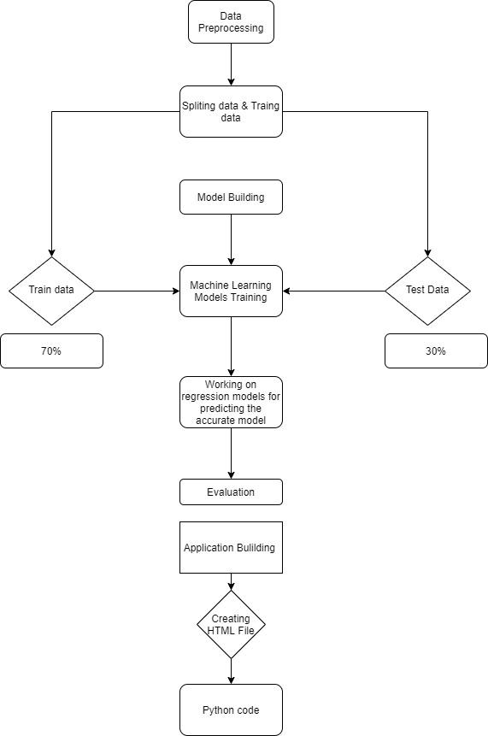

1. **Result**

We have analysed the types of rock images and used Deep CNN

to predict the type of rock.

1. **Advantages and Disadvantages**

**Advantages:**

Using Convolutional Neural Network to predict the type of rock will save more time and more accuracy in predicting the approximately close type can be done easily. Its more trust worthy and cost effective .It also reduces the man power for doing the experiments to find the type of rock in different unknown situations.

**Disadvantages :**

There is a small percent chances that the outcome will not predict the approximate value in that situation it can be troublesome.

1. **Applications:**

* Can be used to identify type of rocks in mines
* Implementable on the website

1. **Conclusion**

In this study, a prediction model of rock identification was established by Convolutional Neual Network. A total of 500 sample data collected from the experimental test were used to develop the CNN model for predicting the type of rock. The CNN was first calibrated and then verified using the experimental data from rock images.

1. **Future Scope**

This model can predict the outcome with many different inputs within seconds. The model will save a lot of time of the construction companies. Experiment cost is also reduced with creates a bigger opportunity for mining companies in cost effectiveness work.

1. **Bibliography**

**Books**

Hastie, Friedman, and Tibshirani, The Elements of Statistical Learning, 2001

Bishop, Pattern Recognition and Machine Learning, 2006

Ripley, Pattern Recognition and Neural Networks, 1996

Duda, Hart, and Stork, Pattern Classification, 2nd Ed., 2002

Tan, Steinbach, and Kumar, Introduction to Data Mining, Addison-Wesley, 2005.

**Data repositories**

Kaggle.com

**Algorithms**

Thesmartbridgeteachable.com

1. **Appendix**

**Source Code :**

from keras.preprocessing.image import ImageDataGenerator

from keras.models import Sequential

from keras.layers import Dense

from keras.layers import Conv2D

from keras.layers import MaxPooling2D

from keras.layers import Flatten

from keras.models import load_model

import numpy as np

import cv2

#from skimage.transform import resize

import PIL

train_datagen = ImageDataGenerator(rescale=1./255,shear_range=0.2,zoom_range=0.2,horizontal_flip=True)

test_datagen=ImageDataGenerator(rescale=1./255,shear_range=0.2,zoom_range=0.2,horizontal_flip=True)

x_train=train_datagen.flow_from_directory(r"C:\Users\tirumala guddanti\Desktop\rocks\trainset",target_size=(64,64),batch_size=32,class_mode="categorical")

x_test=test_datagen.flow_from_directory(r"C:\Users\tirumala guddanti\Desktop\rocks\testset",target_size=(64,64),batch_size=32,class_mode="categorical")

model = Sequential()

model.add(Conv2D(32,3,3,input_shape=(64,64,3),activation="relu"))

model.add(MaxPooling2D(pool_size=(2,2)))

model.add(Flatten())

model.add(Dense(output_dim=128,activation="relu",init="random_uniform"))

model.add(Dense(output_dim=5,activation="softmax",init="random_uniform"))

model.compile(optimizer="adam",loss="categorical_crossentropy",metrics=["accuracy"])

model.fit_generator(x_train,samples_per_epoch=8000,epochs=10,validation_data=x_test,nb_val_samples=2000)

model.save("mymodel.h5")