**INTRODUCTION**

**Overview**

The **news** is **important** because it informs our view of the world, and in response we take action and make choices based on how we perceive the world to be. **News** has grown to take on more forms than ever.

[News](http://clearlyexplained.com/news/index.html) is important for a number of reasons within a [society](http://clearlyexplained.com/society/index.html). Mainly to inform the public about events that are around them and may affect them.

Often news is for entertainment purposes too; to provide a distraction of information about other places people are unable to get to or have little influence over. News can make people feel connected too.

News is important as a social gathering space too, hence newspapers either online or physical place an emphasis on news. Where there are a lot of people gathered there is opportunity to advertise. This advertising sometimes can cause a conflict of interest in the way news is reported.

The web is home to massive amounts of data, with more being created every day. Organizations can harness this constant stream of information to gain understanding, plan strategies, and find opportunities. Enriched news data can help your application make dynamic connections across current events faster.

**PURPOSE**

This app allows the user to search for any news at any time. The Watson discovery service used has an inbuilt collection of news in various topics which brings news to the doorstep in a jiffy.

**FLOWCHART**

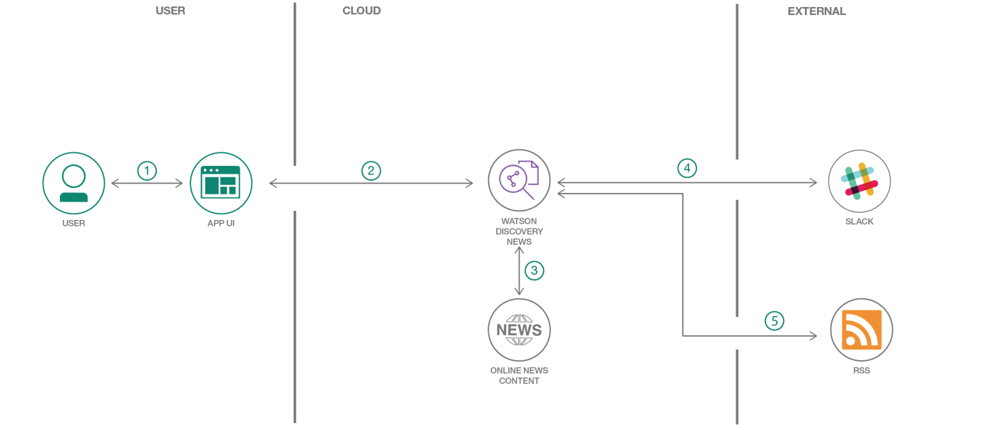

1. The user interacts with the app UI to request relevant news content.

2. The app sends user requests to Watson Discovery News.

3. The Watson Discovery Service is continually crawling the web to update its Discovery News collection.

4. The Watson Discovery Service responds to Slack search requests.

**RESULT**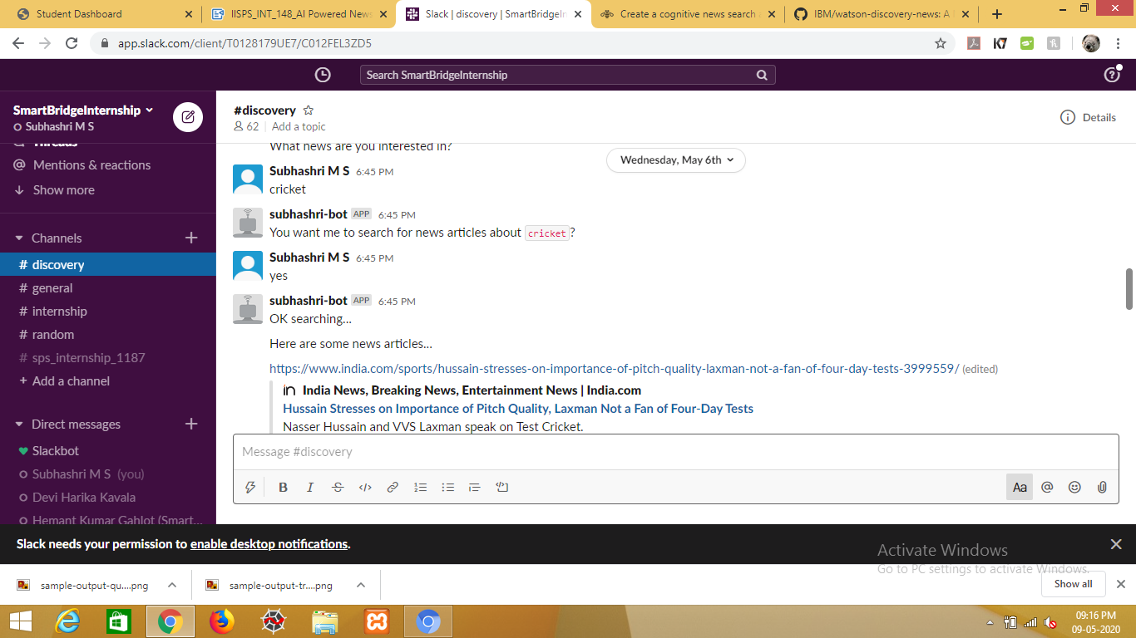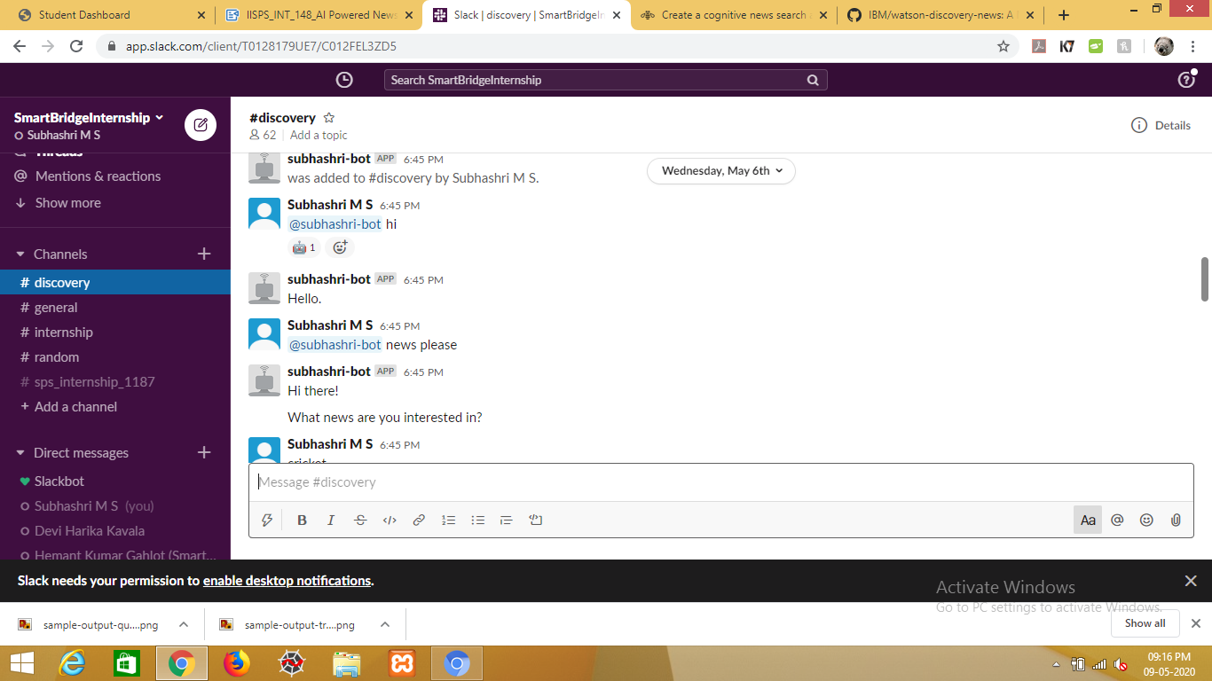

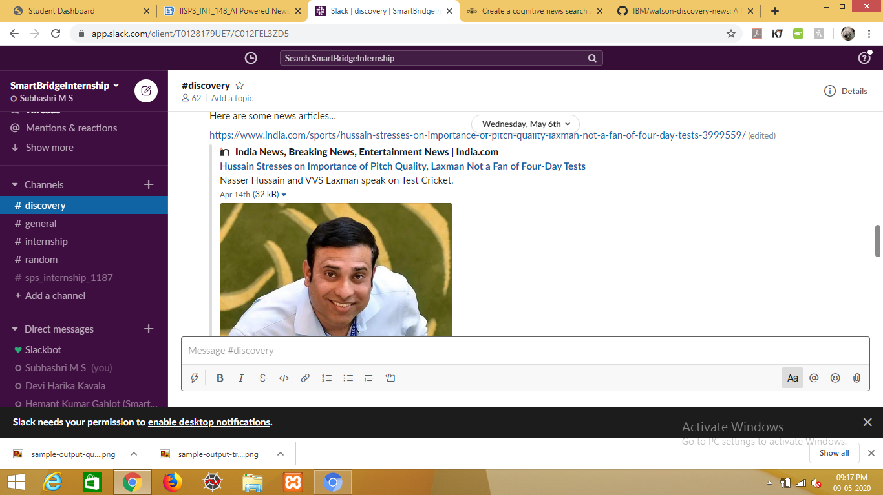

**UI LINK:**<https://node-red-mmygl.eu-gb.mybluemix.net/ui/#!/0?socketid=8k2btcAw8IvvIK5qAAAE>

**ADVANTAGES**

* The user is can search for any news.
* Easy to use.
* Easy to run.
* Provides sentiment analysis
* Can be run on a loal machine

**DISADVANTAGES**

* It requires an active internet connection.
* Can provide very old new in some instances.

**CONCLUSION AND FUTURE SCOPE**

After processing through all phases of the system development life cycle, the portal is developed. In future it will be hosted on the internet server which will be accessed by all people in the world and can view the site and learn as much as news and information about the world. Also in future we can add more features to support it to common social media like facebook,instagram and so on.