**Predicting life expectancy using Machine learning**

**Create IBM Account:**

 Go to [IBM Platform](https://cloud.ibm.com) to create an IBM account.

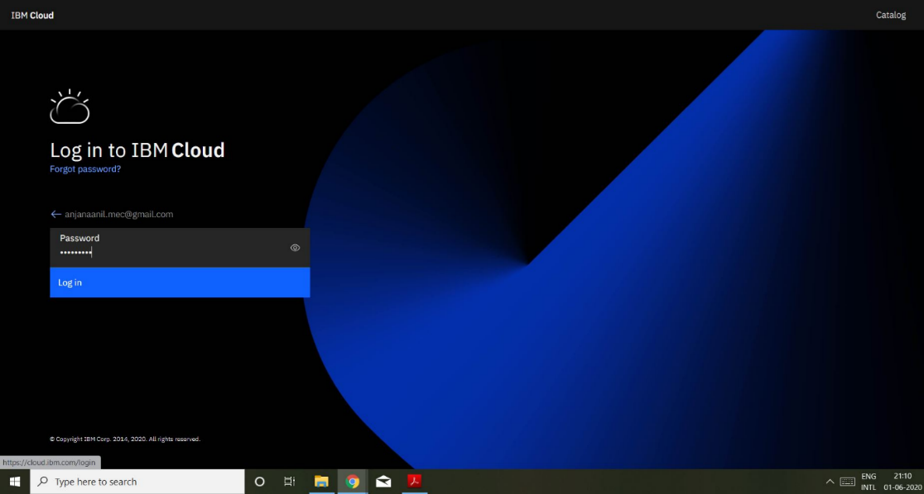

**To create Watson Studio Service**

1.Go catalog 🡪 Search Watson Studio in search bar

2.Click on **Get started** 🡪 Create project and add cloud object storage

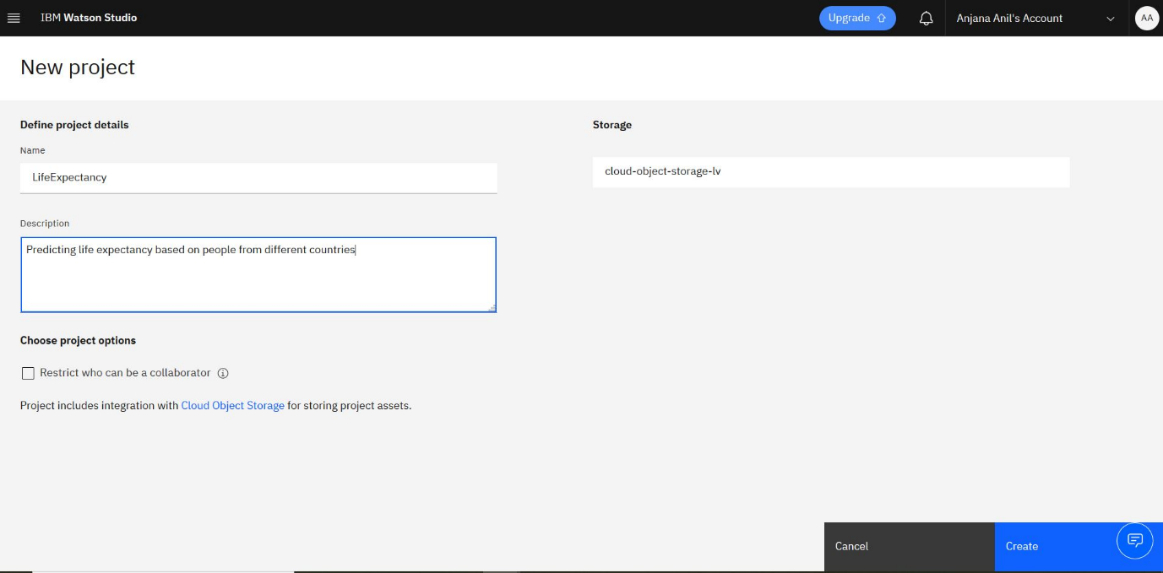

3.Inside the project Tab 🡪 Assets 🡪 Add Data Set and Notebook

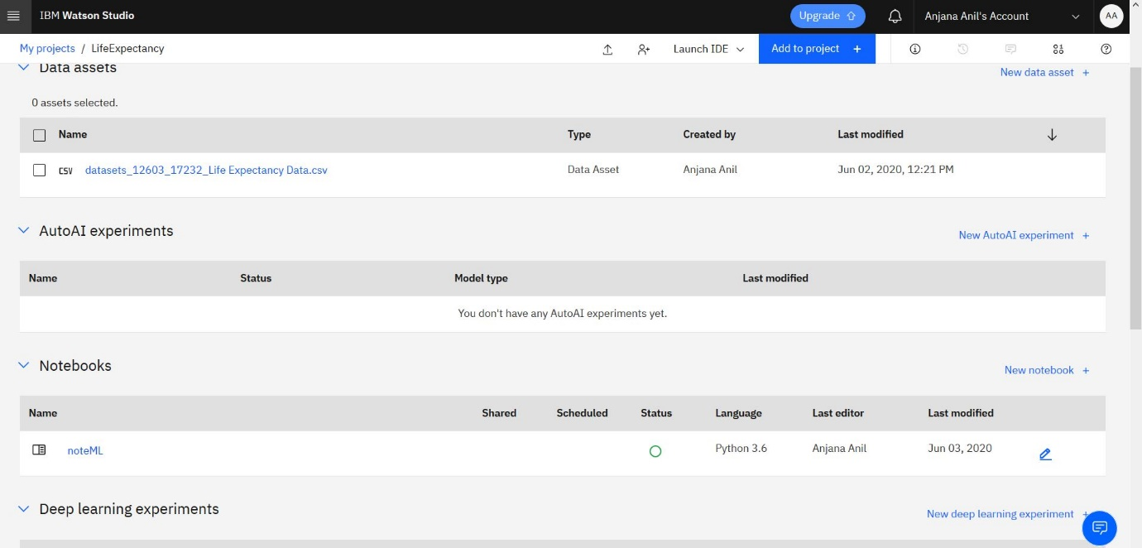

Notebook Link : <https://github.com/SmartPracticeschool/llSPS-INT-1531-Predicting-Life-Expectancy-using-Machine-Learning/blob/master/noteML(4).ipynb>

**To create Node-Red Application**

1.From Dashboard select catalog.

2.Select Software

3.Select Web and Application

4.Select Node-Red Application

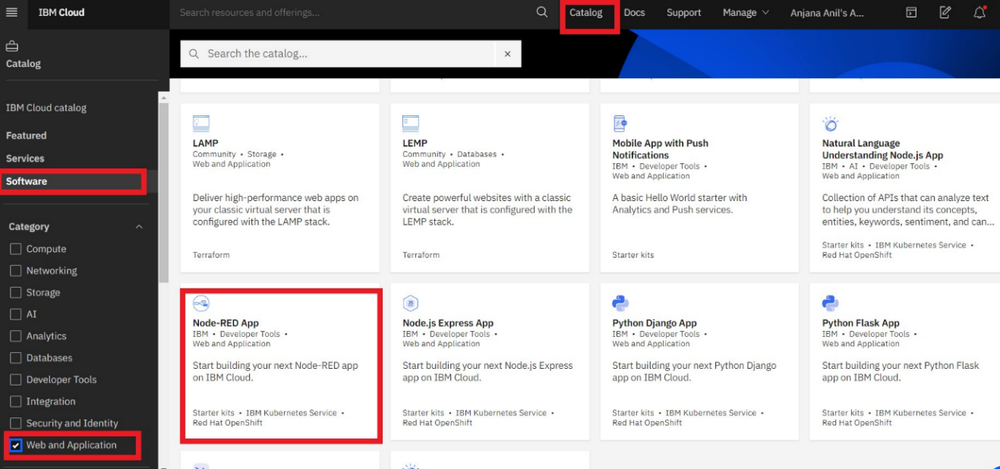

5.Keep all the values to default and continue the App development.

6.Once you select on click **Create app** and then proceed to click on **Deploy App.**

7.After deployment wait for the status turn into **Success.**

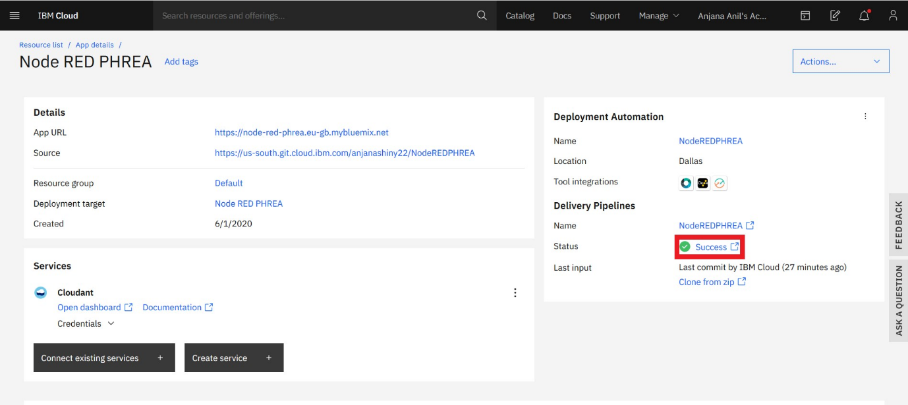

8.App URL will appear after successful deployment . Click on the App URL

* Add connections to the associated services clicking Connections 🡪 Add Connections.
* Click on Visit App URL in the Overview page.
* Setup the Node RED editor.

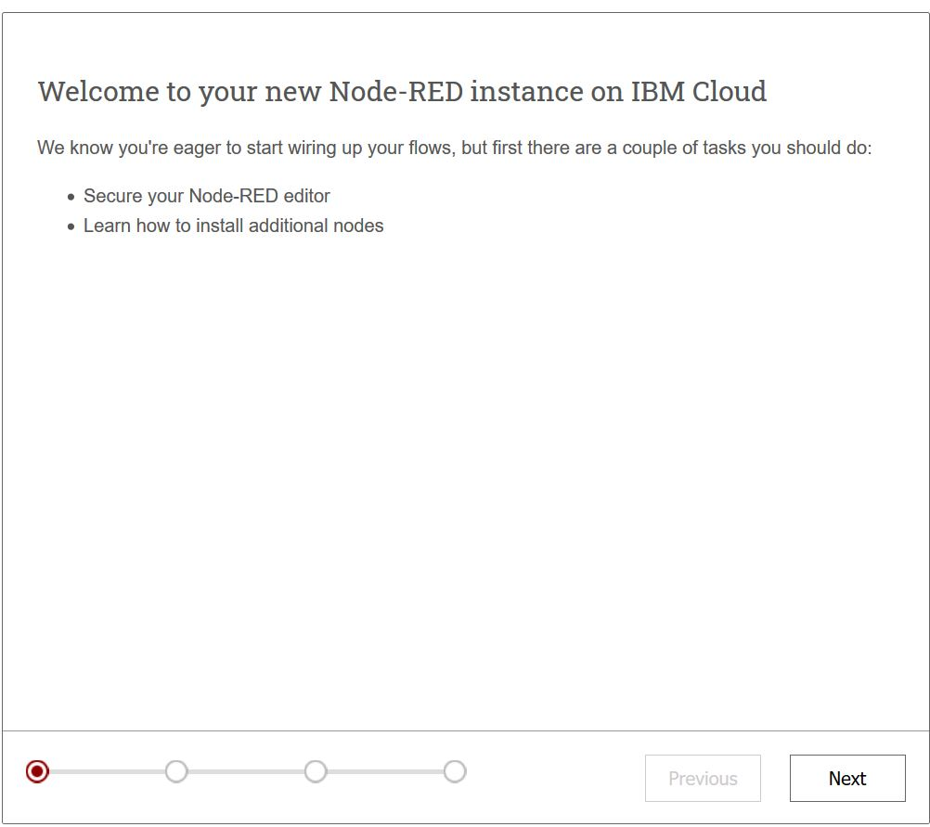

9.Continue clicking on Next and click on Finish at the end to launch the Node RED editor.

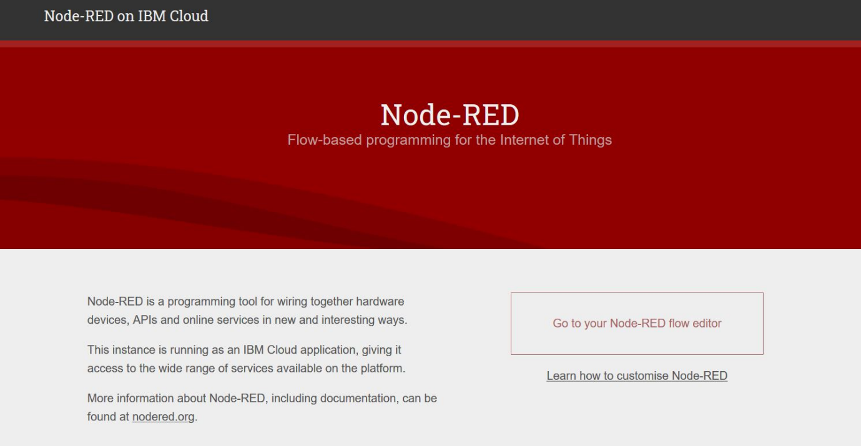

10.Click on Node-RED flow editor.

11.Flow for the App is created by taking the necessary nodes.

12.Install “node-red-dashboard” from Manage Palette.

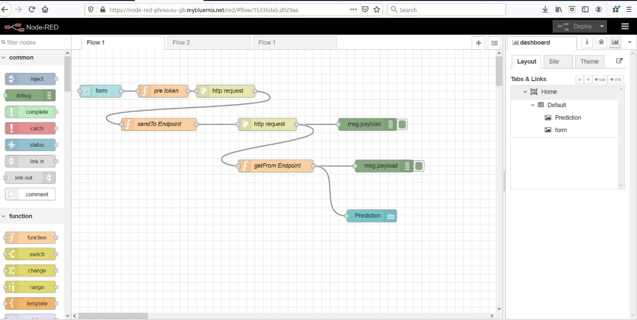

 The link to Flow: <https://node-red-phrea.eu-gb.mybluemix.net/red/#flow/15336da5.d929aa>

 The Dashboard will show predicted Life Expectancy from the given Input.

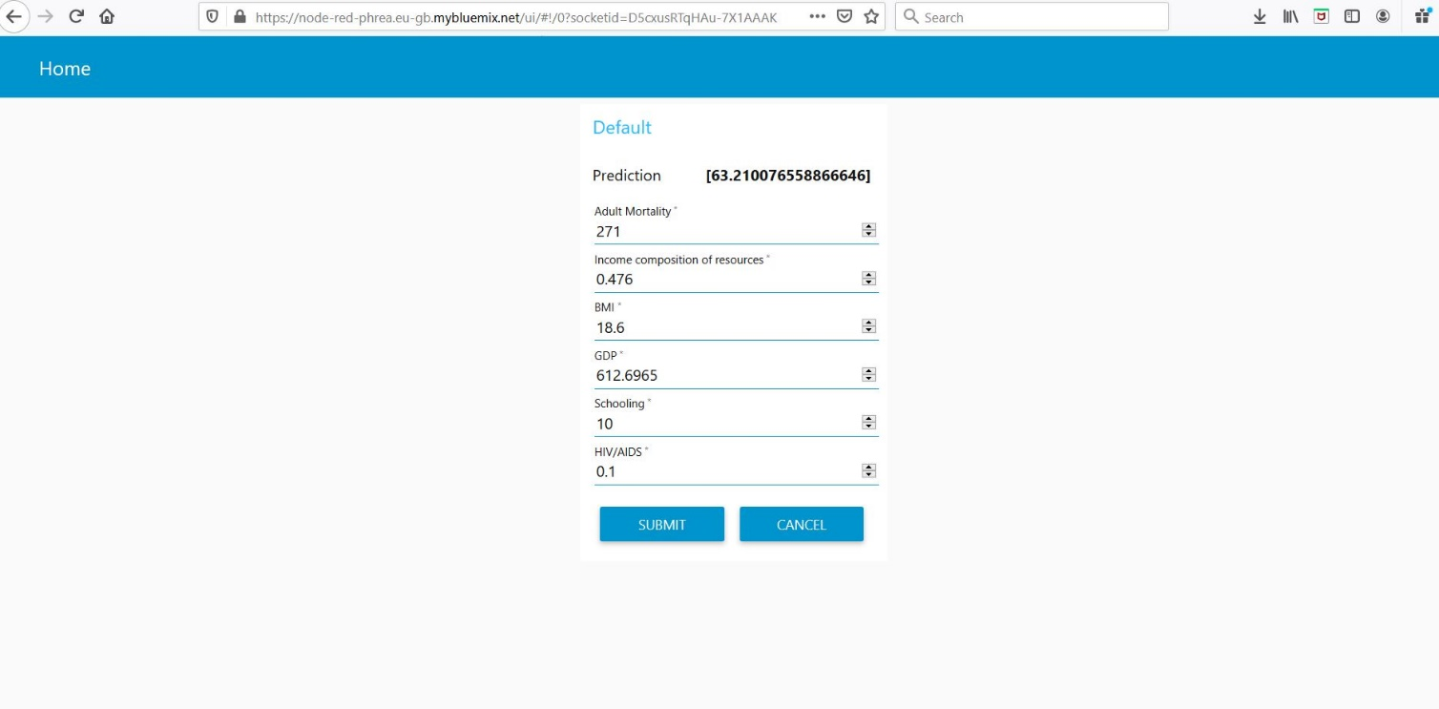

 Link to Dashboard : <https://node-red-phrea.eu-gb.mybluemix.net/ui/#!/0?socketid=D5cxusRTqHAu-7X1AAAK>