# Predicting Life Expectancy using

# Machine Learning

**Project Summary:**

Life expectancy is a statistical measure of the average time a human being is expected to live, Life expectancy depends on various factors: Regional variations, Economic Circumstances, Sex Differences, Mental Illnesses, Physical Illnesses, Education, Year of their birth and other demographic factors. This project provides a way to predict average life expectancy of people living in a country when various factors such as year, GDP, education, alcohol intake of people in the country, expenditure on healthcare system and some specific disease related deaths that happened in the country are given.

**Project Requirements:**

**Functional Requirements:**

Regression Models, Maintaining Historical Data, Receiving input as the factors needed.

**Technical Requirements:**

Python, ML Codebase, IBM Cloud, IBM Watson

**Software Requirements:**

Watson Cloud, GitHub, IBM Cloud, NODE RED

**Project Delivarables:**

**Phase 1: Discovery**

Delivarables: A project document specifying the trivial and complex features of the project.

**Phase 2: Exploration**

Delivarables: A proof of concept explaining the performace metrics of the project.

**Phase 3: Development**

Delivarables: A completely ready Machine Learning algorithm.

**Phase 4: Improving**

Delivarables: A Machine Learning Project with improved and needed accuracy.

**Final Product:**

An IBM Node-Red flow Frontend where user can give the various inputs needed and obtain the needed life expectancy prediction.

**Project Team:**

Sai Thanmae Kambhampati. (Individual Project)

**Project Scehdule:**

Phase 1 - 2 days.

Phase 2 - 2 days.

Phase 3 - 10 days.

Phase 4 - 6 days.

**Literature Survey:**

* The exisiting solutions for the problem statement are mostly tha algorithms developed by many people.
* The proposed solution is by the IBM's innovative AutoAI.

**Block Diagram:**

MODEL

AUTO AI

DATASET

**Results:**

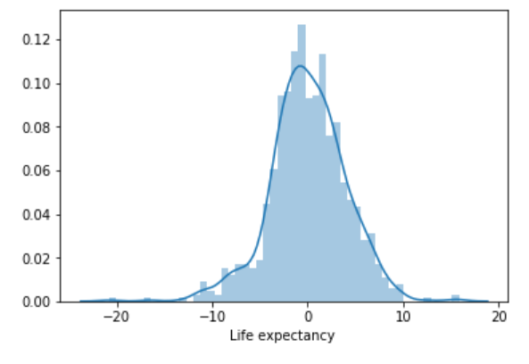

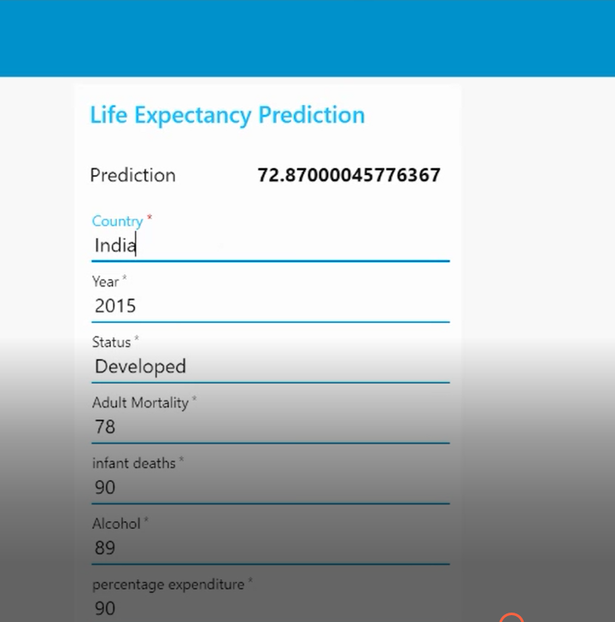

**Applications:**

We can use the generated model to display the life expectancy of a person based on the features he provide.

This model can also be used in decision making in the health care sector.

**Conclusion:**

These days when many models are used to work with data, AutoAI had done the job in little time with best possible results that predict with higher accuracy.