**HEALTH CARE MONITORING SYSTEM**

**1 INTRODUCTION**

**1.1 Overview**

In this Health monitoring system we will be detecting the status of ill health of the person and here we are seeing some parameters of the person which are blood pressure,pulse and temperature by these parameters we can analyze his health status from 0-2 where 0 is that he is perfectly okay, 2 is that the person is very much ill that he need to consult doctor.

**1.2 Purpose**

To predict the health status of a person depending on some specified parameters such as Blood Pressure , Pulse , Temparature of body . and it outputs the health performance of that particular person.

**2 LITERATURE SURVEY**

**2.1  Existing problem**

The essential part of the life is healthcare. These days it is necessary for all of us to regularly monitor our health condition. In particular when you are in a position that you cant consult a doctor . so sometimes you need some thing to get you out from that problem.

**2.1  Solution**

We tried to propose a solution to that problem and we designed a model which takes some parameters related to the person health as input and predicts the health condition of that person.

**3 THEORITICAL ANALYSIS**

**3.1 Block diagram**

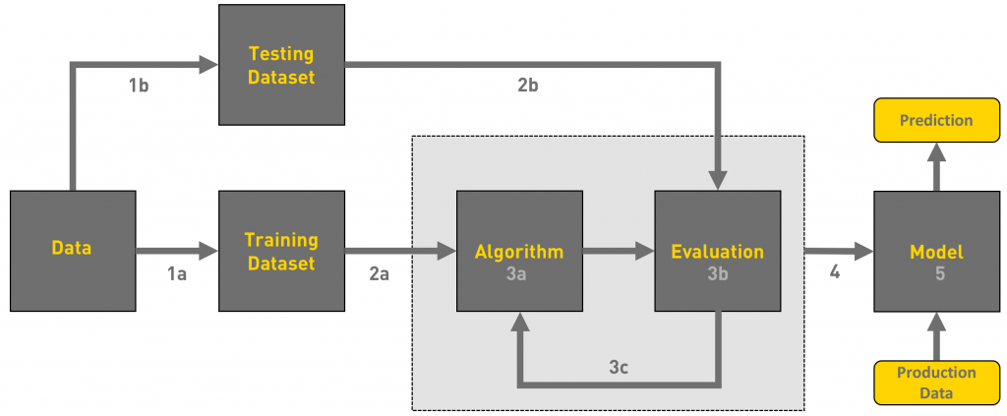

**3.2  Hardware / Software designing**

* Strategy: matching the problem with the solution.
* Dataset preparation and preprocessing. Data collection. Data visualization. Labeling. Data selection. Data preprocessing. Data transformation.
* Dataset splitting into train data and test data.
* Modeling. Model training. Model evaluation and testing. Improving predictions with ensemble methods.
* Model deployment.

**4 EXPERIMENTAL INVESTIGATIONS**

During our investigation, we found a dataset with we need for our model and depending upon the performance of model we have choosen the best model with good accuracy.

**5 FLOWCHART**

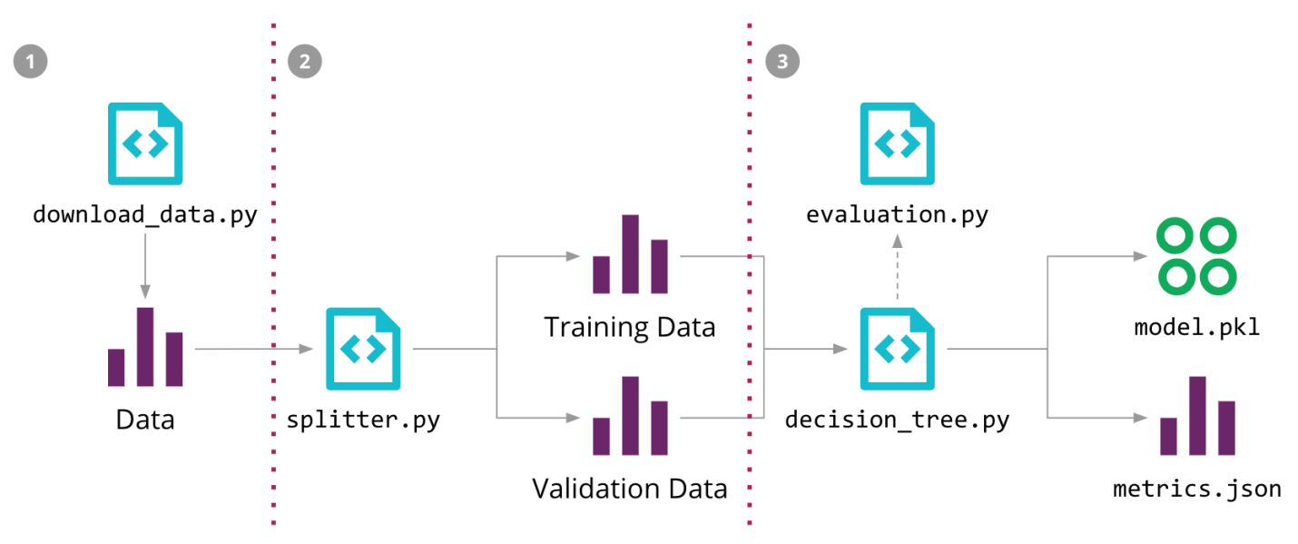

**6 RESULT**

Based on all the inputs entered by the user, the model predicts the helth performance of the user which have three different kinds of outputs depending on his/her health condition.

**7 ADVANTAGES & DISADVANTAGES**

Advantages:

* It gives very accurate output for users input as the accuracy of model is 96 percent.
* It has a very user friendly interface.
* And the results can be easily understood by the users.

Disadvantages:

* The model at present have only few parameters and it could be much more efficient if there could be more input parameters.

**8 APPLICATIONS**

It can be used to check the health condition of a performance sitting at his own place.

**9 CONCLUSION**

As we know health is wealth . In a nut shell with this application we can predict the health sttsus of a person with much good accuracy.

**10 FUTURE SCOPE**

In future this can be developed in such a way that it can give certain precautions to user depending upon his/her health status and with more input parameters.

**11 BIBILOGRAPHY APPENDIX**

Model Building & Application Building

[Click here](https://github.com/SmartPracticeschool/llSPS-INT-177-Health-Monitoring-using-Machine-Learning/tree/master) to get into our Git repository