PROJECT REPORT --INTELLIGENT CUSTOMER HELP DESK
WITH SMART DOCUMENT UNDERSTANDING

INTRODUCTION

OVERVIEW
Conversations play an important role in everyday life. Conversation can be general which are used to generate fun or they can be used to solve queries. For any conversation in general at least two people are required.Conversation can also occur between a computer and a human. Such conversations can be achieved through chatbots.

What is a Chatbot?
Chatbot is made up of two words “Chat” representing conversation and “Bot” representing a robot. Hence a chatbot is enabling conversations with a robot.
■ Generally speaking a bot is any software that performs an automated task, however, weare interested in the class of bots that live online in chat platforms or on social mediacalled chatbots.
■ The most intuitive definition is that a bot is software that can have a conversation with ahuman. For example, a user could ask the bot a question or give it an instruction and thebot could respond or perform an action as appropriate.

PURPOSE
Chatbot applications streamline interactions between people and services, enhancing customerexperience. At the same time, they offer companies new opportunities to improve the customerengagement process and operational efficiency by reducing the typical cost of customer service.To be successful, a chatbot solution should be able to effectively perform both of these tasks.

LITERATURE SURVEY

Existing Problem

The typical customer care chatbot can answer simple questions, such as store locations and hours, directions, and maybe even making appointments. When a question falls outside of the scope of the pre-determined question set, the option is typically to tell the customer the question isn’t valid or offer to speak to a real person.This human intervention should be reduced by making the assisstant more capable of guiding the user by refering the appropriate section in the manual which is stored in the backend.
Proposed Solution
In this project, there will be another option. If the customer question is about the operation of a device, the application shall pass the question onto Watson Discovery Service, which has been pre-loaded with the device’s owners manual. So now, instead of “Would you like to speak to a customer representative?” we can return relevant sections of the owners manual to help solve our customers’ problems.
To take it a step further, the project shall use the Smart Document Understanding feature of Watson Discovery to train it on what text in the owners manual is important and what is not. This will improve the answers returned from the queries.
THEORETICAL ANALYSIS
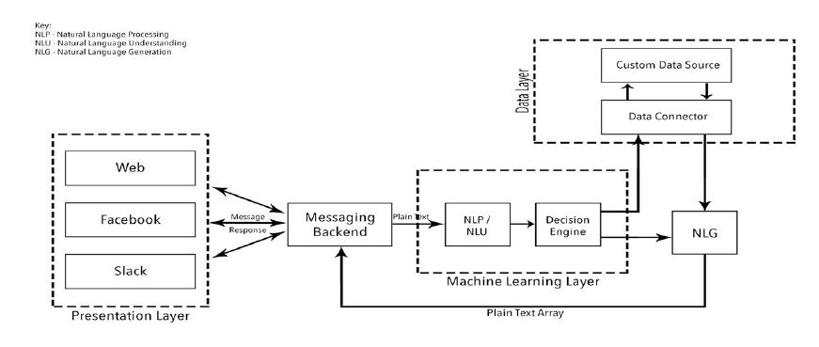
BLOCK DIAGRAM
SOFTWARE DESIGNING
Create a customer care dialog skill in Watson Assistant
Use Smart Document Understanding to build an enhanced Watson Discovery collection
Create an IBM Cloud Functions web action that allows Watson Assistant to post queries to Watson Discovery
Build a web application with integration to all these services & deploy the same on IBM Cloud Platform

EXPERIMENTAL INVESTIGATIONS
IBM Watson Assistant is trained on the entities and intents created by the developer.Whenever the backend data dialog node is triggered with user query,IBM Watson Assisstant uses cloud functions to connect to IBM Watson discovery service which is already trained with the user manual which is used to answer the customers’ queries.
The web app utilizes multiple Watson services to create a better customer care experience.
Using the Watson Discovery Smart Document Understanding (SDU) feature, we will enhance the Discovery model so that queries will be better focused to only search the most relevant information found in a typical owner's manual.
Using Watson Assistant, we will use a standard customer care dialog to handle a typical conversation between a custmomer and a company representitive. When a customer question involves operation of a product, the Assistant dialog will communicate with the Discovery service using a webhook.
SDU trains Watson Discovery to extract custom fields in your documents. Customizing how your documents are indexed into Discovery will improve the answers returned from queries.
With SDU, you annotate fields within your documents to train custom conversion models. As you annotate, Watson is learning and will start predicting annotations. SDU models can also be exported and used on other collections.
A webhook is a mechanism that allows you to call out to an external program based on something happening in your program. When used in a Watson Assistant dialog skill, a webhook is triggered when the Assistant processes a node that has a webhook enabled. The webhook collects data that you specify or that you collect from the user during the conversation and save in context variables, and sends the data to the Webhook request URL as an HTTP POST request. The URL that receives the webhook is the listener. It performs a predefined action using the information that is provided by the webhook as specified in the webhook definition, and can optionally return a response.

In our example, the webhook will communicate with an IBM Cloud Functions web action, which is connected to the Watson Discovery service.

FLOWCHART
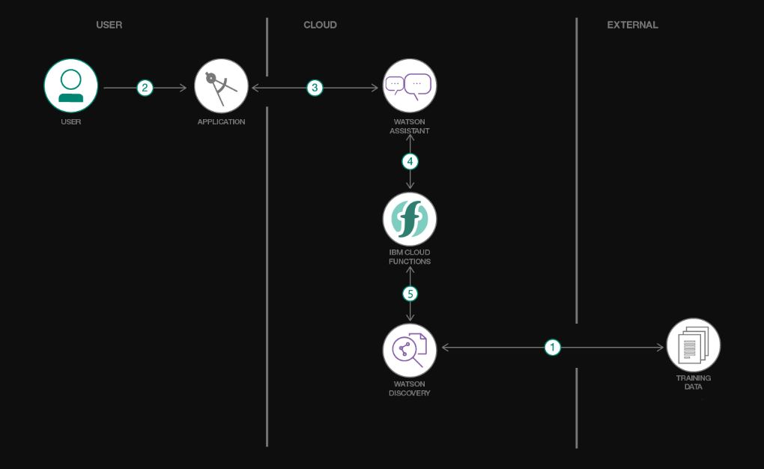

RESULT
The chatbot is able to respond to general greetings,simple queries like location and hours of operation of the store,directions and even making appointments on a given time slot.
The customer also query the assisstant about the tasks that can be done by it.General greetings are replied with appropriate greetings based on time.
Other queries such as location,hours of operation can also be fetched from the assisstant.
When a query about products are made it refers the manual which is used to train the watson discovery service and fetches the most appropriate result in the manual and returns it to assistant which in turn displays it to the customer.
The chatbot also provides an option to talk to a real customer representative if in case it could not understand the query of the customer.

ADVANTAGES AND DISADVANTAGES
Advantages:
- Keeping up with the trends:Being present on messaging platforms
- Improved customer service
- Extensing Customer Assistance
- Always available customer support
- Proactive customer interaction
- Monitoring consumer data and gaining insights
- Better lead generation,qualification and nurturing
- Easier approach to global markets
- Cost savings
- Multiple Customer Handling
Demerits:
- Lack emotions
- Made to handle first level questions only
- Requires maintenance
- Zero decision-making
- You need to train them to converse with your customers in the right way.
- You also need to structure and optimize your knowledge base in a bot-friendly way

APPLICATIONS
- Content delivery
- Order food
- Book flights
- Market research
- Russian technology company Endurance developed its companion chatbot for Senior People and Patients with Alzheimer’s Disease
- Transportation
- Healthcare
- E-commerce

CONCLUSION
From my perspective, chatbots or smart assistants with artificial intelligence are dramatically changing businesses. There is a wide range of chatbot building platforms that are available for various enterprises, such as e-commerce, retail, banking, leisure, travel, healthcare, and so on.
Chatbots can reach out to a large audience on messaging apps and be more effective than humans. They may develop into a capable information-gathering tool in the near future.
FUTURE SCOPE
The chatbot can be integrated with several messaging apps such as facebook,slack.There can also be stand alone integrations with webchat,voice telephony.The chatbot can also deal with images such as menu card of restaurant.The code for it is already been configured in the nodeflow.But we are not dealing with the images present in user manual of this project.It can also be integrated with databases(db2) to store the credentials of customers using it. For example, in case of appointments,the customer data is made to flow to backend where details is stored according to the schema of the database.The stored data can also be used for market research and with suitable tools and techniques,insights can also be derived from the stored data.In this project, the query and reply from assistant is replaced everytime when a new query arrives.This can be improved with a continuous chat flow as in other chat applications so that the information asked in previous query if forgotten need not be asked again as simple scrolling will fetch the results.

BIBLIOGRAPHY
https://cloud.ibm.com/docs/overview?topic=overview-whatis-platform
https://www.ibm.com/cloud/get-started
https://developer.ibm.com/tutorials/how-to-create-a-node-red-starter-application/
https://www.w3schools.com/howto/howto_make_a_website.asp
https://www.youtube.com/watch?v=hitUOFNne14
https://www.youtube.com/embed/5z3i5IsBVnk
https://developer.ibm.com/articles/introduction-watson-discovery/
https://www.youtube.com/embed/Jpr3wVH3FVA
https://www.youtube.com/embed/G3bqRndQtQg
https://developer.ibm.com/patterns/enhance-customer-help-desk-with-smart-document-understanding/

APPENDIX
Source code:
https://github.com/SmartPracticeschool/llSPS-INT-1843-Intelligent-Customer-Help-Desk-with-Smart-Document-Understanding.git
Youtube link:
https://youtu.be/eqwgBZ3xDjE
Testimonials:
https://youtu.be/iYAwFo8f-v8

