Yashasya Shah

!80770116107@socet.edu.in

Abstract

This AI based chatbot is made to solve the problem of the solve the problems of companies who aren’t being able to maintain a customer care for their customer. It uses NLP which provides Customer a feeling of Frictionless Conversation

**Intelligent Customer Help Desk with Smart Document Understanding**

**1 INTRODUCTION**

1.1 Overview

1.2 Purpose

**2 LITERATURE SURVEY**

2.1 Existing problem

2.2 Proposed solution

**3 THEORITICAL ANALYSIS**

3.1 Block diagram

3.2 Software designing

**4 EXPERIMENTAL INVESTIGATIONS**

**5 FLOWCHART**

**6 RESULT**

**7 ADVANTAGES & DISADVANTAGES**

**8 APPLICATIONS**

**9 CONCLUSION**

**10 FUTURE SCOPE**

**`11 BIBILOGRAPHY**

**1 INTRODUCTION**

**1.1 Overview**

In this project I am planning to build a Customer care Chatbot which is an Intelligent Customer Help Desk with Smart Document Understanding which will receives questions from Users, tries to understand the question and provide appropriate answer.

 It can answer simple questions such as store locations and hours, directions, and maybe even make appointments.

 If the question is outside of the predetermined set of questions it will suggests you to speak to a real question. Moreover, if the question is about the operation of a device then the Chatbot will return the relevant sections of the owner’s manual to help solve our customers’ problems.

**1.2 Purpose**

The purpose of this project is to showcase the power of Chatbot and how they can be an alternative to using an application or even a website. The Chatbot should be easy to use, respond in a timely fashion and be all round user friendly. The bots should make the users interaction as easy and fast as possible to ensure that the users time is not wasted and that they get what they want without any difficulty or misunderstanding from the bot. The conversation should flow and always keep the user in control of the conversation. Users should always have a feeling that they have been in a conversation with a real person.

The main aim of this AI based Chatbot is to use the great empowering service provided by IBM cloud which is Watson discovery which save the time of the programmer to program every single question and answer in the Chatbot. Users should come away from their experience with the Chatbot and think that it was a fun, easy to use and straightforward interaction that would encourage them to come back without any hesitation

**2 LITERATURE SURVEY**

**2.1 Existing problem**

There are basically 3 main problems that existed before this project

**1) No 24/7 Customer Care Facility:**

Despite a lot of efforts companies were unable to provide a 24/7 customer care because for that they have to hire a lot of staff in multiple shift which is not cost efficient

**2) Delayed responses:**

One of the problem with customer care is that many times it takes way much longer for the customer care to solve the query and it irritates the customer

**3) Unable to provide frictionless support:**

The main problem with the normal Chatbot is that they don’t provide user with the feeling of talking to a real customer care. They have a set of predefined questions and they can provide solution to only those problems

**2.2 Proposed solution**

**1) 24/7 Customer Care Facility:**

One of the major advantages of using an AI Chatbot is that it provides you with an 24/7 usage facility with low cost and less maintenance

**2)Quick responses:**

One big problem related to customer care is solved as the AI based Chatbot can provide the functionality of faster and efficient responses to the customer. We have used Watson Discovery to provide the maximum support to the customer.

**3) Provides Frictionless Support:**

Many time it happens that customer get annoyed from the Chatbot because of the limited reach of Normal Chatbot but our AI based Chatbot will understand the question and gives the customer the response according to the feeling of the question. The customer will feel as if he is talking to a real customer care person

**3 THEORITICAL ANALYSIS**

3.1 Block diagram

User Input

Entity Recognition

Intent Classification

Entities

Intent

Response from Watson Discovery

Response from Watson Assistant

Candidate Response Generator

Response Selector

Response

**3.2 Software designing**

**Designing the Watson Assistant:**

There are basically 3 section to design in a chatbot:

1. Intents
2. Entities
3. Dialogues

In the Intents I have developed 6 Intents which will help me in categorising the question generated from the user. These intents include greeting, goodbyes, inquiry of product, shop location, branch, and shop timings

There is only one entity in my chatbot which is names as location which helps me categories the location of the store

In the dialog section I have created different dialogs which will respond to the questions based on the classification done on the basis of entities and Intents

**Designing the Node Red:**

Before designing the node red we need to have API keys from Watson Discovery and Watson assistant and then after integrating it in the node red I have created the following design

**4 EXPERIMENTAL INVESTIGATION**

Implementation was the hardest part of this project. I was working with Watson services that I never used before and was still in development. It took me a lot of trial and error and a lot of reading to really understand Watson cloud services. Once I had a bot set up and ready to be worked on one of the hardest things I found was trying to control the dialogs, meaning that when I started to further develop the bots to be multifunctional, I ran into difficulties with that. Working on a bot that one main function was fairly easy once I knew what I had to do. As soon as more functionality was added some issues started to arise. Some of the issues included bots getting stuck on the same dialog, or sometimes even just getting into a loop of saying “Sorry I couldn’t understand you.” An example of this issue is that I could implement the FAQ part fine and that caused no issues but the bot would get confused when the user was looking for something other than the FAQ, even something as simple as saying “Hello” or “Goodbye” could sometimes cause the bot to get stuck and crash. To overcome this, I took the help of my fellow colleagues who were also making the Chatbots.

One more problem that arises during the implementation was Integrating the Watson discovery to the Watson Assistant. The main problem was to slice the necessary answer from the huge answer returned from the Watson discovery. To overcome it, I took help from the mentors from SmartBridge and it was done well

**5 FLOWCHART**

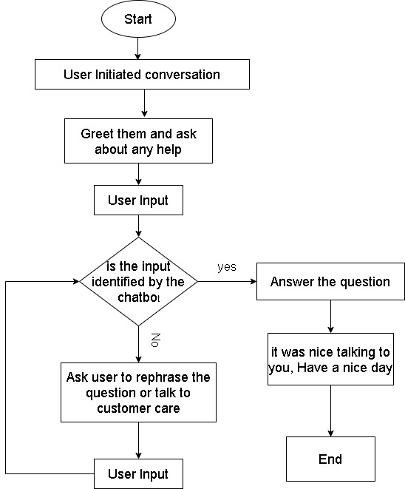

**6 RESULT**

* We have been able to successfully developed an AI Based Chatbot which Interacts with human and provides necessary responses. This Chatbot provides answers to basic question such as greeting, goodbyes and questions related to inquiry of store and products

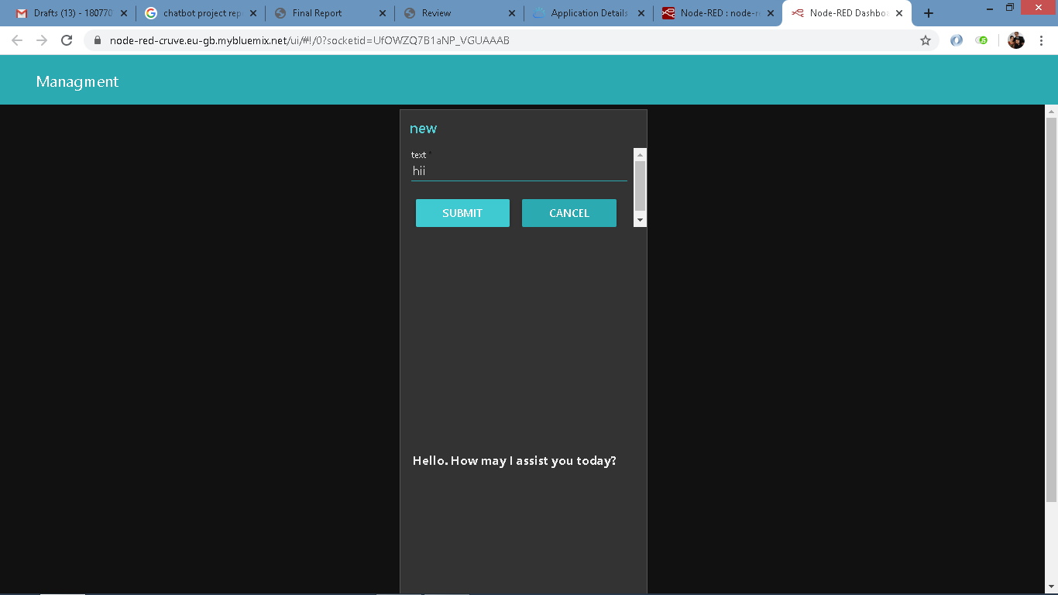

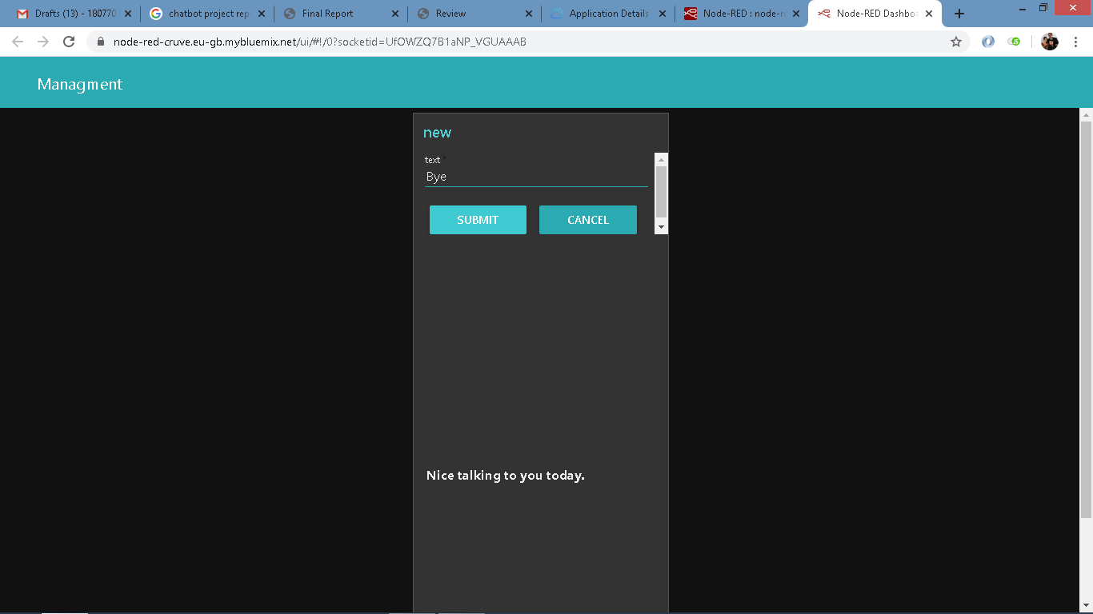

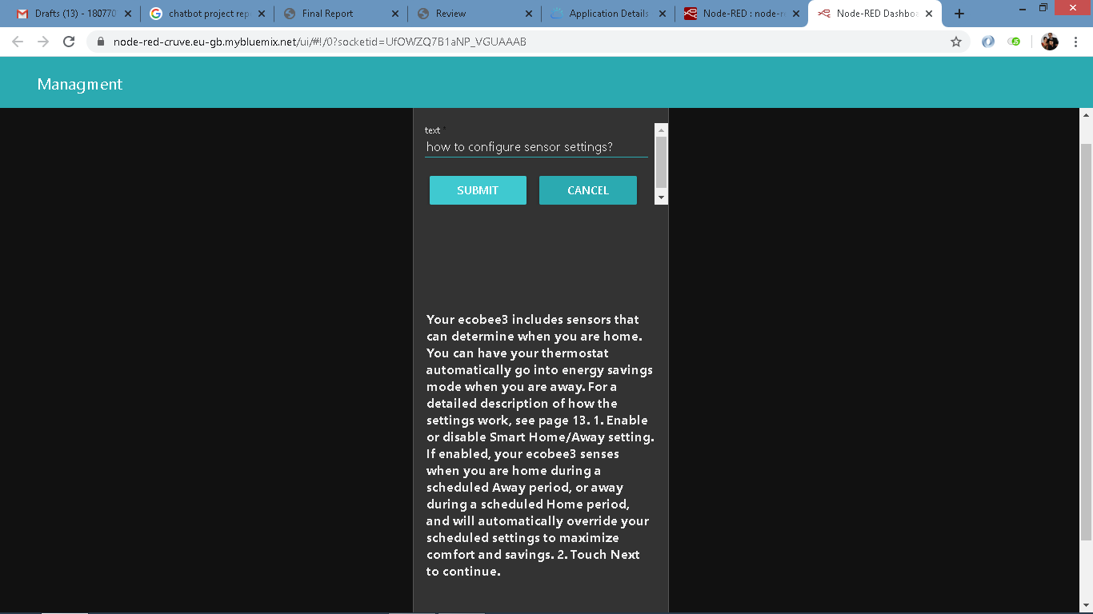 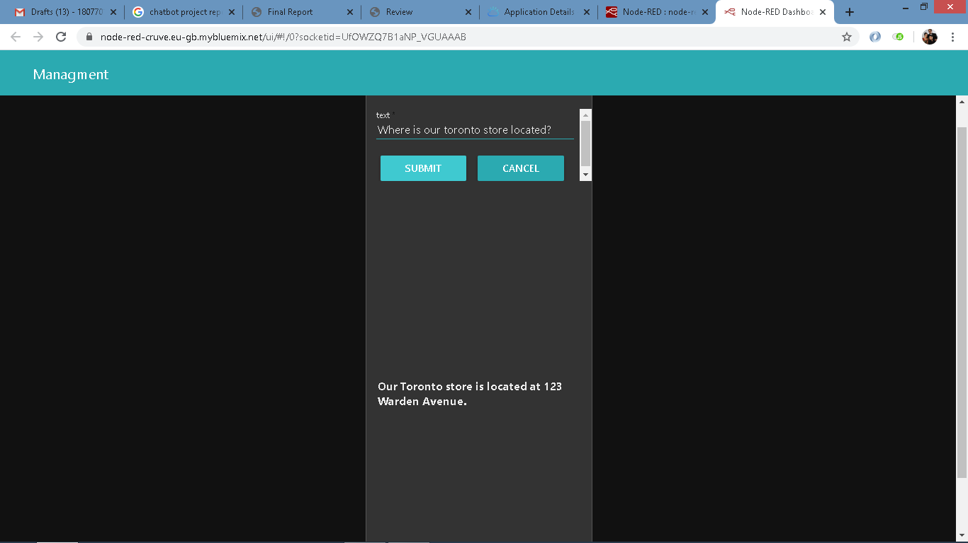

As you all can see our chatbot has provided accurate result for both common questions and enquiry question and it has been testified well.

**7 ADVANTAGES & DISADVANTAGES**

**Advantages**

* **Reduced costs:** Chatbots eliminate the need for labour during online interaction with customers. This is obviously a great advantage for companies that receive multiple queries at once. In addition to saving costs with them, companies can align the chatbot with their objectives, and use them as a means to enhance customer conversion.
* **24/7 Availability:** Unlike humans, once we install a chatbot, it can handle queries at any time of day. Thus, the customer does not have to wait for a commercial of the company to help him. This also allows companies to monitor customer « traffic » during non-working hours and contact them later.
* **Learning and updating:** AI-based chatbots are able to learn from interactions and update independently. This is one of the main advantages. When you hire a new employee, you have to train them continuously. However, AI chatbots do in on their own
* **Management of multiple clients:** Humans can serve a limited number of customers at the same time. This restriction does not exist for chatbots, and they can manage all the necessary queries simultaneously. This is one of the main advantages of using chatbot, as no customer is left unattended and you are solving different problems at the same time. There are chatbots companies already working on developing voice chatbot services.

**Disadvantages**

* **Complex interface:** It is often considered that chatbots are complicated and need a lot of time to understand what you want in customer. Sometimes, it can also annoy the client about their slowness, or their difficulty in filtering responses.
* **They don’t get you right:** Fixed chatbots can get stuck easily. If a query doesn’t relate to something you’ve previously « taught » it, you won’t understand it. This can lead to a frustrated customer and the loss of the sale. Other times they do understand you, but they need double (or triple) as many messages as one person, which spoils the user experience.
* **Time-consuming:** Chatbots are installed with the aim of speeding up responses and improving customer interaction. However, due to the limited availability of data and the time needed for self-updating, this process can be slow and costly. Therefore, there are times when instead of serving several customers at once, chatbots may become confused and not serve the customer well.
* **Installation cost:** Chatbots are useful programs that help you save a lot of labour by ensuring availability at all times and serving several customers at once. But unlike humans, each chatbot needs to be programmed differently for each business, which increases the initial installation cost. Considering the last-minute changes that can always occur, this is a risky investment, as updating the program will generate additional costs.
* **Confusion in decision making:** Chatbots can make some really bad decision while choosing in intends and entities which can completely blunder a result

**8 APPLICATION**

The major application of an AI based chatbots are as follows

* Tasks like hiring a cab, ordering food online, or even checking the weather can be easily accomplished via chatbots. Similarly, businesses can make use of chatbots to manage inventory and purchase orders
* There is no doubt that the future of browsing is mobile; already the number of mobile users is higher than PC users. Using chatbots in mobile apps enables the creation of more streamlined user interfaces. It allows users to browse, evaluate, purchase, and get support from a single interface.
* Human beings have their limitations; an agent may be able to engage with a maximum of 3 customers at a time, whereas AI-based chatbots have no such limits. By fortifying your workforce with chatbots, you can interact with more users, helping you increase your customer base and even enter new markets.
* Customers who have completed a purchase are more likely to purchase again. Chatbots can interact with these customers and leverage the opportunity of upselling to them. Cart abandonment rate is high in e-commerce; email marketing has been marginally successful in getting people to go back to their carts and complete purchases. However, chatbots are capable of doing this job even better.
* Chatbots allow you to categorize your audience and provide different persons a customized experience. It's human nature that we feel pleased when we are recognized, and our preferences are remembered - just as when you walk into a restaurant and the waiter asks you ‘Your usual table? Chatbots can recommend products to you based on your purchase history. This is especially helpful when the product is something the customer would need to buy repeatedly - say pet food, or kitchen towels.

**9 CONCLUSION**

Thus we all conclude that chatbots are really powerful and have some great capabilities to replace humans. It was determined that chatbots perform at a very high standard and provide reliable and rapid responses to users compared to that of traditional methods. The average time spent interacting with the chatbot is very low as it provides an efficient way for users to manage their activity. The low interaction time reflects the high understanding and speech recognition rates, offered through the adoption of conversational user interfaces thus allowing users to freely interact with the chatbot to meet the demands of modern life. The chatbot has proven to fulfil the demand of users wanting instant access and availability information and services.

The user’s transactions could be analysed using NLP techniques to identify spending habits. Due to the increased development of the IOT, it would be good to branch out into this area as chatbots produce a mass amount of data which is needed for concepts such as IOT and Big Data to be successful which also go in hand with further advances in AI and Machine learning. The IOT could be implemented through the Google Home device.

**10 FUTURE SCOPE**

* We are planning that additional languages could be trained in order to cover a wider user base.
* More challenging user problems could be investigated. In particular, computer vision algorithms could be trained to extract information from photos users send of their ID cards, credit cards, etc...
* A different dynamic version of the chatbot could be designed. This variant would need to be more reactive than the variant presented in this document by displaying more small-talk capabilities and creating more direct and customised interactions with customers. This variant could then be deployed to Facebook and other instant messaging services that support the use of bots.
* From time to time, users have multiple problems that they would like to address in a single message. This changes the formulation of the intent classification problem into a multi-label classification problem. Different methods could be considered to address this issue.

**11 BIBILOGRAPHY**

## Udemy course AI Chatbots without programming: <https://courses.edx.org/courses/course-v1:IBM+CB0103EN+1T2020/course/>

# Udemy course Smarter Chatbots with Node-RED and Watson AI

<https://www.edx.org/course/smarter-chatbots-with-node-red-and-watson-ai>

# Udemy course AI Chatbots without Programming

<https://www.edx.org/course/AI-chatbots-without-programming>

Vignesh Jayapalan, H. (2016). Android — Baking a simple ChatBot in 30 minutes (AIML). [online] Medium. Available at: <https://medium.com/@harivigneshjayapalan/androidbaking-a-simple-chatbot-in-30-minutes-aiml-ff43c3269025#.q9zghn2tl>.

Wallace, R. (2016). AIML 2.0 Working Draft. [online] Docs.google.com. Available at: https://docs.google.com/document/d/1wNT25hJRyupcG51aO89UcQEiGHkXRXusukADpFnDs4/pub

AIML Tutorial. [online] Available at: <http://dev.tutorialspoint.com/aiml/index.html>