**Smartbridge**

**Internship Report**

**19/5/20-19/6/20**

**Topic:**

**Predicting Life expectancy using**

**Machine Learning**

**Report By:**

**Saurav Telge**

**Application ID : SPS_APL_20200003729**

|  |
| --- |
| **INTRODUCTION** |
| **Overview**  This project focuses on predicting the life expectancy of a country using the regression model of Machine Learning. The output of the project depends on various features related to life supporting factors. Life expectancy is a statistical measure of the average time a human being is expected to live, Life expectancy depends on various factors: Regional variations, Economic Circumstances, Sex Differences, Mental Illnesses, Physical Illnesses, Education, Year of their birth and other demographic factors. |
|  |

**Purpose**

Work on the data set provided, that is, training the model and testing it out to find the expected life, in general, of a country. The Project is performed on the IBM cloud service and the language used to code is Python / AutoAI.

**Literature Survey**

**Existing Problem**

The expected life value of the people residing in a country was very difficult to calculate in the earlier times due to lack of technology and data.

**Proposed Solution**

Through Machine Learning we can easily calculate the life expectancy in a country with respect to various factors such as year, GDP, education, alcohol intake of people in the country, expenditure on healthcare system and some specific disease related deaths that happened in the country.

**Theoritical Analysis**

3.1 **Block Diagram**

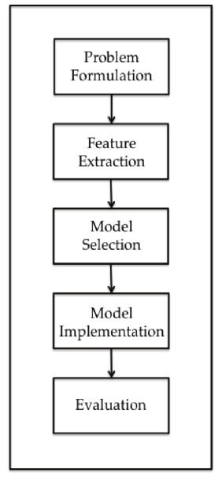

**Hardware/ Software Designing**

This project is worked upon on the online services available and using Python coding language.

Functional Requirements - Proper data set with sufficient amount of data, Coding   knowledge of Python, significant knowledge of graphs, algorithms and statistics.

Technical Requirements - A Laptop or a PC with a good internet connection.

Software Requirements - Python, IBM cloud, IBM Watson, Node- RED, GitHub,  Slack, zoho Writer, IBM Studio

**EXPERIMENTAL INVESTIGATIONS**

The Dataset required for training the model was taken from Kaggle.com. Various factors such as year, GDP, education, alcohol intake of people in the country, expenditure on healthcare system and some specific disease related deaths that happened in the country, were taken into account while calculating the expectancy.

**FLOWCHART**

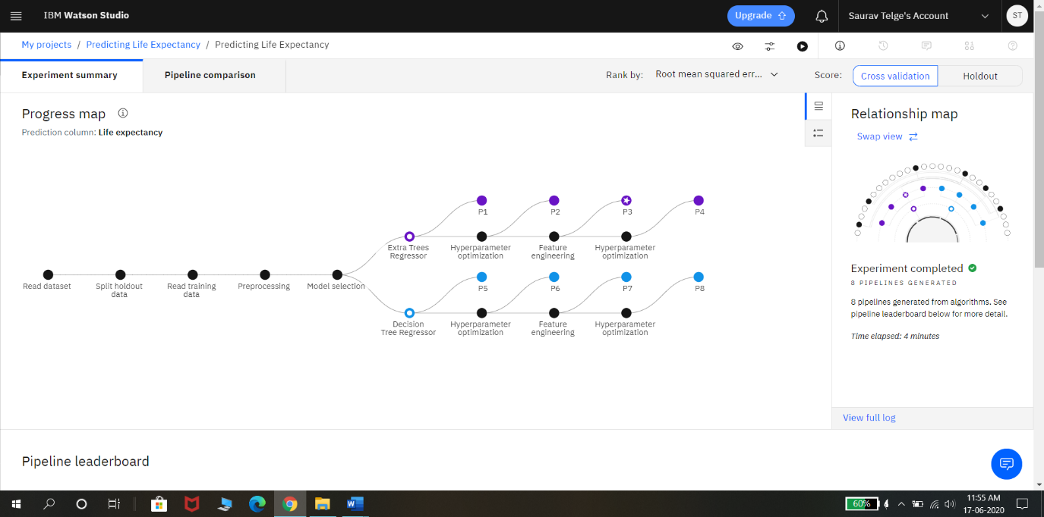

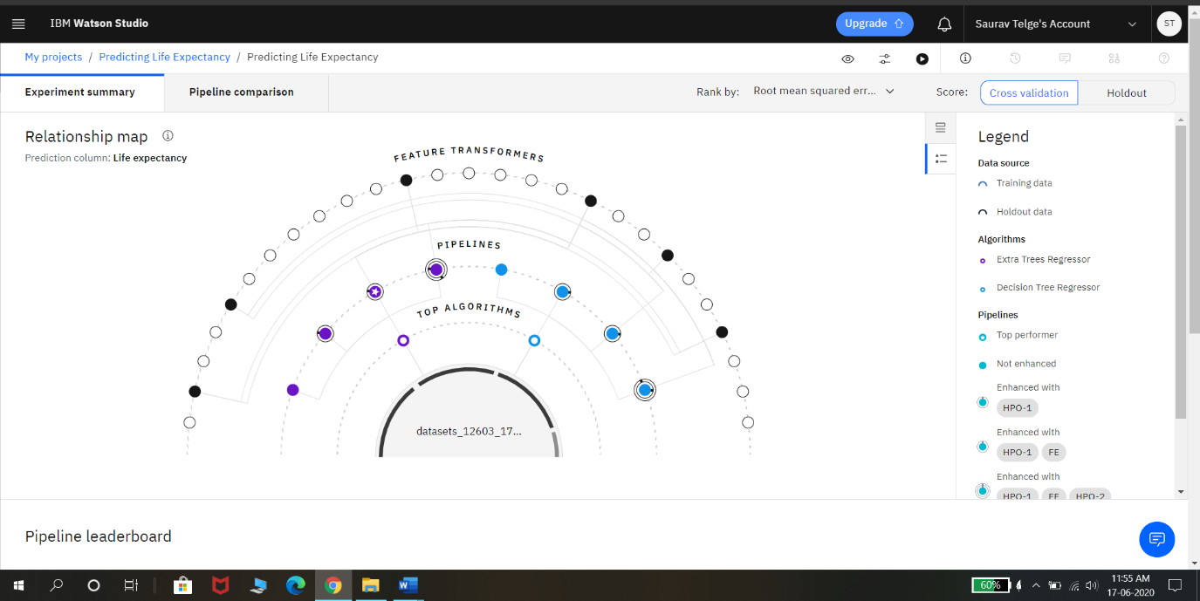

**RESULT**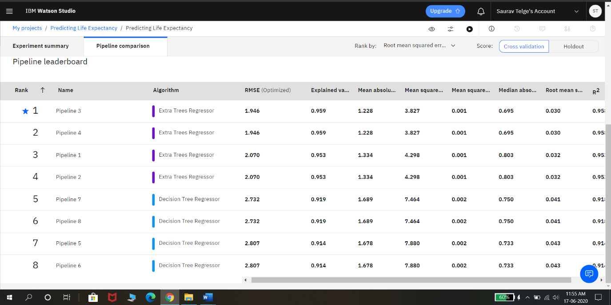

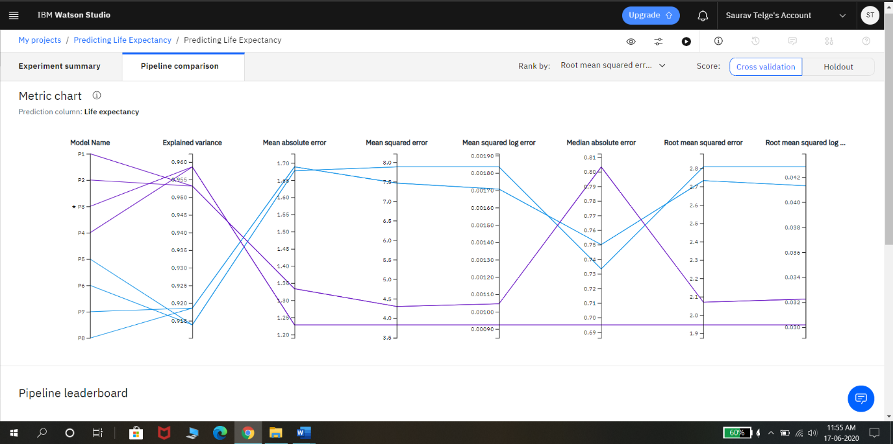

**ADVANTAGES & DISADVANTAGES**

**Advantages: -**

1. The use of extra trees regression model gives a very accurate result of life expectancy.
2. The time of calculation is very minimal.

**Disadvantages: -**

1. The life expectancy is calculated of a country and does not guarantee the expected life of an individual person.
2. The result could mislead if poor or wrong data is provided to the model.

**APPLICATIONS**

1. This data can be used for medical purposes.
2. The government can decide amend various policies according to the results.

**CONCLUSION**

Successful Prediction of the life expectancy through graphs and statistics using Machine Learning. The client would be able to analyze and understand the life expectancy in country with respect to various factors such as year, GDP, education, alcohol intake of people in the country, expenditure on healthcare system and some specific disease related deaths that happened in the country.

**FUTURE SCOPE**

More accurate prediction of the life expectancy which could be useful for all Government records and Laws.

**BIBLIOGRAPHY**

1. Wikipedia.com
2. Google.co.in
3. Coursera.com
4. Youtube.com
5. Stackoverflow.com

**APPENDIX**

<https://github.com/>

<https://www.youtube.com/watch?v=w3jLJU7DT5E&feature=youtu.be>

<https://www.youtube.com/watch?v=7YUTc4Cigc8&feature=youtu.be>

<https://www.zoho.com/writer/help/working-with-text.html>

<https://www.ibm.com/cloud/get-started>

<https://developer.ibm.com/tutorials/how-to-create-a-node-red-starter-application/>

<https://nodered.org/>

<https://github.com/watson-developer-cloud/node-red-labs>

<https://www.w3schools.com/howto/howto_make_a_website.asp>

<https://developer.ibm.com/technologies/machine-learning/series/learning-path-machine-learning-for-developers/>

<https://www.youtube.com/watch?v=NmdjtezQMSM>

<https://bookdown.org/caoying4work/watsonstudio-workshop/jn.html>

<https://developer.ibm.com/tutorials/watson-studio-auto-ai/>

<https://www.youtube.com/watch?v=DBRGlAHdj48&list=PLzpeuWUENMK2PYtasCaKK4bZjaYzhW23L>