**Introduction**

* Overview

Life Expectancy is a real world problem that solved using machine learning implementation that help to predict life expectancy based on the different attributes like  year, GDP, education, alcohol intake of people in the country, expenditure on healthcare system and some specific disease related deaths that happened in the country are given. For easy access and easy prediction for end user make a GUI.

* Purpose

Purpose of this system is automate the life expectancy prediction that help government and people or some other organization to take their decision.

**Literature Survey**

* Existing Problem

There was no any existing automated system available for life expectancy prediction. All the information take using some surveys and from some sources like government.

* Proposed Solution

We going to build solution to predict the life expectancy based on some factors for that end user need to just give the value for the all the factors and based on that the value of the life expectancy was predicted.

**Theoretical Analysis**

* Block diagram

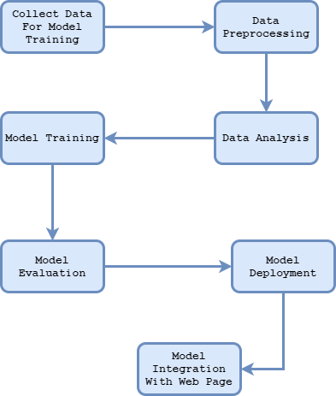

* Software Designing

In Below images show the design of web page that integrate with machine learning model.

* + Life Expectancy Prediction Using Python

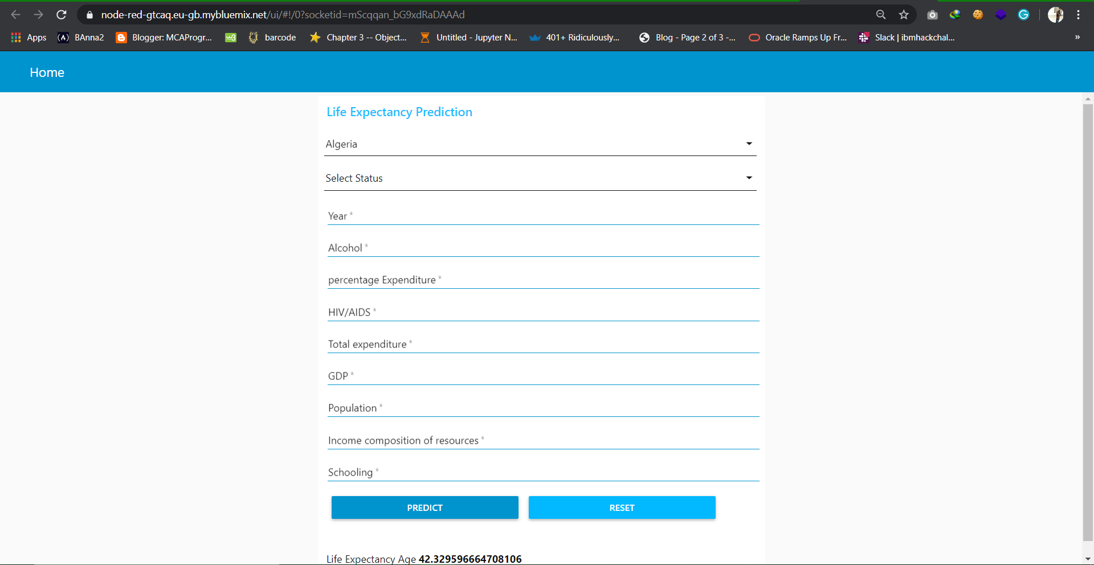

* + Life Expectancy Prediction Using AutoAI

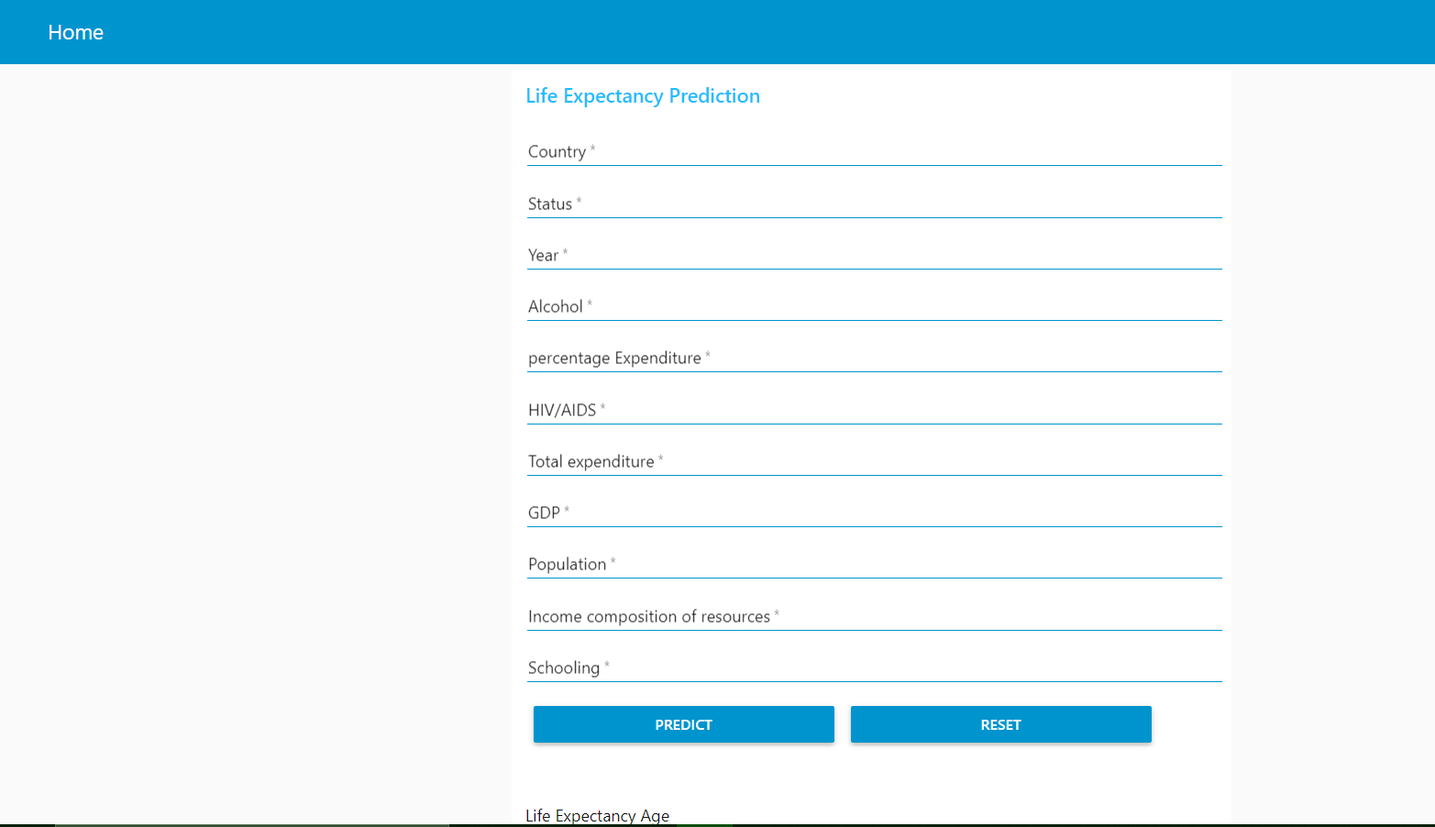

**Experimental Investigations**

**Flowcharts**

In below images show the flow of the node red.

* Life Expectancy Prediction Using Python

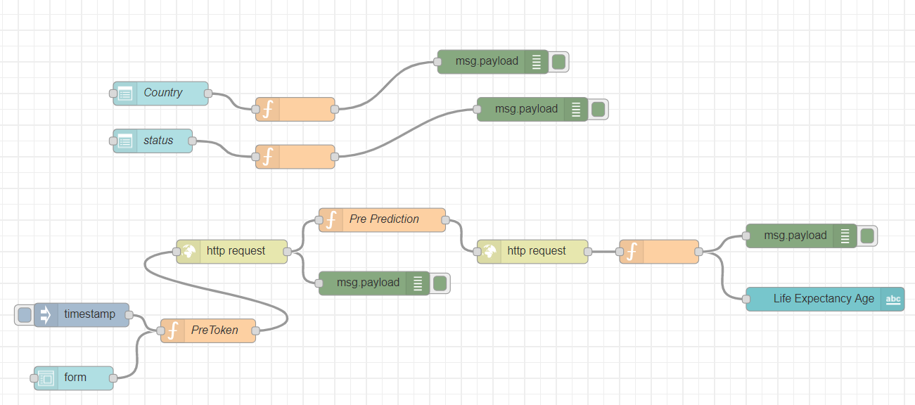

* Life Expectancy Prediction Using AutoAI

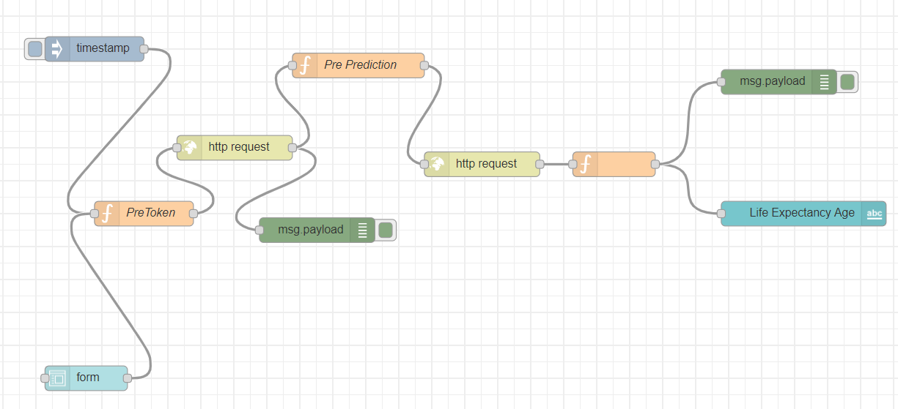

**Result**

From this system we get the prediction of life expectancy as result

**Advantages**

* This system help to predict the life expectancy no need to work manually for predict life expectancy
* This is efficient to predict life expectancy for many new data
* This system help to take some decision to organization and government to decide their policies based on life expectancy value

**Disadvantages**

* This require a proper input data otherwise generate some unexpected output
* In some cases accuracy of predication is very less

**Conclusion**

The goal of this system is to predict life expectancy and for that require some factor information based on that pre trained model help to predict the value. The accuracy prediction is near 93%. But this require correct information.

**Future Scope**

In future try to increase the accuracy of the prediction and also build an android application for Life expectancy prediction.

**Bibliography**

I used all the references provided by smartintenz platform to complete this task.

**Source code**

All source code and data set is at below given github link

<https://github.com/SmartPracticeschool/llSPS-INT-2057-Predicting-Life-Expectancy-using-Machine-Learning>