**Experimental Investigation (Step by step)**

1. Completed kick off document (* updated in zoho writer)

2. Prepared Project Scope Document with following headings (* updated in zoho writer)

Project Summary

Project Requirements

Functional Requirements

Technical Requirements

Software Requirements

Project Deliverables

Project Team

Project Schedule

3. Created GitHub account and successfully collaborated with Smart practice school.

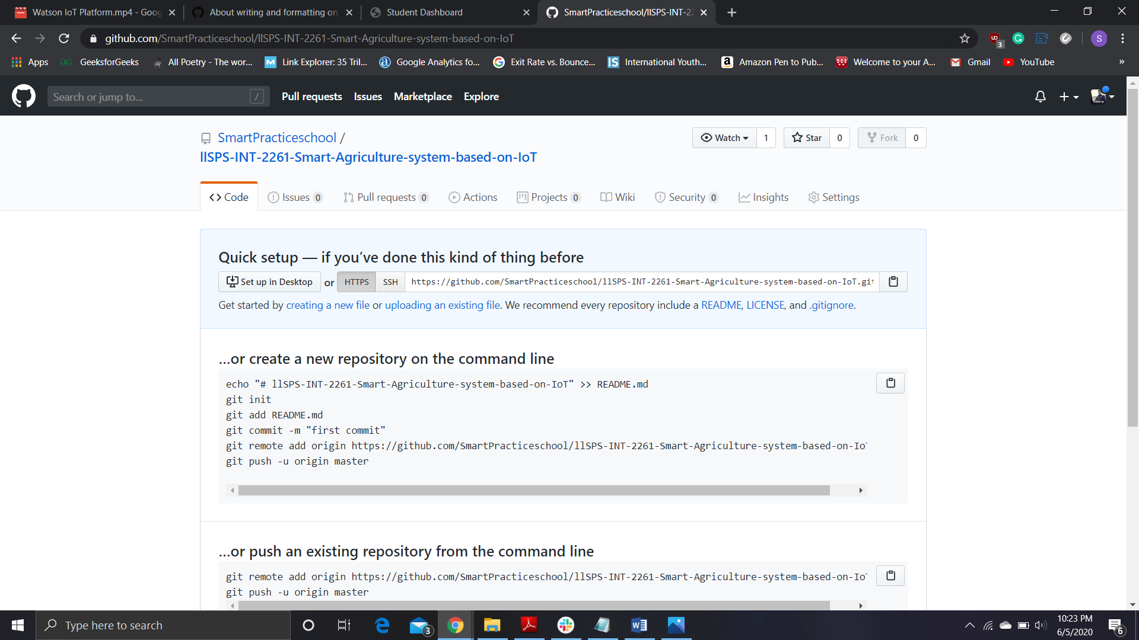

4. Created IBM Cloud account and signed up.

5. Installed Node-RED

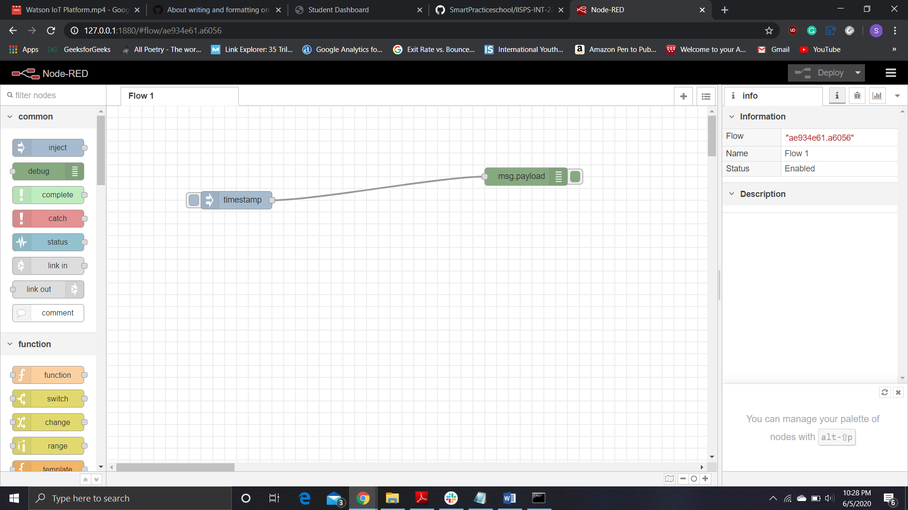

6. Opened Internet of Things service and launched IBM Watson.

7. Created a device in IBM Watson

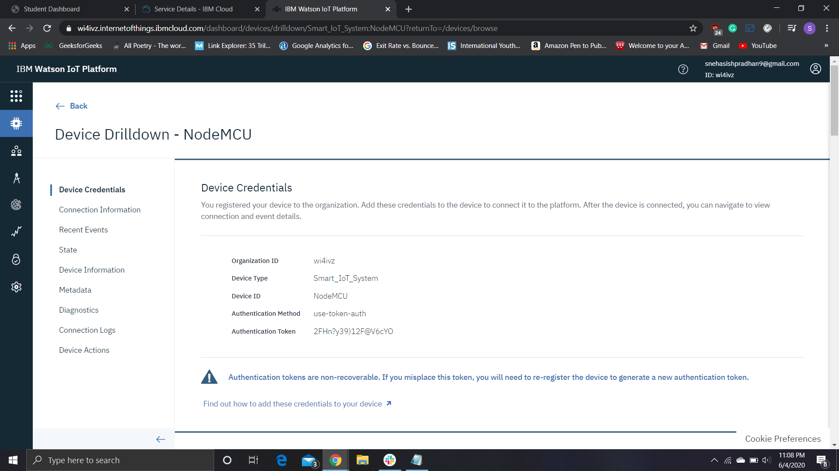

8. Installed Python 3 Idle.

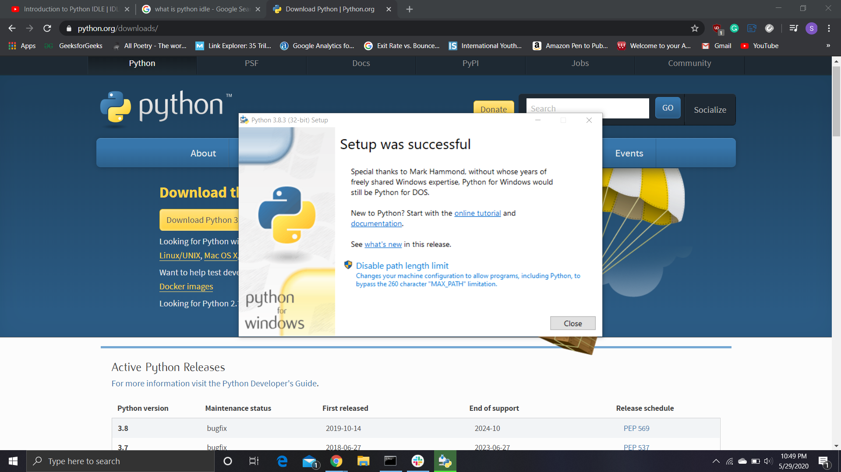

9. Generated API Key in IBM Watson IOT Platform.

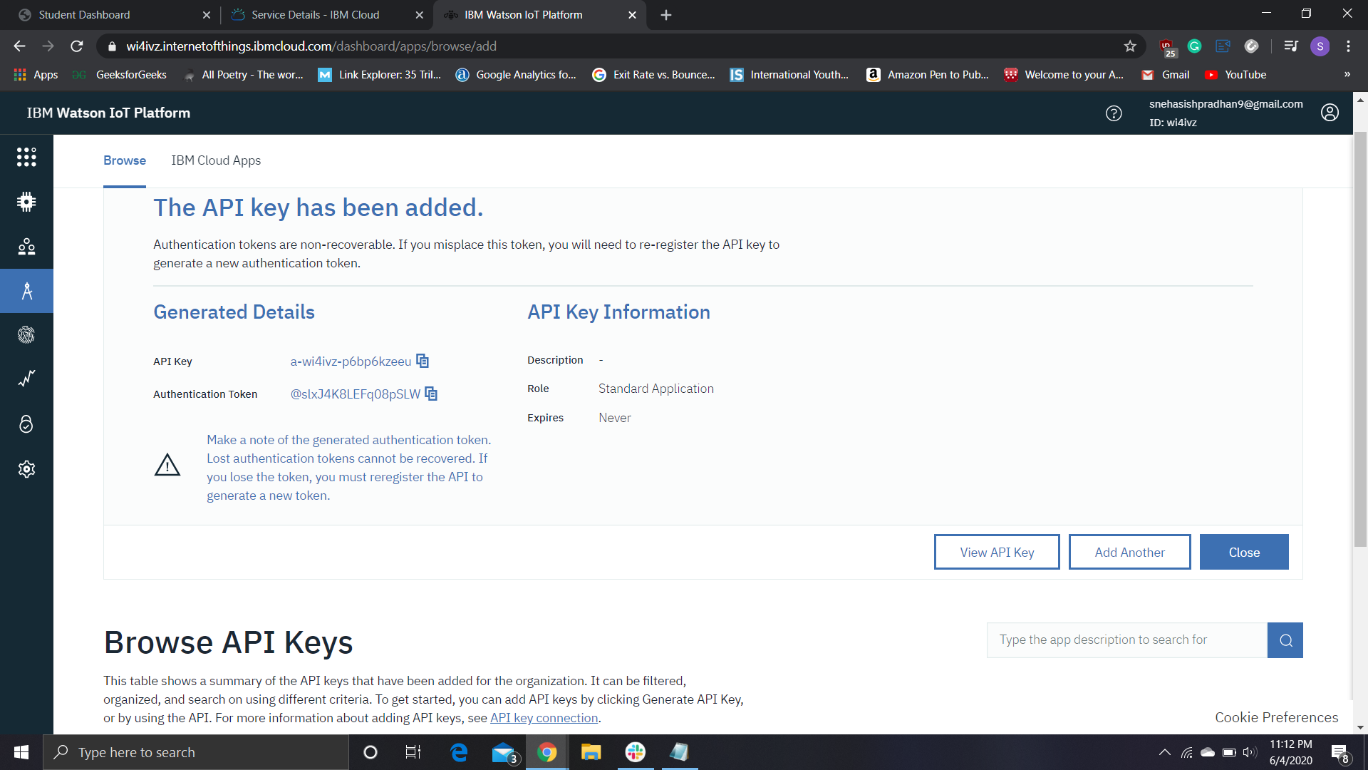

-> Keep all the details in the notepad for future use.

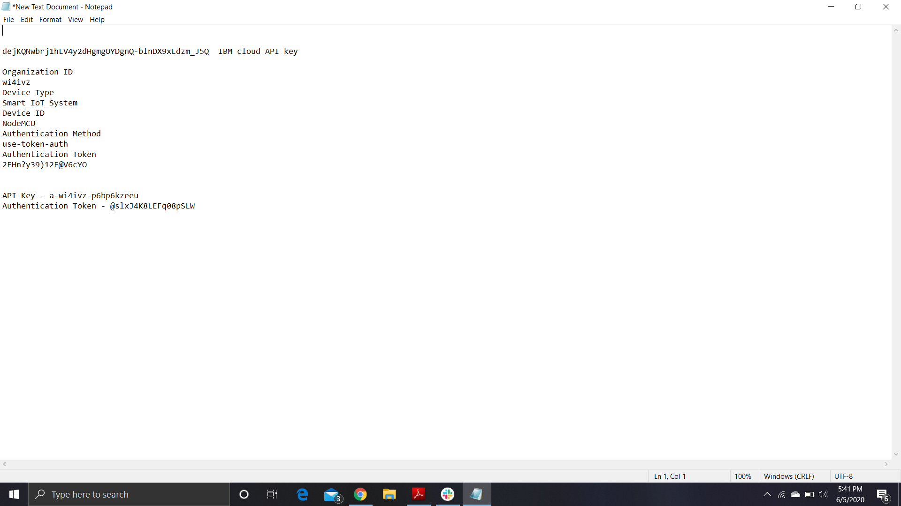

10. Simulated the device created by specifying event payload.

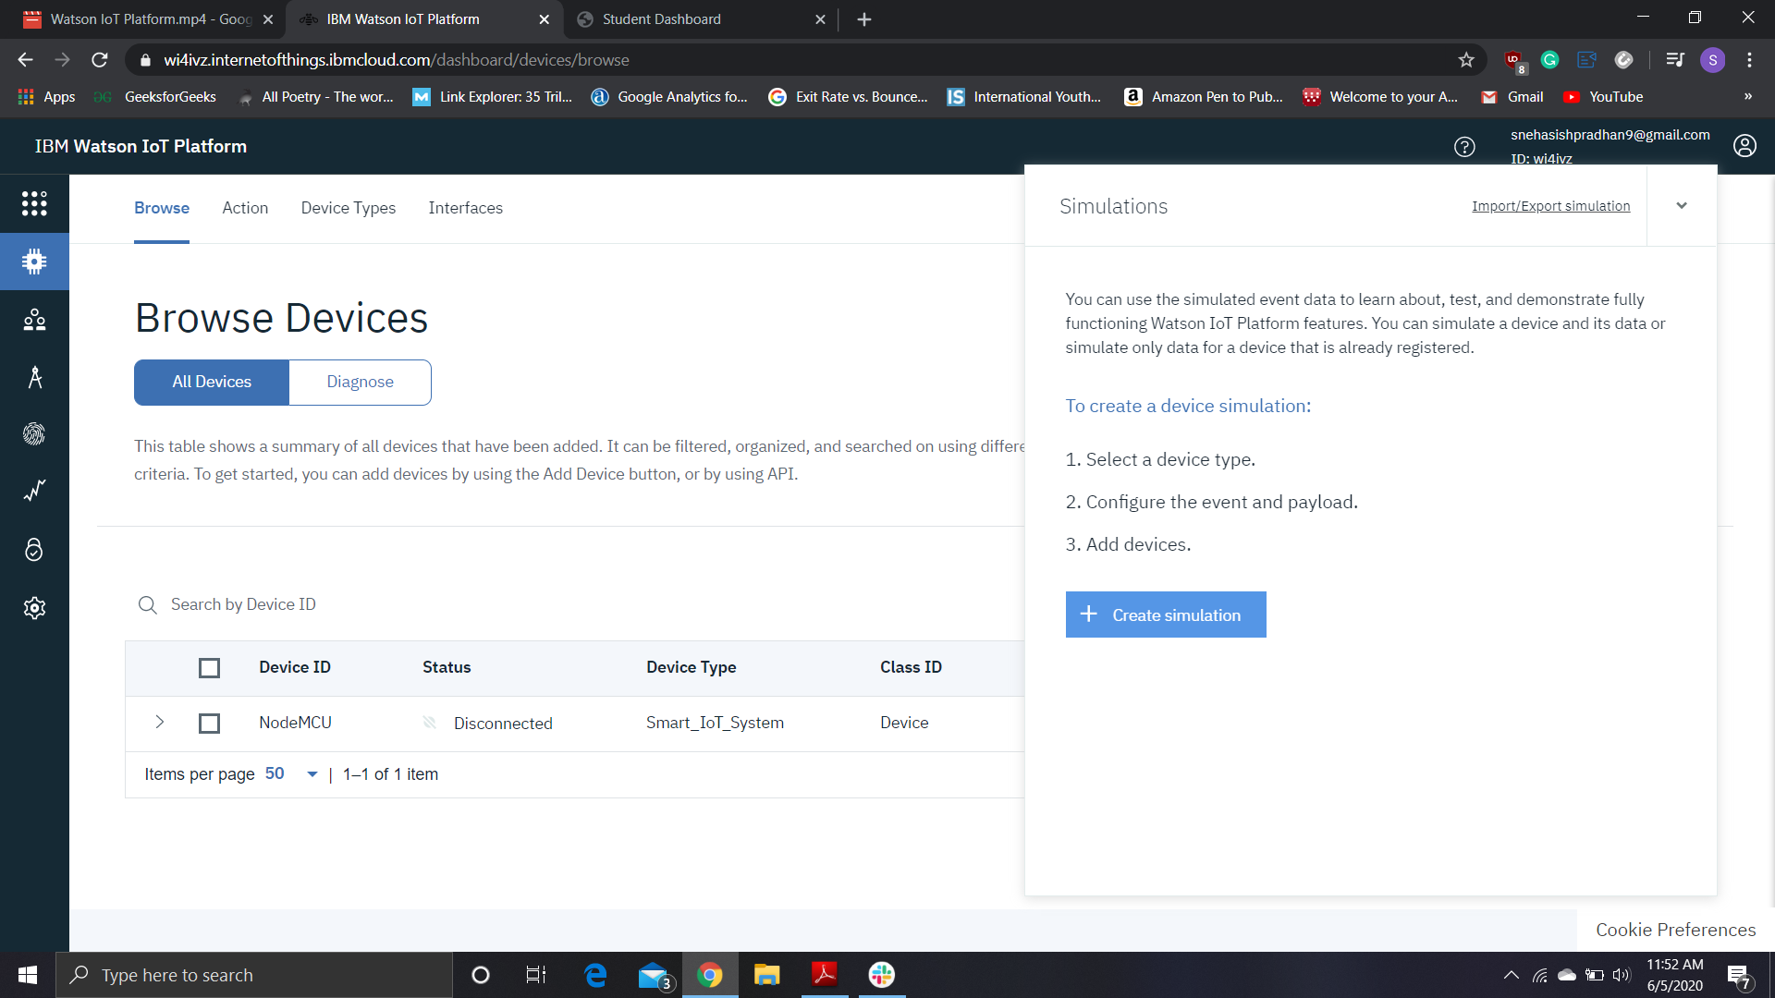

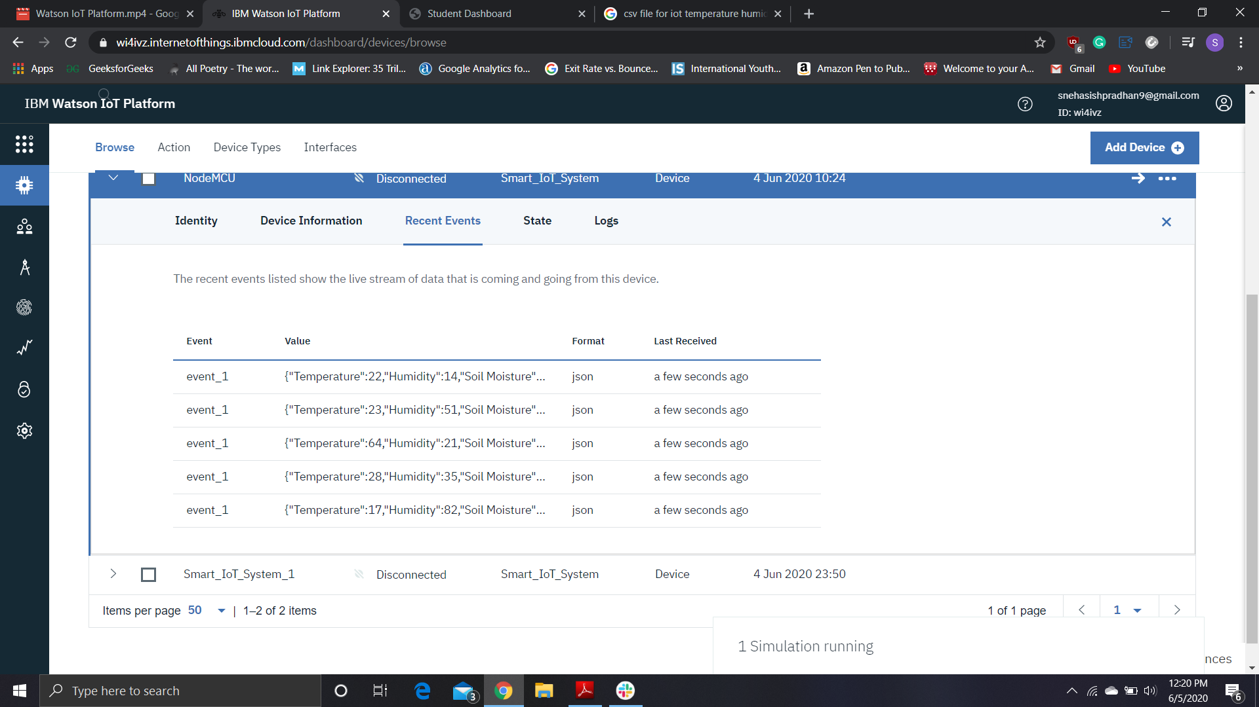

11. Created dashboards for visualizing charts for event_1 simulation.

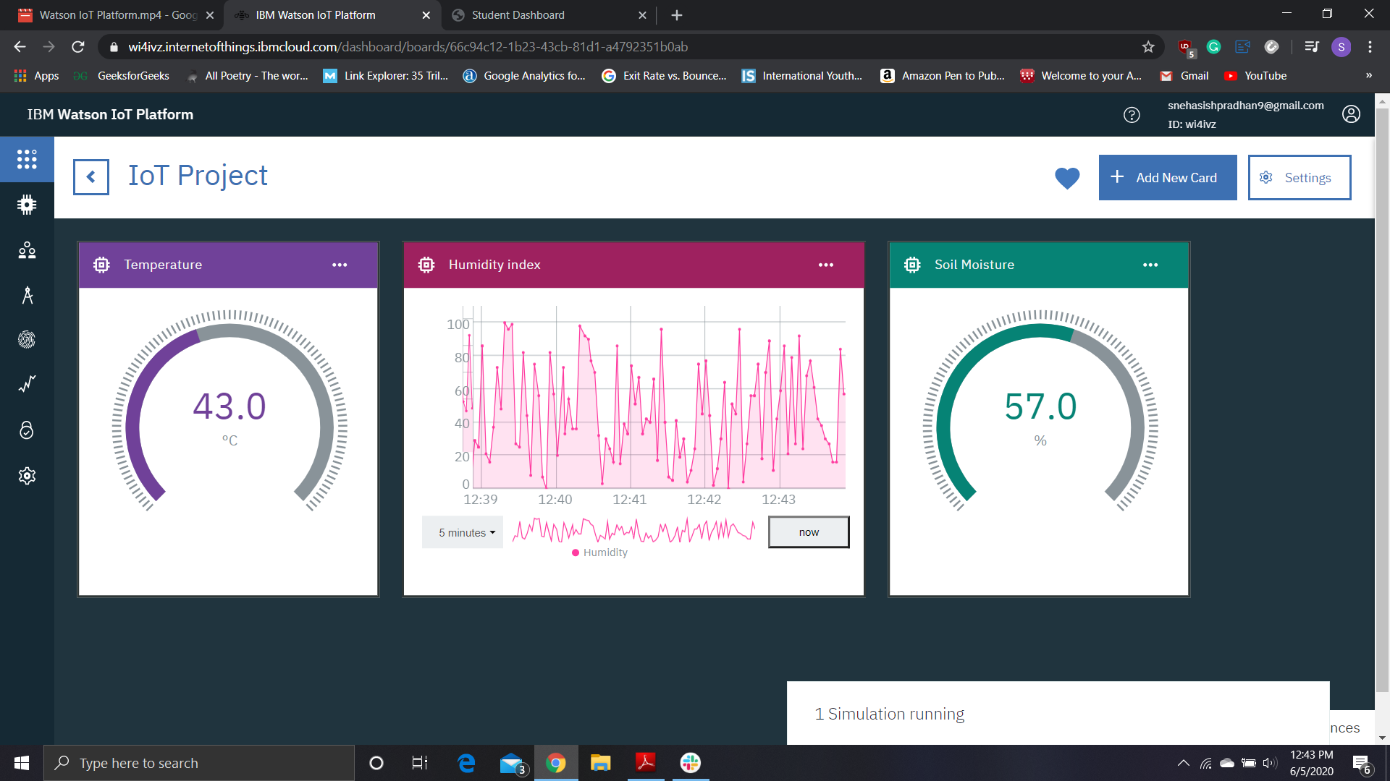

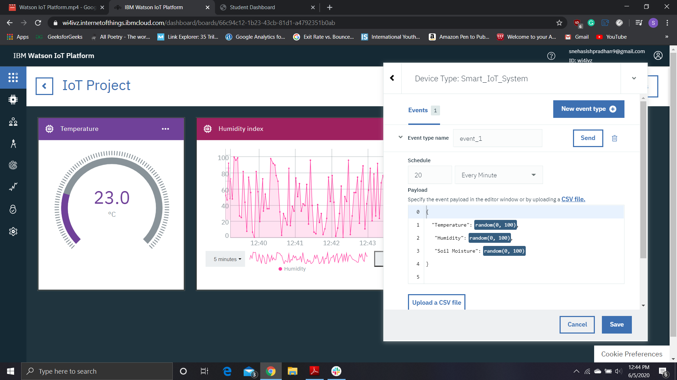

12. Opened IBM IoT sensor simulator and filled relevant credentials.

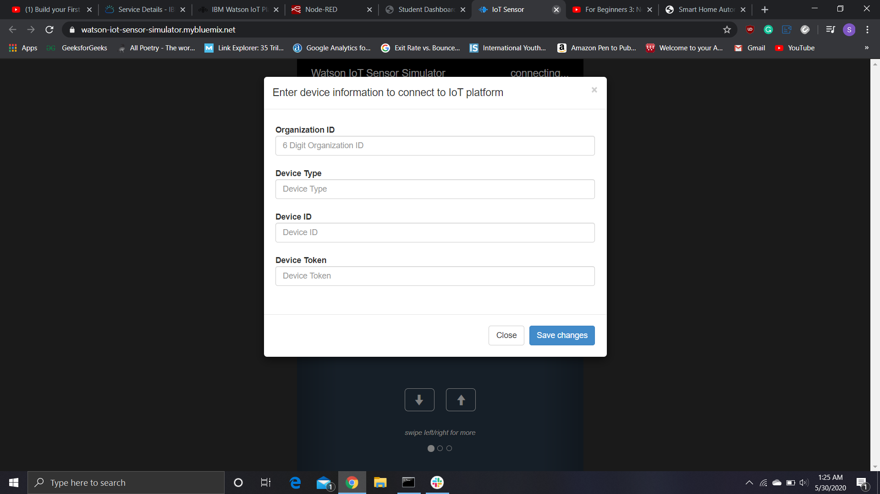

Successfully connected….

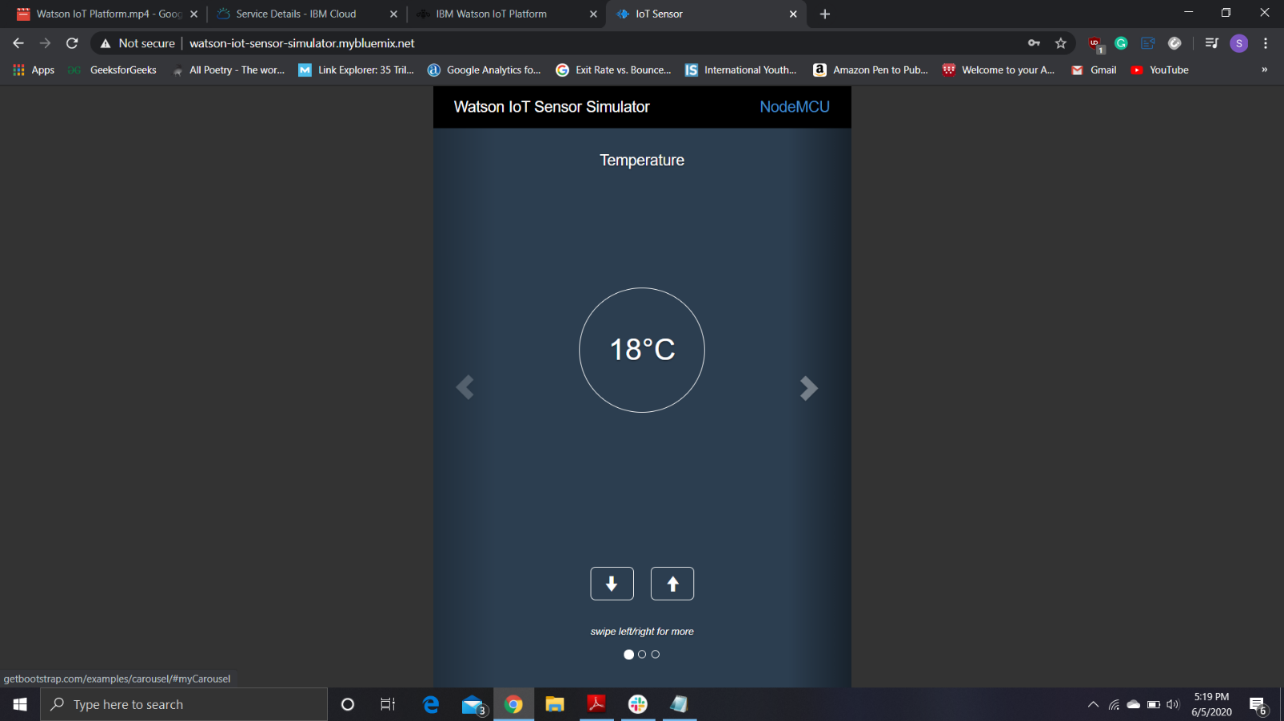

13. The status of the device is now showing connected and data is appearing under recent events.

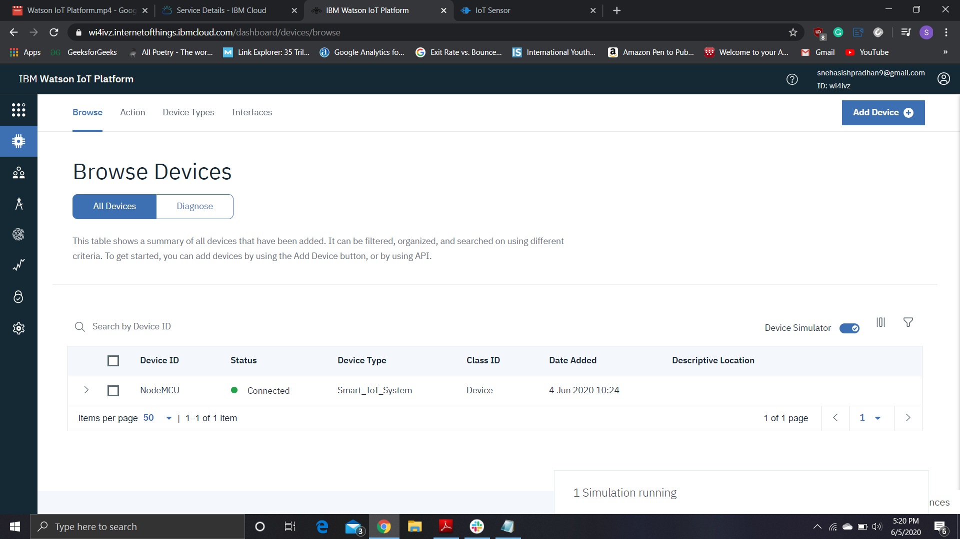

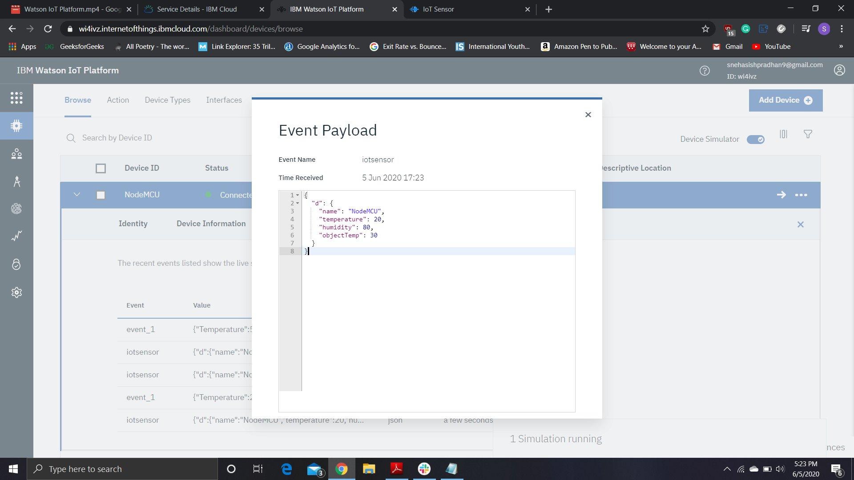

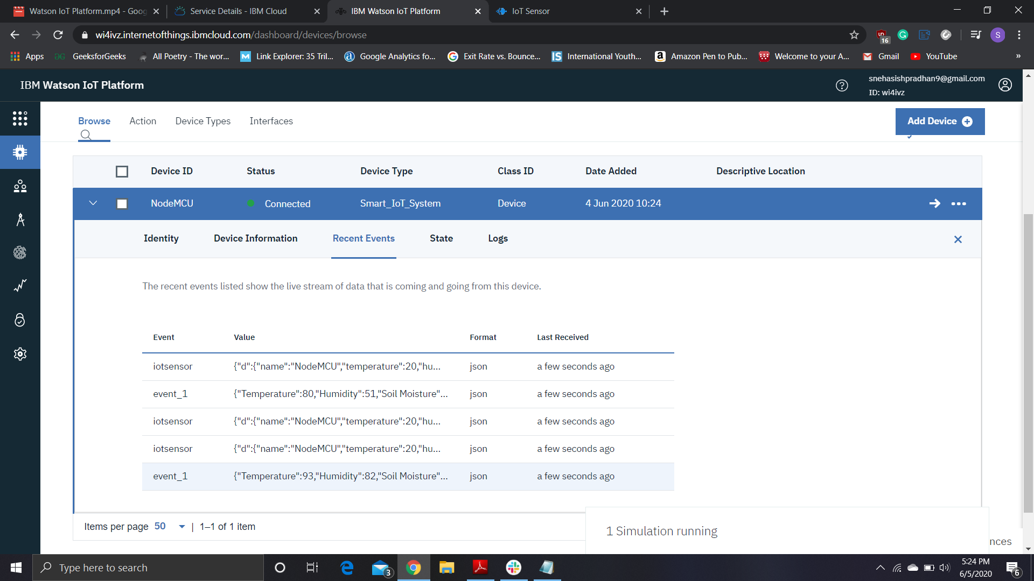

14. Created some more cards in the dashboard for IoT sensor simulator data.

