**A PROJECT REPORT ON**

## SMART AGRICULTURE SYSTEM BASED ON IoT

Carried out a part of internship during

**SUMMER 2020**

At



Submitted by

**-Arisetty Amruth**

**CONTENTS**

##### INTRODUCTION

* 1. Overview
  2. Purpose

##### LITERATURE SURVEY

* 1. Existing problem
  2. Limitations
  3. Proposed solution

##### THEORITICAL ANALYSIS

* 1. Block diagram
  2. Hardware / Software designing

##### EXPERIMENTAL INVESTIGATIONS

1. FLOWCHART
2. RESULT
3. ADVANTAGES & DISADVANTAGES
4. APPLICATIONS
5. CONCLUSION & FUTURE SCOPE APPENDIX

o Source code

# CHAPTER-1 INTRODUCTION

### OVERVIEW

Smart farming is a capital-intensive and hi-tech system of growing food cleanly and sustainable for the masses. It is the application of modern ICT (Information and Communication Technologies) into agriculture.

In IoT-based smart farming, a system is built for monitoring the crop field with the help of sensors (light, humidity, temperature, soil moisture, etc.) and automating the irrigation system. The farmers can monitor the field conditions from anywhere. IoT-based smart farming is highly efficient when compared with the conventional approach.

The applications of IoT-based smart farming not only target conventional, large farming operations, but could also be new levers to uplift other growing or common trends in agricultural like organic farming, family farming (complex or small spaces, particular cattle and/or cultures, preservation of particular or high-quality varieties, etc.), and enhance highly transparent farming.

In terms of environmental issues, IoT-based smart farming can provide great benefits including more efficient water usage, or optimization of inputs and treatments. Now, let’s discuss the major applications of IoT-based smart farming that are revolutionizing agriculture.

### PURPOSE

The Smart Agriculture System is a hi-tech and effective system of doing cultivation and growing food in a sustainable way. It majorly depends on IoT thus eliminating the need of physical work of farmers and growers and thus increasing the productivity in every possible manner. IoT based Smart Agriculture System improves the entire Agriculture system by monitoring the field in real-time. Several great uses for agriculture IoT in this space:

* + - Sensing for soil moisture and nutrients.
    - Controlling water usage for optimal plant growth.
    - Reporting weather conditions.

With the help of sensors and interconnectivity, the IoT in Agriculture has not only saved the time of the farmers but has also reduced the extravagant use of resources such as water and electricity. It keeps various factors like humidity, temperature, soil etc. under check and gives a crystal-clear real-time observation.

# CHAPTER-2 LITERATURE SURVEY

### EXISTING SYSTEM

#### S.Sivachandran, K.Balakrishnan, K.Navin, “Real- Time Embedded Based Soil Analyser”, International Research Journal of Engineering and Technology (IRJET). Volume: 3 Issue 3 | March 2014

In this paper, authors propose an embedded soil analyser with measures the pH value of the soil and based on this value gives measure of various soil nutrients. The system proposed here uses signal conditioning, display, microcontroller unit, sensors, power supply and thermal printer. This model helps in prediction of the soil sequence based on the availability of nutrients. Many techniques monitor various soil parameters and this paper points at soil fertility. The main aim of this model is to replace the conventional method of soil testing by automated soil testing. It automatically measures the major soil nutrients like potassium, phosphorus and nitrogen by calculating the pH value.

#### Chandan Kumar Sahu, Pramitee Behera, “A Low- Cost Smart Irrigation Control System”, IEEE sponsored 2nd International Conference on Electronics and Communication System (ICECS2015)

In this paper, the author proposes a model where the flow and direction of water is supervised and controlled. This is done with the help of DHTT11 and soil moisture sensor. This method also proposes a way to select the direction of water and this information is also sent to the phone and Gmail account of the farmer. This model also enables the farmer to switch on and off the motor with a single click. This paper proposes a prototype

where number of sensors are deployed at different positions in the field. This paper also shows how the proposed model makes the traditional irrigation system more effective and sustainable. This paper also suggests an efficient energy and network model. This paper presents a model that is energy efficient, sustainable, automated and cost effective.

#### Anand Nayyar, Er. Vikram Puri, “IoT Based Smart Sensors Agriculture Stick for Live Temperature and Moisture Monitoring using Arduino, Cloud Computing & Solar Technology” May 2015.

This paper presents an IoT based smart stick that enables live monitoring of the different agricultural parameters. This stick helps farmer acquire live data of temperature, soil moisture. The agricultural IoT stick gives the idea of plug and measures in which farmers can instantly enact smart monitoring system by positioning the stick in the field and obtaining live data feeds on different smart gadgets like smart tablets, phones etc. and the information which is produced through sensors could be simply analysed and processed by agricultural experts even in remote areas via cloud computing technologies.

### LIMITATIONS

A major drawback is that, the models proposed in above research papers are

* Cost ineffective.
* Quite complex
* Use of high technology.

The model proposed by us is way simpler as well as

affordable. It uses cheap yet effective technology and includes all the advantages of the models proposed above.

### PROPOSED SYSTEM

We propose the using evolving technology i.e., IOT for opting Smart Agricultural system. The highlighting feature of this project is that it measures different agricultural parameters effecting the yield and it also a GPS module to get the information about the location. Secondly, it sends all the information to the cloud where it can be further analysed. On top of that this project also contains an android mobile app providing an easy access of information to the farmer. This helps farmers in increasing the quantity as well as the quality of production, water conservation and many more.

# CHAPTER-3 THEORITICAL ANALYSIS

### BLOCK DIAGRAM

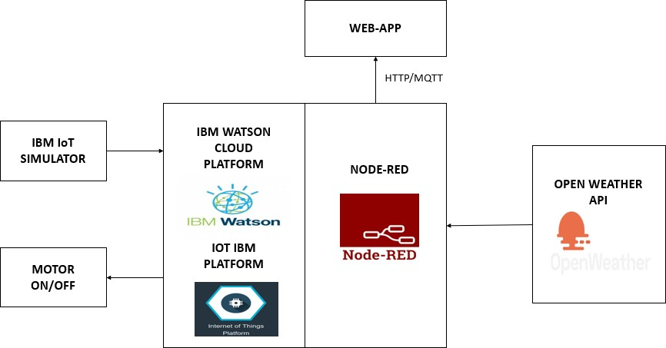

* 1. **HARDWARE/SOFTWARE DESIGNING**
     + Firstly, create a device in IBM Cloud.
     + Connect the device to IBM Simulator by giving device credentials to get the weather conditions.
     + Build a Node-RED flow to display the weather conditions and control the devices for displaying data in the web application.
     + Get the real time weather condition data from open weather API and integrate it in the Node-RED.
     + Control the working of the created web application to the devices by python coding.

**CHAPTER-4 EXPERIMENTAL INVESTIGATIONS**

##### Device Creation

IoT Device Simulator

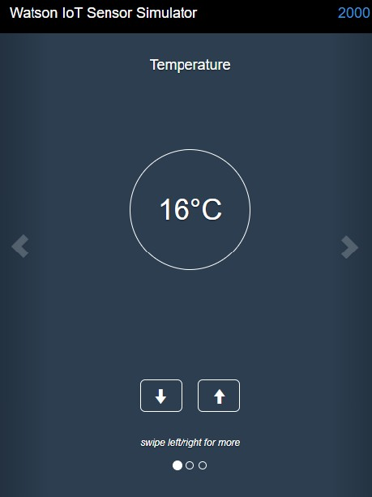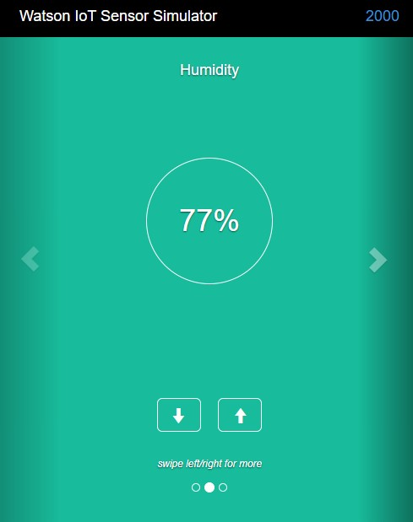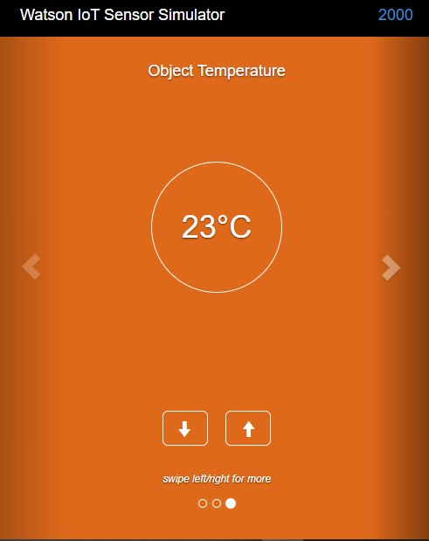

TEMPERATURE HUMIDITY OBJECT-TEMP

##### Open Weather Map

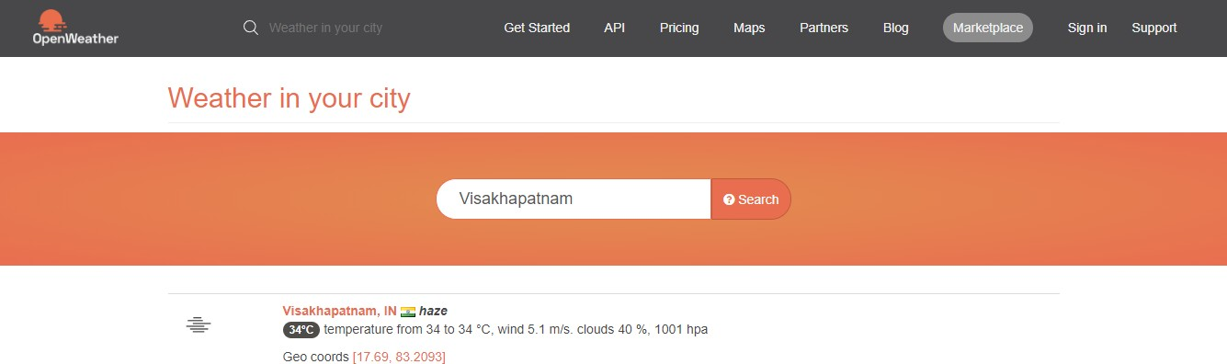

JSON data fetched from API

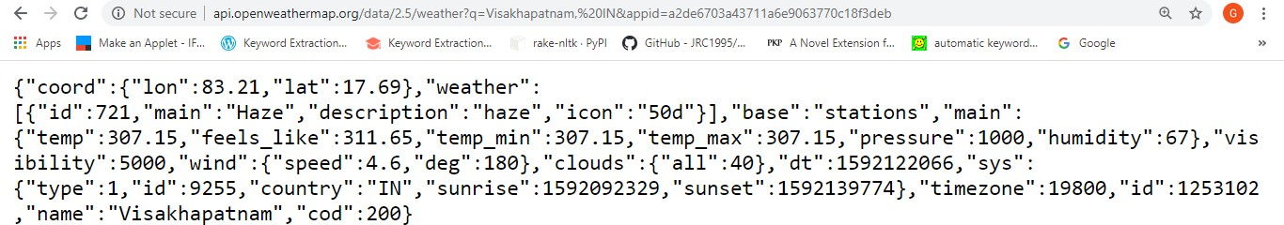

Node-RED HTTP Request

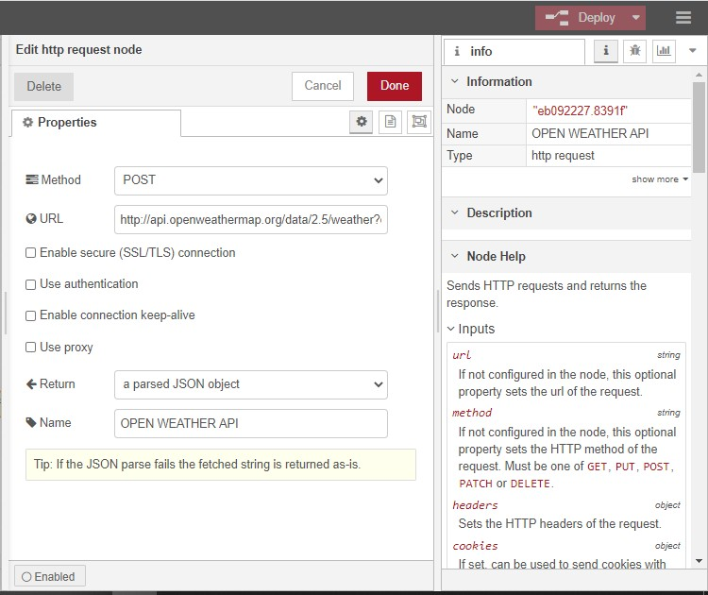

Node-RED UI

**CHAPTER-5 FLOW CHART**

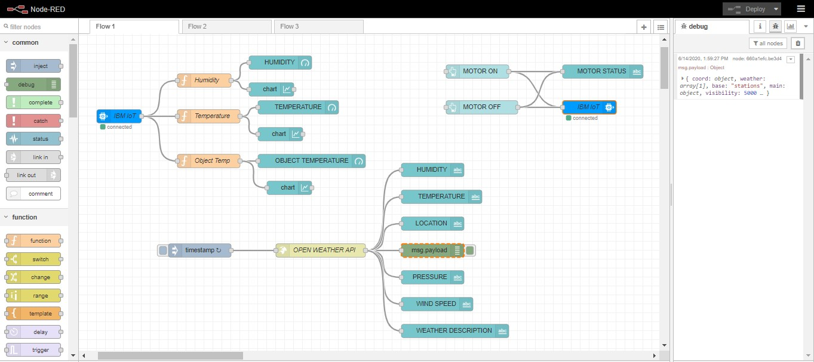

When running Node-Red in the IBM Cloud, there used to be "IBM IoT in" and "IBM IoT out" nodes which allowed to easily connect to the IBM Watson IoT platform.

**Nodes used in Web-App**

* + - IBM IoT -IN and OUT Nodes
    - Function Nodes
    - Debug Node
    - Gauge Nodes
    - Chart Nodes
    - Button Nodes
    - Timestamp Node
    - Text Nodes
    - Http request Node

## CHAPTER-6 RESULT

We have successfully built a web-based UI and integrated the services using Node-RED.

##### STATUS OF MOTOR

When Motor is ON

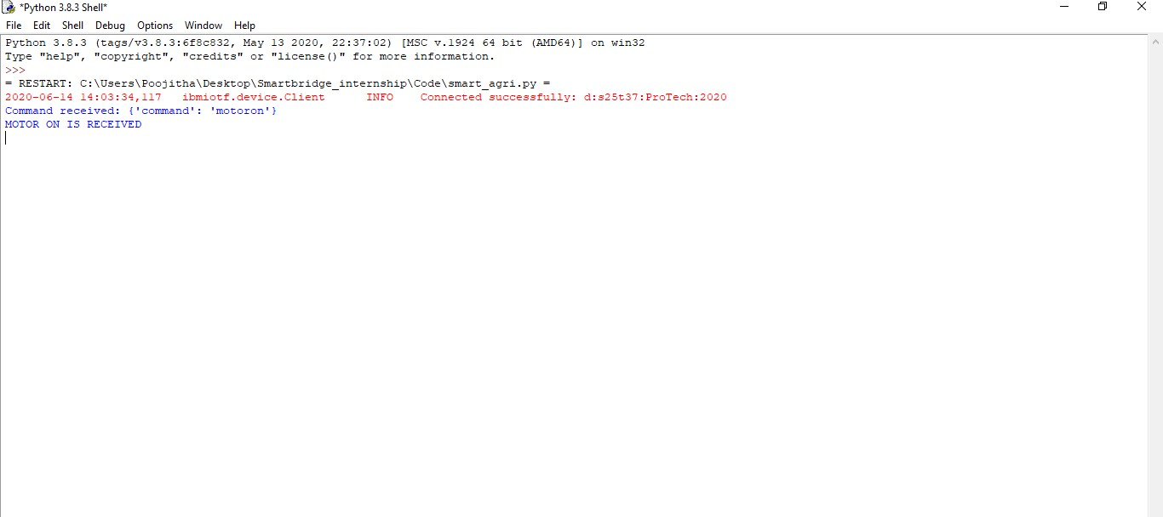

When Motor is OFF

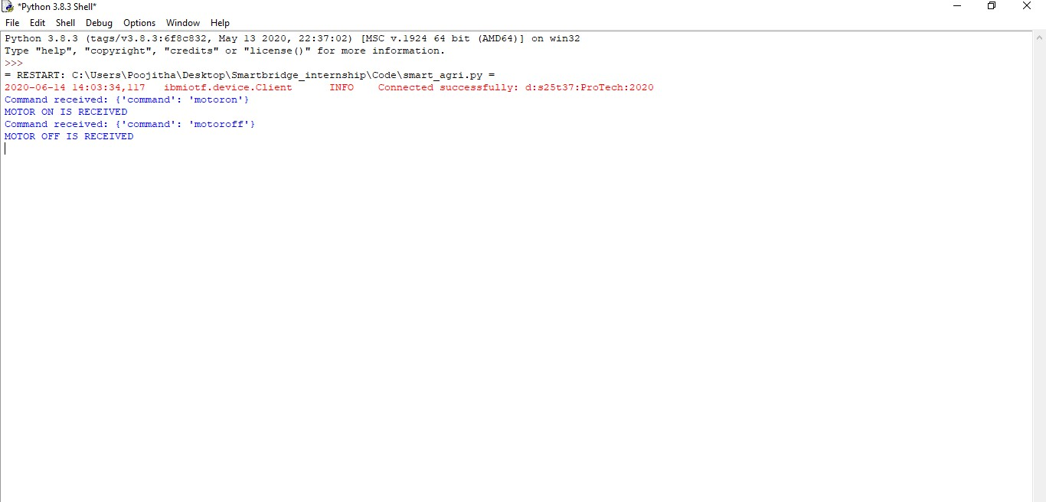

**CHAPTER-7 ADVANTAGES & DISADVANATGES**

The agriculture sector fulfils demand of food of the nation. The agriculture which uses sensors and latest technologies such as IoT/cellular is known as smart agriculture or smart farming. The Smart Agriculture System is an IoT based device which is capable of automating the irrigation process by analysing the moisture of soil and the climate condition.

**ADVANTAGES**

* It allows farmers to maximize yields using minimum resources such as water, fertilizers etc.
* Mobile operated pumps save cost of electricity.
* It is cost effective method.
* It delivers high quality crop production.
* Real-Time Data and Production Insight
* Improved Livestock Farming.
* Remote Monitoring.
* Efficient and saves time.

### DISADVANATGES

* The smart agriculture need availability on internet continuously.
* The smart farming-based equipment’s require farmers to understand and learn the use of technology.
* Lesser employment of menial staff or unskilled workers.

# CHAPTER-8 APPLICATIONS OF

**SMART AGRICULTURE SYSTEM**

Some of the applications for IoT in agriculture are:

* ***Precision Farming***

Precision agriculture is also known as precision ag or precision farming. Perhaps the easiest way to understand precision ag is to think of it as everything that makes the practice of farming more accurate and controlled when it comes to the growing of crops and raising livestock. A key component of this farm management approach is the use of information technology and a wide array of items such as GPS guidance, control systems, sensors, robotics, drones, autonomous vehicles, variable rate technology, GPS-based soil sampling, automated hardware, telematics, and software.

* ***Agriculture Drones***

Large farm owners can utilize wireless IoT applications to collect data regarding the location, well-being, and health of their cattle. This information helps them in identifying animals that are sick so they can be separated from the herd, thereby preventing the spread of disease. It also lowers labor costs as ranchers can locate their cattle with the help of IoT based sensors.

* ***Livestock Monitoring***

Large farm owners can utilize wireless IoT applications to collect data regarding the location, well-being, and health of their cattle. This information helps them in identifying animals that are sick so they can be separated from the herd, thereby preventing the spread of disease. It also lowers labor costs as ranchers can locate their cattle with the help of IoT based sensors.

* ***Smart Greenhouses***

Greenhouse farming is a methodology that helps in enhancing the yield of vegetables, fruits, crops, etc. Greenhouses control the environmental parameters through manual intervention or a proportional control mechanism. As manual intervention results in production loss, energy loss, and labor costs, these methods are less effective. A smart greenhouse can be designed with the help of IoT; this design intelligently monitors as well as controls the climate, eliminating the need for manual intervention.

# CHAPTER-9 CONCLUSION & FUTURE SCOPE

### CONCLUSION

The proposed model explores the use of IoT in the agriculture sector. The objectives of this project “Smart Agriculture System” is to increase the crop production and to avoid the wastage of water. This smart agriculture system is feasible and cost effective. It also focuses on optimizing water resources which combats issues like water scarcity and ensures sustainability and monitors the environmental parameters. It also focuses on the utilization of IoT in agriculture and the solutions proposed in this paper will improve farming methods, increase productivity and lead to effective use of limited resources. A farmer should visualize his agricultural land’s moisture content and the weather conditions from time to time and water level of source is sufficient or not. The agriculture field can be monitored and controlled by an android app at user end. Hence will have a good production of crops and great saving of irrigation water, stronger and healthier plants.

### FUTURE SCOPE

The future scope of this project could be including variety of soil sensors like pH sensor, Rain sensor which helps in the predicting and analysing processes more accurate. We can also monitor the life cycle of the plants. Through smart agriculture system we can analysis the crop yield and can monitor the soil moisture and plant health.