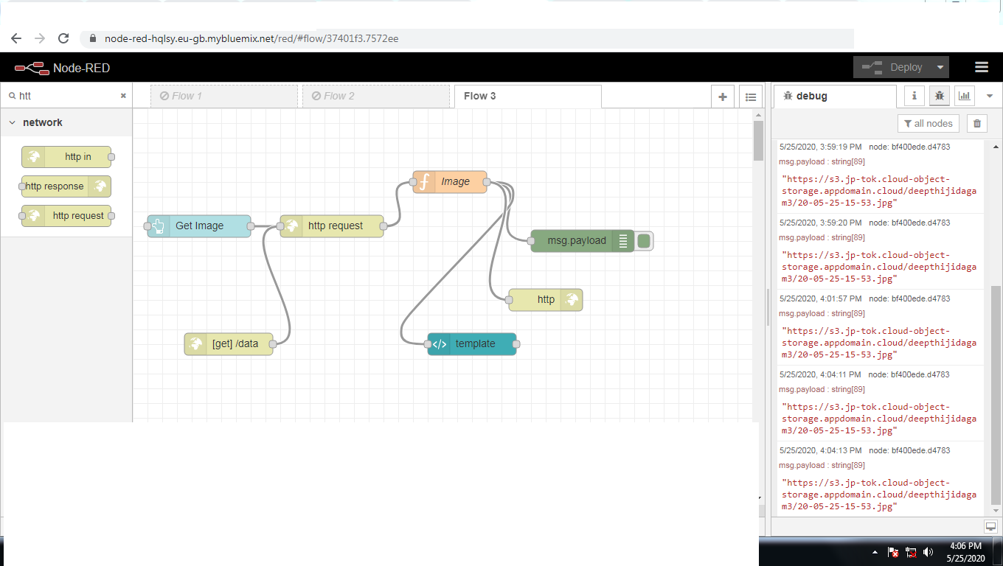

https://node-red-hqlsy.eu-gb.mybluemix.net/ui

https://node-red-hqlsy.eu-gb.mybluemix.net/ui/#!/0?socketid=keK0DbmvLfbUKORMAAAH

