**1.INTRODUCTION**

1.1 Overview

Transportation is playing a seriously important role in one’s day-to-day life. Cars being a part of this are drawing the people’s attention. This fact has helped the company owners to lead a progressive business. Usually when a car is bought, the users usually look into its performance. Although performance can be determined by many factors in our dataset, we predict it by the parameter mileage. We use a machine learning model with a befitting algorithm and integrating it with the flask app.

1.2 Purpose

Often there will be an ambiguity in choosing one from many. Even though there will be other parameters like the cost, dependability, flexibility, etc our job which predicts the performance taking mileage into consideration can help the customers in buying the appropriate car they need. So basically, this prediction helps to compare performances among different cars.

**2.LITERATURE SURVEY**

2.1 EXISTING PROBLEM

Due to lack of proper idea on the performance of cars, they later face problems with their vehicles. Sometimes, there might be some inconvenience with respect to the car in the middle of a journey.

So, the users need to be more specific while buying their car.

2.2 PROPOSED SOLUTION

Taking necessarily, the prerequisite inputs from which performance can be predicted beforehand helps the user to learn a good option which can avoid any kind of interruptions in their journey later on and so. This performance prediction is done with the concept of machine learning that has highest accuracy infers the finest algorithm.

**3.THEORETICAL ANALYSIS**

3.1 BLOCK DIAGRAM

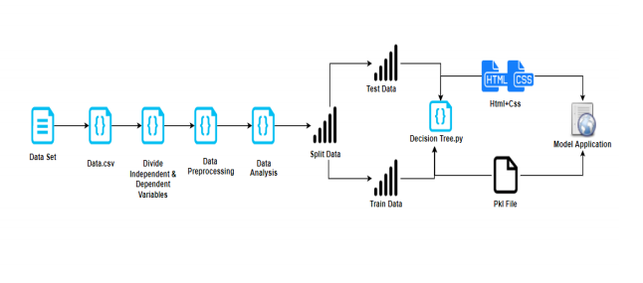

3.2 HARDWARE/SOFTWARE DESIGNING

Car performance prediction

* Dataset preparation
* Dataset pre-processing

1. Data visualisation
2. Taking care of the missing data
3. Label encoding and one-hot encoding(not indispensable)
4. Data transformation
5. Data splitting into train and test

* Model Building

1. Training and testing the model
2. Evaluation and the final predicting method should be such that the accuracy should probably be atmost.

* Model Deployment

1. Creating an HTML file
2. Structuring a proper python code

**4.EXPERIMENTAL INVESTIGATIONS**

In our prediction we collect information i.e. inputs required for the prediction of mileage of the car. In our task we collect parameters like the horsepower, weight, cylinders, displacement and acceleration.

**5.FLOWCHART**

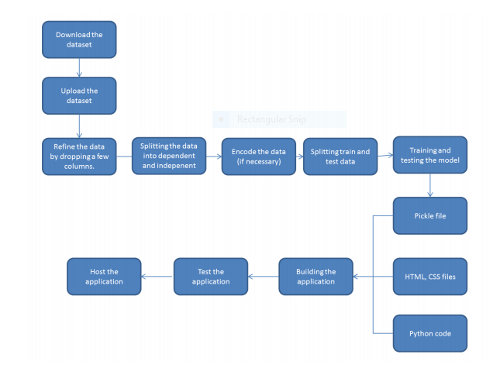

**6.RESULT**

The model can make the users aware of the performance of the car making predictions based on the processed inputs and displays the mileage .

**7.a. ADVANTAGES**

* Accurate predictions
* Easy usable interface
* Results shown are without any errors
* It gives information about mileage as well as performance

**b. DISADVANTAGES**

* For the prediction we need many inputs and sometimes it may lead to some uncertainty in the data or there might be any missing values which need to be taken care about.

**8.APPLICATIONS**

* Checking the performance of a car
* Comparing different figures of performance to find a better car

**9.CONCLUSION**

For a good car, performance is the key factor to know its efficiency. And this is the model which helps in printing the mileage and performance.

**10.FUTURE SCOPE**

With the growing population, the demand for cars has also been increasing. So the people also keep searching for the best car in a suitable price. And this best car is determined by its performance and this is known with our machine learning algorithm.

**11.BIBLIOGRAPHY**

**APPENDIX**