**FINAL PROJECT REPORT ON**

**PREDICTING LIFE EXPECTANCY USING MACHINE LEARNING**

**BY**

**ASHISH KUMAR BARAI**

**CONTENTS**

1. Introduction………………………………………………….….3

1.1 Overview………………………………………………..3

1.2 Purpose………………………………………………….3

2. Literature Survey……………………………………………….4

2.1 Existing solution………………………………………...4

2.2 Proposed solution……………………………………….4

3. Theoretical Diagram……………………………………………5

3.1 Block Diagram…………………………………………..5

3.2 Hardware/software Designing…………………………..6-10

4. Experimental Investigation……………………………………..9-10

5. Flow chart……………………………………………………....11

6. Result…………………………………………………………...12-13

7. Advantages and Disadvantages………………………………...14

7.1 Advantages……………………………………………...14

7.2 Disadvantages…………………………………………...14

8. Applications…………………………………………………….14

9. Conclusion……………………………………………………...15

10. Future scope…………………………………………………...15

11. Bibliography…………………………………………………..15

12. Appendix……………………………………………………….16-19

1. **INTRODUCTION**

**1.1 Overview:**

Life expectancy is the average number of years a person in a population could expect to live after age x. It is the life table parameter most commonly used to compare the survival experience of populations. The age most often selected to make comparisons is 0.0 (i.e., birth), although, for many substantive and policy analyses, other ages such as 65+ and 85+ are more relevant and may be used (e.g., for determining person-years of Medicare and Social Security benefit entitlement).

In order to predict life expectancy rate of a given country, we will be using Machine Learning algorithms to draw inferences from the given dataset and give an output. For better usability by the customer, we are also going to be creating a UI for the user to interact with using Node-Red.

**1.2 Purpose**

Life expectancy is perhaps the most important measure of health. Life expectancy increases due to healthcare improvements like the introduction of vaccines, the development of drugs or positive behavior changes like the reduction in smoking or drinking rates.

Life expectancy is a statistical measure of the average time a human being is expected to live, Life expectancy depends on various factors: Regional variations, Economic Circumstances, Sex Differences, Mental Illnesses, Physical Illnesses, Education, Year of their birth and other demographic factors. This problem statement provides a way to predict average life expectancy of people living in a country when various factors such as year, GDP, education, alcohol intake of people in the country, expenditure on healthcare system and some specific disease related deaths that happened in the country are given.

**2. LITERATURE SURVEY**

**2.1 Existing Solution:**

As a result of the evolution of biotechnologies and related technologies such as the development of sophisticated medical equipment, humans are able to enjoy longer life expectancies than previously before. Predicting a human’s life expectancy has been a long-term question to humankind. Many calculations and research have been done to create an equation despite it being impractical to simplify these variables into one equation.

Currently there are various smart devices and applications such as smartphone apps and wearable devices that provide wellness and fitness tracking. Some apps provide health related data such as sleep monitoring, heart rate measuring, and calorie expenditure collected and processed by the devices and servers in the cloud. However no existing works provide the Personalized Life expectancy.

**2.2 Proposed Solution:**

The project tries to build a model based on the given dataset. The first step was to clean the data, this included detecting and dealing with both missing values and outliers. The variables and dataset were given a general description so that a better understanding of what the variables mean could be gathered. Then both explicit and inexplicit missing values were detected. Inexplicit missing values were values that didn't make sense for a variable given the nature of the data.

Our first step in this project is DATA PRE PROCESSING , is a crucial step that helps enhance the quality of data to promote the extraction of meaningful insights from the data. It refers to the technique of preparing the raw data to make it suitable for a building and training. We will drop required columns which will not be used in Regression. Analyzing data sets to summarize their main characteristics, often with visual methods is done. We build coefficient matrix and we obtain boxplots to analyze the outliers.

We train our regression models we will need to first split up our data into a ‘A’ array that contains the features to train on, and a ‘B’ array with the target variable, here it is "Life Expectancy column". We split the data into a training set and a testing set. We will train out model on the training set and then use the test set to evaluate the model and the best model is chosen to evaluate the predictions.

**3. THEORITICAL ANALYSIS**

**3.1 Block Diagram:**

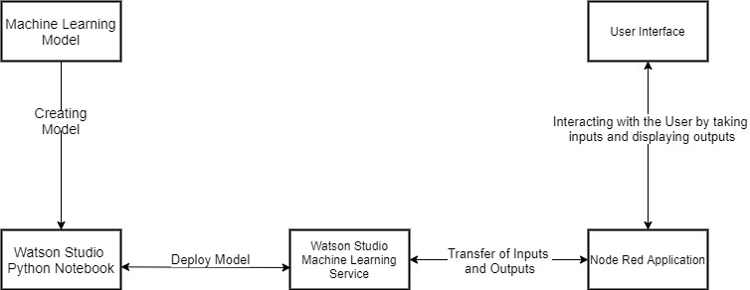

**3.2 Hardware/Software Designing:**

**Project Requirements:**

**i) Functional Requirements:**

To be able to predict the life expectancy accurately using Machine Learning models.

**ii)Technical Requirements:**

Any working laptop/PC with minimum 2.2Ghz processor and at least 8GB of memory with an Internet connection.

**iii) Software Requirements:**

a) Python

b) IBM Cloud

c) IBM Watson

**Model Designing (Watson Studio) :**

Steps: Open Watson studio => New Project => Create an empty Project => Give project name => Click Create => Add to Project => Notebook

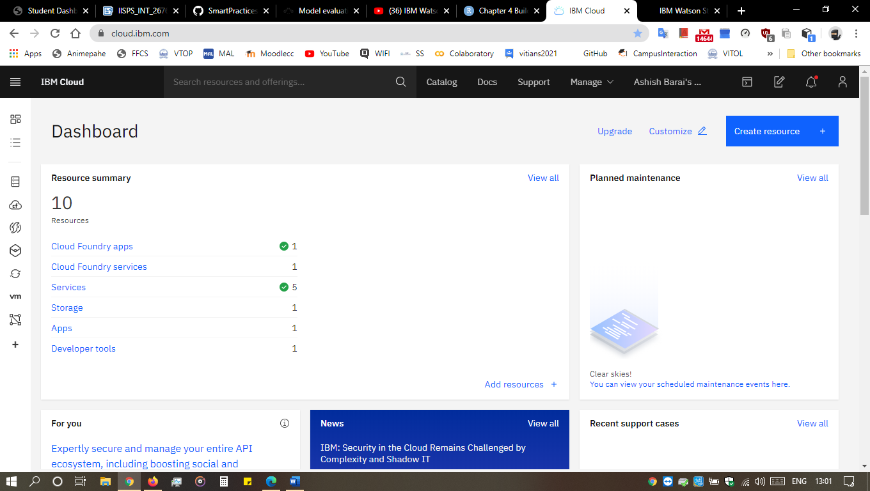

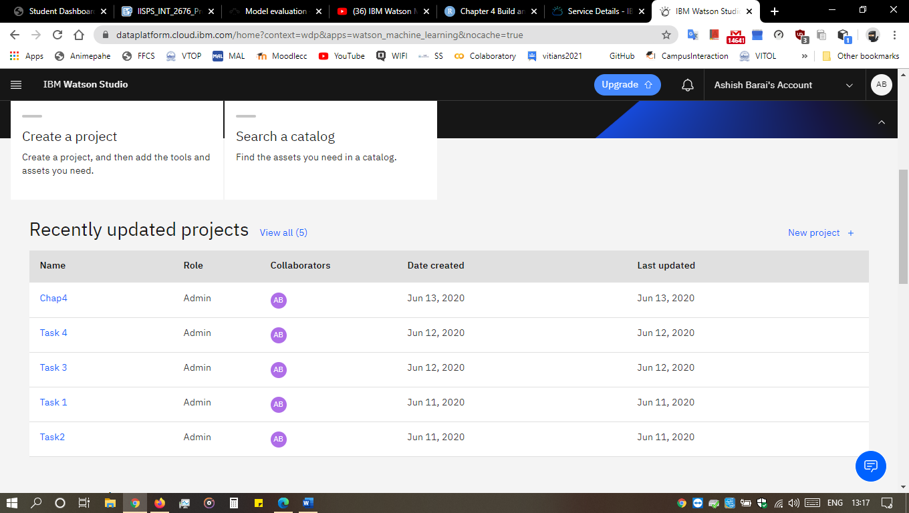

This is the backend of our project. In order to connect our front end and backend we need to generate a scoring point.

**Scoring point Generation:**

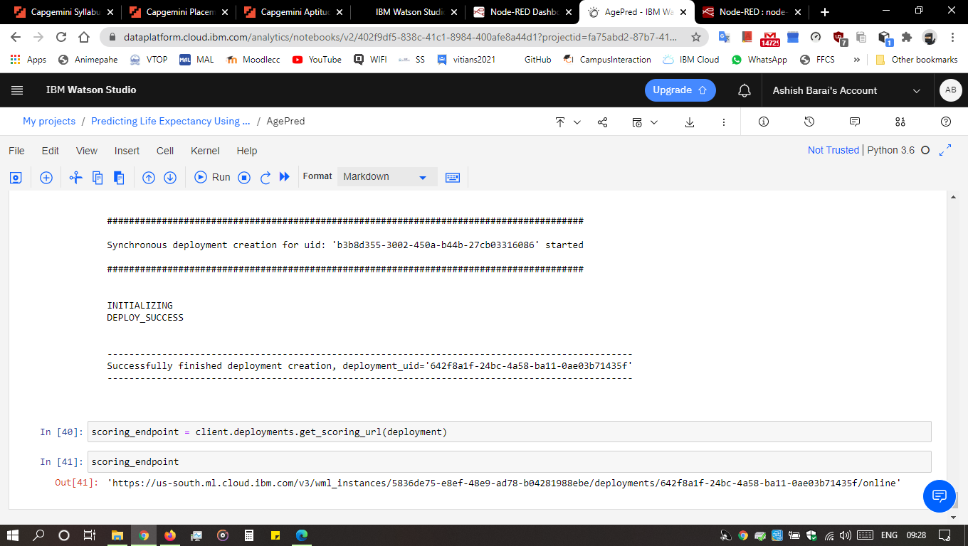

**Nodered integration with ML model:**



**4. EXPERIMENTAL INVESTIGATIONS**

Analyzing every feature in our dataset is very important which helps us to build a model which gives more accurate result.

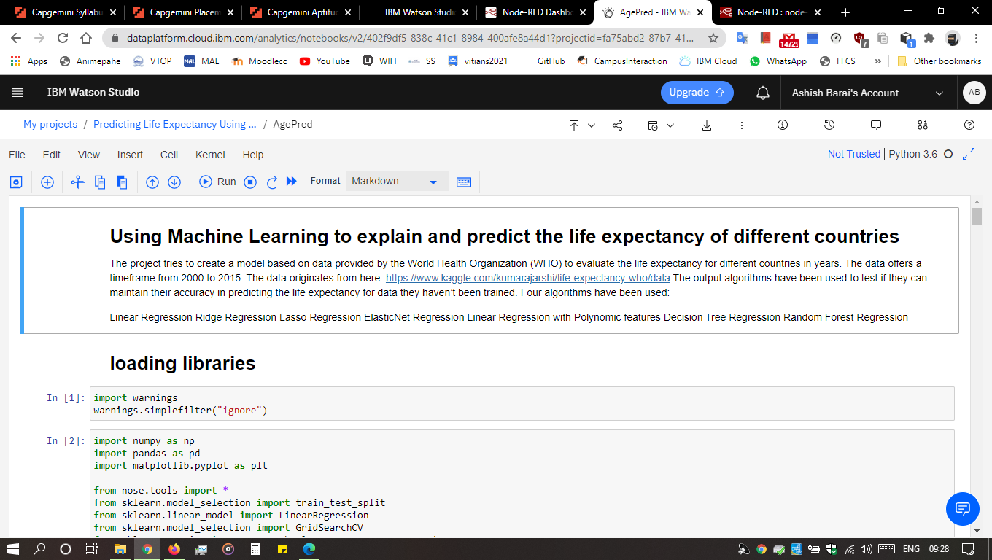

Performing Exploratory Data Analysis to see the correlation among various different the columns

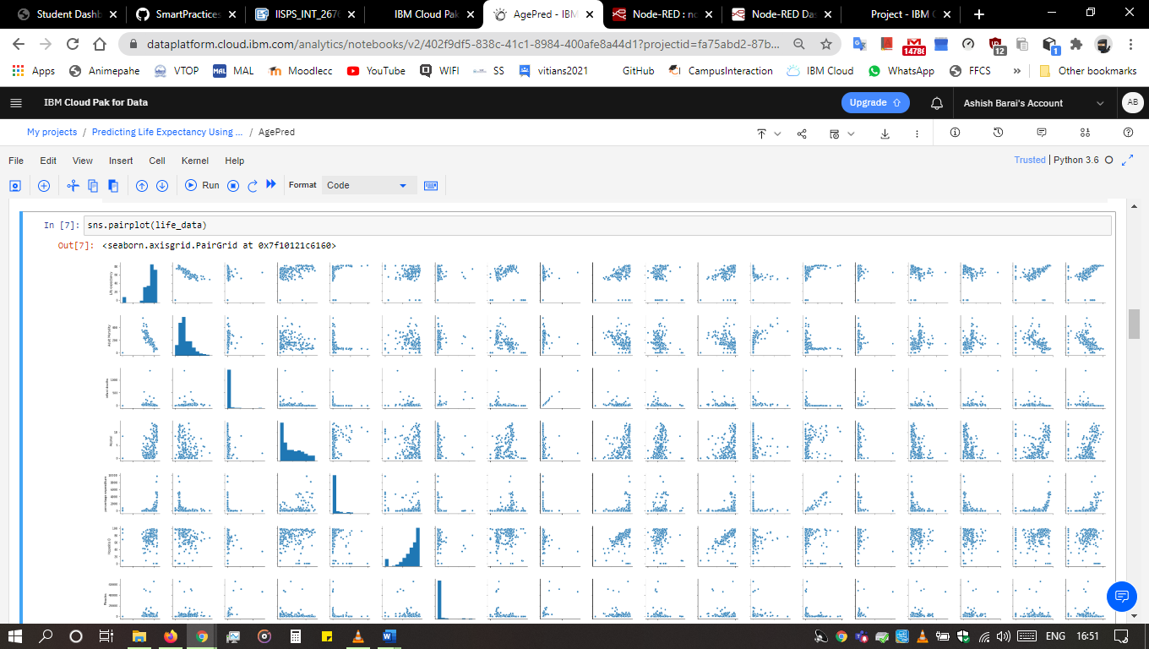

Now we will plot the correlation matrix visualizing it with a heatmap.

The legend tells that the warmer colours show higher and positive correlation, while the colder low or negative.

There is a very high correlation between thinness of 5-9-year-old and that of 1-19-year-old and also between population and infant deaths, under 5 deaths, another is between schooling and income composition of resources.

On the other hand, Life expectancy and Adult Mortality are very highly negatively correlated.

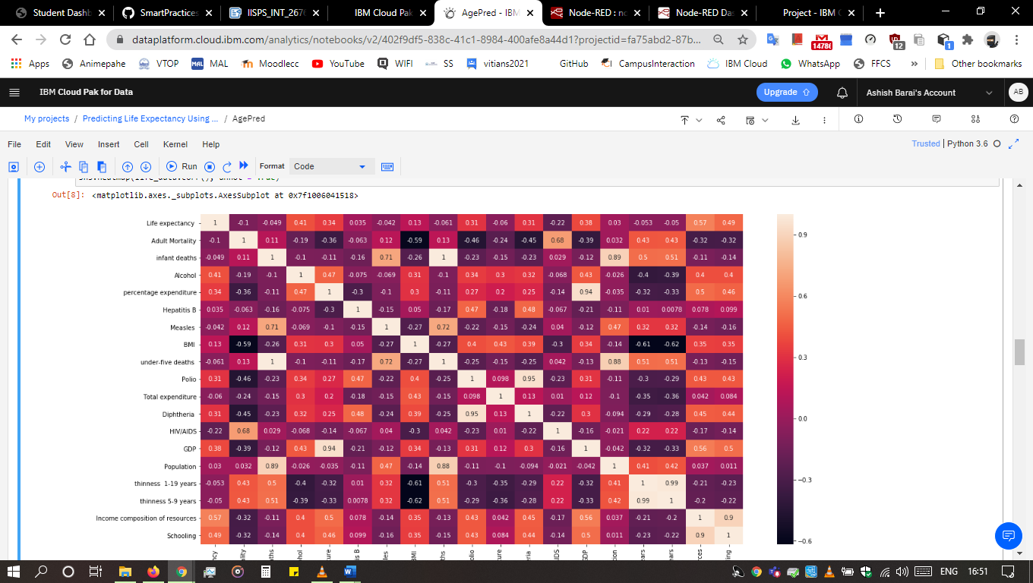

**5. FLOW CHART**

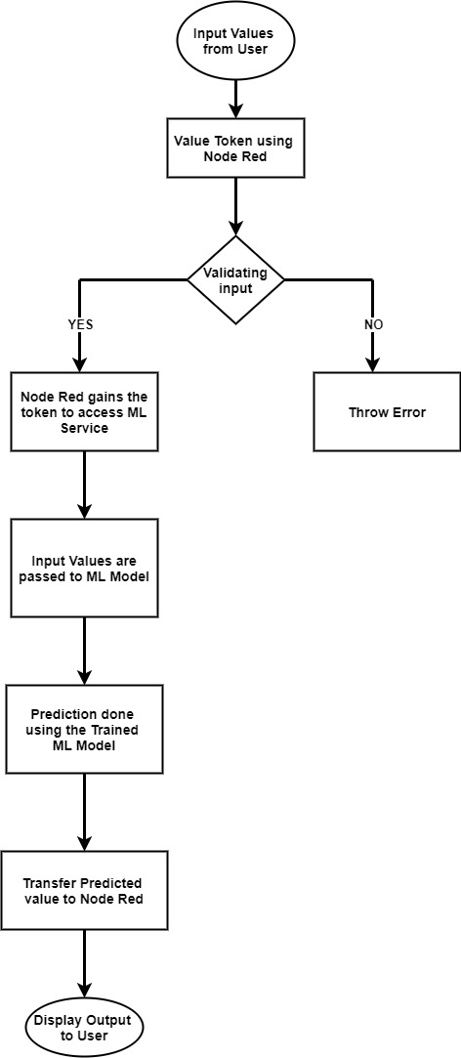

**6. RESULT**

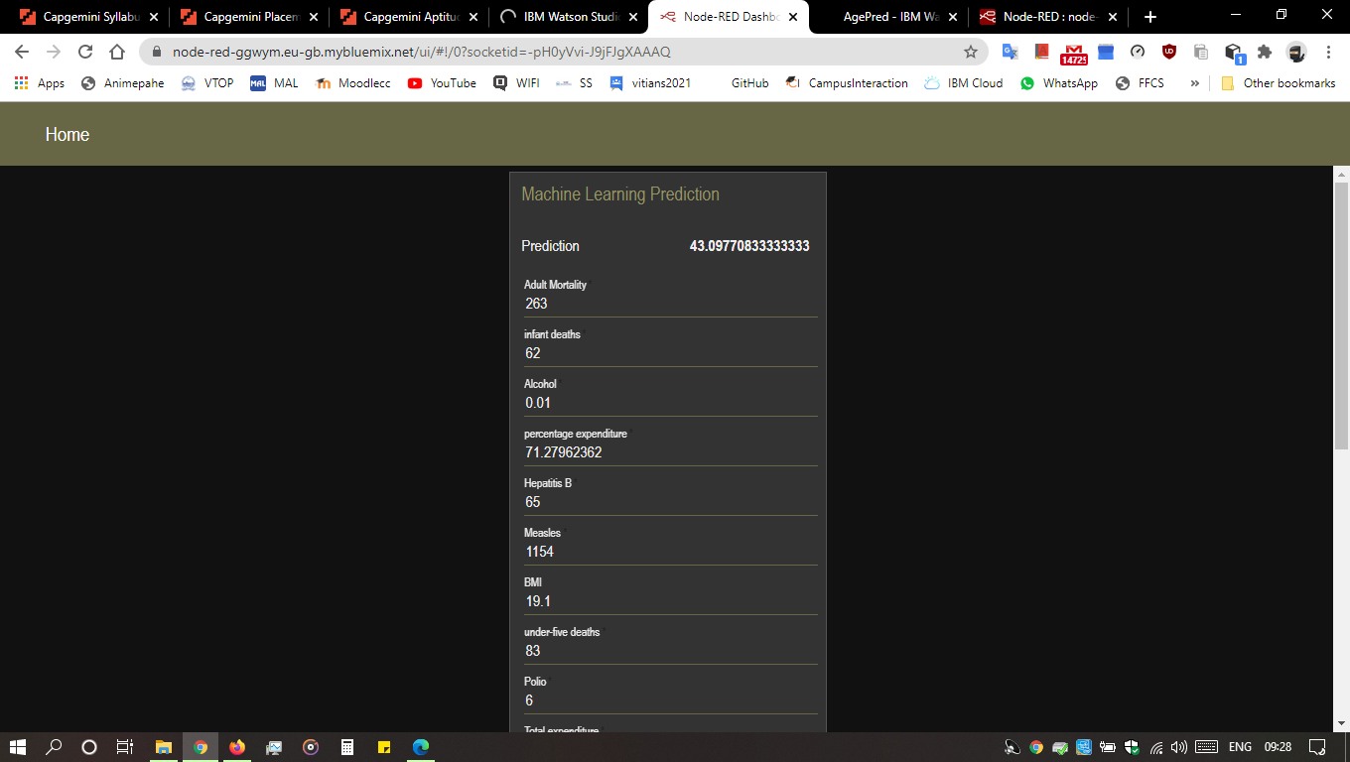

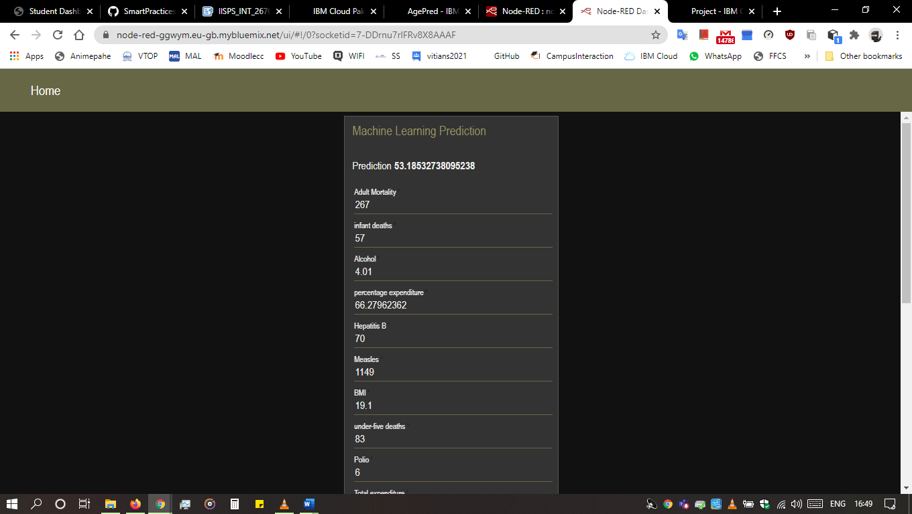

**7. ADVANTAGES AND DISADVANTAGES**

**7.1 Advantages:**

Life expectancy can be estimated at any age, e.g. life expectancy at 65 years. Gives more weight to deaths at younger ages. Life expectancy has been used nationally to monitor health inequalities.

The application learns the patterns and trends hidden within the data without human intervention which makes predicting much simpler and easier. The more data is fed to the algorithm, the higher the accuracy of the algorithm is. It is also the key component in technologies for automation.

**7.2 Disadvantages:**

This model is developed using Machine Learning in which human involvement is very less and might cause some errors and if any error occurs it takes a lot of time for the developer to identify the root cause.

**8. APPLICATIONS**

Individuals can predict their own life expectancy by inputting values in the corresponding fields. This could help make people more aware of their general health, and its improvement or deterioration over time. This may motivate them to make healthier lifestyle choices

**Health Sector:** Based on the factors used to calculate life expectancy of an individual and the outcome, health care will be able to fund and provide better services to those with greater need.

**Insurance Companies:** Insurance sector will be able to provide individualized services to people based on the life expectancy outcomes and factors.

**9. CONCLUSION**

Prognostication of life expectancy is difficult for humans. Our research shows that machine learning and natural language processing techniques offer a feasible and promising approach to predicting life expectancy. The research has potential for real-life applications, such as supporting timely recognition of the right moment to start Advance Care Planning. This breakthrough can widely impact health sectors and economic sectors by improving the resources, funds and services provided to the common people. It can also increase the ease of access to the individuals.

1**0. FUTURE SCOPE**

One can plan to explore methods for gaining more insight in the nature of the patterns that are detected by neural networks, as well as making the determinants of a certain prediction transparent. For future use, one can integrate the life expectancy prediction with providing suggestions and medications to the individual using the application. This will help predict as well as increase the individual’s life expectancy.

The scalability and flexibility of the application can also be improved with advancement in technology and availability of new and improved resources. Also, with the growth in Artificial Neural networks and Deep learning, one can integrate that with our existing application. With the help of Convolutional Neural networks and Computer vision, we can also try to take into account the physical health and appearance of a person. Mental health can also be taken into account while predicting life expectancy with the help of sentiment analysis systems as well.

**11. BIBLIOGRAPHY**

* <https://developer.ibm.com/tutorials/how-to-create-a-node-red-starter-application/>
* [https://bookdown.org/caoying4work/watsonstudio-workshop/jn.html#deploy-model-as- web-service](https://bookdown.org/caoying4work/watsonstudio-workshop/jn.html#deploy-model-as-web-service)
* <https://www.ibm.com/watson/products-services>

**12. APPENDIX**

* **Watson Assistant:**

Watson Assistant is a conversation AI platform that helps you provide customers fast, straightforward and accurate answers to their questions, across any application, device or channel.

* **Watson Studio:**

Analysts prepare data and build models at scale across any cloud. Build models using images with IBM Watson Visual Recognition and texts with IBM Watson Natural Language Classifier. Deploy and run models through one-click integration with IBM Watson Machine Learning.

* **IBM Cloud Function:**

IBM Cloud provides a full-stack, public cloud platform with a variety of offerings in the catalog, including compute, storage, and networking options, end-to-end developer solutions for app development, testing and deployment, security management services, traditional and open-source databases

* **Node-Red:**

Node-RED is a flow-based development tool for visual programming developed originally by IBM for wiring together hardware devices, APIs and online services as part of the Internet of Things. Node-RED provides a web browser-based flow editor, which can be used to create JavaScript functions.

CODE: