Analysis Of Amazon Cell Phone Reviews
-By Casandra Josephine
ABSTRACT:
90 percent of the consumers read online reviews before they decide to purchase any Mobile phone from any e-commerce website. Online Mobile applications have revolutionized the way consumers purchase mobile phones online as these apps have all the information regarding any mobile phone at users finger tips. Amazon is one of the best mobile applications which is considered as a treasure trove of all mobile reviews, and their review system is accessible across all channels presenting reviews in an easy-to-use format. So,there should be a system which analyses thousands of reviews of unlocked mobile phones sold on Amazon.com to find insights with respect to reviews, ratings, price and their relationships.
1. INTRODUCTION:
1.1. OVERVIEW:
The smart phone market has been growing increasingly, not only in the conventional sales but has also been penetrating in the online shop. But not all smart phones have good quality to support the needs of consumers and it is to be noticed by the consumer. Before consumers decide to buy a smart phone, they should know the details of the specifications and functions of the smart phone, it can be learned from results of a review of smart phone users.
1.2. PURPOSE:
My project aims at building a model to predict the helpfulness of the review and the rating based on the review text. Corpus-based and knowledge-based methods can be used to determine the semantic similarity of review text. I used Natural language processing to analyse the sentiment (positive or a negative) of the given review.
For Example: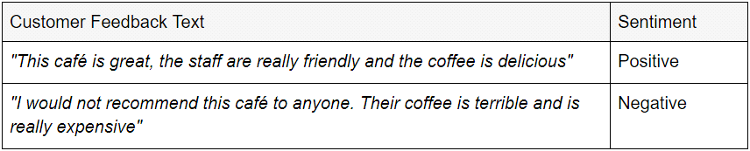
I also heard sentiment analysis being referred to (less commonly) as opinion mining and emotion AI.
Why is sentimental analysis needed?
In today’s environment where we’re suffering from data overload (although this does not mean better or deeper insights), companies might have mountains of customer feedback collected. Yet for mere humans, it’s still impossible to analyze it manually without any sort of error or bias.Sentiment analysis provides answers into what the most important issues are. Because sentiment analysis can be automated, decisions can be made based on a significant amount of data rather than plain intuition that isn’t always right.

2. LITERATURE SURVEY:
2.1. EXISTING PROBLEM:
Amazon’s product review platform shows the average length of the reviews comes close to 230 characters.Sentiment analysis shows that positive sentiment is prevalent among the reviews and in terms of emotions, ‘trust’, ‘anticipation’ and ‘joy’ have highest scores. So, I was assigned to create an analysis system capable of analyzing the reviews based on NLP.
2.2. PROPOSED SOLUTION:
I started building a model to predict the helpfulness of the review and the rating based on the review text.Currently consumers who write reviews online are increasing. If the consumers read the whole review it can consume a lot of time. But if it is read without some evaluation it will be biased. Sentiment classification aims to overcome this problem by automatically classifying user review by positive or negative opinion.

3.THEORITICAL ANALYSIS:

3.1.BLOCK DIAGRAM:

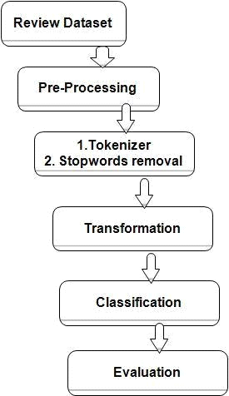

3.2.SOFTWARE DESIGNING:

For software we would need a compatible operating system for python, java script and HTML.Software needed are:
1) Tensorflow
2) Keras
3) Flask

4.EXPERIMENTAL INVESTIGATION

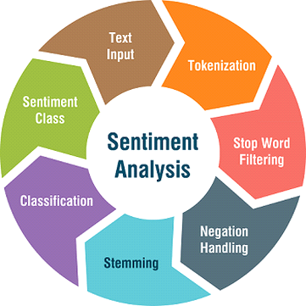

1) Data Collection: Data for this experiment was collected from online sources.It is a dataset of size 24KB.

2) Initial Processing Data: I imported the dataset and using libraries like pandas and numpy & removed the punctuations and numbers.Also I removed the unwanted like name,date etc.I removed the null values and regular expressions.I converted each word into lower case of its own and applied stemming to remove the stop words.
3)Using rating we convert them into binary: If rating is greater than or equal to 3,then the data is “Positive”.If the rating is less than 3,then the data is “Negative”.
4)Model making: I initialized the model and added input ,hidden and output layer.I configured the learning process,trained and tested the model,and optimized the model.I predicted the model by giving inputs and finally saved it.
5)Preparing HTML file: Finally I prepared the HTML file and ran my model. This model will predict positive and negative reviews from the input given.
5.FLOWCHART:
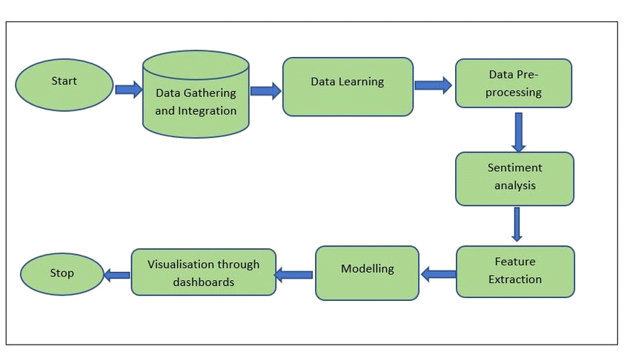

6.ACCURACY ACHIEVED:
I got an accuracy of 0.975 which is a good measure for Natural language processing.The Model analysis and predicts the review whether it is a positive or a negative review.
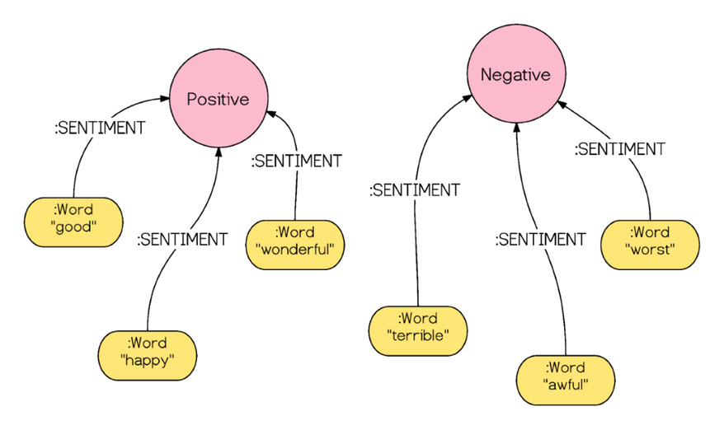

7.ADVANTAGES AND DISADVANTAGES:
Advantages:
By using sentiment analysis, you gauge how customers feel about different areas of your business without having to read thousands of customer comments at once.
Increases confidence in new customers and will save their time.
Brings credibility to products and the company.
Knowing which product works best.
Disadvantages:

One negative review of a product or business can skew a potential customer’s view of them.

We need to keep reviews current and up to date.Otherwise they will seem out of date and irrelevant.

Disgruntled customers have the freedom to say whatever they like.This could lead to malicious or damaging information being posted.

Lack of touch or feel of products during online shopping is a drawback.

8.APPLICATIONS:
63% of customers are more likely to purchase from a site which has user reviews.Also to make them user friendly and easy for customers,my project analyses whether the review is a positive or a negative review and allows the customer to make good decisions.

9.CONCLUSION
A model which can predict the amazon mobile phone reviews whether it is a positive or negative review using NLP was created.

10.BIBLIOGRAPHY:
*Kaggle dataset link: https://github.com/grikomsn/amazon-cell-phones-reviews

11.APPENDIX:
