Project Report

**Name:** Abhishek Soni (abhisheksoni1998@gmail.com)

**Title:** *Intelligent Customer Help Desk with Smart Document Understanding*

**Category**: *Artificial Intelligence*

*Internship at smartinternz.com@2020*

1. **Introduction**

**1.1 Project Overview:**

The typical customer care chatbot can answer simple questions, such as store locations and hours, directions, and maybe even making appointments. When a question falls outside of the scope of the predetermined question set, the option is typically to tell the customer the question isn’t valid or offer to speak to a real person.

In this project, there will be another option. If the customer question is about the operation of a device, the application shall pass the question onto Watson Discovery Service, which has been preloaded with the device’s owner’s manual. So now, instead of “Would you like to speak to a customer representative?” we can return relevant sections of the owner’s manual to help solve our customers’ problems.

To take it a step further, the project shall use the Smart Document Understanding feature of Watson Discovery to train it on what text in the owner’s manual is important and what is not. This will improve the answers returned from the queries.

**Project Requirements**: Python, IBM Cloud, IBM Watson

**Functional Requirements**: IBM cloud

**Technical Requirements**: AI, ML, WATSON AI, PYTHON

**Software Requirements**: Watson assistant, Watson discovery.

**1.2 Purpose**

* To Create an Intelligent Chatbot that understands the Product in reference to the User Manual provided by the owner in Watson Discovery.
* To create a customer care dialog skill in Watson Assistant
* Use Smart Document Understanding to build an enhanced Watson Discovery collection
* Create an IBM Cloud Functions web action that allows Watson Assistant to post queries to Watson Discovery.
* Build a web application with integration to all these services & deploy the same on IBM Cloud Platform.

1. **Literature Survey**
   1. **Proposed Problem**

Generally Chatbots means getting input from users and getting only response questions and for some questions the output from bot will be like “try again”, “I don’t understand”, “will you repeat again”, and so on… and directs customer to customer agent but a good customer Chatbot should minimize involvement of customer agent to chat with customer to clarify his/her doubts. So, to achieve this we should include a virtual agent in chatbot so that it will take care of real involvement of customer agent and customer can clarifies his doubts with fast chatbots.

* 1. **Proposed Solution**

For the above problem we provide an alternative i.e. whenever our virtual assistant doesn’t know what to answer to a specific question, we route the chatbot flow towards the Discovery application where based on User Manual uploaded by the owner, we try to find the answer within this document and if found we reply with that answer thus making our chatbot more superior and understandable from other normal virtual assistants. Few Steps necessary for the setup of our Virtual Assistant are setting up IBM services, configuring them according to our need and integrating all these services to create our final Chatbot.

**3.Theoretical Analysis**

**3.1 Block Diagram**

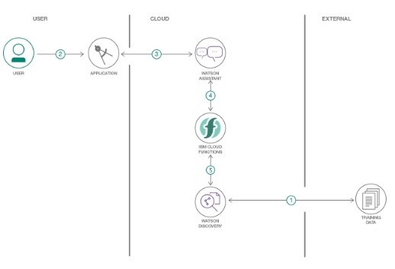

**3.2 Hardware and Software Designing**

* 1. Create IBM Cloud services
* Watson Discovery
* Watson Assistant
* Node Red App
  1. Configure Watson Discovery
* Import and Annotate the Document
  1. Create IBM Cloud Functions action.
* Configure Action script and parameters
  1. Create a Node red flow to connect all the services together.
  2. Configure Watson Assistant.
* Create required Intents, Entities, webhooks and Dialog Skills.
  1. Create flow and configure node
  2. Deploy and run Node Red Chatbot App.

**4.Experimental Investigations**

**Create IBM Cloud services**

Create the following services:

* + Watson Discovery
  + Watson Assistant
  + Node Red
  + IBM cloud function

**Creation of Node-RED in IBM cloud:**

* + Step-1: Login to IBM and go to the catalog
  + Step-2: Search for node-red and select “Node-RED Starter” Service.
  + Step-3: Enter the Unique name and click on create a button
  + Step-4: Configure your application accordingly and go to flow editor to get started.

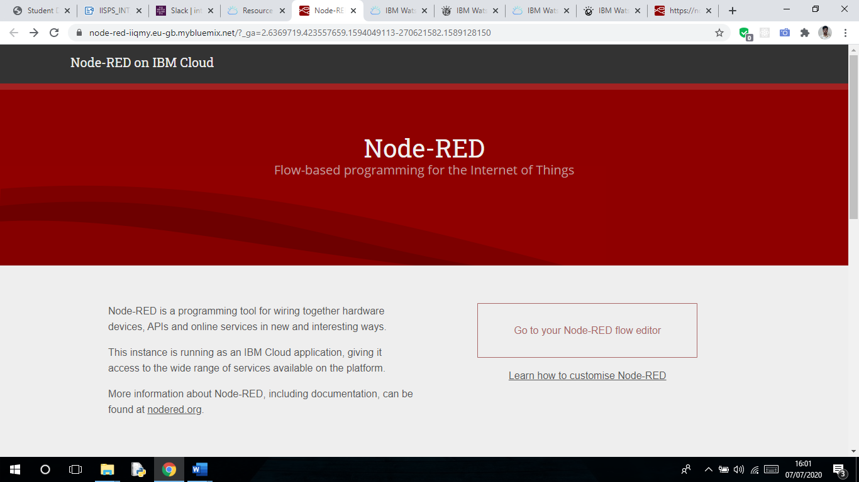

* + Step-5: In flow Editor you can start creating the UI and Backend of you Application.

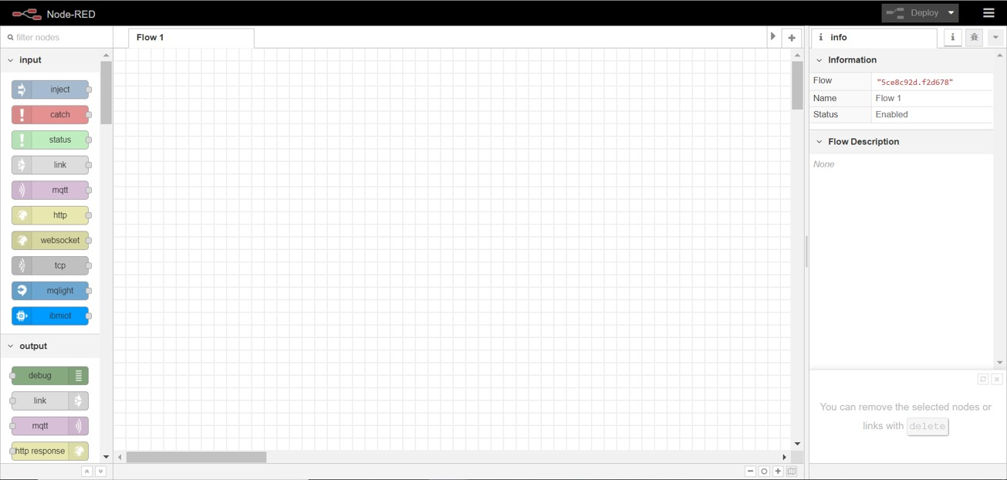

**Creation of Watson Discovery in IBM cloud:**

* + Step-1: Create a Discovery Service.

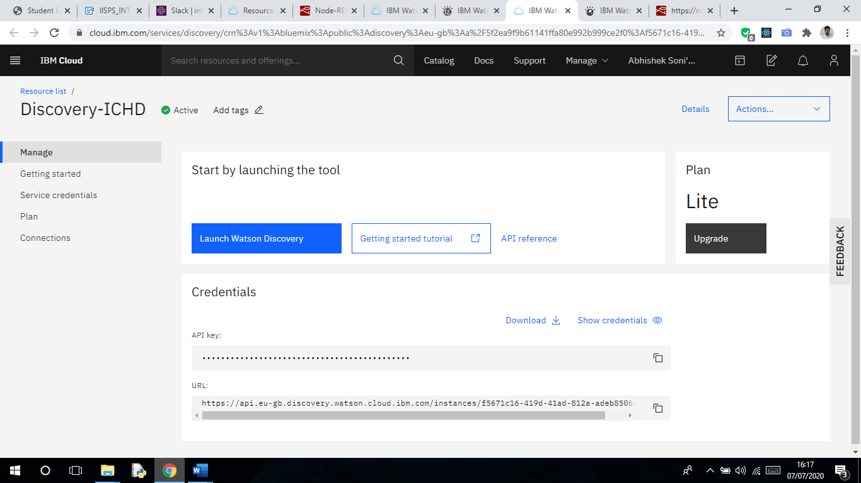

* + Step-2: Upload your Document (User Manual LG W150 Manual)

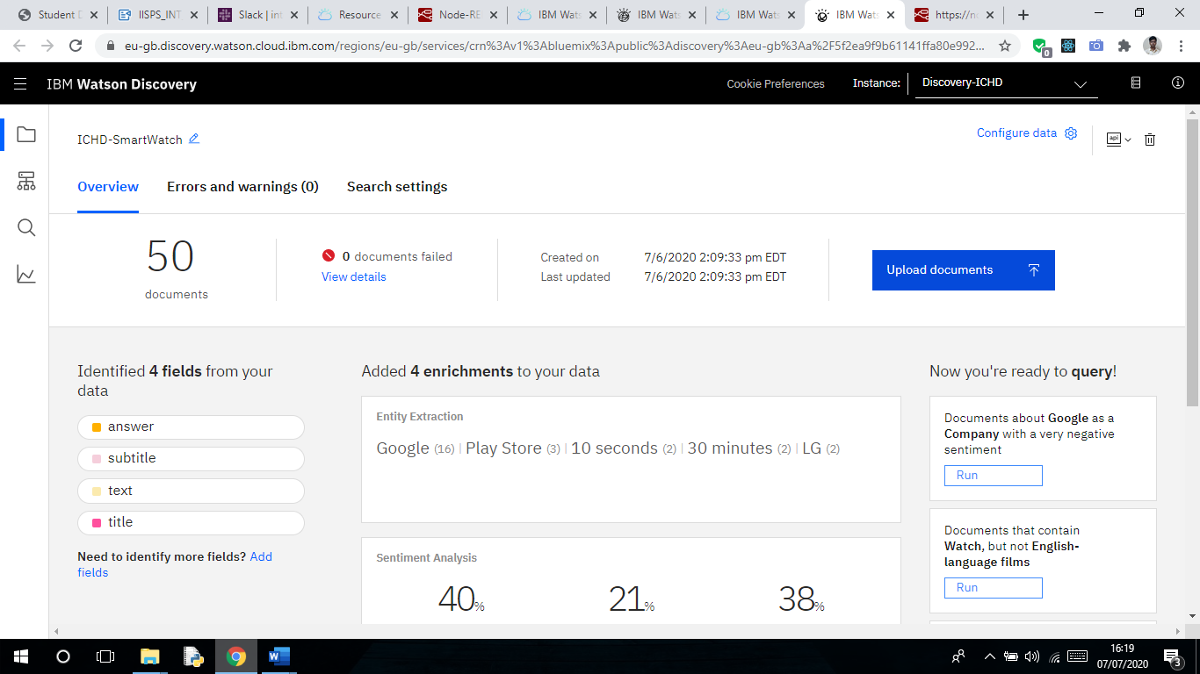

* + Step-3: Annotate your Document and save/Submit all the changes.

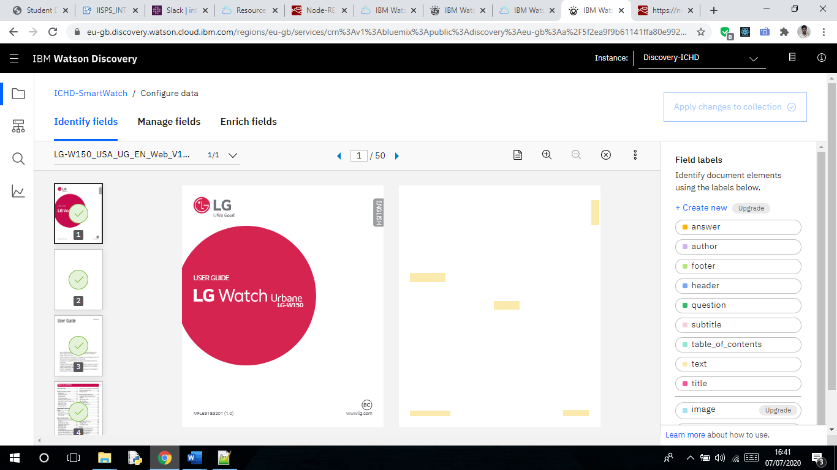

* + Step-4: Edit manage fields (select required values only) and save/Submit all the changes.

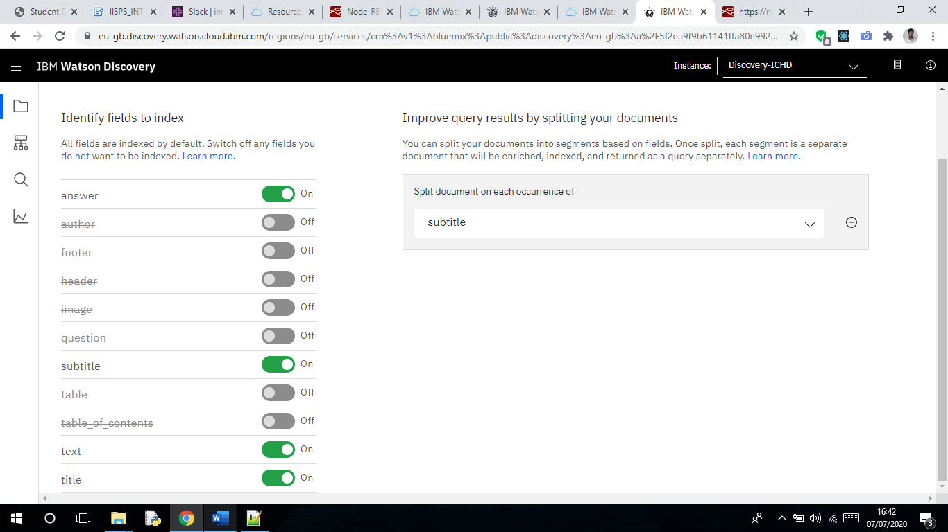

**Creation of Cloud Functions in IBM cloud:**

* + Step-1: Create a cloud Function Action.

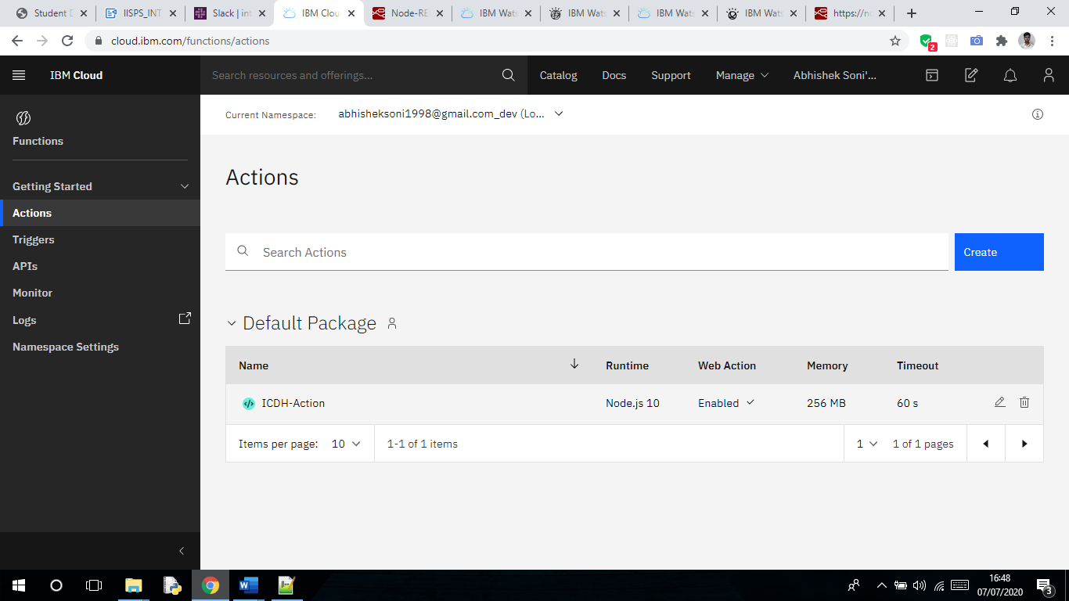

* + Step-2: Prepare the Scripts and upload in Code section.

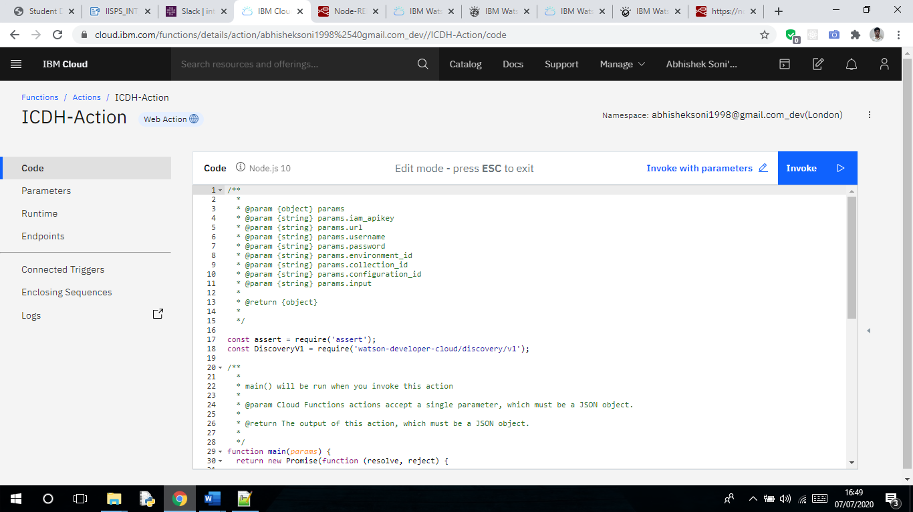

* + Step-3: Configure the Parameters section.

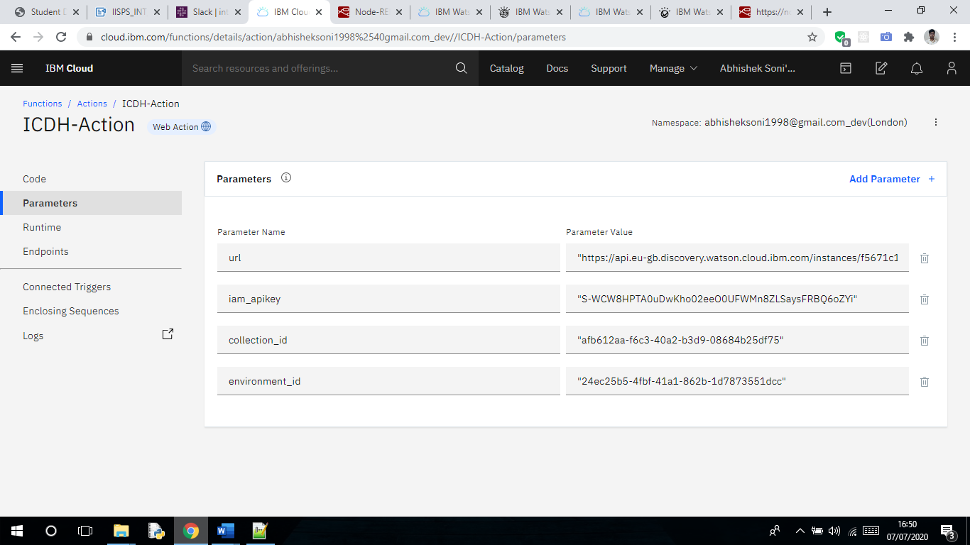

**Creation of Watson Assistant in IBM cloud:**

* + Step-1: Create Watson Assistant service.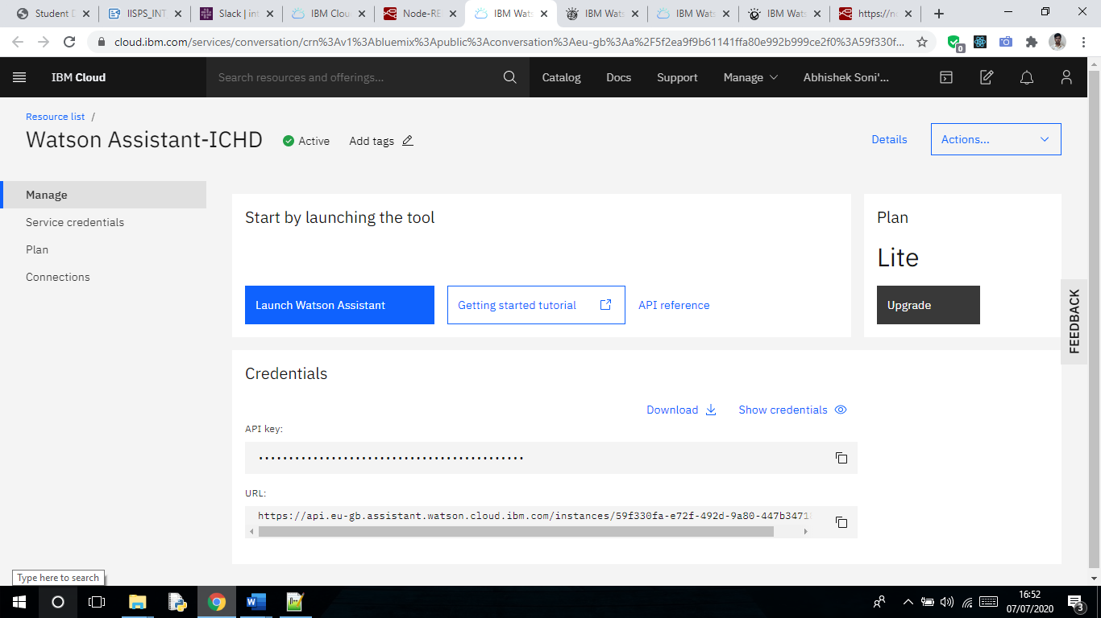
  + Step-2: Create a Skill for your Assistant.

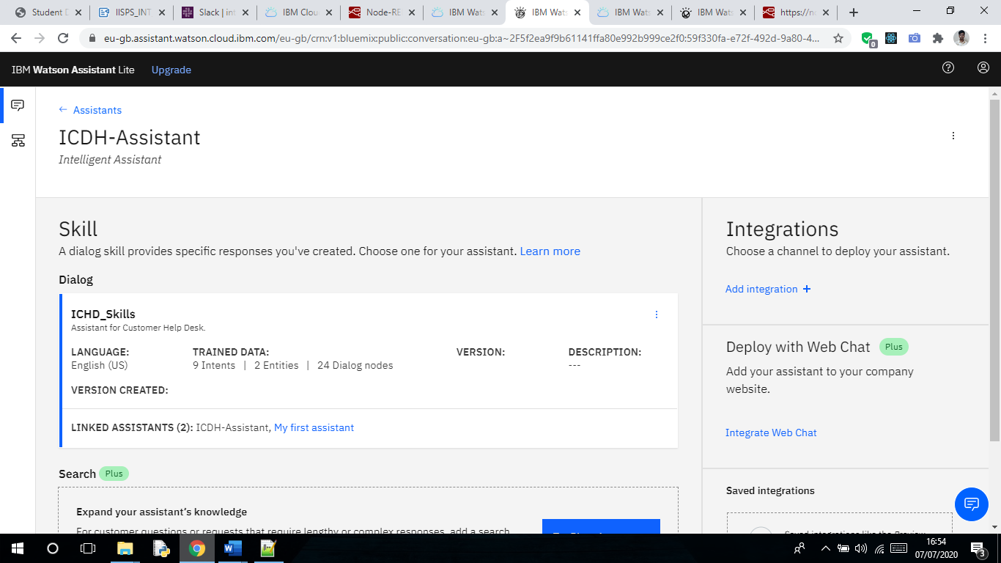

* + Step-3: Create Intents, Entities and Dialog Skills.

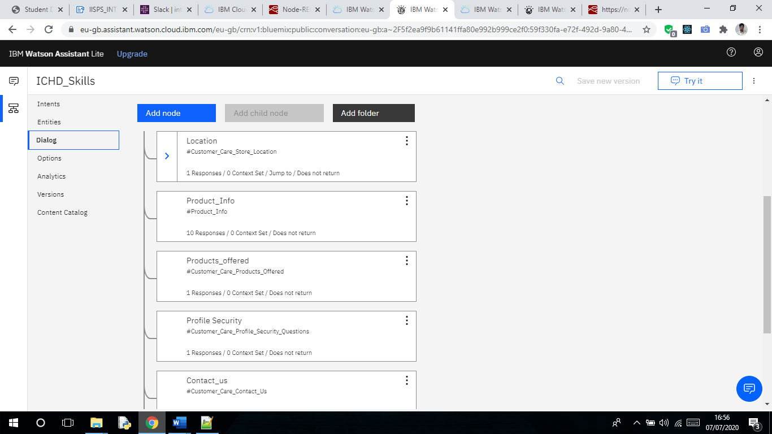

1. **Flowchart**

Overall Flow of My Project is divided in two Flows.

1. Frontend

Nodes: Http In Node, Template (Function) Node, Http Response Node.

1. Backend

Nodes: Web-Socket In/Out Nodes, Function Node, Assistant Node.

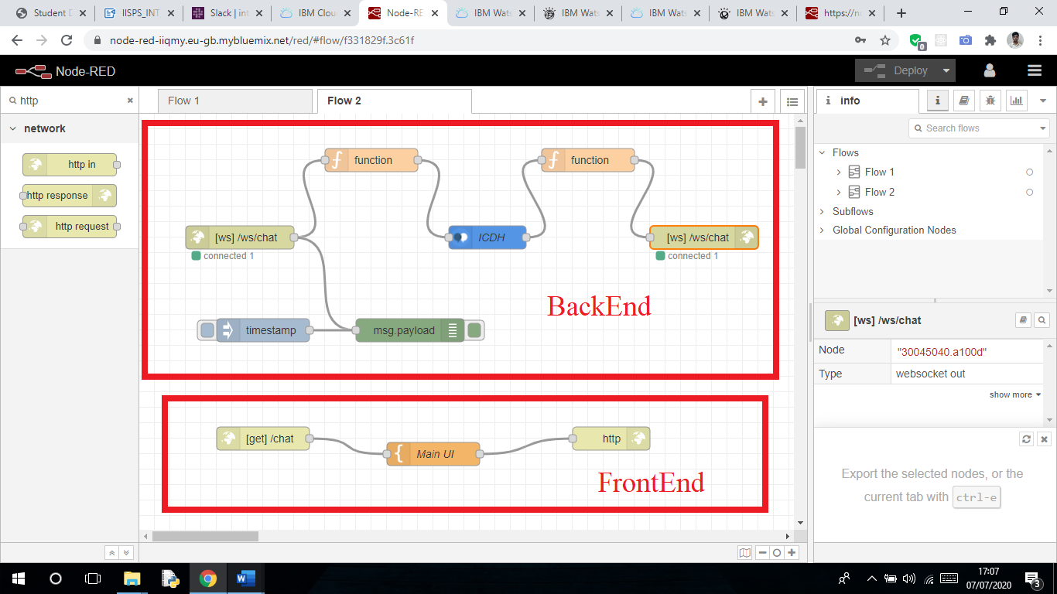

**6.Results**

The chatbot was successfully made using Watson assistant and using SDU. All the services were integrated using Node Red Application.

URL - <https://node-red-iiqmy.eu-gb.mybluemix.net/chat>

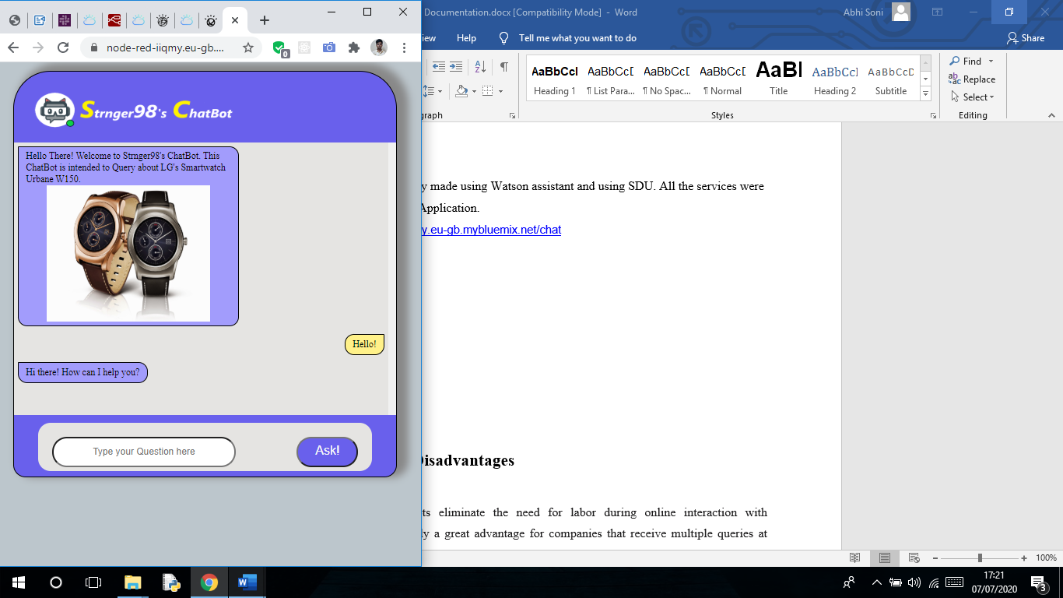

**7.Advantages and Disadvantages**

**Advantages:**

1. Reduced costs: Chatbots eliminate the need for labor during online interaction with customers. This is obviously a great advantage for companies that receive multiple queries at once. In addition to saving costs with them, companies can align the chatbot with their objectives, and use them as a means to enhance customer conversion.
2. 24/7 Availability: Unlike humans, once we install a chatbot, it can handle queries at any time of day. Thus, the customer does not have to wait for a commercial of the company to help him. This also allows companies to monitor customer traffic during non-working hours and contact them later.
3. Learning and updating: AI-based chatbots are able to learn from interactions and update independently. This is one of the main advantages. When you hire a new employee, you have to train them continuously.
4. Management of multiple clients: Humans can serve a limited number of customers at the same time. This restriction does not exist for chatbots, and they can manage all the necessary queries simultaneously. This is one of the main advantages of using chatbot, as no customer is left unattended and you are solving different problems at the same time. There are chatbots companies already working on developing voice chatbot services.

**Disadvantages:**

1. Complex interface: It is often considered that chatbots are complicated and need a lot of time to understand what you want in customer. Sometimes, it can also annoy the client about their slowness, or their difficulty in filtering responses. They don’t get you right: Fixed chatbots can get stuck easily. If a query doesn’t relate to something you’ve previously taught it, you won’t understand it. This can lead to a frustrated customer and the loss of the sale. Other times they do understand you, but they need double (or triple) as many messages as one person, which spoils the user experience.
2. Bad memory: The chatbots are not able to memorize a conversation already had, which forces the user to write the same thing over and over again. This can be cumbersome for the client and annoying for the effort required. Therefore, it is important to be careful when designing chatbots and make sure that the program is able to understand users’ queries and respond accordingly.

**8.Applications**

Some applications can be: -

1. Help User: This chatbot will be useful for the user to ask the assistant the queries related to the Product and will give them clear guidance about the Product. If the Assistant doesn’t know about a certain query, it will redirect to the correct person for it.
2. Content delivery: Media Publishers have realized that chatbots are a powerful way to engage with their audiences and monitor engagement to gain valuable insights on reader interests. Chat with the CNN and Wall Street Journal Chatbots on Facebook Messenger and receive the latest news directly in Messenger, without having to visit their websites.

2] Companionship: The primary function of the chatbot is to be a virtual companion – To speak with senior people on general topics like the weather, nature, hobbies, movies, music, news, etc. The chatbot asks questions, reacts to the answers, is able to speak on various topics, and share interesting news and facts from Google.

1. **Conclusion**

This chatbot will be useful for the user to ask the assistant the queries related to the Product and will give them clear guidance about the product. If the Assistant doesn’t know about a certain query, it will redirect to the correct person for it. Chatbots are quickly making transformational changes and allowing businesses to thrive through customer interactions. The feedback and survey through chatbots strengthen the position of businesses as they analyze the reason behind different levels of customer approval. Use of conversational AI chatbots only means better engagement and relentless need for customer satisfaction in the near future.

1. **Future Scope**

Future Scope of this chatbot can be by adding the following to make it more advance: -  
1] Smarter Virtual Assistants: Much of what virtual assistants do now are basic skills, such as retrieving data and basic computation. As natural language processing (NLP) continues to mature, virtual assistants will improve their comprehension and response capabilities, allowing for their use to become more widespread and complex. Also, as machine learning progresses, we may see virtual assistants become smarter and begin to learn and predict customer needs.

2] Integration with IoT Devices: Car speakers, smart home devices, and wearables are just a few examples where the virtual assistant is departing from its original hardware and making its way to in-context devices. These integrations ensure that virtual assistants can always be near their human and ready to support any need. It is expected that these integrations will continue at an accelerated pace throughout 2018.

3] Voice-control: Voice recognition can be added with the virtual assistant. Then the customer can control application by using his voice. Soon, we could be joining meetings with a voice command, instead of dialing in the long meeting ID and password.

1. **Bibliography**
2. https://[www.ibm.com/cloud/architecture/tutorials/cognitive_discovery](http://www.ibm.com/cloud/architecture/tutorials/cognitive_discovery)
3. https://cloud.ibm.com/docs/assistant?topic=assistant-getting-started
4. https://developer.ibm.com/recipes/tutorials/how-to-create-a-watson-chatbot-on-nodered/
5. <http://www.iotgyan.com/learning-resource/integration-of-watson-assistant-to-node-red>
6. https://github.com/IBM/watson-discovery-sdu-with-assistant
7. https://[www.youtube.com/watch?v=Jpr3wVH3FVA](http://www.youtube.com/watch?v=Jpr3wVH3FVA)