**One Year Life expectancy post thoracic surgery Using IBM Watson**

**Index:**

**1.INTRODUCTION**

**1.1 Overview**

**1.2 Purpose**

**2.LITERATURE SURVEY**

**2.1 Existing Problem**

**2.2 Proposed Solution**

**3.THEORITICAL ANALYSIS**

**3.1 Block diagram**

**3.2 Hardware/Software designing**

**4.EXPERIMENTAL INVESTIGATIONS**

**5.FLOWCHART**

**6.RESULT**

**7.CONCLUSION**

**INTRODUCTION**

**Overview:**

The dataset for this project is taken from Kaggle. It is a platform for predictive modelling and Analytics competitions. Here organization and researchers post the data. Statisticians and data scientist from all over the world compete to produce the best models.

**Problem Statement:** Predicting Life Expectancy Using Machine Learning

**Purpose** : Built a machine learning model for the prediction of life expectancy.

**LITERATURE SURVEY:**

**Existing problem:**

Lung cancer is the most common form of cancer world-wide, and the most common cause of cancer death. Radical surgical resection, with or without adjuvant treatment, is still a Prerequisite for cure. In spite of different additional modes of treatment, survival is still poor.It is important to have knowledge of peri- and postoperative mortality (life expectancy) and morbidity (health complications), and also of risk factors prior to surgery, to be able to improve the quality of operative procedures and identify patients running the highest risk.This helps to optimize the patient’s condition, medication and respiratory status before surgery. Furthermore, the operative risks must be considered in relation to the long-term results in order to identify patients who will clearly benefit from surgery.

**Proposed Solution :**

The aim of the project is to examine the operative mortality (life expectancy) and morbidity (Health issues) after lung cancer surgery and to identify factors associated with an adverse Outcome. IBM Watson AutoAI Machine Learning Service is developed to predict the post operative life expectancy of lung cancer patients using the computational methods. These methods were used specifically to predict whether a lung cancer patient will survive one year after he or she has had thoracic surgery. The results of each of the techniques were then measured and compared based on accuracy and performance.. The model is deployed on IBM cloud to get scoring end point which can be used as API in mobile app or web app building. We are developing a web application which is built using node red service. We make use of the scoring end point to give user input values to the deployed model. The model prediction is then showcased on User Interface.

**THEORITICAL ANALYSIS**

**Block diagram:**

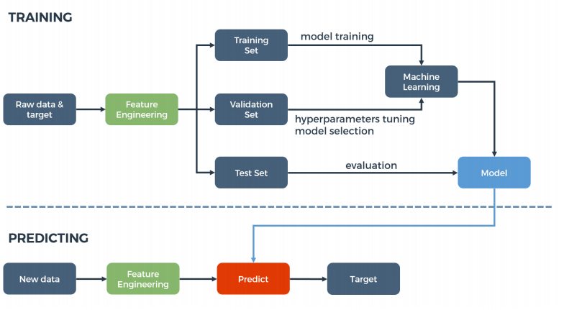

**Hardware/Software designing:**

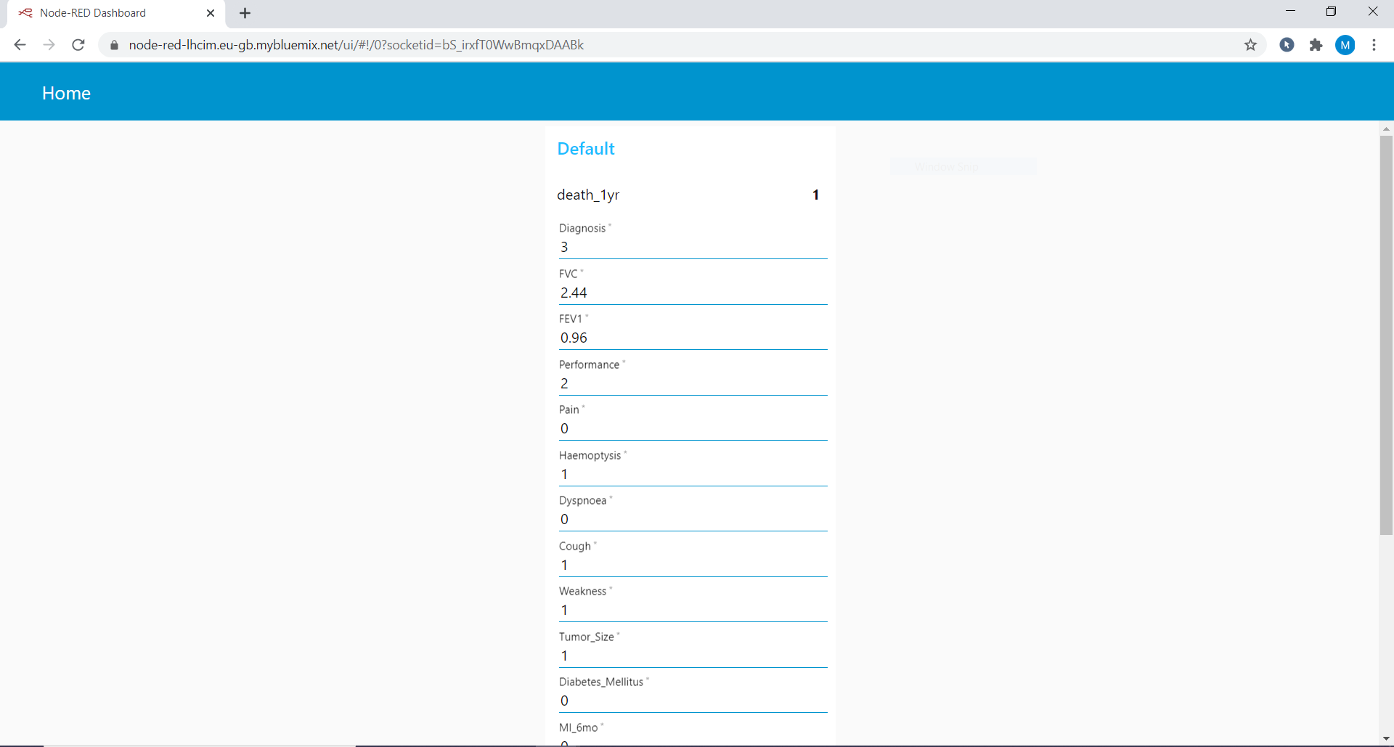

**EXPERIMENTAL INVESTIGATIONS:**

* Collection of data set from Kaggle.

<https://www.kaggle.com/sid321axn/thoraric-surgery>

* On IBM Watson studio machine learning using auto ai build a model to predict life expectancy.

➢ To do so first create account on IBM Watson studio.

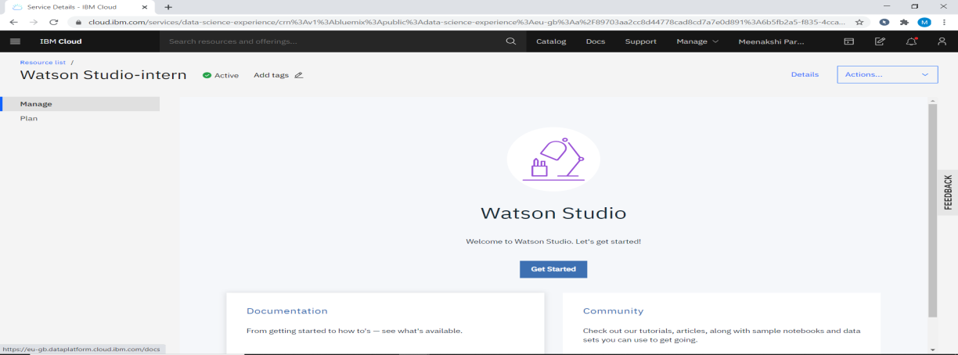

➢ Using Add to project choose auto AI.

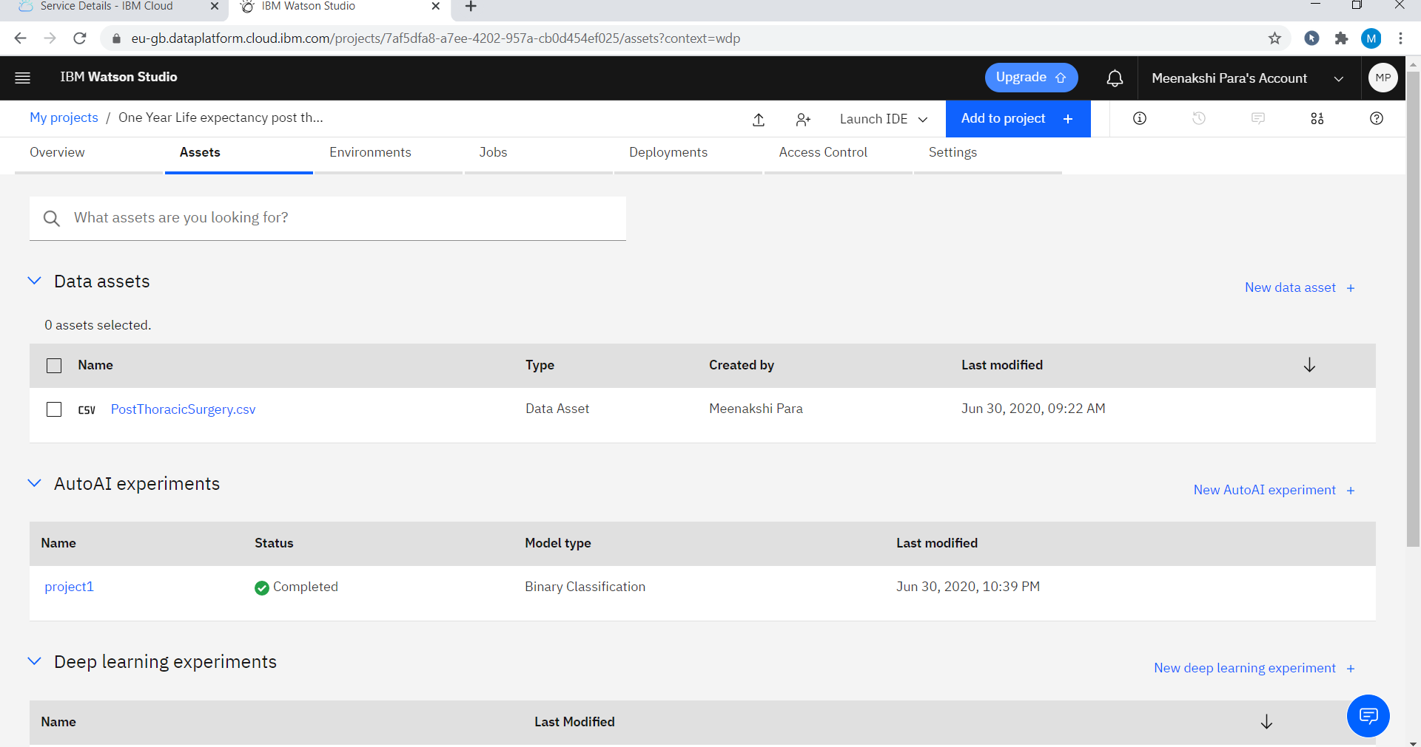

➢ Then upload data set

➢ Choose best way to predict.

➢ Save as a model which is on the top

➢ Deploy the model.

➢ Test the model.

➢ Create service credential

* Create cloud foundry app
* Make node-RED flow

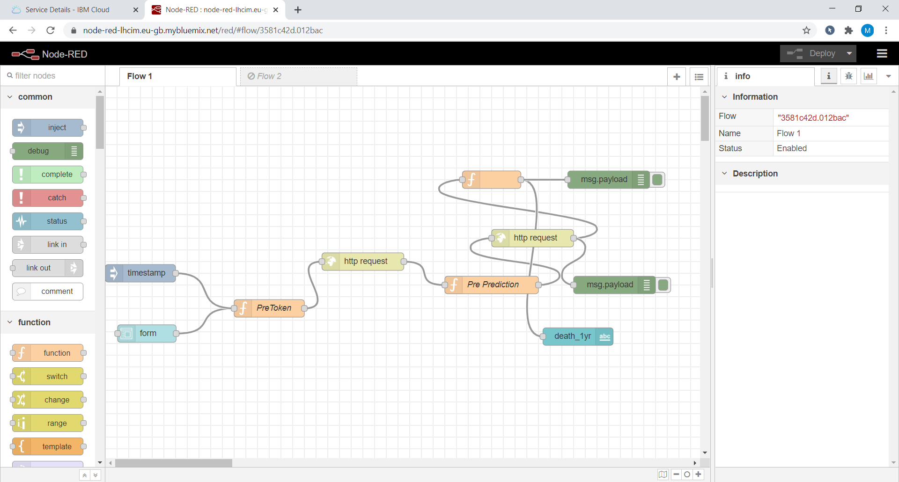

* After deploying the model from dashboard UI can be seen.

**FLOWCHART**



**RESULT**

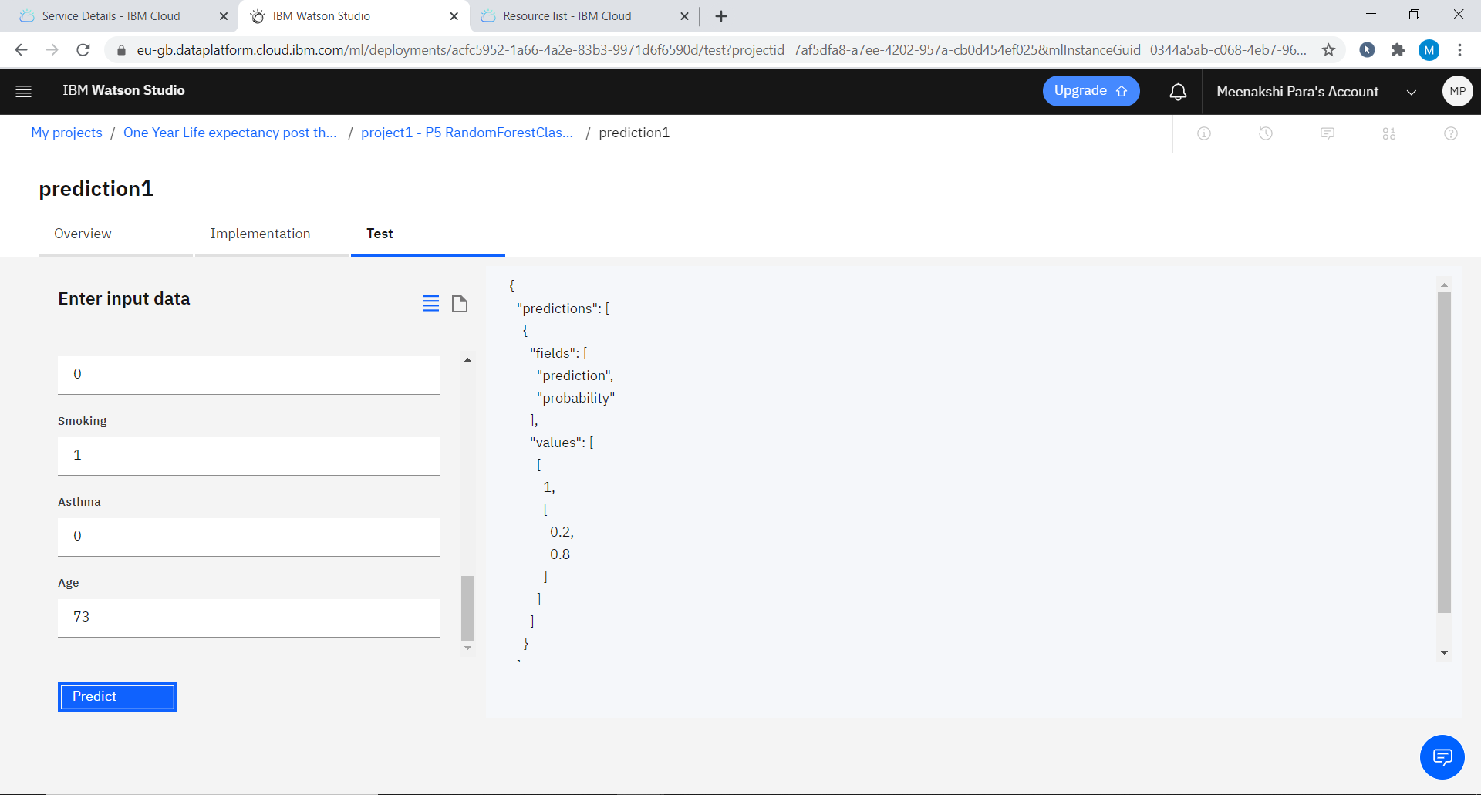

**CONCLUSION:**

I can honestly say that my time spent interning with Smartbridge resulted in one of the best summers of my life. I have gained new knowledge, skills and met many new people. I achieved my several learning goals. I got insight into professional practice. Related to my study I learned more about how to make a project, feed a model, train a model, prepare an UI and many more from IBM cloud. There is still a lot to discover and to improve. Bootcamps during this period was very helpful to complete my project. All mentors were very supportive.

The internship was also good to find out what my strengths and weaknesses are. This helped me to define what skills and knowledge I have to improve in the coming time.At last this internship has given me new insights and motivation to pursue a career in machine learning.