**ROCK IDENTIFICATION USING DEEP CONVOLUTION NEURAL NETWORK**

**1. Introduction:**

***1.1Overview:***

      The traditional method for rock classification is a manual work with many problems such as time-consuming and low accuracy. With the development of science and technology,

Artificial intelligence is successfully applied in many fields. Its application here has effectively identified rock types from the captured images of the rocks. Convolution neural network (CNN) is an important deep learning architecture. It can extract the image features automatically and has a high classify accuracy. It proposes an accurate approach for identifying rock types in the field based on image analysis. The results shows that this approach helps to solve several difficulties in identification of rock types in the field.

***1.2Purpose:***

      The aim of this project is to identify the rock types with the help of image analysis using deep convolutional neural networks.

**2. Literature Survey:**

***2.1 Existing Problem:***

     To identify a rock one should think like a geologist and examine its physical characteristics for clues. It is very difficult to identify the type of rock without undergoing some chemical tests and a few physical tests such as Color, Streak, Luster, Cleavage, Fracture, Hardness, Mohs hardness scale, Crystal Shape, Density and grade level. The most common rocks on earth are sedimentary rock, metamorphic rock and igneous rock. Sedimentary rocks are formed from pre-existing rocks or pieces of once-living organisms. They form from deposits that accumulate on the Earth's surface. Metamorphic rocks are formed under the surface of the earth from the metamorphosis (change) that occurs due to intense heat and pressure (squeezing).Igneous rocks (from the Greek word for fire) form when hot, molten rock crystallizes and solidifies.

***2.2 Proposed Solution:***

  By using convolution neural network one can build a AI system with machine learning algorithm for identifying the type of rock. Initial step is  the collection of dataset( images of types of rocks )with good quality of images. Then the data should to split into test and train data sets. Both will contains all categories of rocks. Appropriate algorithm is made to make the machine learn about the types of rocks. Then a web app is created with HTML to get desired output of the given input image.

**3. Theoretical Analysis:**

***3.1 Block Diagram:***

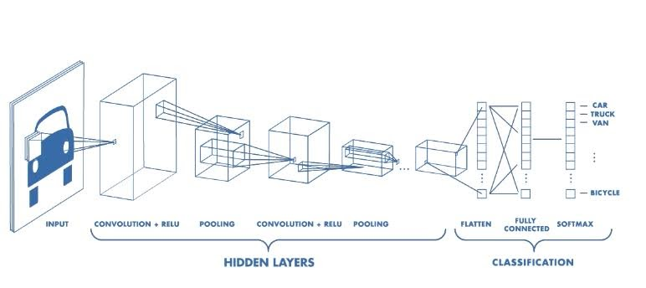

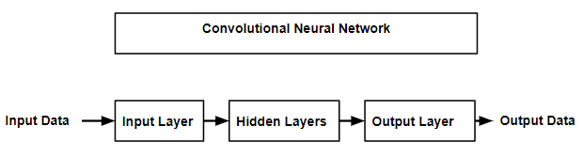

***3.2 Hardware / Software Designing:***

     While machine learning techniques have been increasingly applied to land cover classiﬁcation problems, these techniques have not focused on separating exposed bare rock from soil covered areas. Therefore, we built a convolutional neural network (CNN) to differentiate exposed bare rock from soil cover . The resulting CNN approach is likely scalable but dependent on high-quality imagery and high-performance algorithms using representative training sets informed by expert mapping. As image quality and quantity continue to increase globally, machine learning models that incorporate high-quality training data informed by geologic, topographic, or other topical maps may be applied to more effectively identify exposed rock in large image collections

**4. Flowchart:**

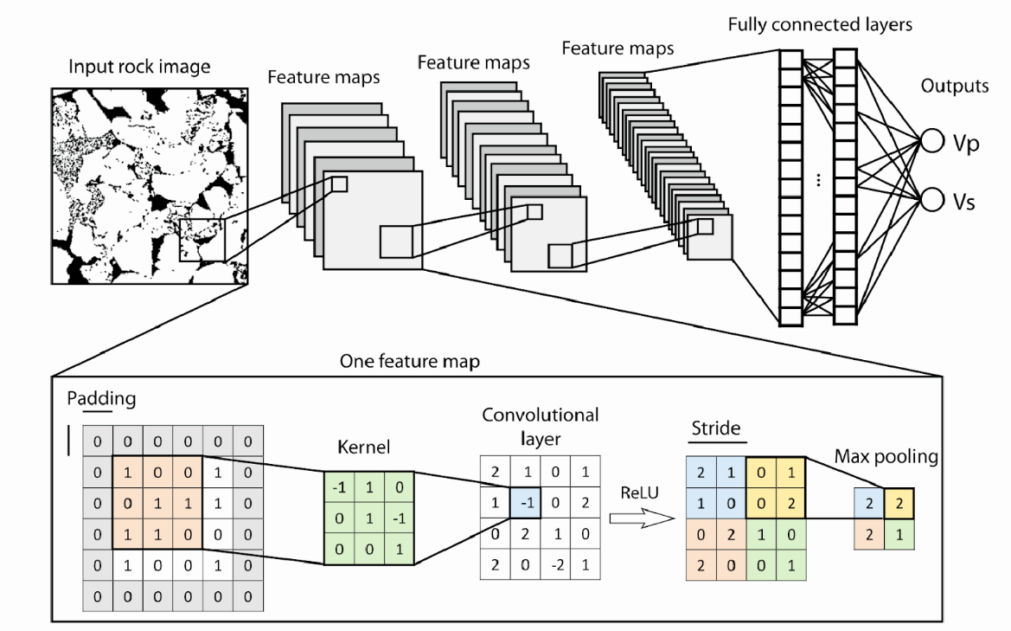

**5. Result:**

 The following is the output of the developed deep convolutional neural network.

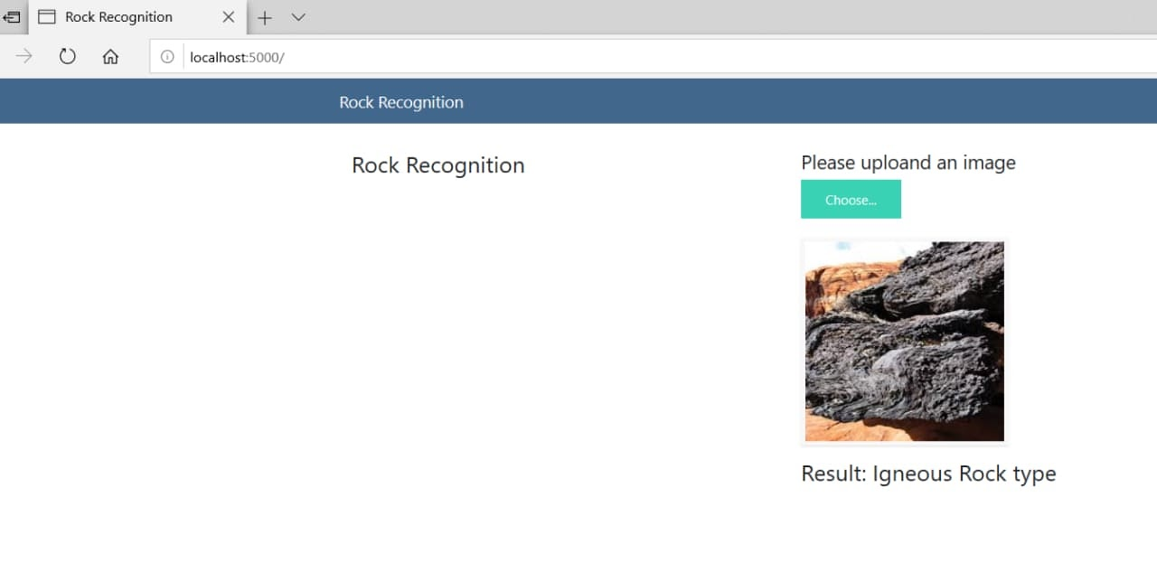

**6. Advantages & Disadvantages:**

Advantages:

* Will reduce the man power.
* Testing cost will be eliminated.
* This will reduces the time to identify the type of rock.

Disadvantages:

* It will result in the reduction  of job vacancies for people in this field.
* The result of the system may be uncertain.
* The resolution of images should be very high to get best results. Thus requires high quality camera.
* A big data of rocks are needed to train the AI system.

**7. Applications:**

    Any good rockhound is bound to come across a rock that a person has trouble identifying, especially if the location of where the rock was found is unknown. It is difficult to identify the type of rock.

       Now, with this AI system any one can know the type of rock just by uploading a single image of rock without having the basic knowledge in this field.

**8. Conclusion:**

     Finally, the type of rock is identified using deep convolution neural network with the desired output.

**9. Future Scope:**

     In this project the basic machine learning program is feed in the machine to identify the basic type of rock. By making this as a basic step to build  a good AI system that has a capability to identify the type of rock by feeding lot of data may help the geologist and the mining engineers in future.

**10. References:**

1. Rock Classification from Field Image Patches Analyzed Using a Deep Convolutional Neural Network. *Xiangjin Ran, Linfu Xue, Yanyan Zhang, Zeyu Liu, Xuejia Sang  and Jinxin He.*

www.mdpi.com/journal/mathematics

2. Rock images classification by using deep convolution neural network. *Guojian Cheng and Wenhui Guo*

IOP Conf. Series: Journal of Physics: Conf. Series 887 (2017) 012089

doi :10.1088/1742-6596/887/1/012089

3. Deep convolutional neural networks as a geological image classification tool. *Rafael Pires de Lima, Alicia Bonar, David Duarte Coronado, Kurt Marfurt, Charles Nicholson.*