**BREAST CANCER RISK PREDICTION USING IBM AUTO AI**

***DESCRIPTION:***

Breast cancer being one of the major causes of death worldwide it is very essential for the medical community and humanity to detect the lump in it's early stages.Early detection of the risk of breast cancer is instrumental in opening a gateway for treatment options, increased survival, and improved quality of life. Determining the risk of breast cancer in early stages is the key to healthy living and reduced deaths indeed.

***PROPOSED SOLUTION :***

Taking into account the various parameters involved and the changes developed in the lump area a machine learning model is developed that helps to predict the risk of cancer as early as possible. The machine learning model takes into consideration various parameters like the mean radius, mean texture, mean perimeter, mean area and mean smoothness and thereby predicts the risk of breast cancer in the format of 0 and 1.

The EarlyAware interface is the place where you get the predictions.

***INPUT PROVIDED***   ***:***

The input provided include mean radius,texture,perimeter,area and the smoothness which needs to be provided by the user. The input parameters can be integer or float datatypes. The user needs to submit the feed.

***OUTPUT EXPECTED :***

The output is predicted with the discrete value of 0 or 1. The person who is at a high risk of having cancer in near future is scaled to value 1. The person having no risk of cancer is scaled to 0 value. Thereby an important insight is provided to get the medical attention in time and to make a person more aware of the condition.

***THE  USER INTERFACE LAYOUT:***

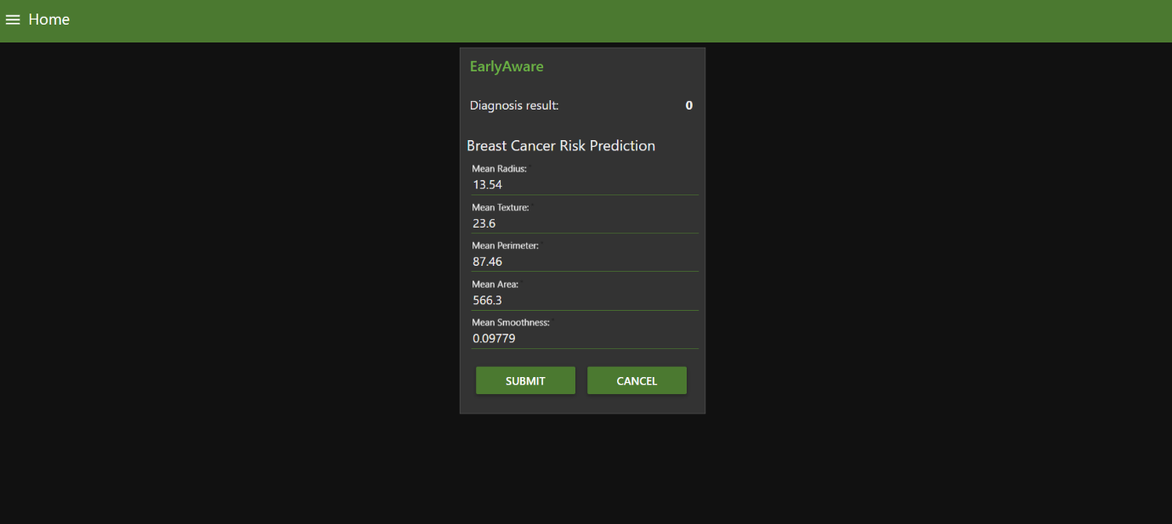

***TECHNOLOGY STACK:***

The entire machine learning model named EarlyAware is trained using Auto AI service in IBM Watson cloud and can be deployed in on web or mobile application environment. The UI to the model is provided by IBM Node-RED using json framework. The machine learning model build is based on heuristic algorithm that provides best possible optimization and a decent accuracy.

***LINK FOR THE PROJECT DEMONSTRATION:***

<https://drive.google.com/file/d/18ea5zDK3qFwOnrdq94uhcBb9UH5HrVor/view?usp=sharing>

(Please view this link for working video demonstration)

***SOCIAL IMPACT:***

The Machine learning model can thus predict the early risk of cancer and further prove to be a milestone in cancer related work, research and cure. It can provide newer insights to the medical fraternity to bring down the number of deaths due to breast cancer in collaboration with the machine learning model.

**BREAST CANCER RISK PREDICTION USING IBM AUTO AI**

***DESCRIPTION:***

Breast cancer being one of the major causes of death worldwide it is very essential for the medical community and humanity to detect the lump in it's early stages.Early detection of the risk of breast cancer is instrumental in opening a gateway for treatment options, increased survival, and improved quality of life. Determining the risk of breast cancer in early stages is the key to healthy living and reduced deaths indeed.

***PURPOSE:***

The main purpose of this project integrated with the machine learning model is to provide future insights to the doctors to early predict the risk of cancer in early stages. Due to it a doctor can even carry out studies and research work to know how cancer develops or what are the specifics that lead in to the lump formation. It can make the studies more concrete.

***EXISTING PROBLEM:***

There are various processes in order to diagnose cancer like the mamography. However it is not sufficient enough as it only let's us know cancer after it has surfaced and not before surfacing. Hence there is high risk of a person losing his life due to it. As the saying goesprevention is better than cure this model can predict the risk in a timely manner.

***PROPOSED SOLUTION :***

Taking into account the various parameters involved and the changes developed in the lump area a machine learning model is developed that helps to predict the risk of cancer as early as possible. The machine learning model takes into consideration various parameters like the mean radius, mean texture, mean perimeter, mean area and mean smoothness and thereby predicts the risk of breast cancer in the format of 0 and 1.

The EarlyAware interface is the place where you get the predictions.

***INPUT PROVIDED***   ***:***

The input provided include mean radius,texture,perimeter,area and the smoothness which needs to be provided by the user. The input parameters can be integer or float datatypes. The user needs to submit the feed.

***OUTPUT EXPECTED :***

The output is predicted with the discrete value of 0 or 1. The person who is at a high risk of having cancer in near future is scaled to value 1. The person having no risk of cancer is scaled to 0 value. Thereby an important insight is provided to get the medical attention in time and to make a person more aware of the condition.

***THE  USER INTERFACE LAYOUT OR THE RESULT:***



***ADVANTAGES:***

The main advantage of the entire process of machine learning is that it does not need any gigantic environment. A well trained model can fulfill all the requirements and even it can produce accurate results. It can further help researchers to understand the patterns in cancer patients and thereby come up with some threshold parameters. It can help researchers to detect cancer in early stages.

***DISADVANTAGES:***

At present the only disadvantage associated with the machine learning model is that it does not give the extreme exact accuracy but however with the bigger datasets the entire accuracy can be marginally increased.

***APPLICATION:***

The major application of the entire model is that it helps to predict the risk of cancer in it's initial stages without further complications.

It can help researchers to gain insights to understand the patterns of cancer and come forward with greater research.

The social stigma associated with it can be weakened and people can be made more optimistic about the disease.

***TECHNOLOGY STACK AND HARDWARE/SOFTWARE DESIGNING:***

The entire machine learning model named EarlyAware is trained using Auto AI service in IBM Watson cloud and can be deployed in on web or mobile application environment. The UI to the model is provided by IBM Node-RED using json framework. The machine learning model build is based on heuristic algorithm that provides best possible optimization and a decent accuracy. It makes use of various languages like html, css, json, javascript. The main language used here is python which is quite influential in training the machine learning model. The IBM cloud, IBM auto AI and IBM nodered services provide the entire architecture for the UI.

***BIBLIOGRAPHY:***

These are the various insights and datasets inferred from AI for social good by merinsha asuwal. The various insights are also taken from cancer research institute and cancer research journals.

***LINK FOR THE PROJECT DEMONSTRATION:***

<https://drive.google.com/file/d/18ea5zDK3qFwOnrdq94uhcBb9UH5HrVor/view?usp=sharing>

(Please view this link for working video demonstration)

***SOCIAL IMPACT AND FUTURE SCOPE:***

The Machine learning model can thus predict the early risk of cancer and further prove to be a milestone in cancer related work, research and cure. It can provide newer insights to the medical fraternity to bring down the number of deaths due to breast cancer in collaboration with the machine learning model. In future the accuracy can be increased marginally by training the model with huge dataset.