**ELECTRONIC VOTING MACHINE USING NODE MCU**

**Introduction:**

We all are quite familiar with Electronic Voting Machines, where your vote gets registered electronically and you don’t need to use ballot paper to vote in election. Today security is a major concern and it also needs to be ensured that someone can’t vote twice, so this problem can be solved by introducing Finger Print Based Voting, where a person can be authorized based on his finger Print. This will also stops fake voting.

**project description:**

while registering for the voting the users should enroll their fingerprint and it will be stored in the database

While voting the user has to scan their fingerprint, if the fingerprint it matched then only he will be given access to vote

After entering inside he needs to press the button of the specific party to which he wants to vote

Every data is stored in the cloud platform

After voting is done the admin can view the results using the web application

**software/hardware designing:**

The hardware part of the project involves the ESP8266 model. The buttons, OLED (GM009605) and buzzer are connected to the ESP8266.

The software part of the project involves cloudant DB, Nodered, IBM Watson cloud Platform, iot IBM platform and Web/Mobile app.

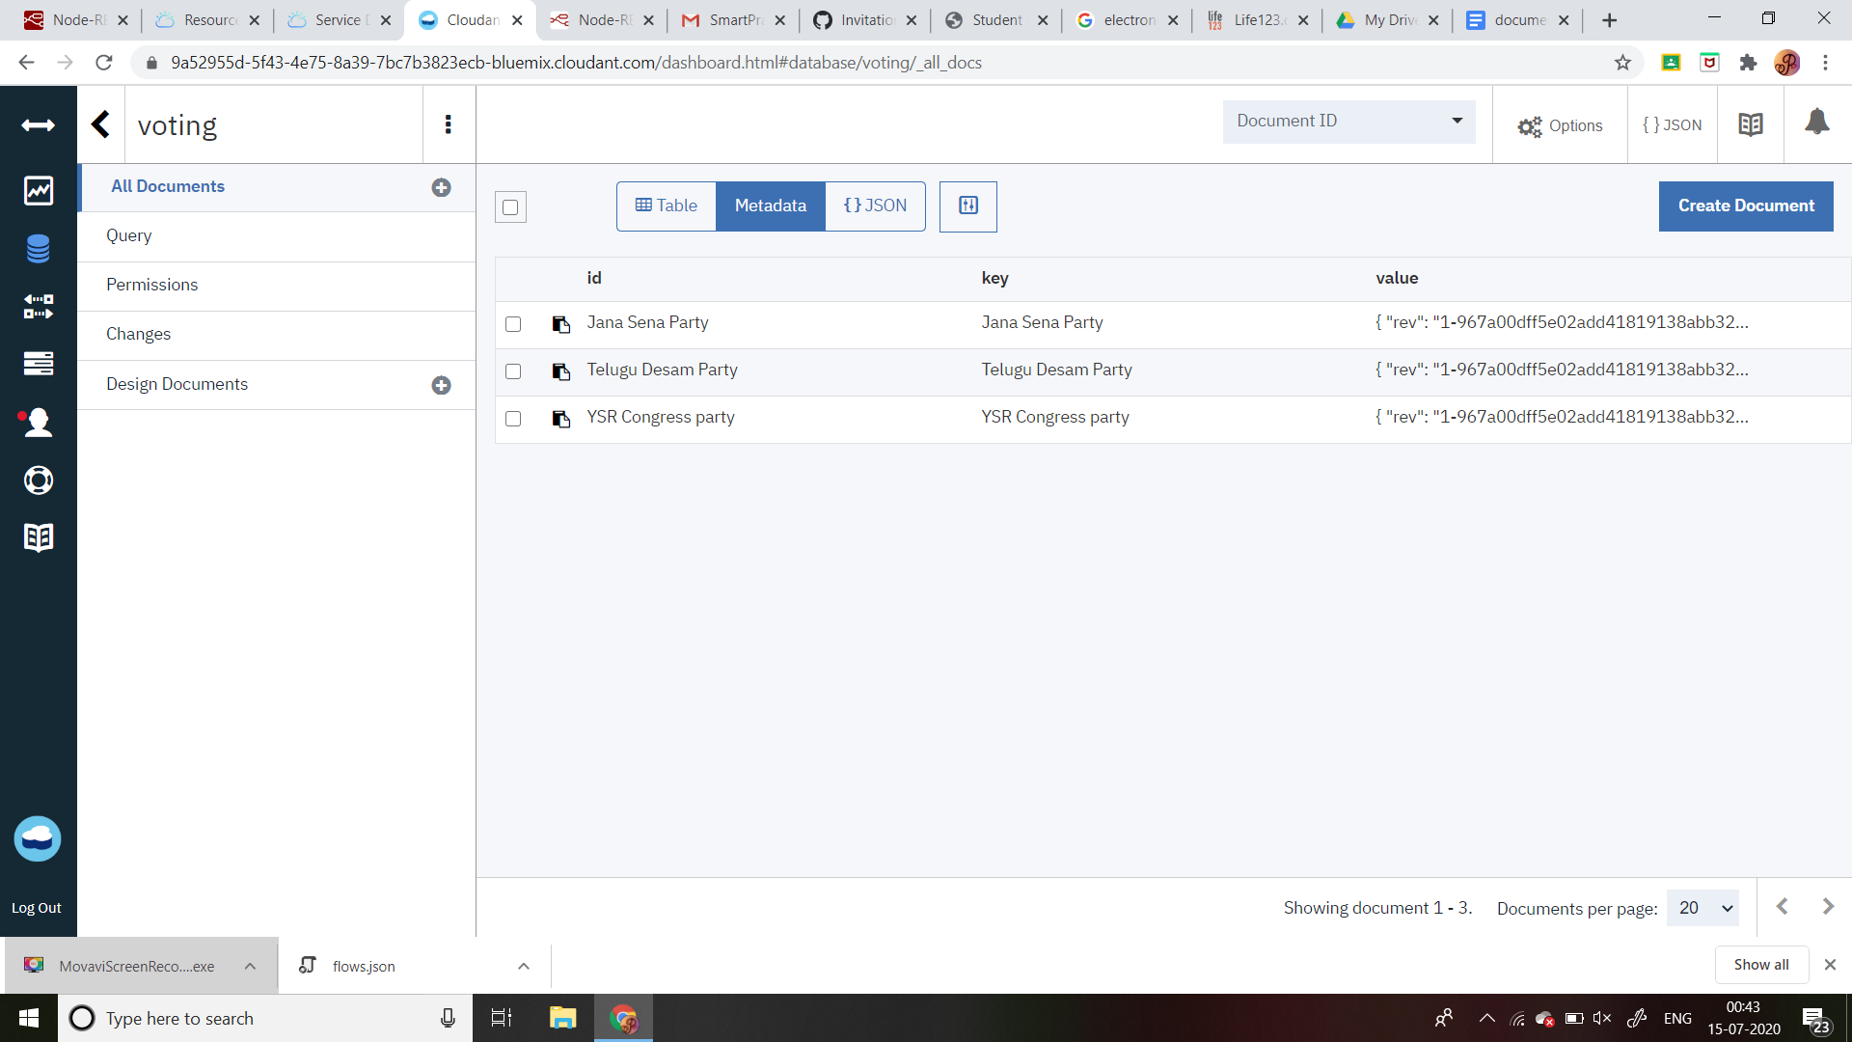

Figure 1: Database Screenshot

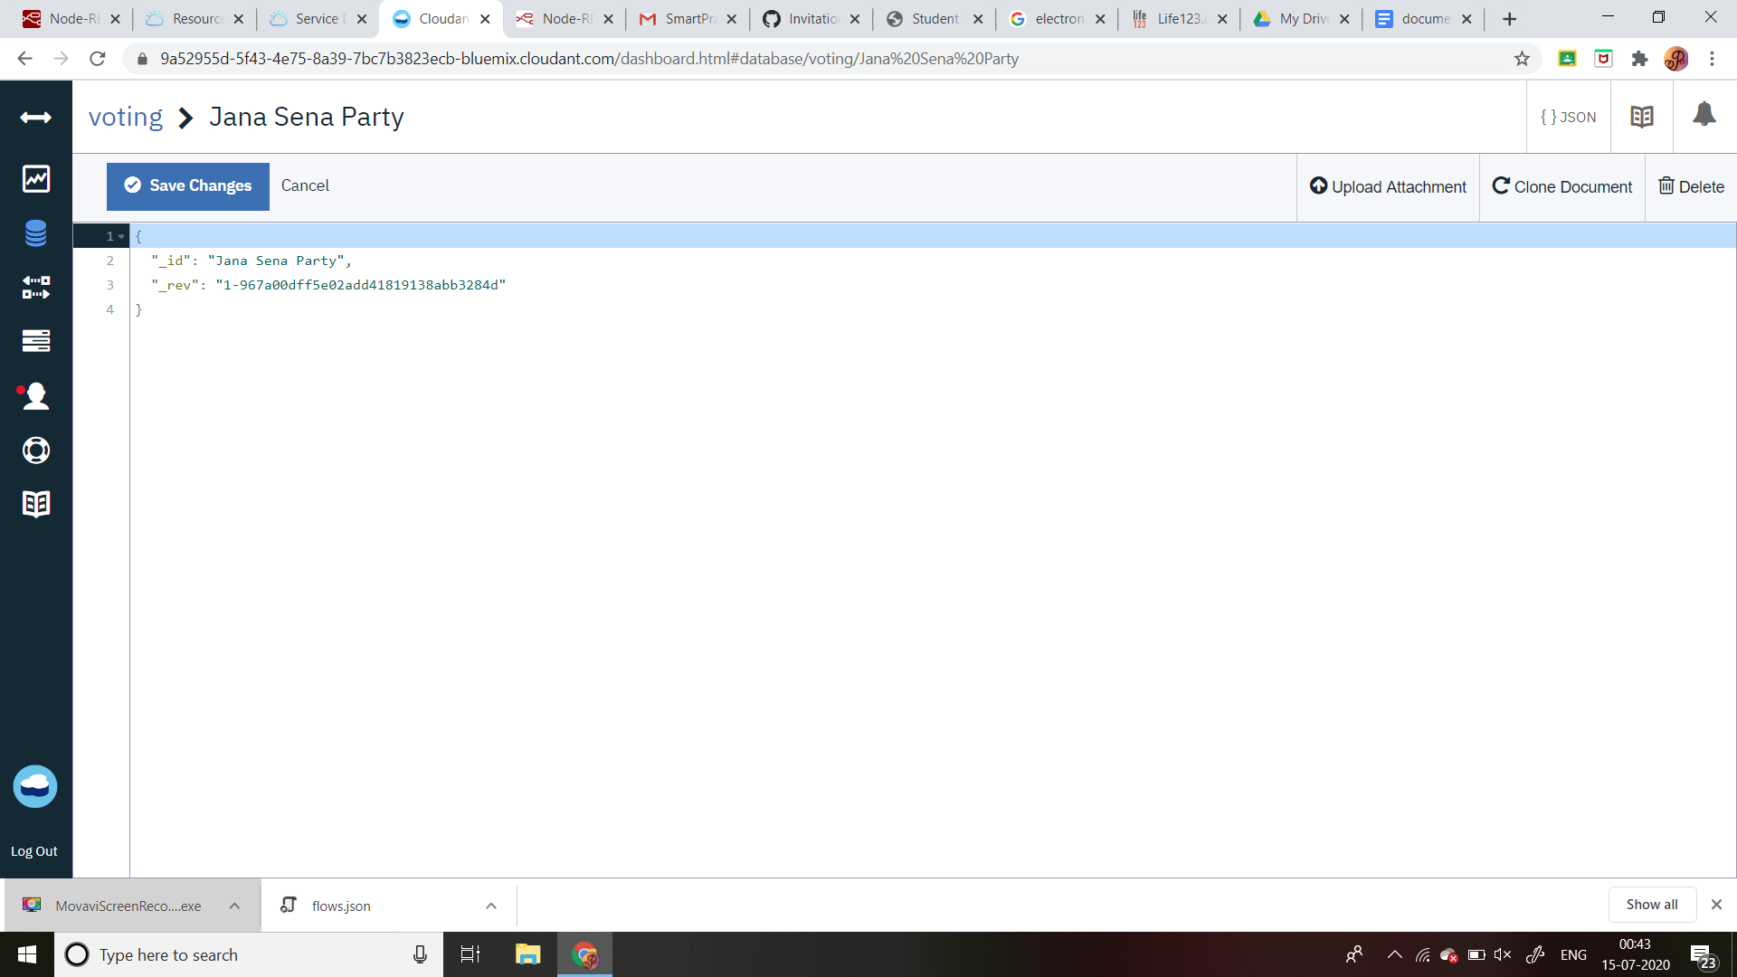

Figure 2:Sample Database Document Screenshot

**Advantages & Disadvantages:**

**Advantages of electronic voting machine:**

* Electronic voting technology intends to speed the counting of ballots, reduce the cost of paying staff to count votes manually and can provide improved accessibility for disabled voters
* Results can be reported and published faster
* oters save time and cost by being able to vote independently from their location
* For the country, electronic voting may improve the country's image and serve as a promotion.

**Disadvantages of electronic voting machine:**

1.voting machines are also notorious for misuse

2.secure storage of cast votes

**Output Screenshots:**

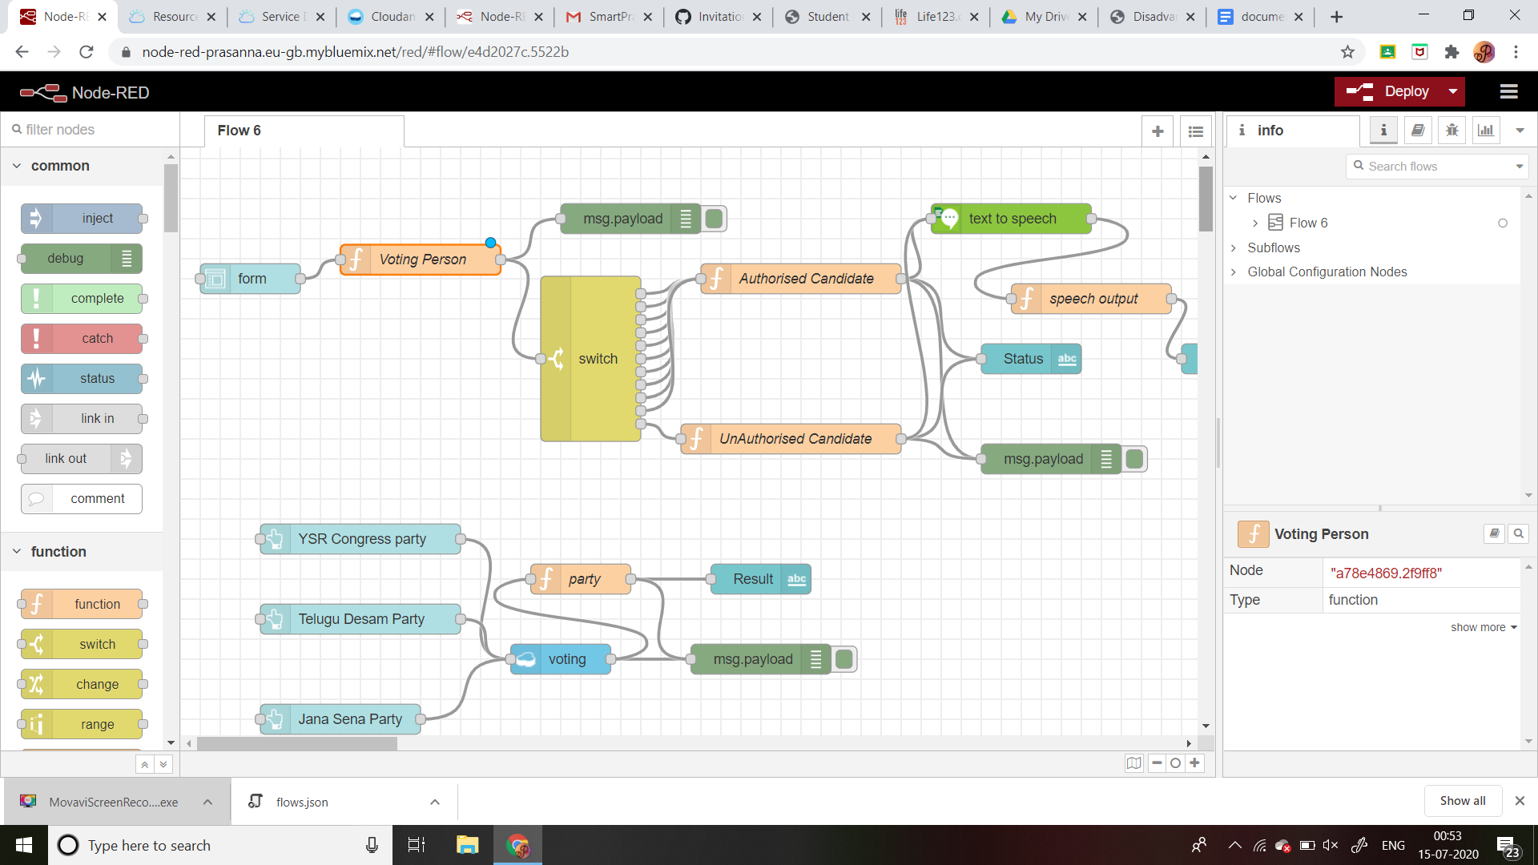

Figure 3:NodeRed flow and out on the Debug Screen

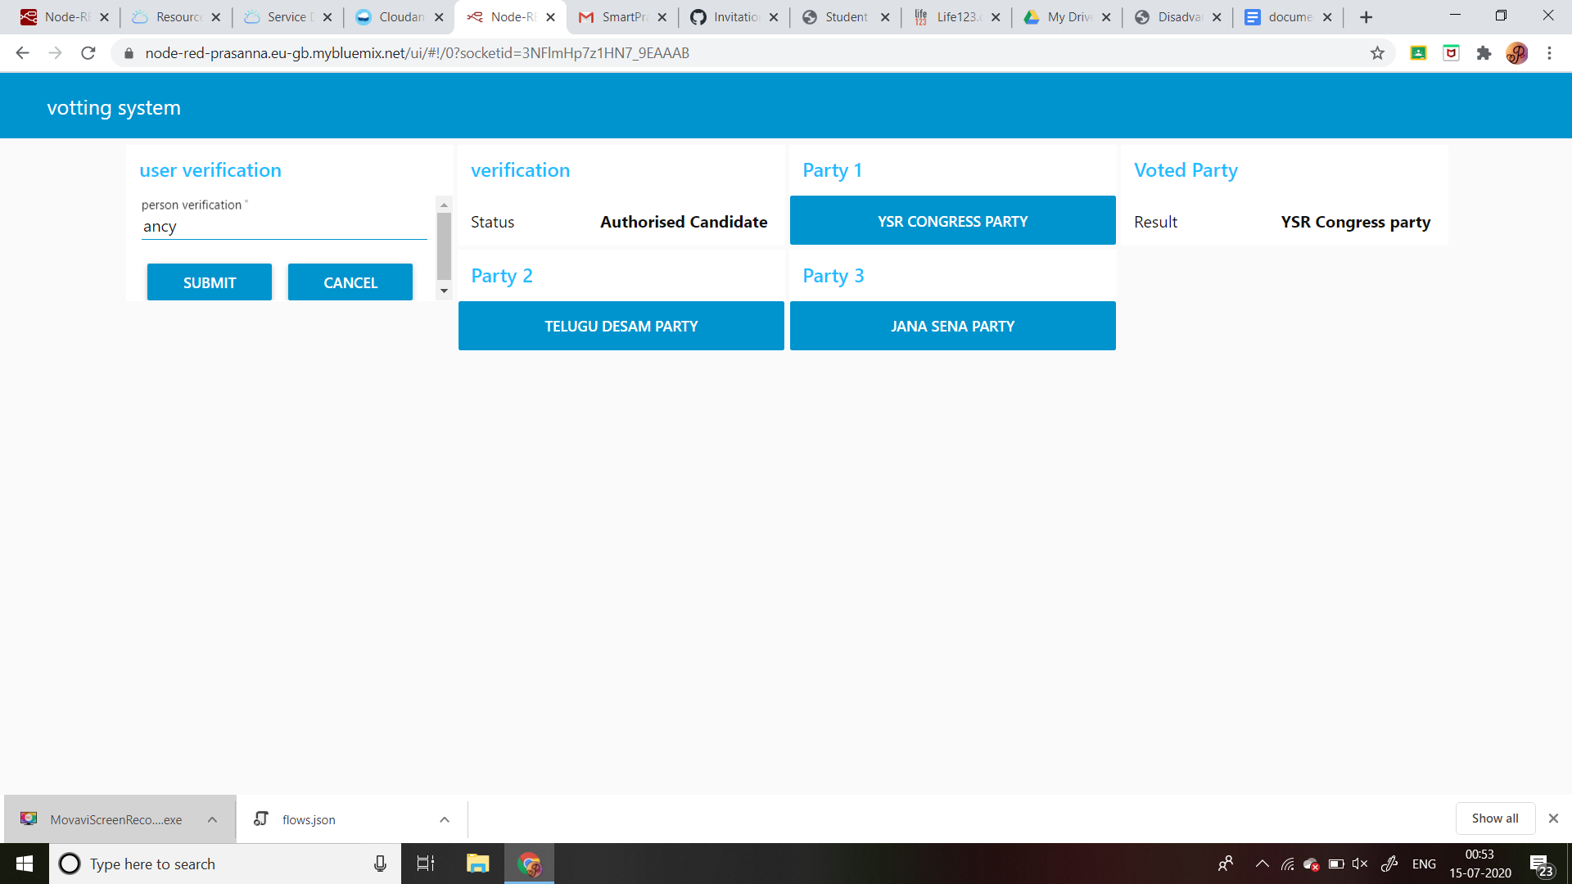

Figure 4:out put on User Interface

**Conclusion:**

The conclusion for the project is to give where a person can be authorized based on his finger Print. This will also stops fake voting.

**Future Scope:**

It increases more applications and different problems and it increases opportunities and decreases problems.