**Personal Assistance For Independent**

**Senior Citizens**

**Introduction:**

In recent times, development in computing and consumer electronics technologies have triggered Internet of Things (IoT) paradigm. Internet of Things (IoT) is described as enabler that links seamless objects surrounding the environment and performs some sort of message exchange among them. The Internet of Things (IoT) is a collection of objects that work jointly in order to serve consumer tasks in a federated manner. It binds computational power to deliver data about the surrounding environments. In current water billing system, each building consists of one analog water meter and the total bill amount is equally divided to each home in that building, irrespective of what amount of water that home has consumed, our system is cost effective enough to be installed in every household, floors. And also many of the watering Systems used in the process are analog (mechanical) and digital meter both meters however don’t give the facility to read out the values and communicate it timely to the user, allowing the user to monitor the usage on a daily basis and therefore helps in future planning of water usage and thus helps in water conservation measures.

**Purpose:**

At present user has to wait till the end of the month to know his water usage and the water bill usage detailed is the total amount, the daily usage data virtually can’t be accessed by the user. And apart from that the delivery of the water bill is bogged by delay as person from water has

to come and provide the bill. Our project aims to eliminate all the said issues, by giving user Timely Notification and SMS to the user’s mobile, the water usage on a daily basis can be accessed through free cloud platform, and the total amount of water.

**Literature survey:**

This model has designed and implemented wireless sensor network for measuring utilities such as electricity, water. Because of disadvantages of traditional meter reading such as errors in reading, International Journal of Engineering Research in Computer Science and Engineering (IJERCSE) Volume 4, Issue 4, April 2017

ISSN (Online) 2394-2320 inaccuracy, external conditions affecting readings, delayed work we have implemented meter reading system based on IOT technology. This system performs tasks such as taking meter reading, distribution of bills, sending notice. An automatic remote meter reading system based on GSM is presented in this paper. This paper is useful to obtain meter reading when desired so meter readers don’t need to visit each customer for the consumed data collection and to distribute the bill slips. Microcontroller can be used to monitor and record the meter readings. In case of a customer defaulter, no need to send a person of utility to cut off the customer connection. Utility can cut off and reconnect the customer connection by short message service (SMS). Furthermore, the customer can check the status of consumption just by sending a simple SMS request. In this system energy meter readings are being transferred by making use of GSM. Water utility customers also have an important role in leakage control. It essential that this resource can be captured not only because it is an increasing scarce supply but also because of its embedded energy and the greenhouse gas footprint it represents. Although in many parts of the country water might be considered the cheapest utility commodity, water loss is still very costly to customers and water utilities

**Existing problem:**

In current water billing system, each building consists of one analog water meter and the total bill amount is equally divided to each home in that building, irrespective of what amount of water that home has consumed, our system is cost effective enough to be installed in every household, floors. And also many of the watering Systems used in the process are analog (mechanical) and digital meter both meters however don’t give the facility to read out the values and communicate it timely to the user, allowing the user to monitor the usage on a daily basis and therefore helps in future planning of water usage and thus helps in water conservation measures.

**Proposed solution:**

The prototype for the flow conservation is to measure inflow and outflow of water. Water supplied from water distribution Authority is stored in ground level reservoirs and overhead tanks and is further distributed to rest of the consumers. This project installs flow measurement sensors at the input and then measure water volume in the water reservoirs. The volume of water inside the reservoir would give the accumulated difference

between inflow and outflow of water. Hence, then the outflow can be calculated.

**Block diagram:**

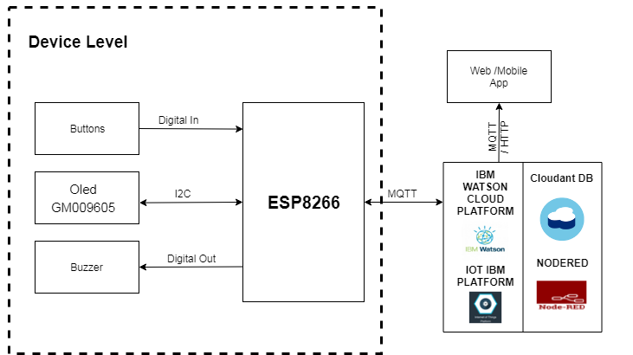

Figure 1: Block diagram

**Software/hardware designing:**

The hardware part of the project involves the ESP8266 model. The buttons, Oled (GM009605) and buzzer are connected to the ESP8266.

The software part of the project involves Cloudant DB, Nodered, Ibm Watson cloud Platform, iot Ibm platform and Web/Mobile app.

**Experimental investigations:**

There are several IOT authentication challenges and issues that need to be understood before employing the right security solution that can dynamically vary with the situation based on certain critical situations such as IOT health applications, frequent authorization and authentication are necessary and cloud dynamically vary, potentially resulting in changes to the authorization of Iot devices. To address these issues, automated mutual authentication without user intervention is required in supporting users from remembering passwords for a large number of devices.

**Flowchart:**

**Advantages & Disadvantages:**

**Advantages of IOT in Personal Assistance:**

* Just like any other company and business, having the appropriate tools is crucial to the success or failure of the business. One of the critical tools used for the operations of any company. It is important for every company to own and use efficient and effective [water billing system](http://www.quikwaters.com/) in place. Having the appropriate software in place is important for many reasons. It helps every business to be more effective and efficient in the general billing methods whilst helping boost productivity
* New water technologies can help the internal billing procedures into an effective, easy and simple to use system. So, if your business is seeking for the best and something that could boost productivity while minimizing the customer responses and increase customer satisfaction, you need to research and find the best one that is appropriate for your business needs.
* These systems are usually integrated with any software can help to create quick print outs of bills. They can compute complicated bills in just a minute or less than an hour. That is why, the task associated with the accountant and store manager is made a lot easier. Billing systems are simple to learn, understand and use which can also execute and outsource any service.

**Disadvantages of IOT in Personal Assistance:**

* Automatic water billing system came into existence because of human error and inconsistence that is associated with manually operated system. There is also problem in the process of turn ON-OFF the water pump.

**Applications:**

* Medicine intake.
* Emergency alerts to doctors.
* Emergency alerts to family members.

**Conclusion:**

Conservation methods and technologies that support water preservation and management is an area of increased priority. By investing in such technologies and systems now, communities can significantly reduce consumption and ease the strain on our nation’s water supplies. The paper describes the design and working of Smart Energy Meter and represents how Smart Energy Meter can be used for Automatic Meter Reading. It is the most economical implementation to develop mankind in this era of technology.

**Future Scope:**

It increases more applications and different problems and it increases opportunities and decreases problems.