**Predictive Analytics For Retail Banking**

**Project Report**

-Submitted By:

**Praveenraj S**

**Prem Sai Bhyri**

**Sahana R**

**Gopinath V**

**Contents**:

|  |  |  |  |  |  |  |  |  |  |  |
| --- | --- | --- | --- | --- | --- | --- | --- | --- | --- | --- |
|  | **INTRODUCTION** | | | |  | | |  |  | |
|  | 1.1 Overview | | | |  | | |  |  | |
|  | 1.2 Purpose | | | |  | | |  |  | |
|  | **LITERATURE SURVEY** | | | |  | | |  |  | |
|  | 2.1 Existing Problem | | | | | | |  |  | |
|  | 2.2 Proposed Solution | | | | | | |  |  | |
|  | **THEORITICAL ANALYSIS** | | | |  | | |  |  | |
|  | 3.1 Block Diagram | | | |  | | |  |  | |
|  | 3.2 Software Designing | | | | | | |  |  | |
|  | **EXPERIMENTAL INVESTIGATIONS** | | | | | | |  |  | |
|  | **FLOWCHART** | | | |  | | |  |  | |
|  | **RESULT** | |  | |  | | |  |  | |
|  | **ADVANTAGES & DISADVANTAGES** | | | | | | |  |  | |
|  | **APPLICATIONS** | | | |  | | |  |  | |
|  | **CONCLUSION** | | | |  | | |  |  | |
|  | **FUTURE SCOPE** | | | | **`** | | |  |  | |
|  | **BIBILOGRAPHY** | | | |  | | |  |  | |
|  | **APPENDIX** | | | |  | | |  |  | |
| Source Code | |  | |  | |  |  | | |

**Abstract:**

Today banks are facing intensive competition due to the gradual growth of many banks as well as due to the increase in demands of the customers. Customers easily switch to another bank if the other bank is providing them more benefits and facilities that they want. To tap these needs of the customers and reduce the customer attrition, many banking institutions are using predictive analytics. Using the predictive analytics banks are trying to improve their relationship with customer, and retain their existing customers and also devise effective mechanism for marketing.

**INTRODUCTION**:

**Overview of the Project:**

Predictive analytics is the process of using computer models to predict future events. Sophisticated programs rely on artificial intelligence, data mining, and machine learning to analyze enormous amounts of information. With those resources, the model attempts to determine what is likely to happen next, given current conditions.

**The term “predictive” doesn't mean the models always predict the future accurately. It means they deliver their best prediction based on the available information.**

For better or worse, institutions use a variety of data sources and machine learning. For example, they have your transaction history, and they may tie in demographic information and additional details from external databases.

**Purpose:**

In banking, analytics can use data to help customers manage their accounts and complete banking tasks quickly. Financial institutions also benefit by reducing risk and minimizing costs.

Aim of the project is to show how a simple predictive analytics exercise may be carried out on real data using open source statistical modeling software.

To demonstrate how the results from a predictive analytics study can be applied to produce real, tangible improvements in a company’s business performance.

The data which we are considering is related with direct marketing campaigns of a banking institution. The marketing campaigns were based on phone calls. Often, more than one contact to the same client was required, in order to access if the product (bank term deposit) would be ('yes') or not ('no') subscribed. The goal is to predict if the client will subscribe a term deposit or not. An application is also build which integrates with the model.

**LITERATURE SURVEY:**

**Existing Problem:**

In Retail Banking there are many challenges some of them are:

1. **Increasing Competition**
2. **Organizational Silos**
3. **Acting Fast**
4. **A Single View of the Customer**
5. **Innovation**
6. **Cost Reduction**
7. **Improving the Customer Experience**
8. **Employee Engagement and Retention**

**Proposed Solution:**

Retail banking customer segmentation is key to retaining customers. Similarly, it can help drive up their lifetime value (LTV). Lifecycle marketing can help you create engaging conversations in every stage of their journey. By segmenting customers this way, you can apply a marketing strategy that communicates the right message at the right time.

For instance, running a data model can help you predict which customers are most likely to churn. This way, you can reach out to them to understand their needs and provide an offering that suits their needs. By reaching out to them in a timely manner, you reduce the risk of churn.

When you create an integrated system of data and provide actionable insights to every relevant employee, you create a culture of ownership With this becoming an organization-wide outlook, your customers will surely feel the difference in the personalized service that they receive.

Predicting by manual methods takes more time, So, we have used Machine Learning Techinque to predict

**THEORITICAL ANALYSIS:**

**Block Diagram:**

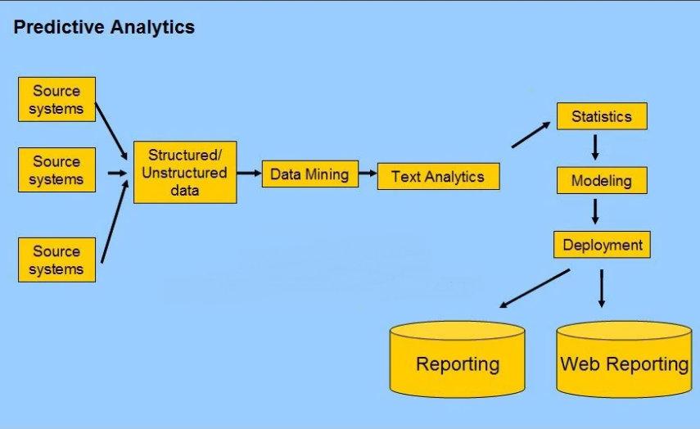

**Software Designing:**

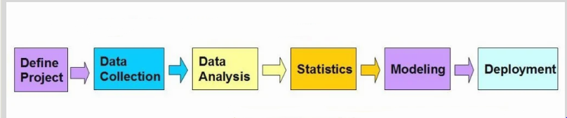

**i) Define Project:**

Define the project outcomes, deliverables, scoping of the effort, business objectives, identify the data sets which are going to be used.

**ii) Data Collection:**

Data Mining for predictive analysis prepares data from multiple sources for analysis. This provides a complete view of the customer interactions.

**iii) Data Preprocessing:**

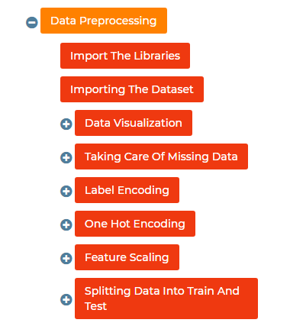

It is the process of inspecting, cleaning, transforming, and modeling data with the objective of discovering useful information, arriving at conclusions.

**iv) Statistics:**

It enables to validate the assumptions, hypotheses and test them with using standard statistical models.

**v) Modeling:**

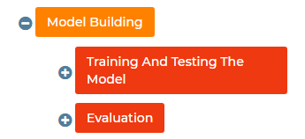

Predictive Modeling provides the ability to automatically create accurate predictive models about future. There are also options to choose the best solution with multi model evaluation.

**vi) Deployment:**

Predictive Model Deployment provides the option to deploy the analytical results in to the every day decision making process to get results, reports and output by automating the decisions based on the modeling.

**vii) Model Monitoring:**

Models are managed and monitored to review the model performance to ensure that it is providing the results expected

**viii) Web Reporting:**

To view the result the web reporting is done, Online project reports makers often use graphs, images, and charts to visually present useful information such as project status, length of activity, and time spent doing each task. These reports are easy to interpret, making them an ideal way of communicating the latest updates to all consumers.

**EXPERIMENTAL INVESTIGATIONS:**

The project is about for the given features whether the customer deposits the amount are not for that, We have created a dataset, pre-processed it by **Data visualizing** for checking the outliers then the categorical columns are encoded using **Label Encoding technique** and **One Hot Encoding Technique** after which the training and test is done with **Random Forest Algorithm** for finding the accuracy, then the front end part is created by **Bootstrap, HTML, CSS file**, we deployed the model by using **Flask** In front end user should give in category so, encoding technique is used here, then the output is send through HTML file to the user.

**FLOWCHART:**

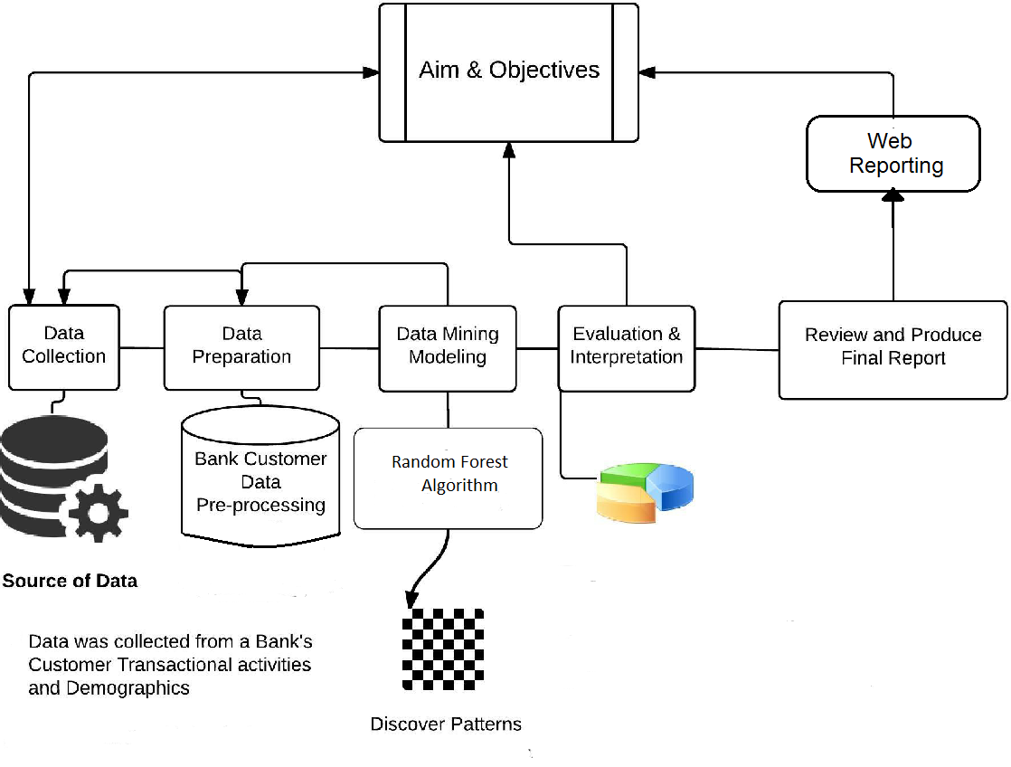

**RESULT:**

We got an accuracy of 0.81 which is good measure for predicting Retail Banking analysis. The Model predicts the stage with good efficiency.

**ADVANTAGES & DISADVANTAGES:**

**Advantages of Predictive analysis for Retail Banking:**

In its multiple forms—predictive modeling, decision analysis and optimization, transaction profiling, and predictive search—predictive analytics can be applied to a range of business strategies and has been a key player in search advertising and recommendation engines. These techniques can provide managers and executives with decision-making tools to influence upselling, sales and revenue forecasting, manufacturing optimization, and even new product development. Though useful and beneficial, predictive analytics isn’t for everyone.

**Dis-Advantages of Predictive analysis for Retail Banking:**

A company that wishes to utilize data-driven decision-making needs to have access to substantial relevant data from a range of activities, and sometimes big data sets are hard to come by. Even if a company has sufficient data, critics argue that when anticipating human behaviour computers and algorithms fail to consider variables—from changing weather to moods to relationships—that might influence customer-purchasing patterns.

Time also plays a role in how well these techniques work. Though a model may be successful at one point in time, customer behaviour changes with time and therefore a model must be updated. The financial crisis in 2008-2009 exemplifies how crucial time consideration is because invalid models were predicting the likelihood of mortgage customers repaying loans without considering the possibility that housing prices might drop.

**APPLICATIONS:**

i) Customer relationship management(CRM)

ii) Health Care

iii) Collection Analytics

iv) Cross Sell

v) Fraud detection

vi) Risk Management

vii) Direct Marketing

viii) Underwriting

**CONCLUSION:**

Understanding the importance of analytics is very important. Banks should understand its potential, and how its power which is limitless can be utilized to the fullest. When using analytics, banks should bear in mind the needs of the customer, which is the base or the core of the analytics to be successful. There is a wide range of data generated everyday which goes untapped from various sources such as emails, social media, CRM and so on. With analytics, retail banks can use this data to drive key business decisions and deliver proactive services to the customers and also formulate business strategies. It has been observed that the use of analytics has been enhanced in the last decade; many companies are using analytics to satisfy their customer, retain them and also make decision about the right product to right customer at right time so as to increase the financial standings of the companies.

**FUTURE SCOPE:**

Data is the new science and driving force for every industry’s growth, financial institutions being one of it. Banking industry has incorporated the traits that were once limited just to segment like data and analytics. Over the last couple of years, the spurt of big data has opened up enormous opportunities for the banking sector to grow. Data is seen as the most valuable asset to successfully stabilise the overall evolving banking environment.

1. **Better Personalisation With Rich Data**
2. **The Growth Prospect of Open Banking**
3. **Digital-only Banking**
4. **Payments Infrastructure**
5. **Incorporation of Advanced Analytics**

**BIBILOGRAPHY:**

1. Jupiter
2. Spyder
3. Visual Studio code
4. Flask
5. HTML, CSS and Bootstrap( front-end Frame work)

**APPENDIX:**

**Source Code:**

Notebook:

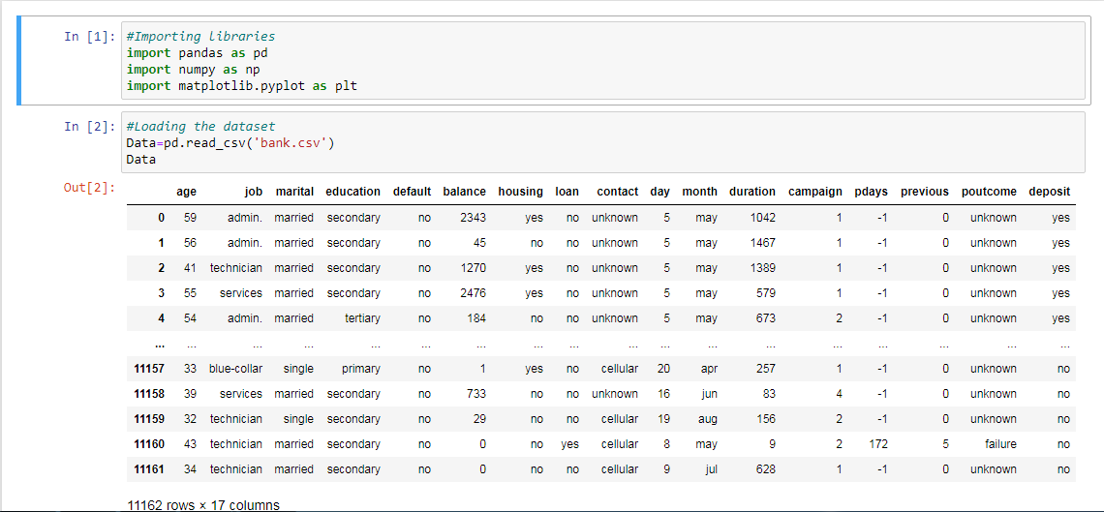

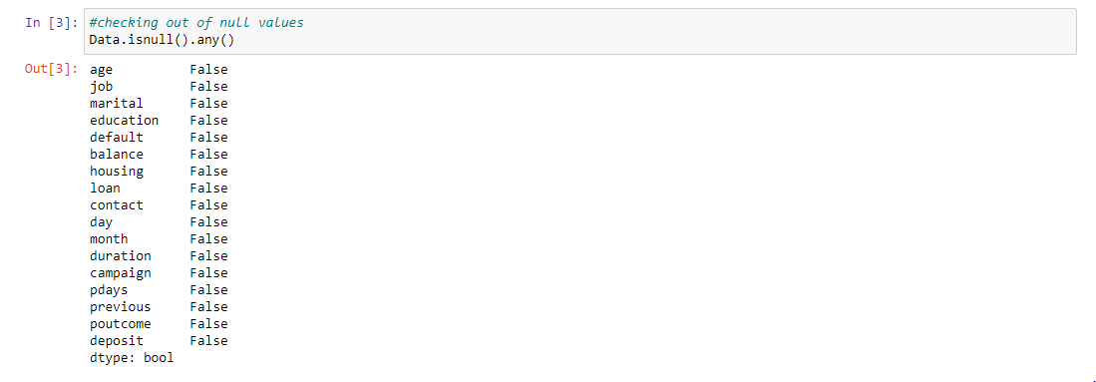

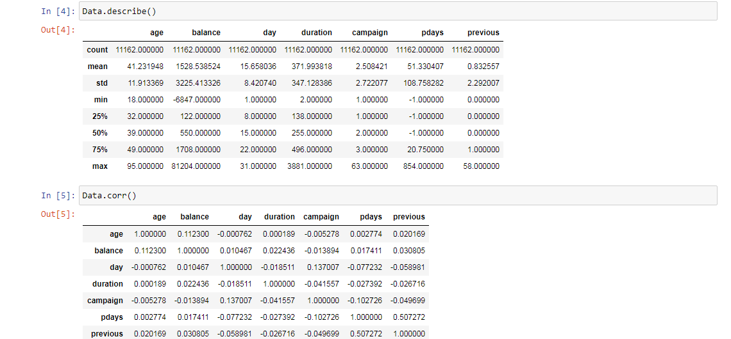

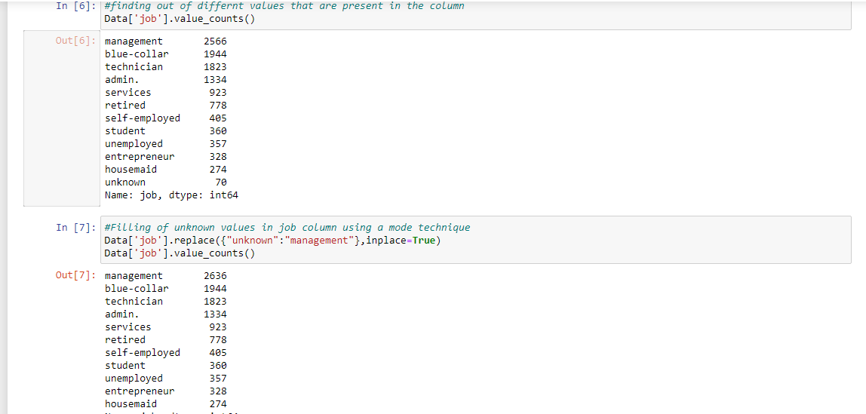

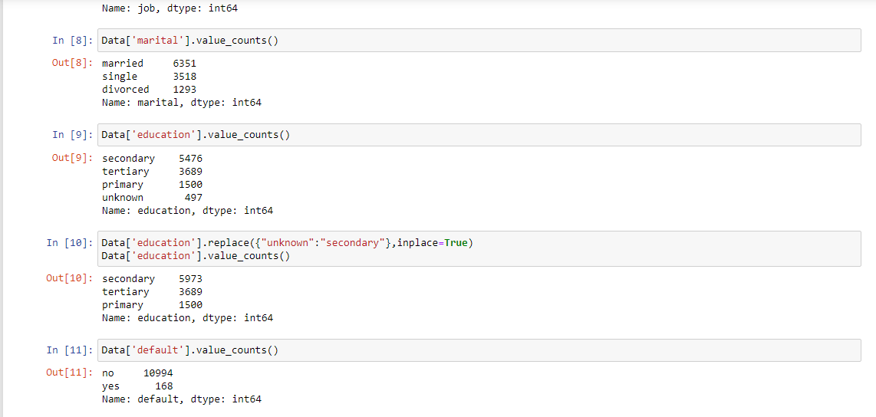

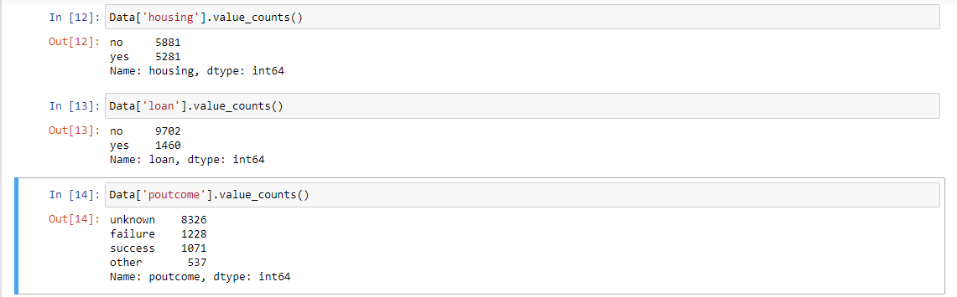

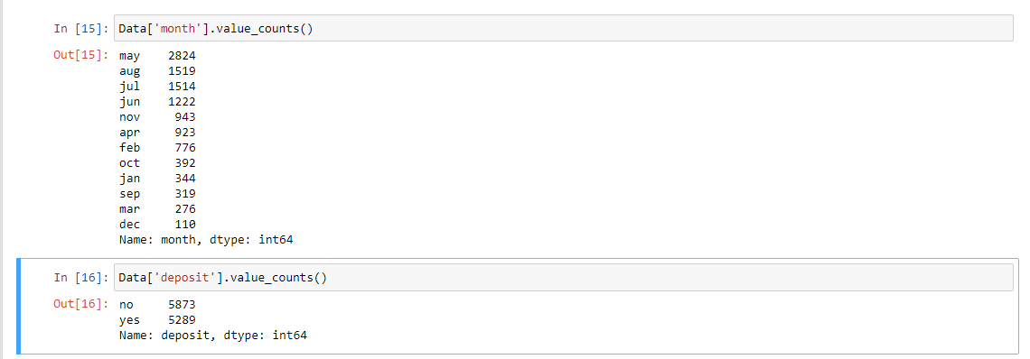

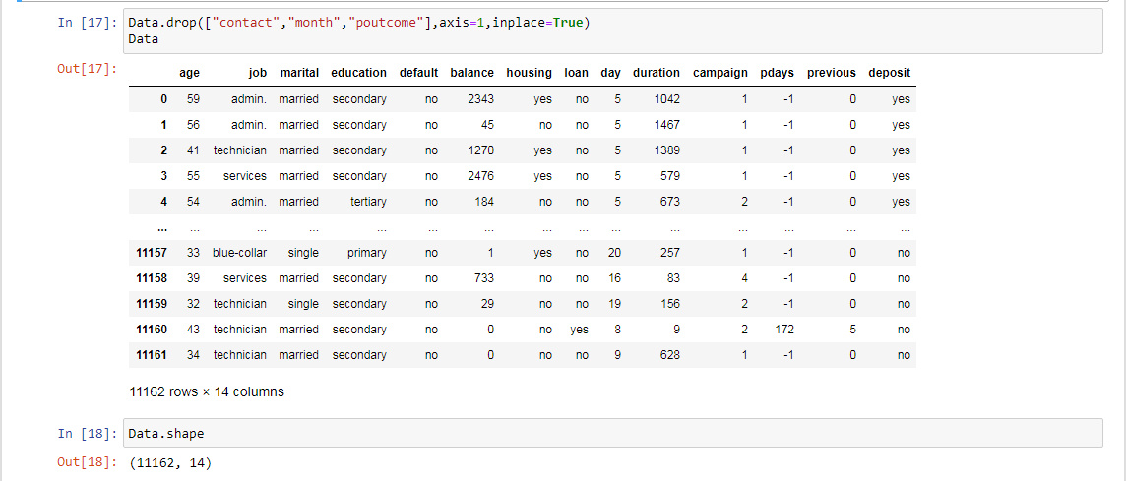

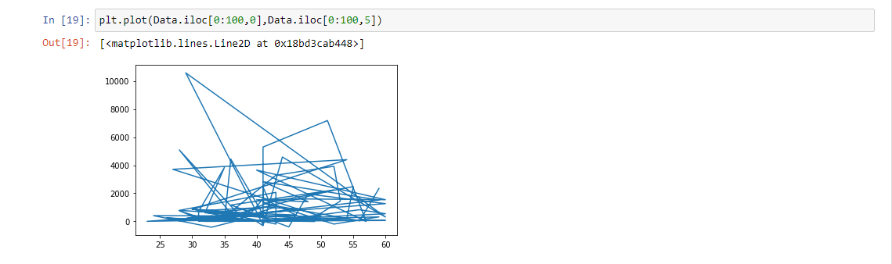

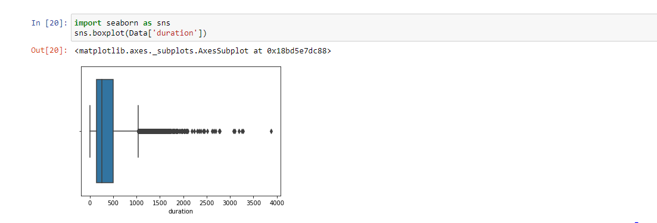

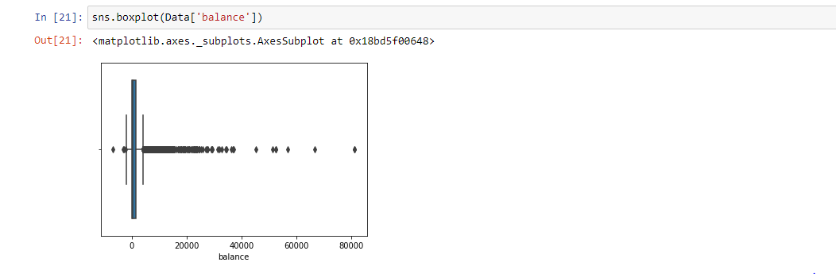

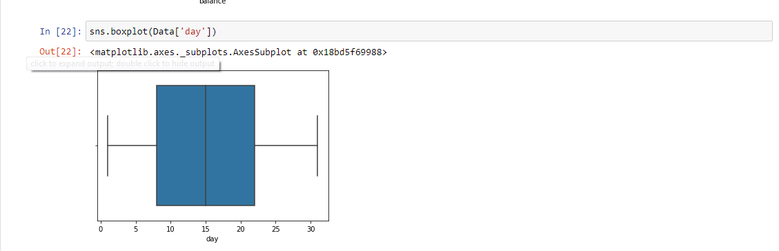

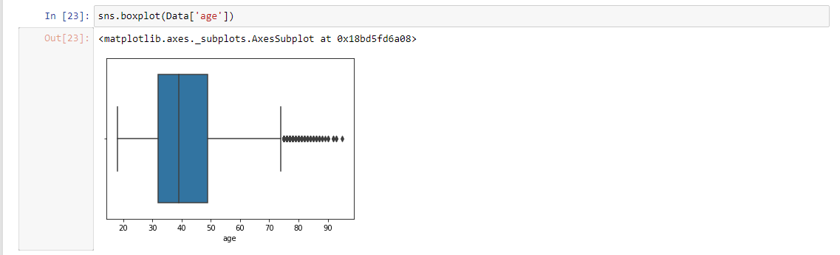

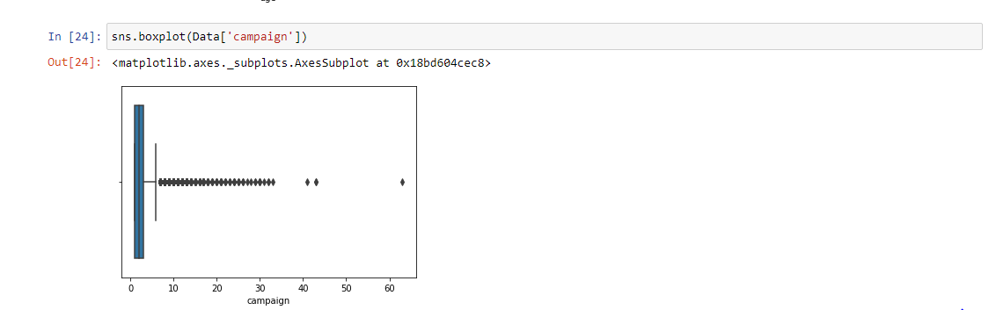

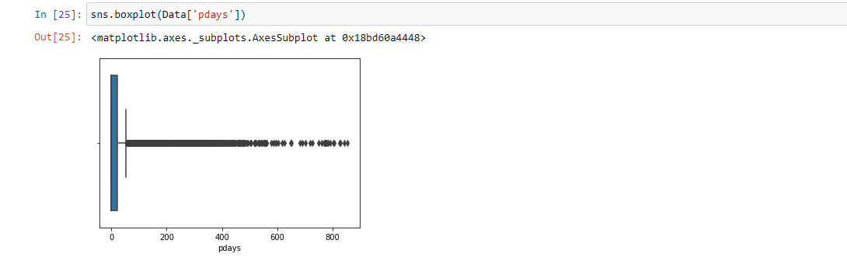

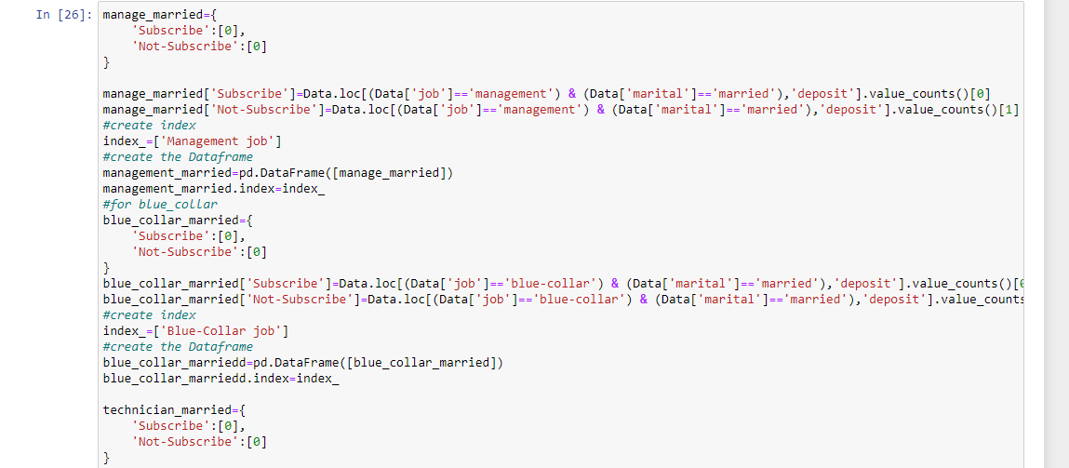

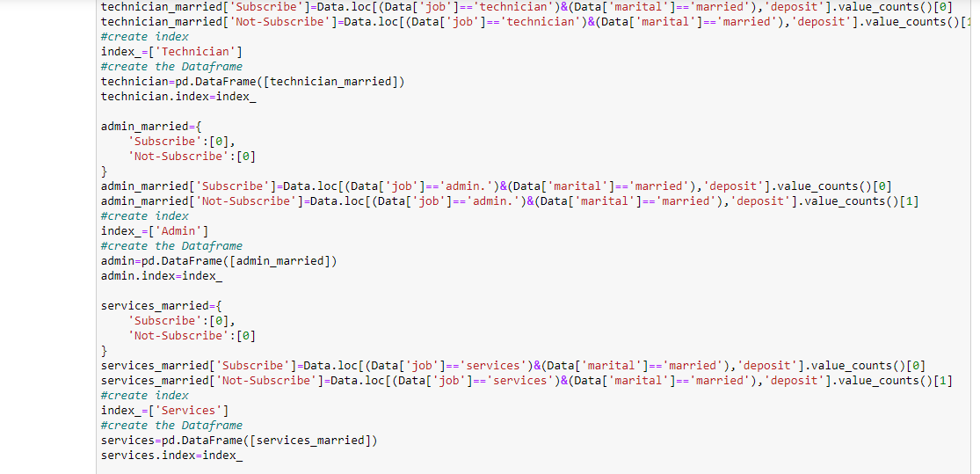

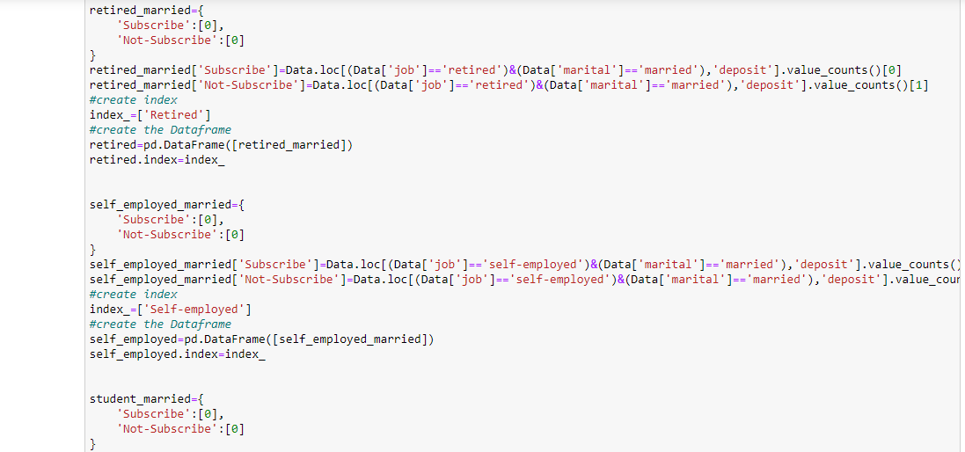

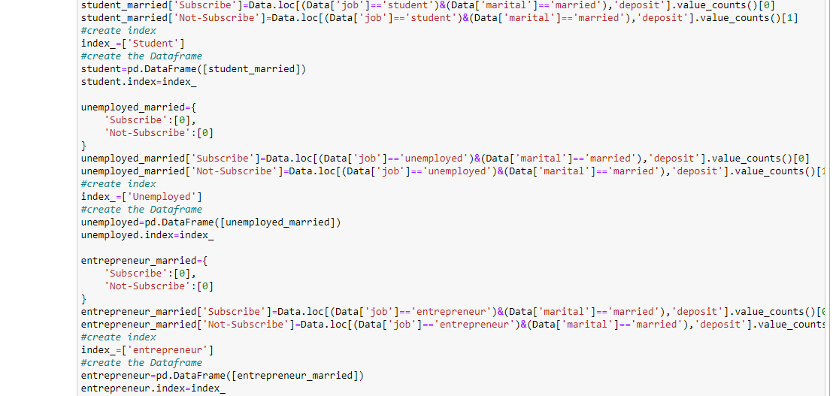

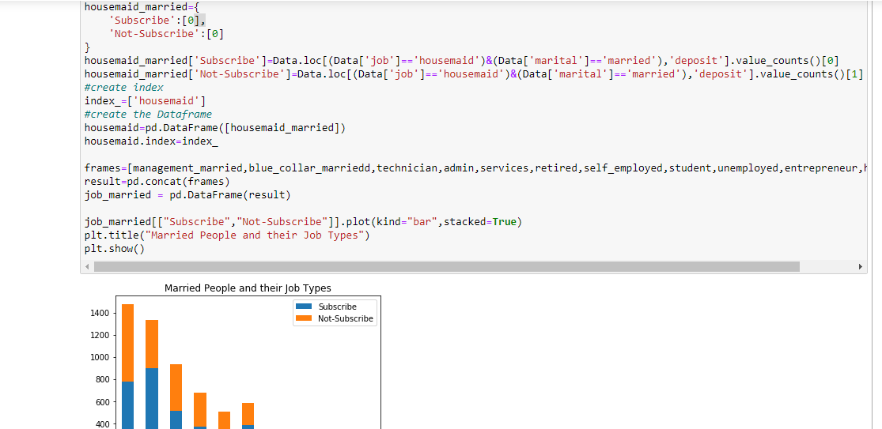

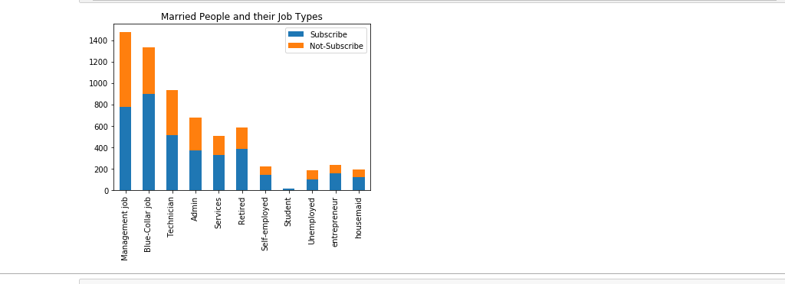

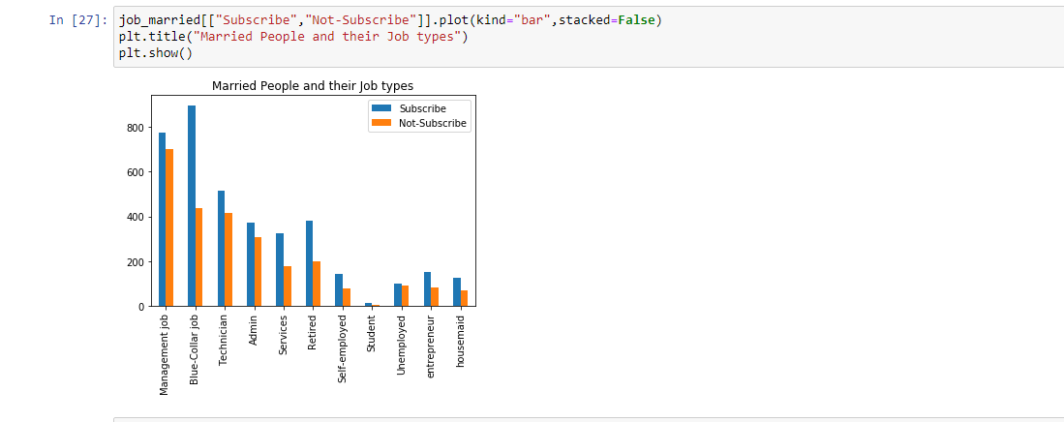

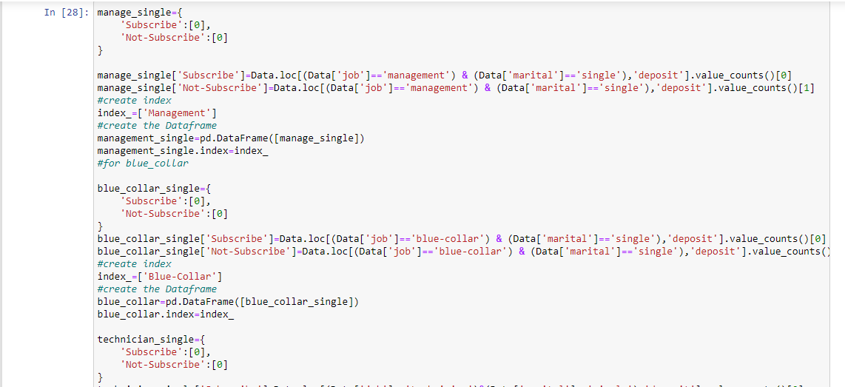

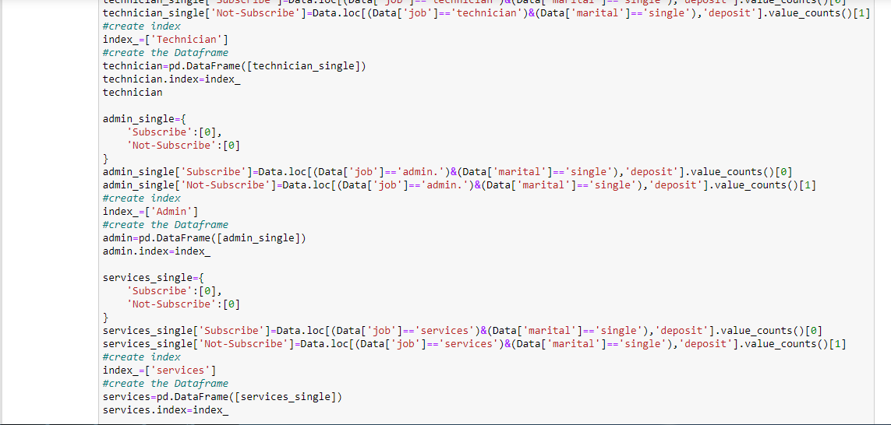

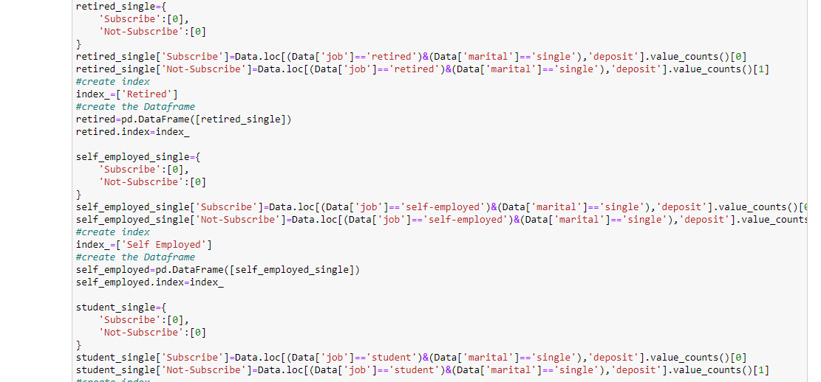

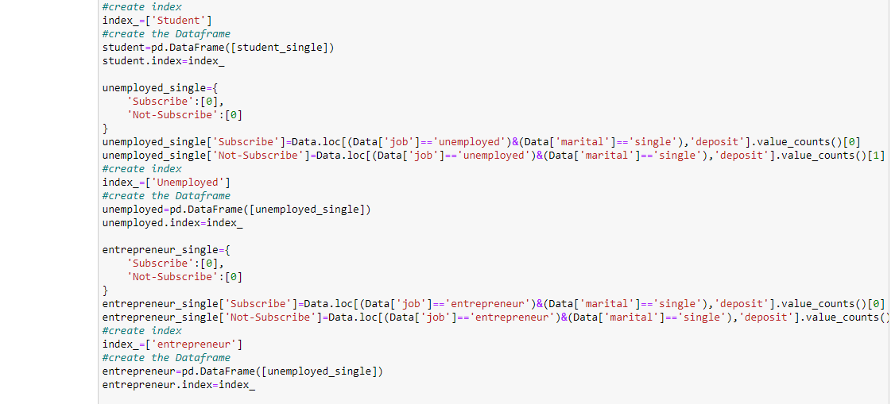

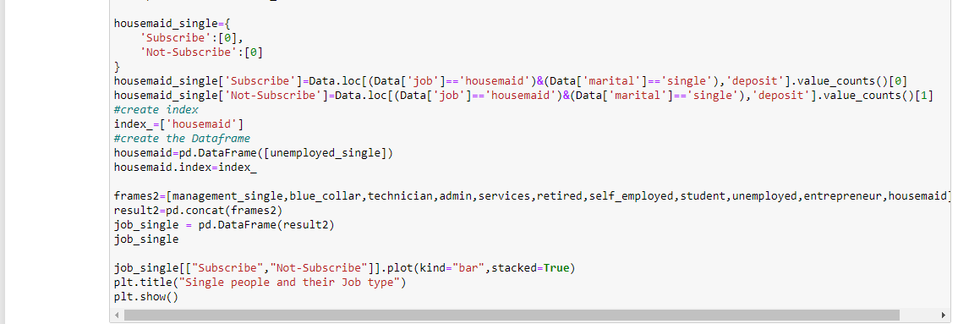

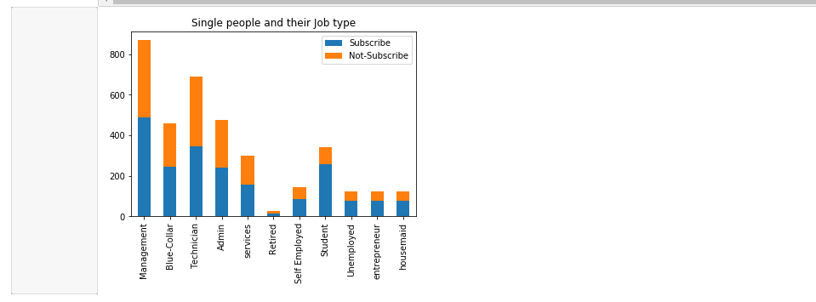

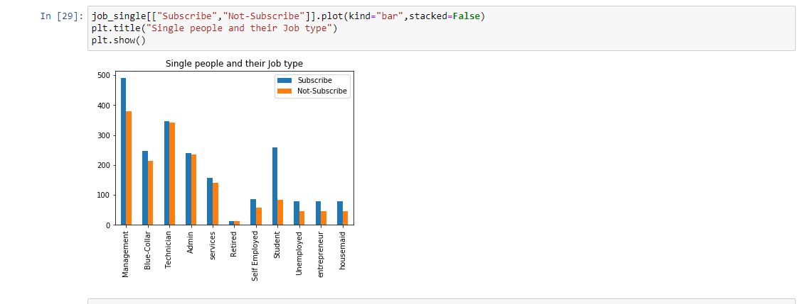

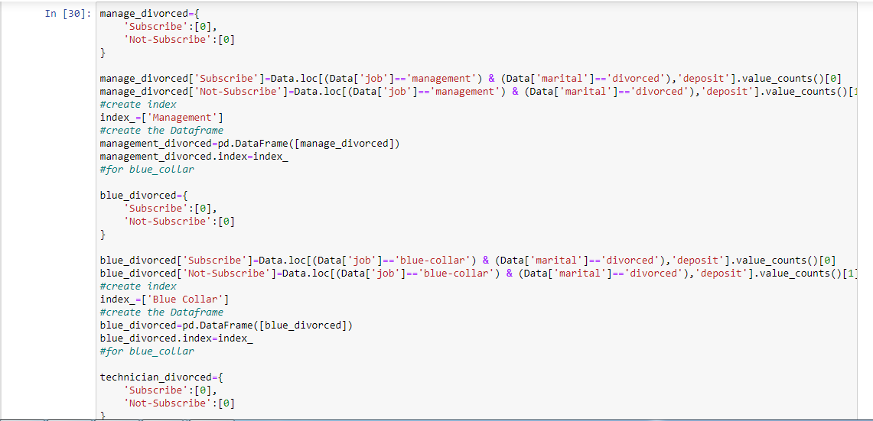

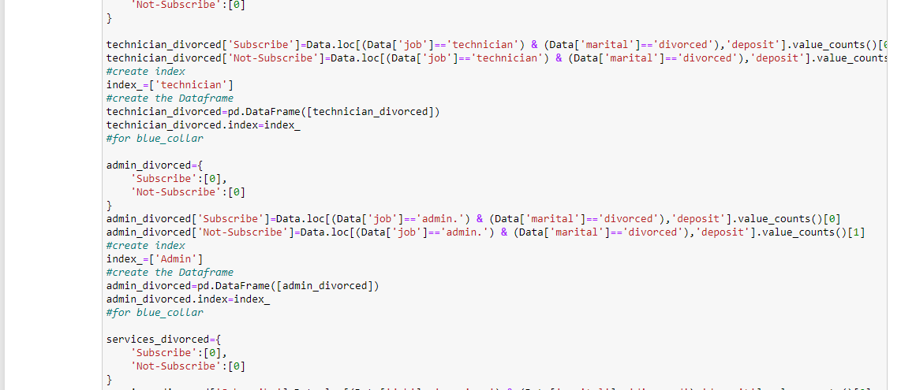

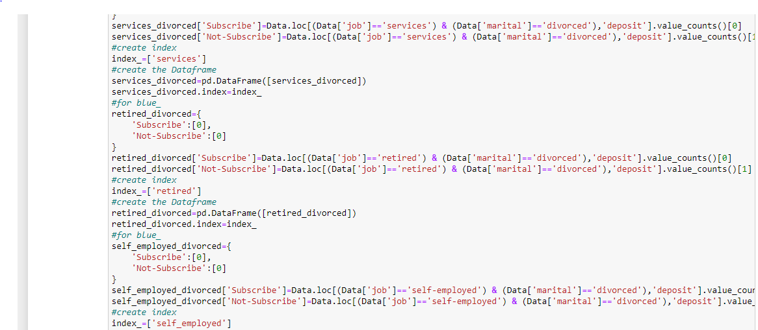

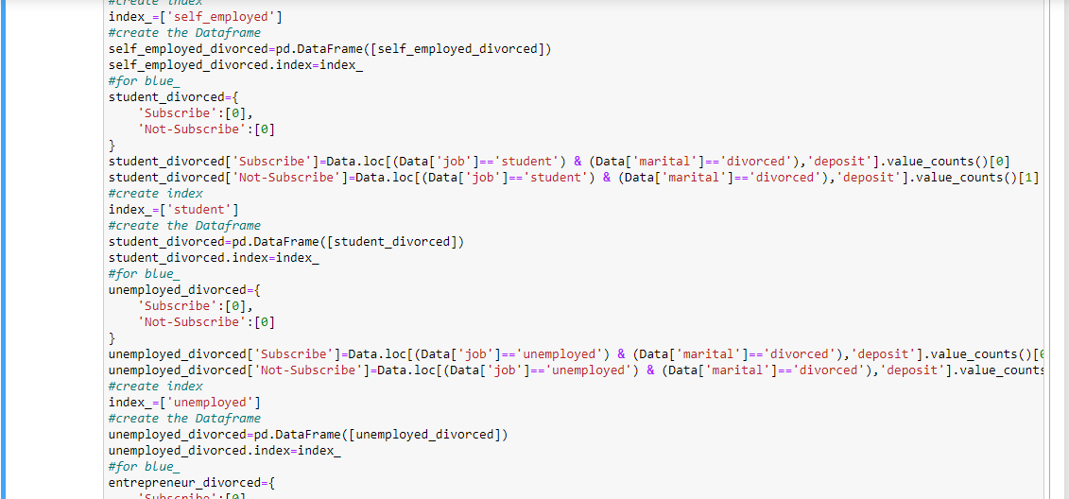

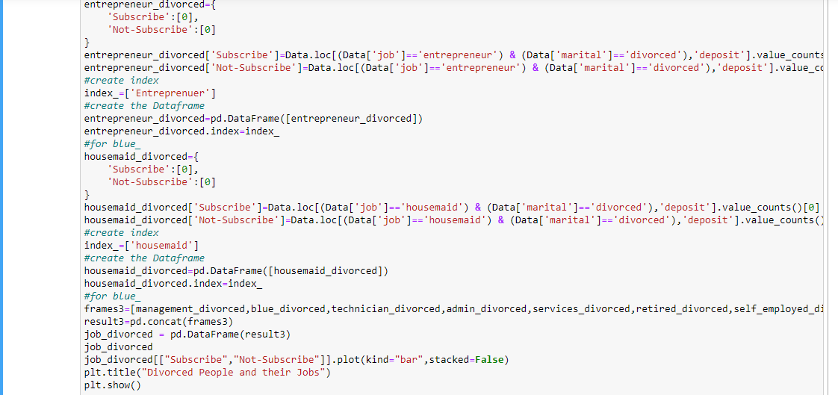

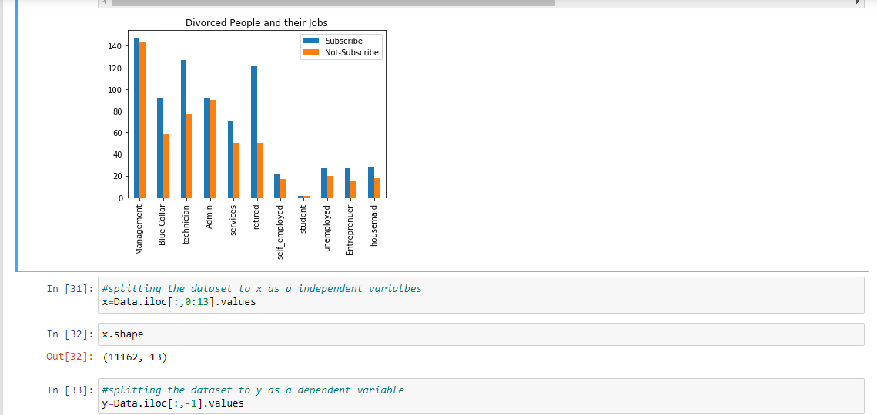

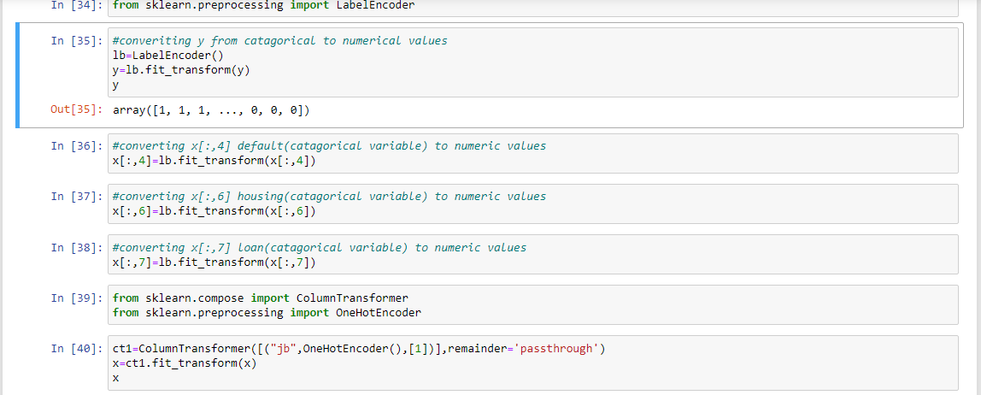

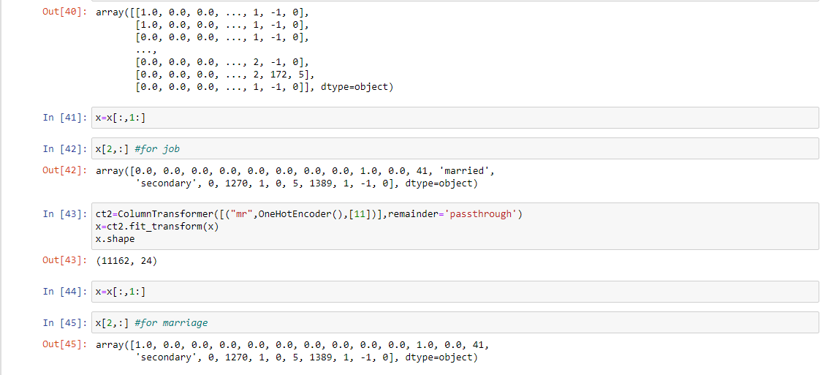

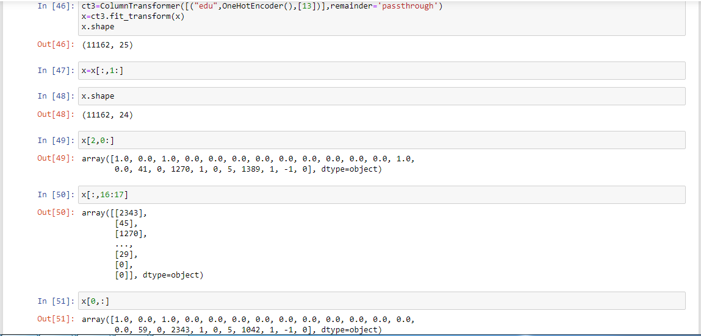

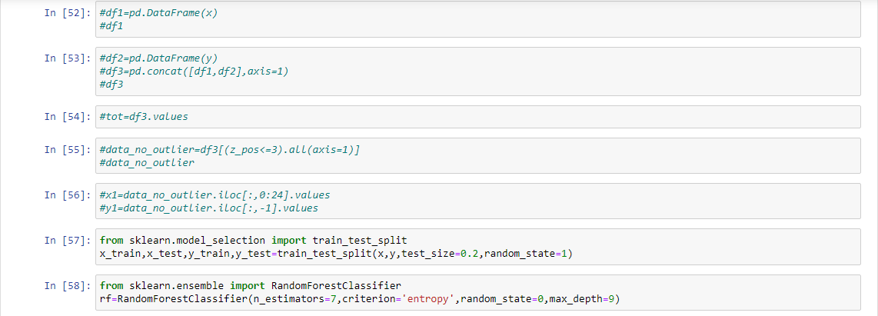

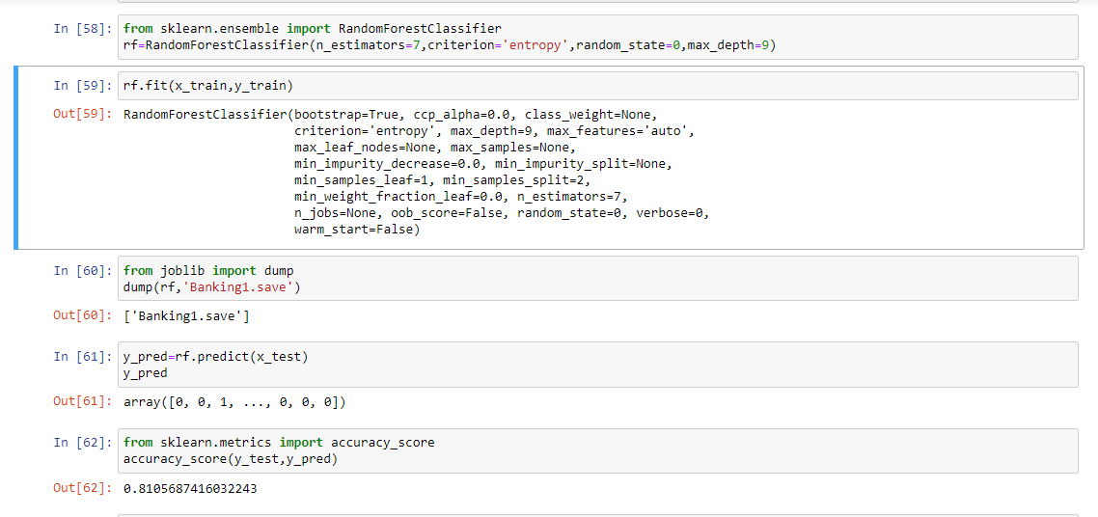

Frontend Program:

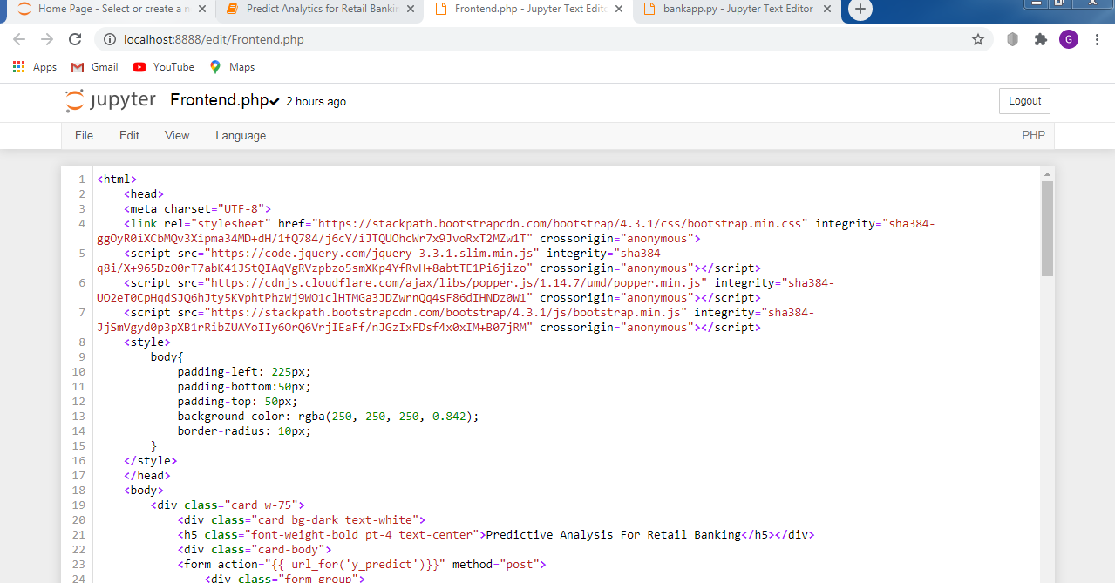

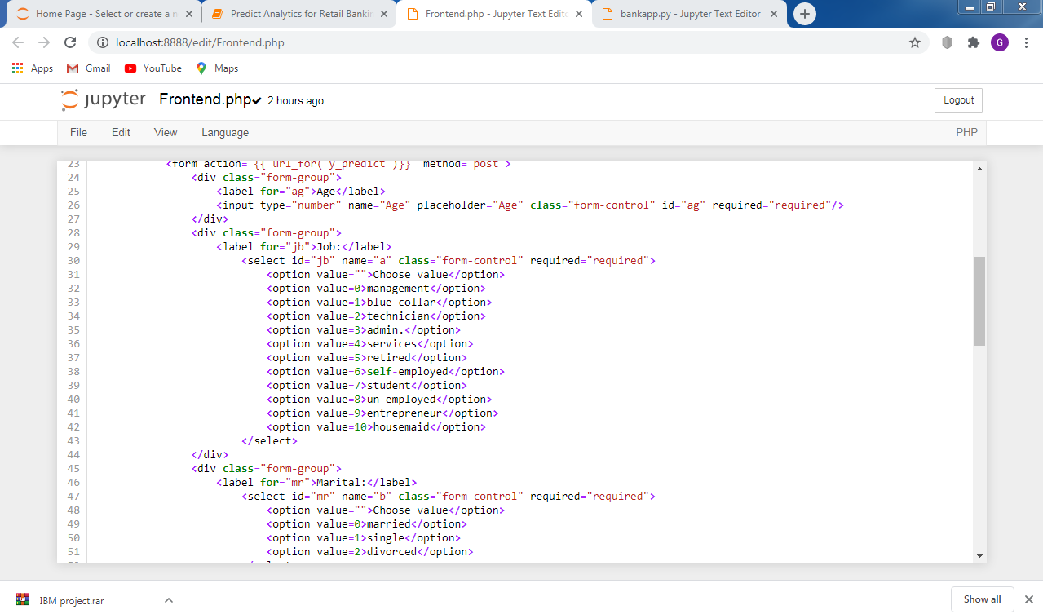

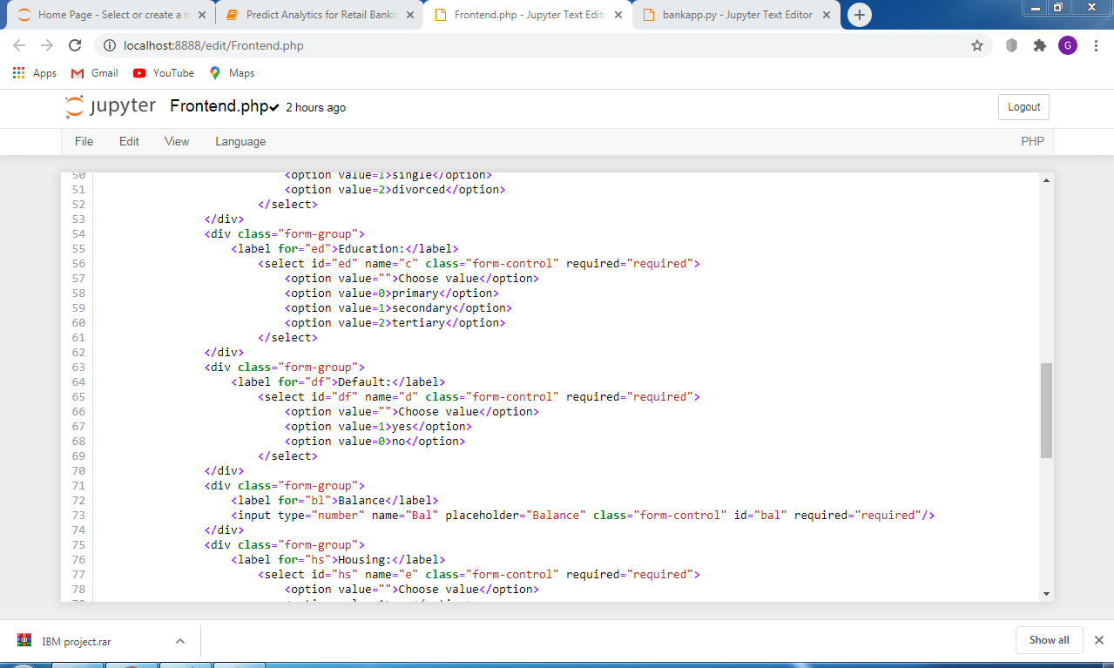

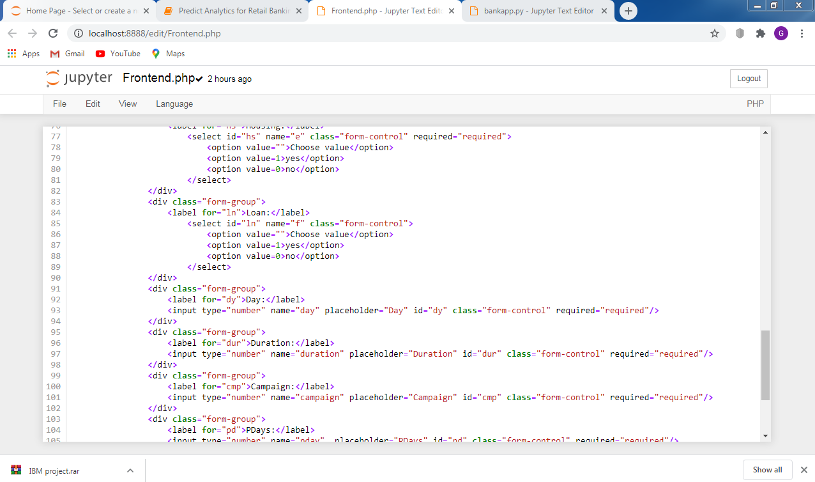

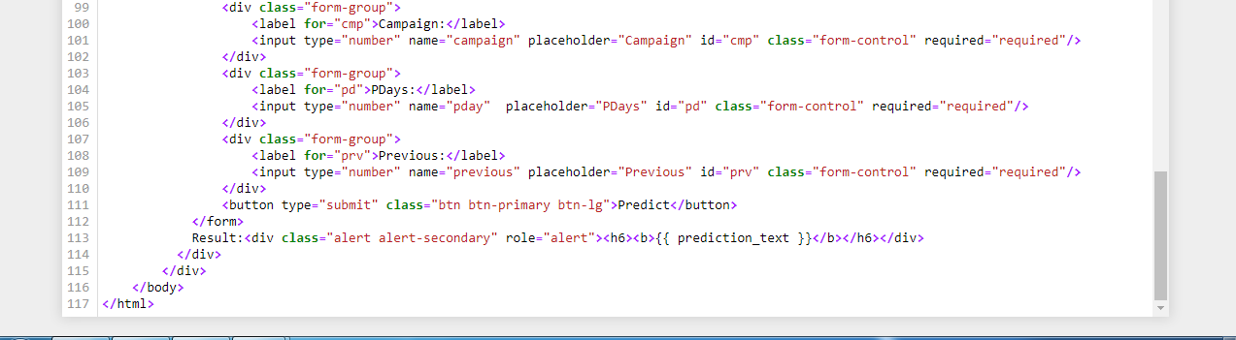

Flask Program:

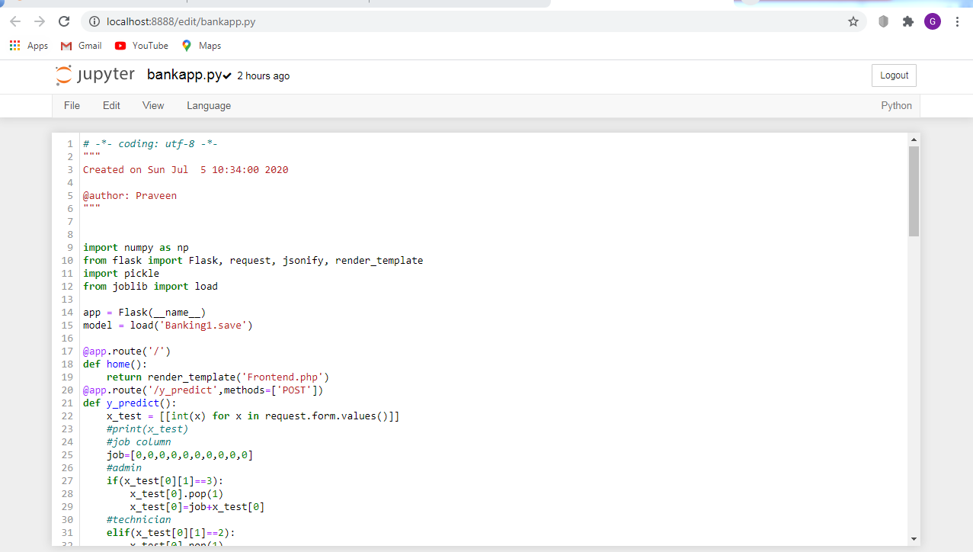

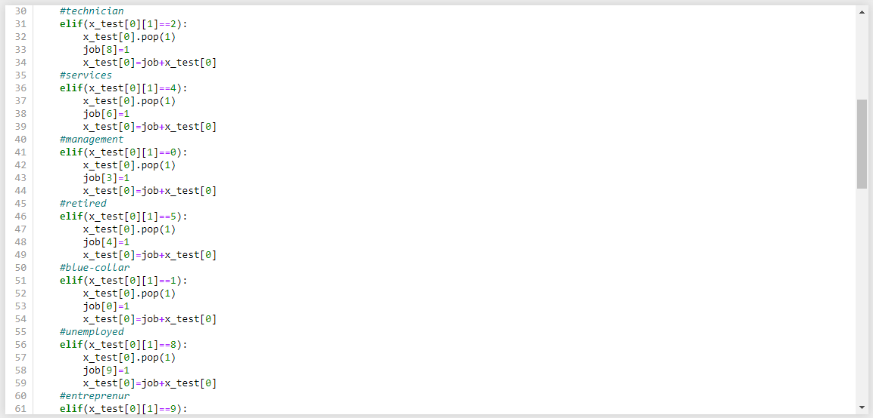

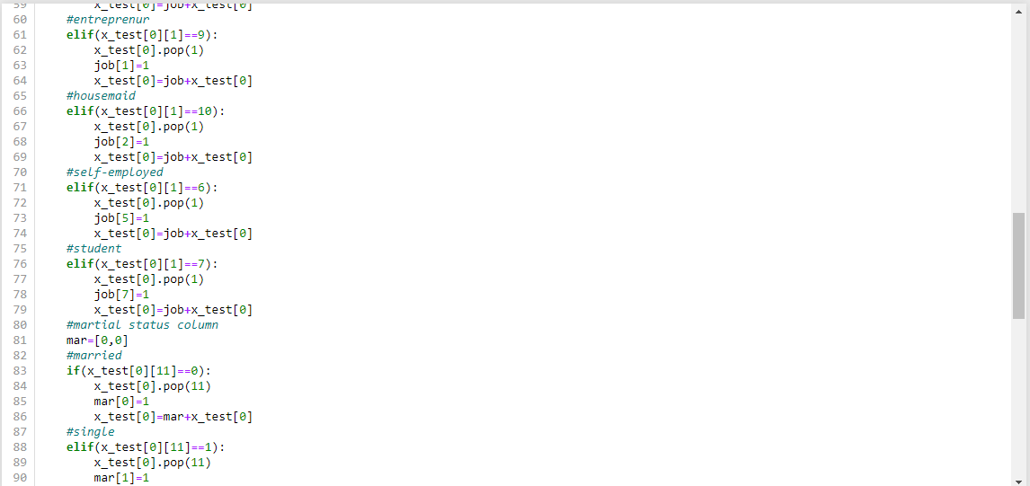

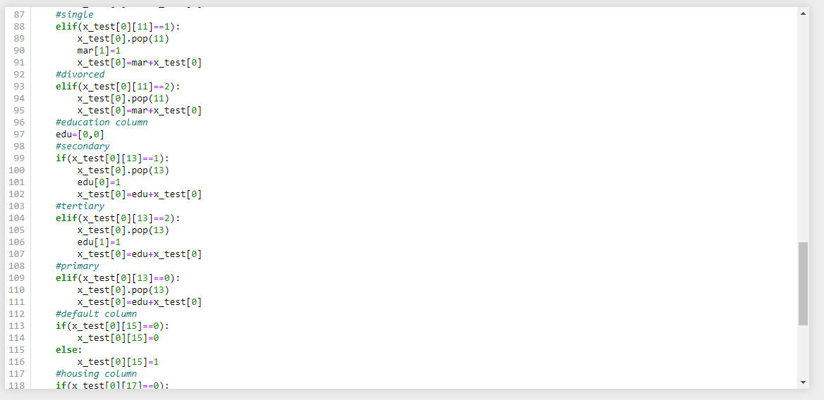

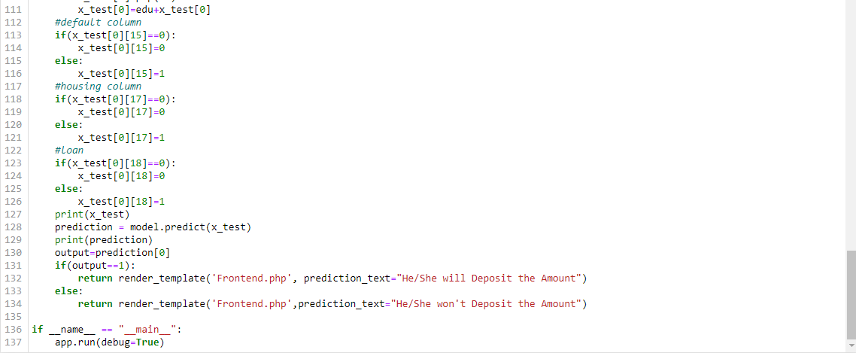

Front-end Output page:

