The project tries to create a model based on data provided by the World Health Organization (WHO) to evaluate the life expectancy for different countries in years. The data offers a timeframe from 2000 to 2015.

The data originates from here:

h ttps:/[/www.kaggle.com/kumarajarshi/life-expectancy-who/dat](http://www.kaggle.com/kumarajarshi/life-expectancy-who/data)a

The output algorithms have been used to test if they can maintain their accuracy in predicting the life expectancy for data they haven’t been trained. Four algorithms have been used:

Linear Regression

Linear Regression with Polynomic features Decision Tree Regression

Random Forest Regression

# Schedule:

**Team:**

**Name:** GOVIND RATNAKAR NAIK

# Deliverables:

**None.**

**Setup the Development Environment:**

**Github:**

GitHub is a for-proﬁt company that offers a cloud-based Git repository hosting service. Essentially, it makes it a lot easier for individuals and teams to use Git for

version control and collaboration.

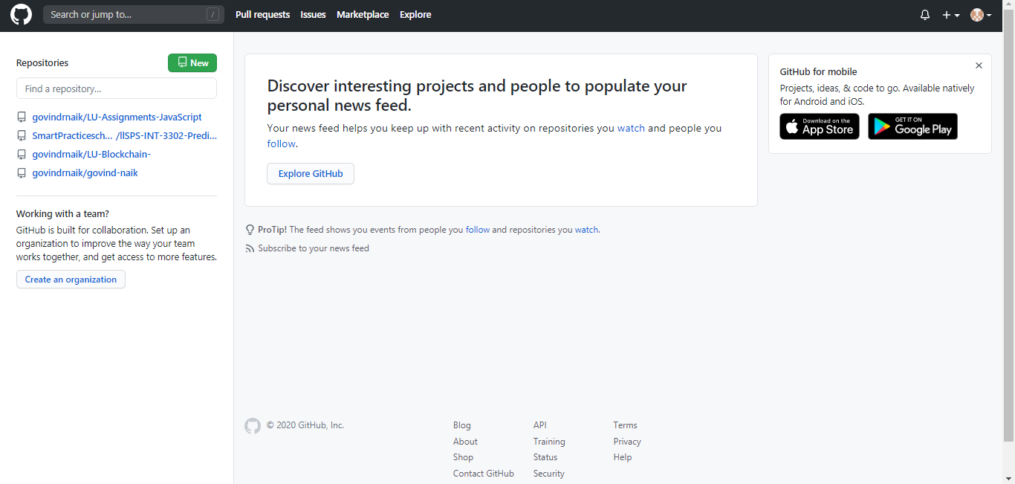

# Slack:

Slack is essentially a chat room for your whole company, designed to replace

Email as your primary method of communication and sharing. Its workspaces allow you to organize communications by channels for group discussions and allows for private messages to share information, ﬁles, and more all in one place.

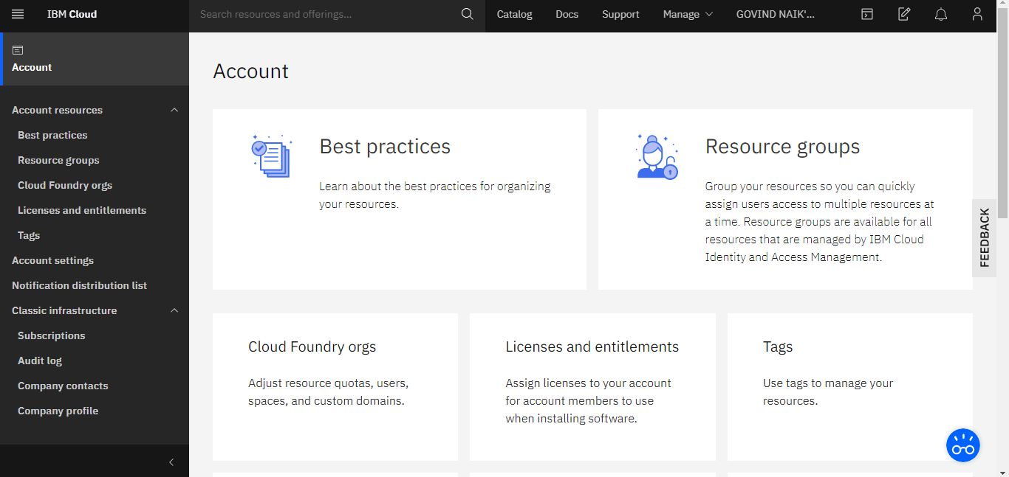

# Node-red Starter application:

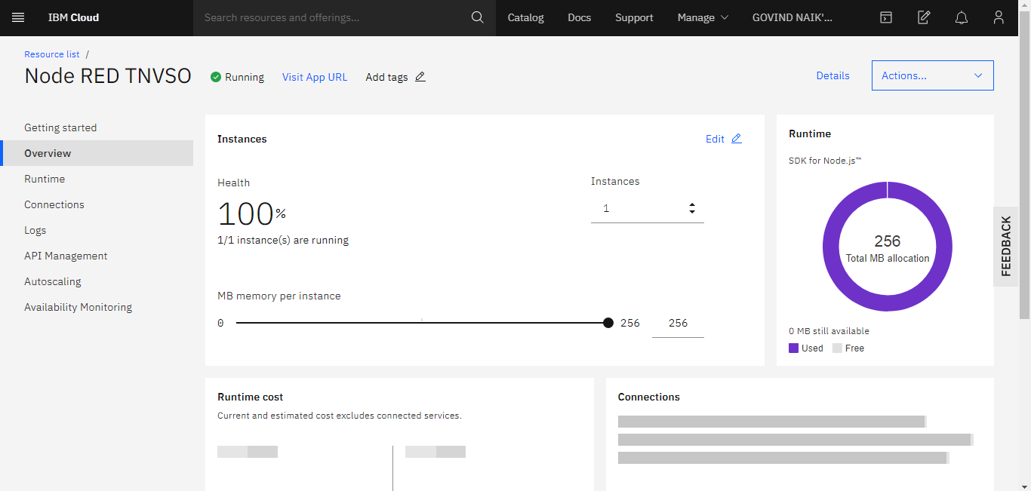

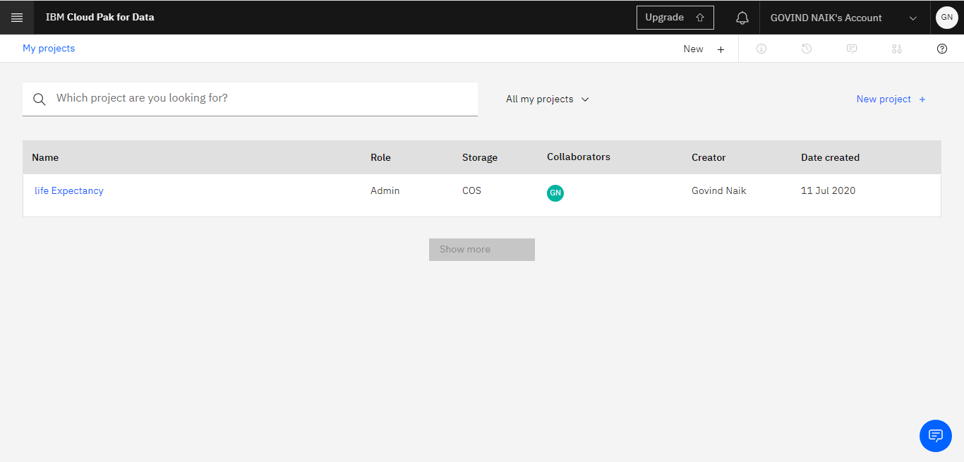

**IBM Watson Studio:**

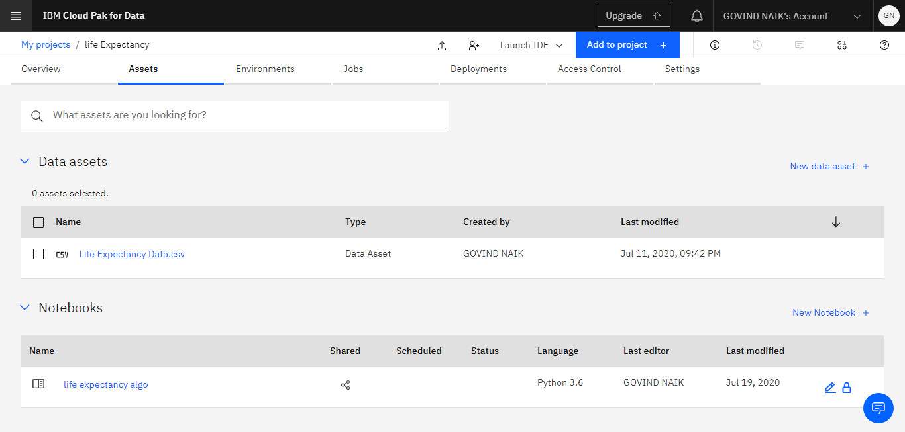

**Dataset:**

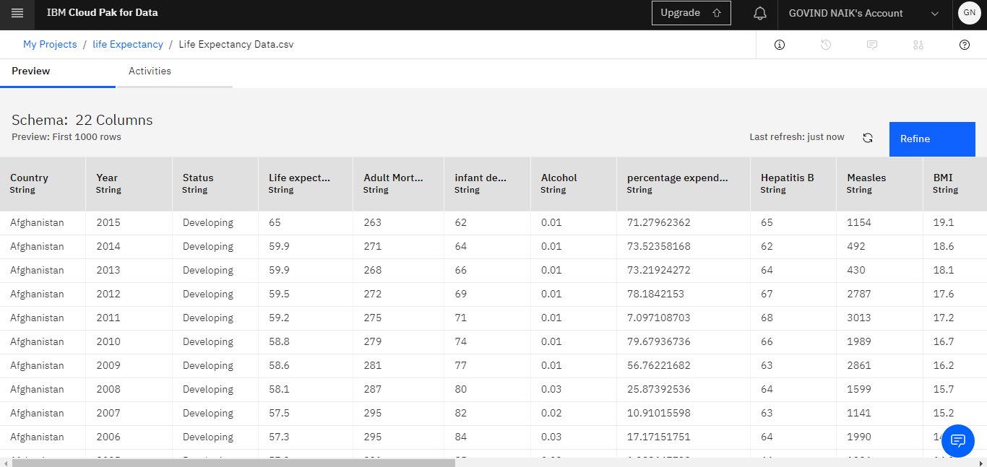

**IBM Cloud Services:**

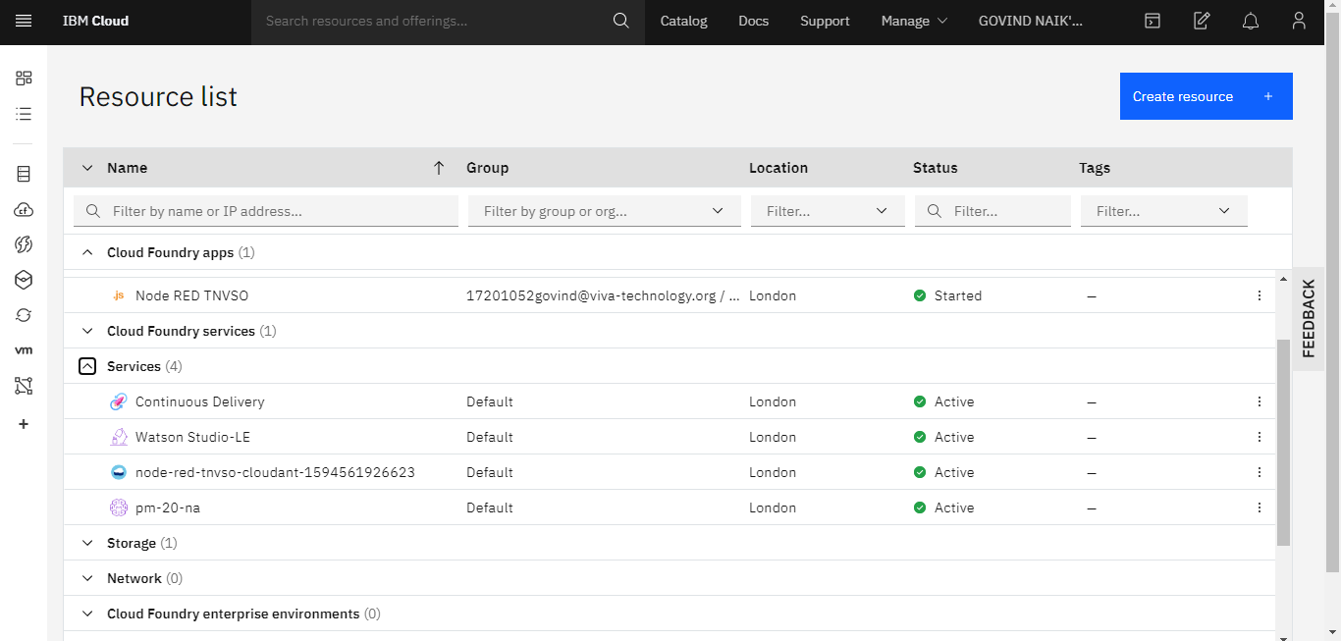

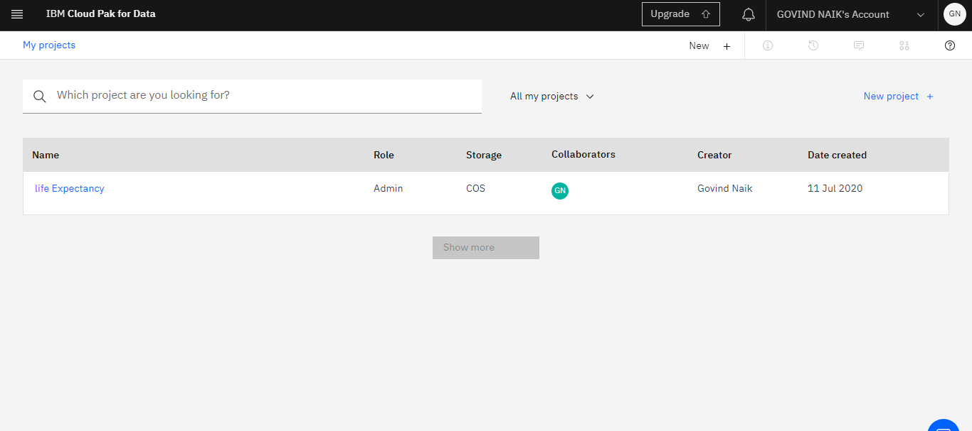

**Create Machine Learning Service:**

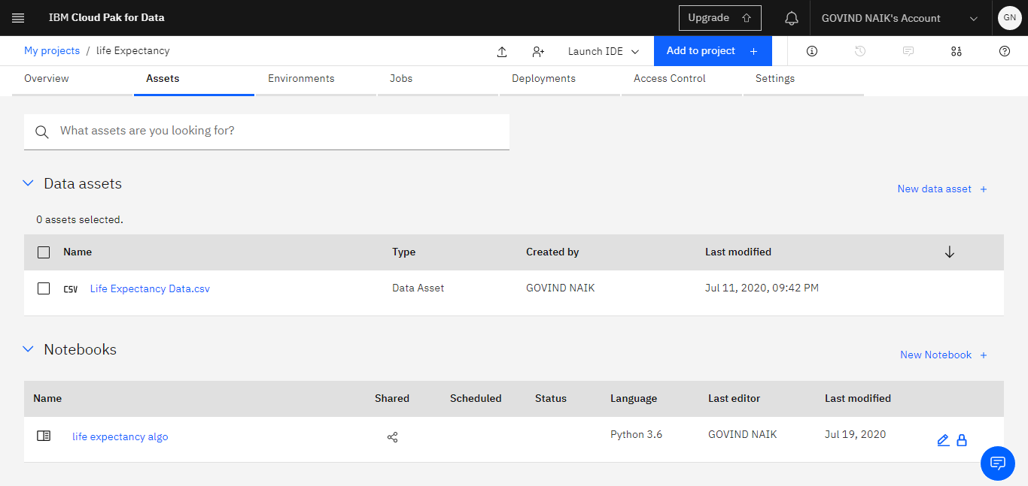

**Node-Red Flow:**

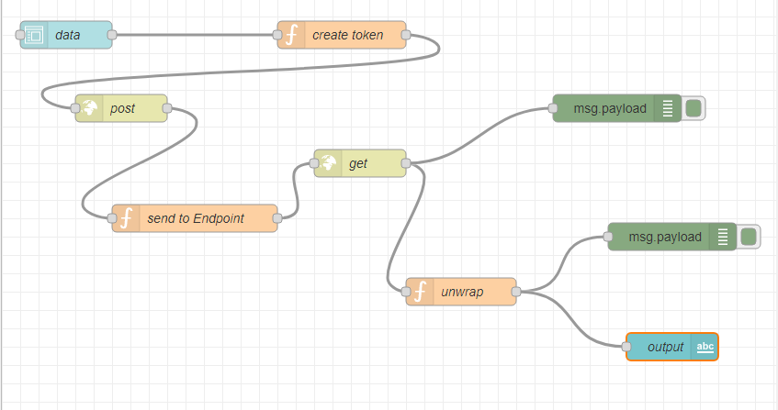

**Output:**

