PROJECT ON

**One Year Life Expectancy Post Thoracic Surgery Using IBM Watson**

Submitted BY:

***BISWAJIT BEHERA***

**INTRODUCTION:**

Cancer is a disease in which cells in the body grow out of control and is one of the most serious health problems in the world. Among various different types of cancer, lung cancer is one of the leading causes of death in both men and women. According to World Health Organization, it was observed that in the year 2018 2.09 million cases of lung cancer was registered and a total of 1.76 million died due to lung cancer. One of the reasons for the high death rate due to lung cancer is the late detection of the lung cancer. Also, the treatment and the prognosis depend on the type of the lung cancer, the stage and the patient’s performance. Once the lung cancer is detected, possible treatments include thoracic surgery, chemotherapy and radiotherapy.

At present, there are few biological or technical methods to prevent cancer. Therefore, the project focuses on the early detection of the lung cancer which is the vital factor in the treatment which will in turn increase the survival rate post the treatment. Also, if lung cancer is detected, an attempt is made to predict the survival of the patient for a minimum span of one-year Post Thoracic Surgery which will assist the doctors to take the proper decision for the medication. The project develops a system that detects the lung cancer by processing the Computed Tomography (CT) image of the lungs under test. The system uses Convolution Neural Network (CNN) which takes CT scan lung images which is present in Digital Imaging and Communications in Medicine (DICOM) format as input and further outputs whether the image is cancerous or non-cancerous. If lung cancer is detected, further the life expectancy post thoracic surgery can be predicted using the Machine Learning techniques. Thus, the system can be taken as an aid for the doctors to effectively make decisions for the treatment of lung cancer patients.

***1.1OVERVIEW:***

*Lung Cancer is a disease characterized by the uncontrolled cell growth in tissues of the lungs. It is one of the dangerous and life taking disease in the world. Early detection of lung cancer helps in identification of the treatment to be given which in turn increases the chances of survival of the lung cancer infected patient. This paper presents an approach which utilizes Convolution Neural network (CNN) to classify the CT lung images as cancerous or non-cancerous. The accuracy obtained by means of CNN is 95% which is more efficient when compared to accuracy obtained by the traditional neural network systems. Once the cancer is detected the paper also presents an approach to predict the life expectancy of the lung cancer infected patient post thoracic surgery. The prediction part is implemented using Machine Learning techniques. Linear Discriminant Analysis gave an accuracy of 83.76% with a F-measure of 0.83 which is more compared to other machine learning algorithms used.*

**1.2Purpose:**

Through this repository we can:

1.Apply the fundamental concepts of machine learning from an available dataset

2.Evaluate and interpret my results and justify my interpretation based on observed data set

The analysis is divided into four sec ons, saved in juypter notebooks in this repository

1. Identifying the problem and Data Sources

2. Exploratory Data Analysis

3. Pre-Processing the Data

4.Build model

**Literature Survey:**

**EXISTING PROBLEM:**

1:Patients who receive thoracic surgery for lung cancer do so with the expectation that their lives will be prolonged for a sufficient amount of time afterwards.

2.The problem to solve is whether there is a way to determine postoperative 1 year survival of lung cancer patients utilizing the patient attributes in the data set.

**PROPOSED SOLUTION:**

Disha Sharma *et al.* (2011), proposed an approach for the early detection of lung cancer by analyzing lungs CT images using Image Processing techniques[1]. The authors used bit-plane slicing, erosion and Weiner filter image processing techniques to extract the lung regions from the CT image. Further the extracted lung regions were segmented using Region growing segmentation algorithm and later Rule based model was used to detect the cancerous nodules. With the help of diagnostics indicator, it was observed that the proposed method achieved an overall accuracy of 80%.

Hamid Bagherieh *et al.* (2013) gave a methodology to detect and classify the lung nodules using Image processing and Decision- Making techniques[2]. Initially, image preprocessing was carried out on a CT images by using contrast enhancement and linear filtering. Next, the filtered image was segmented using Region growing Segmentation process. Further the features like area and color was given as input to the Fuzzy system which employed fuzzy membership function to find the abnormalities.

Sindhu V *et al*. (2014), proposed an approach where the authors aimed to classify the survival of lung cancer patients post thoracic surgery[3]. The authors used Naïve Bayes, PART, J48, OneR, Random Forest and Decision stump algorithm techniques to classify the target function. The performance measurement shows that Random Forest gave high accuracy of 95.65% compared to other ML techniques used.

Prashant Naresh *et al.* (2014), proposed a methodology to detect the lung cancer using Image processing and Neural Techniques[4]. Initially the CT image of lung was filtered to remove Gaussian white noise and Otsu’s threshold technique was used to do the segmentation of the image. The structural and features were extracted and these features were given as input to the classifier. The SVM and ANN techniques were used for the classification and it was found that SVM techniques gave a higher accuracy of 95.12%.

Kwetishe Joro Danjuma (2015), proposed a methodology to predict the one- year survival of the patient post thoracic surgery[5]. Naïve Bayes, J48 and Multilayer Perceptron algorithms were used to classify the target class. The Naïve Bayes gave an accuracy of 74.4%, J48 gave an accuracy of 81.8% and MLP gave an accuracy of 82.4%.

Abeer S Desuky *et al.* (2016), proposed a methodology to predict the post-operative life expectancy after Thoracic Surgery using attribute and selection ranking by using Simple Logistic, Multilayer Perceptron and J48 techniques[6]. The Simple Logistic gave an accuracy of 84.68%, MLP gave an accuracy of 81.28% and J48 gave an accuracy of 84.47%.

Peyman Rezaei *et al.* (2017), proposed a methodology to predict the one-year survival of lung cancer patients post thoracic surgery using the combination of Bayesian Network (BN) and Uniform counts discretization[7]. Both BN and Uniform counts discretization yielded an accuracy of 91.28%.

Wafa Alakwaa *et al*. (2017), demonstrated a CAD system for lung cancer classification of CT scans with unmarked nodules[8]. Thresholding was used as initial segment approach which produced best lung segmentation. A modified U-Net trained on LUNA16 data was used to detect nodule candidates. The U-Net output were fed into 3D Convolutional Neural Networks (CNNS) to ultimately classify CT scans as positive or negative for lung cancer. The 3D CNNS produced a test set accuracy of 86.6%.

**Prediction of Life Expectancy**

This is the second part of the system which aims at predicting the survival of lung cancer infected patient post thoracic surgery.

The dataset includes 17 attributes which are specified in Table- 1. Among all those attributes, Risk1Y is the target class specifying zero if the patient survives for at least one-year post thoracic surgery and one for those who died before completing one-year post surgery.

The visualization of the dataset is done using the Matplotlib and Seaborn libraries of Python. Further the essential attributes are found based on the Information Gain (IG) attribute evaluation which is used to find the importance of an attribute by using the Information Gain with respect to the target class.

IG (Class, Attribute) = E (Class) – E (Class | Attribute)

where, E stands for Entropy

After the IG Attribute Evaluation on all the 16 independent attributes in the dataset, it is found that the attributes PRE19 and PRE32 gives the IG value as zero and hence are the least useful attributes for training the model. Therefore, these two attributes are eliminated and the remaining 14 attributes are used to train the model.

Dataset Attributes

|  |  |  |
| --- | --- | --- |
| Name | Description | Type |
|  |  |  |
| DGN | Diagnosis – specific combination | Nominal |
|  | of ICD-10 codes. |  |
|  |  |  |
| PRE4 | Forced Vital Capacity – FVC | Numeric |
|  |  |  |
| PRE5 | Forced Expiratory Volume – FEV! | Numeric |
|  |  |  |
| PRE6 | Performance Status – Zubrod | Nominal |
|  | Scale |  |
|  |  |  |
| PRE7 | Pain before Surgery | Binary |
|  |  |  |
| PRE8 | Haemoptysis before Surgery | Binary |
|  |  |  |
| PRE9 | Dyspnoea before surgery | Binary |
|  |  |  |
| PRE10 | Coughing up blood before | Binary |
|  | surgery |  |
|  |  |  |
| PRE11 | Weakness before Surgery | Binary |
|  |  |  |
| PRE14 | T in clinical TNM-size of original | Nominal |
|  | tumor, |  |
|  | From OC11 (smallest) to |  |
|  |  |  |

https://eu-

|  |  |  |
| --- | --- | --- |
|  | OC14(largest) |  |
|  |  |  |
| PRE17 | Type 2 DM – Diabetes Mellitus | Binary |
|  |  |  |
| PRE19 | MI up to 6 months | Binary |
|  |  |  |
| PRE25 | PAD – Peripheral Arterial Disease | Binary |
|  |  |  |
| PRE30 | Smoking | Binary |
|  |  |  |
| PRE32 | Asthma | Binary |
|  |  |  |
| AGE | Age at the time of Surgery | Numeric |
|  |  |  |
| RISK1Y | 1 Year Survival (T-Died, F- Alive) | Binary |
|  |  |  |

**THEORITICAL ANALYSIS:**

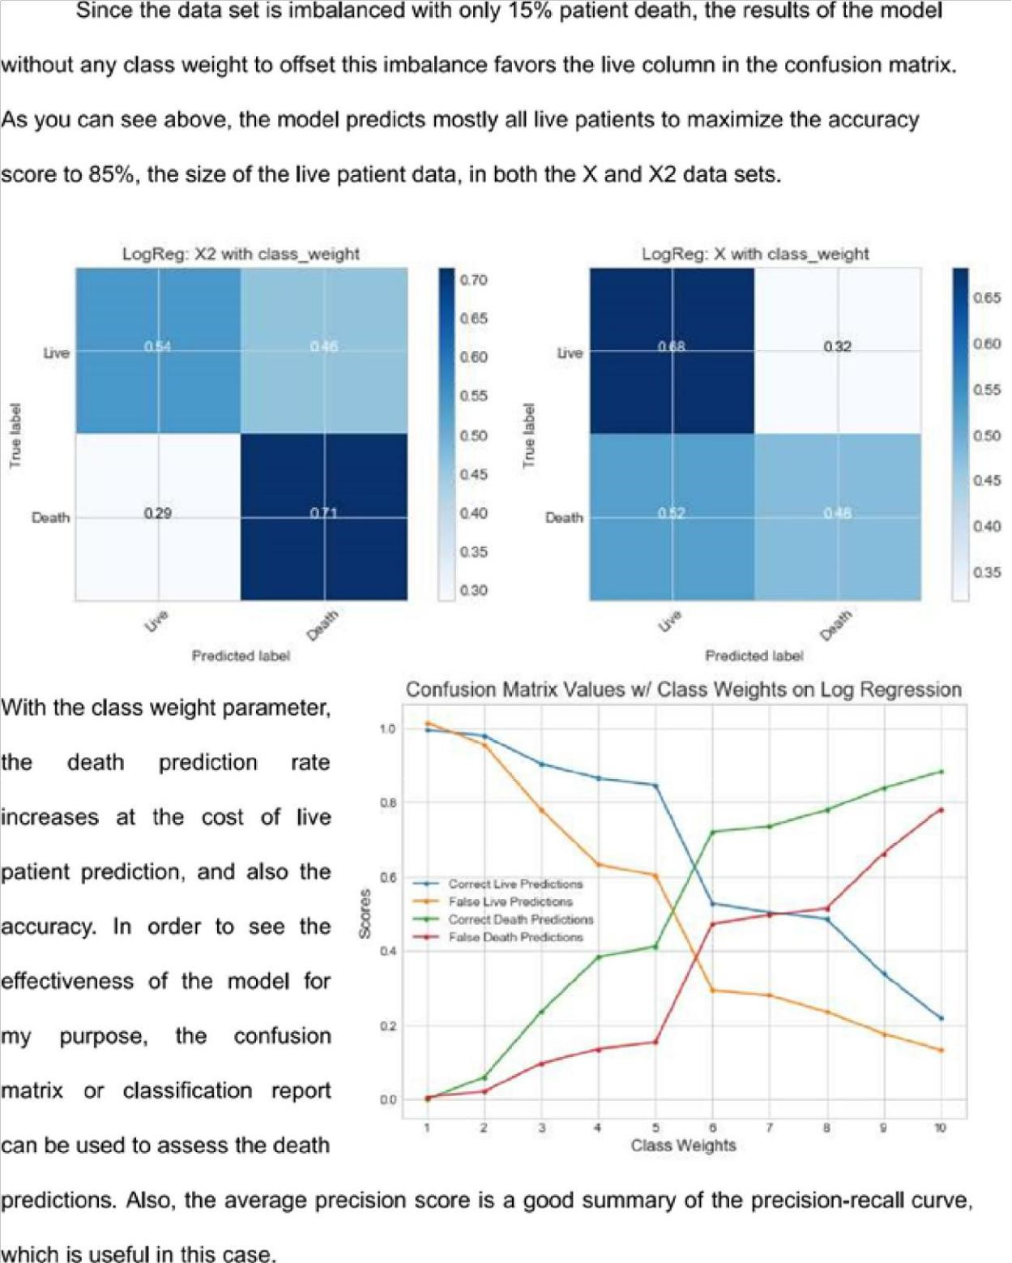



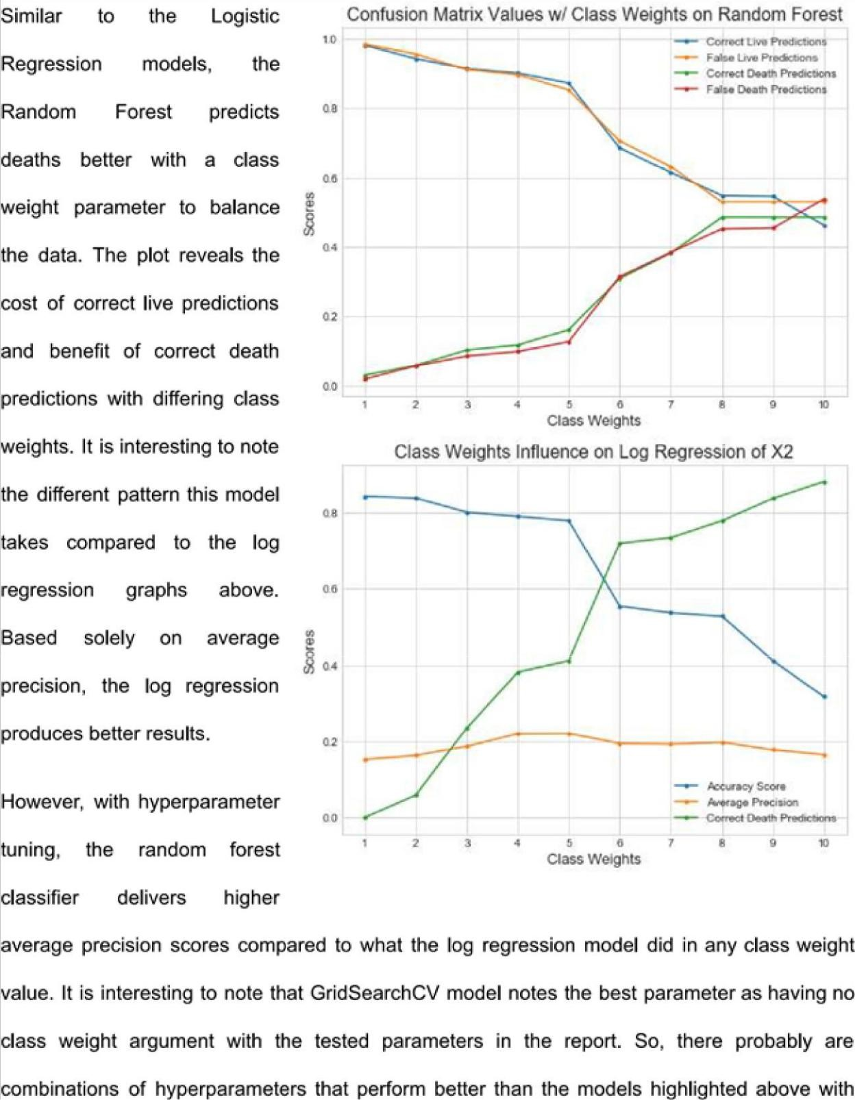

**RESULT:**

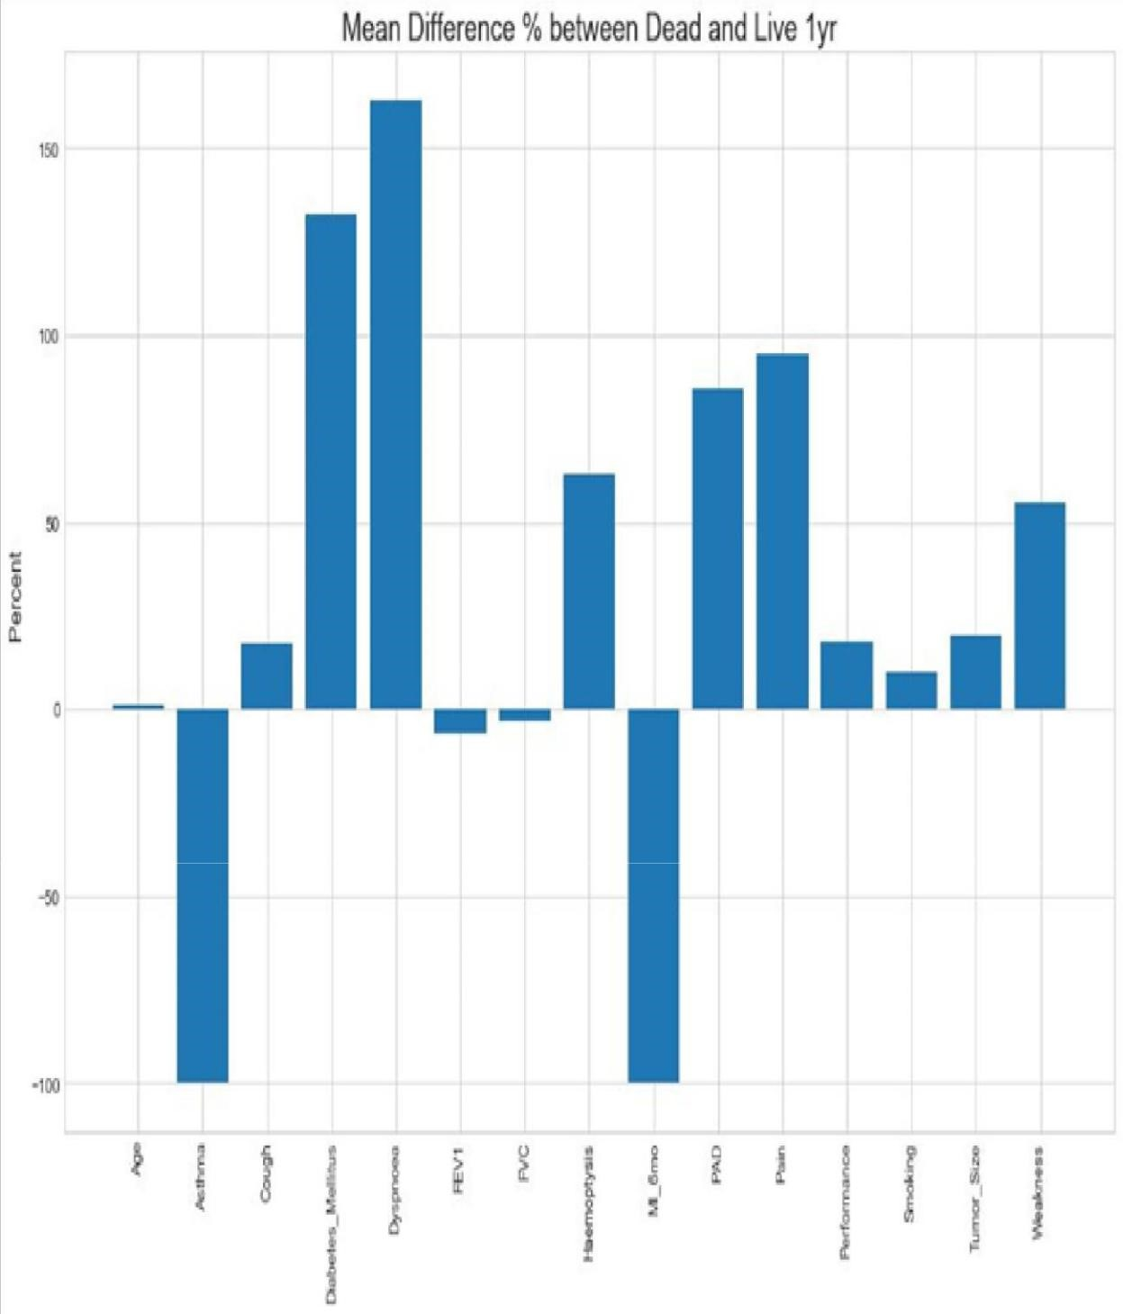

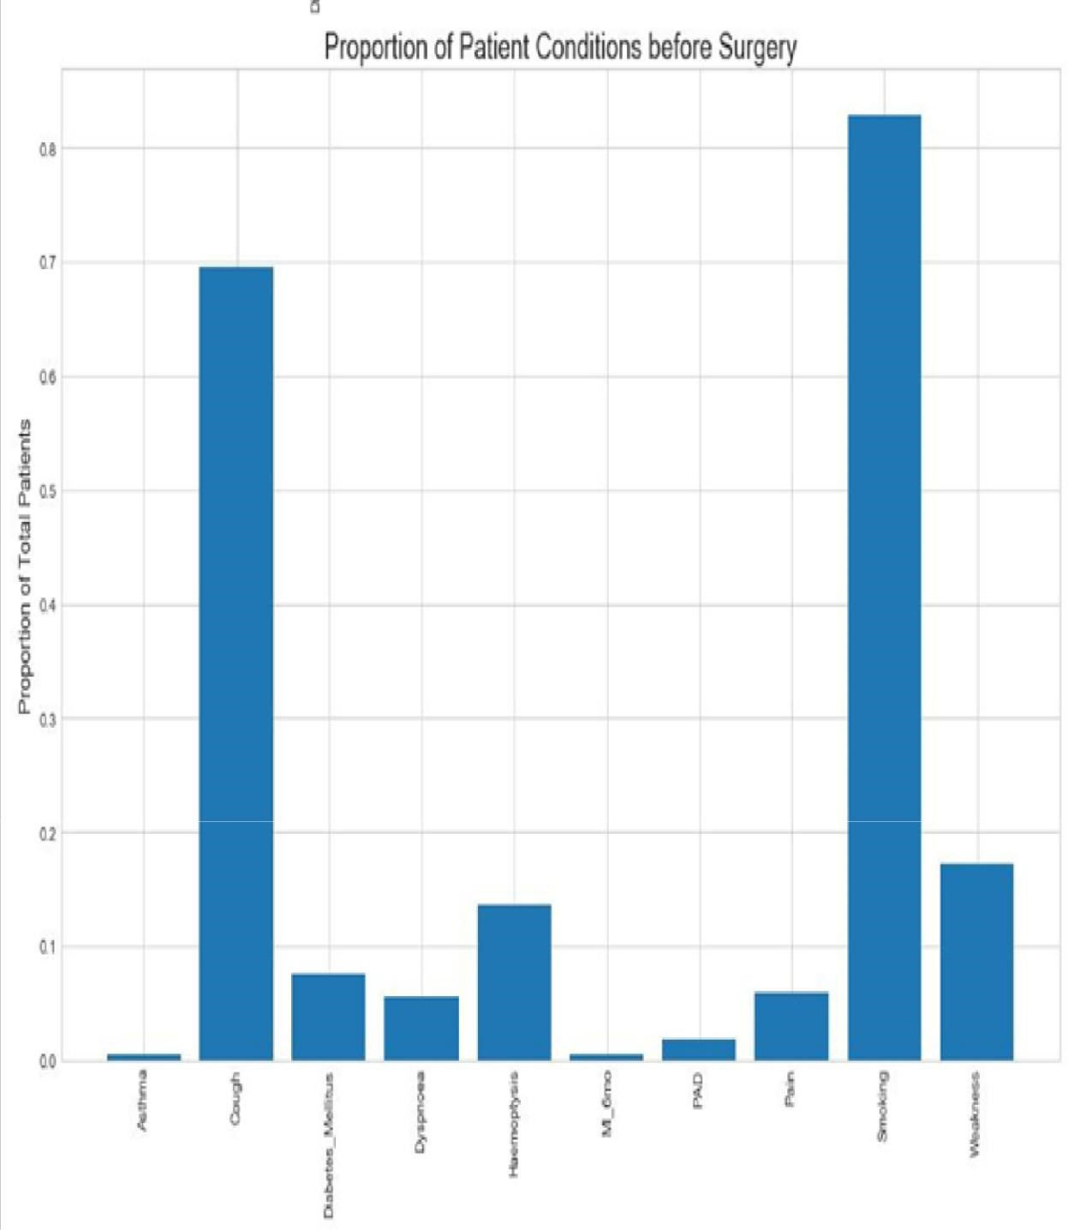

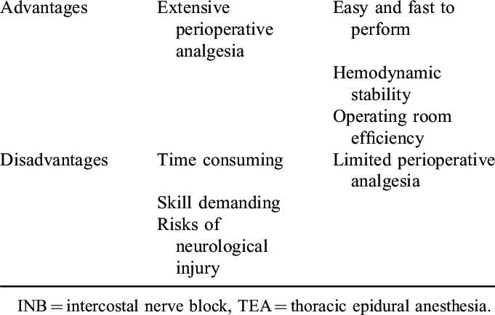

**APPLICATIONS OF THOARAIC SURGERY:**

**Lymphatic mapping:**

Patients with Stage I lung cancer have a recurrence rate of nearly 40% and the overall 5-year survival rate is just 52% [ 12]. The high rate of disease recurrence suggests that these patients are frequently understaged and, subsequently, undertreated. By identifying lymph nodes at highest risk for tumour metastasis, SLN mapping helps identify patients who could benefit from adjuvant therapy. Several NP-based molecular imaging techniques have been explored for potential in the mapping of tumour-draining lymph nodes in human cancers [ 13, 14]. Quantum dots (QDs) have been utilized as lymphatic mapping agents in a porcine model of non-small-cell lung cancer (NSCLC), with favourable properties including appropriate size for lymphatic migration and visible histological fluorescence (Fig. 1) [ 15]. More recently, superparamagnetic iron oxide (SPIO) NPs were coupled with magnetic resonance imaging (MRI) to create ultrasensitive nanoprobes for cellular and molecular imaging of various cancers. Notably, SPIO-enhanced MRI technology has been shown to detect tumour metastases in the SLNs of breast, bladder and prostate cancer patients [ 16, 17]. In a 2011 study of 102 breast cancer patients with clinically negative axillary nodes, Motomura *et al* . [ 16] demonstrated that SPIO-enhanced MRI achieved almost 90% accuracy in the detection of SLN metastases. These promising results warrant the

upcoming investigation of SPIO-enhanced MR imaging as an SLN mapping strategy for lung and oesophageal cancer patients.

**Image-guided nanosurgery**

NP-based technologies possess several properties that enhance imaging of biological targets, including the ability to amplify contrast signal, unique physiochemical characteristics such as magnetic, thermal and pH-responsive phase changes, and the ability to modify pharmacokinetics via alterations in surface chemistry [ 10]. The development of targeted near-infrared fluorescent (NIRF) and surface-enhanced Raman scattering imaging probes for the evaluation of surgical margins and the real-time intraoperative identification of residual disease is a major focus of recent investigation. These technological advances have been translated to patient care with excellent initial results. Currently, NIRF-image-guided surgery utilizing 5-aminolevulinic acid (5-ALA) generates tumour fluorescence and better tumour visualization in patients with malignant glioma. 5-ALA precursor in the haemoglobin synthesis pathway elicits the accumulation of fluorescent porphyrins in various epithelia and cancerous tissues. Oral administration of 5-ALA leads to preferential accumulation of fluorescent porphyrins within glioma tissue, enabling more complete oncological resection and improved progression-free survival [ 24]. Ongoing research efforts are focused on the clinical translation of various Raman NPs that can be specifically utilized for NIRF imaging of various solid tumours, including lung cancer. It is anticipated that this technology will improve intraoperative guidance of surgical resection with negative margins in the future.

Several investigators have developed triple-modality NP imaging probes for use with a number of cancer imaging modalities, including PET, NIRF and MRI, to allow for preoperative tumour localization and surgical planning. One of the best characterized strategies utilizes MRI-photoacoustic silica-coated Raman NPs [ 25]. Kircher *et al* . reported the intravenous injection of Raman NPs into glioblastoma-bearing mice, which leads to intratumoural accumulation and retention for several days. Triple-modality MRI-based photoacoustic imaging was then used to guide intraoperative resection and accurately delineate tumour margins (Fig. 2) [ 25]. Ultra-sensitive Raman imaging can be utilized to detect and remove residual microscopic tumour burden. Coupling of high-resolution tissue-penetrating photoacoustic imaging and tumour-homing Raman NPs has potential to enable localization and accurate resection of non-palpable deep parenchymal lung lesions. Such approaches highlight the potential for translation of emerging nanotechnology platforms to thoracic surgery, particularly with the focus of enabling more accurate tumour imaging and improve oncological resection in patients with thoracic cancers

IMAGES:

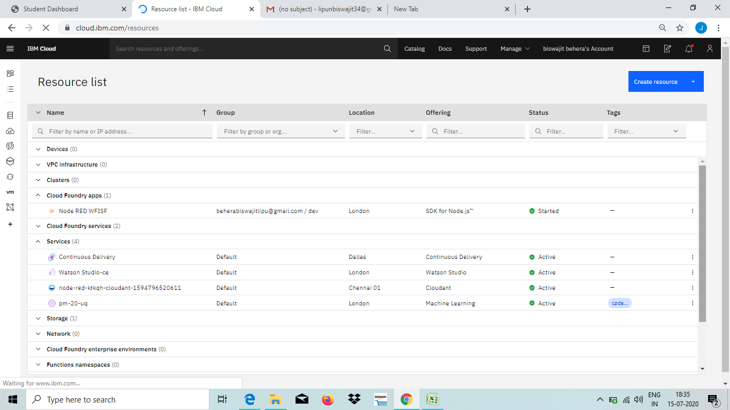



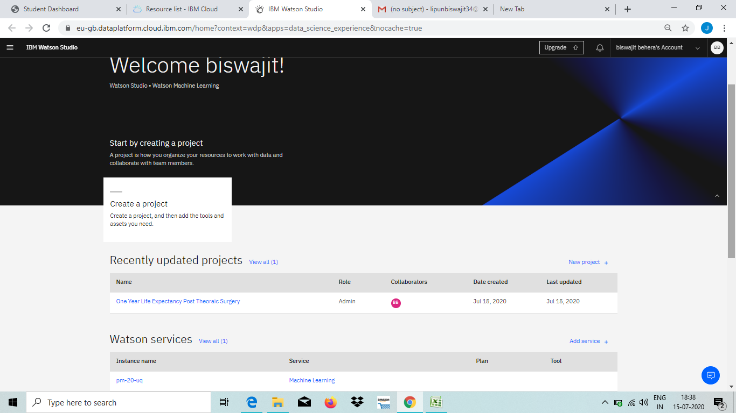

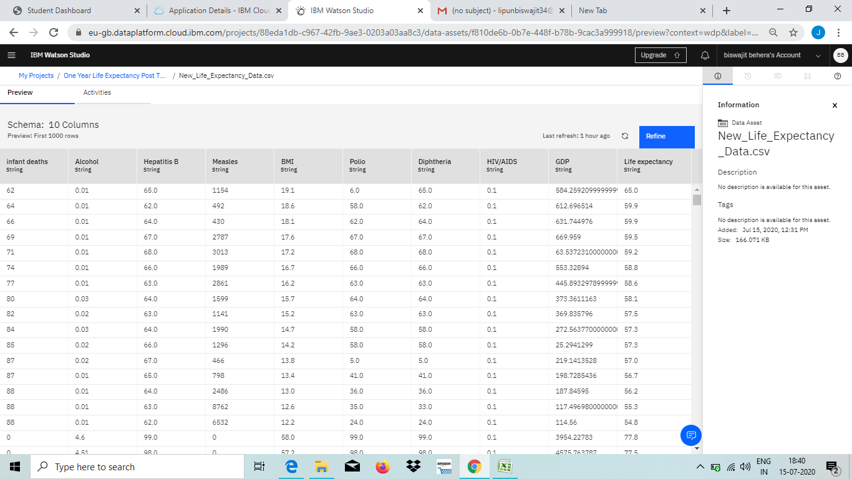

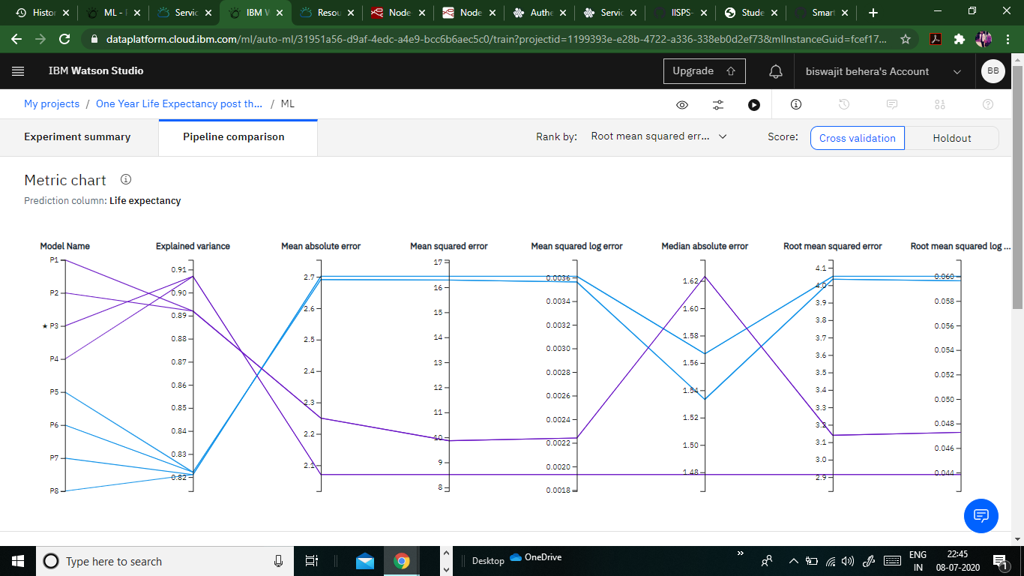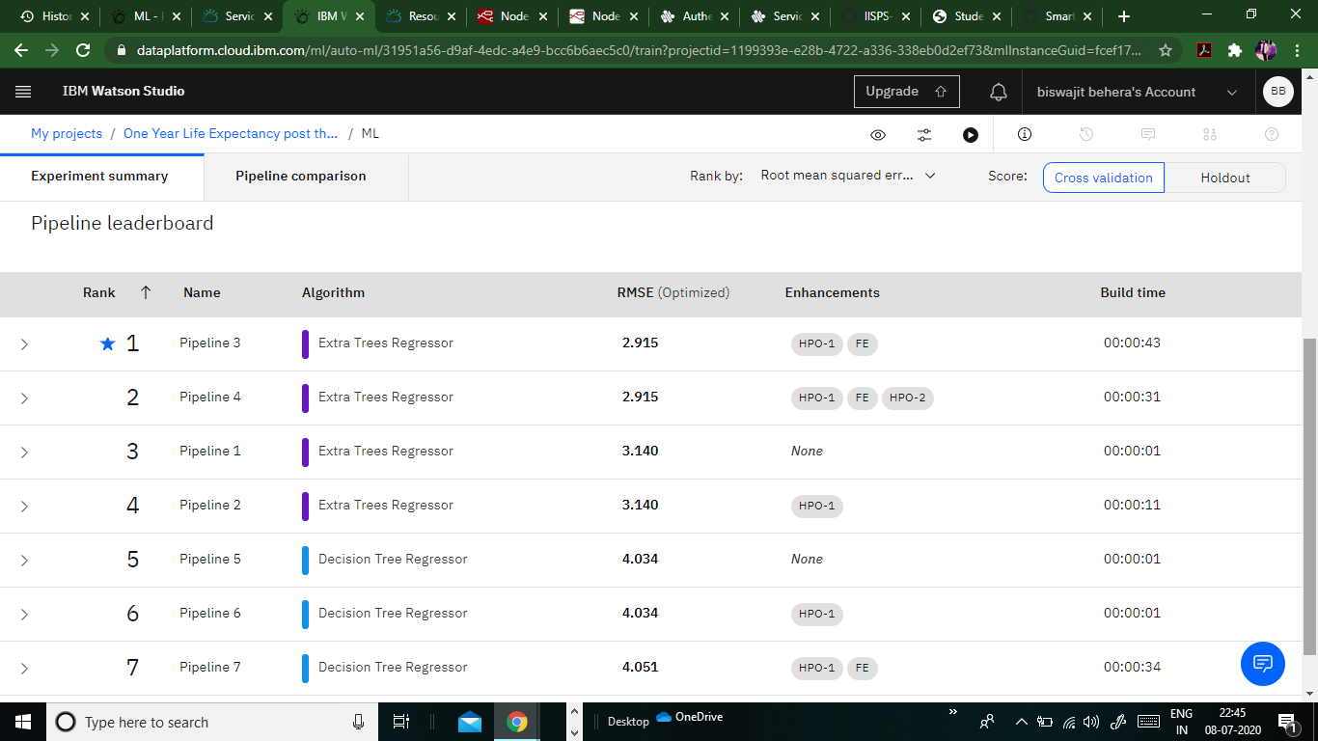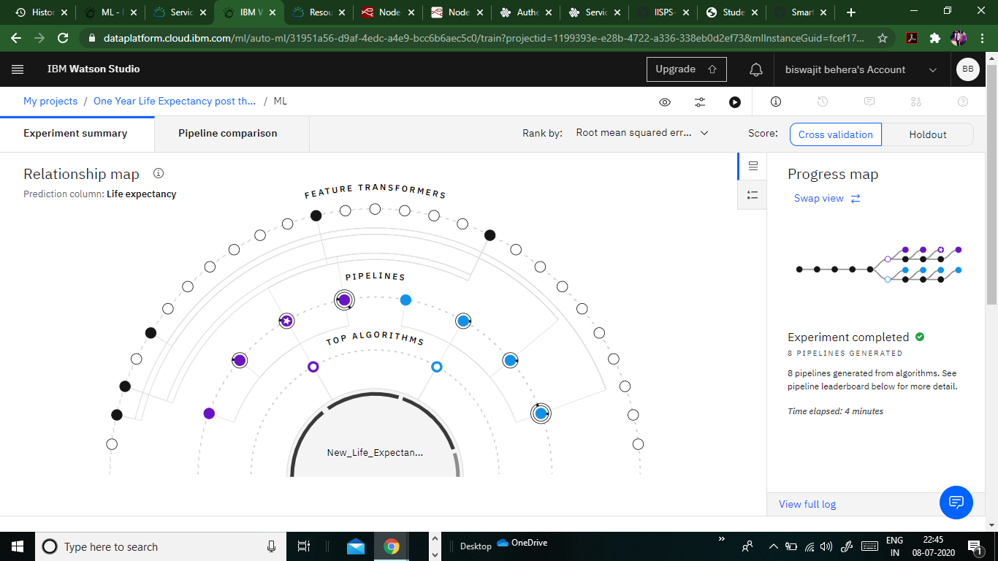

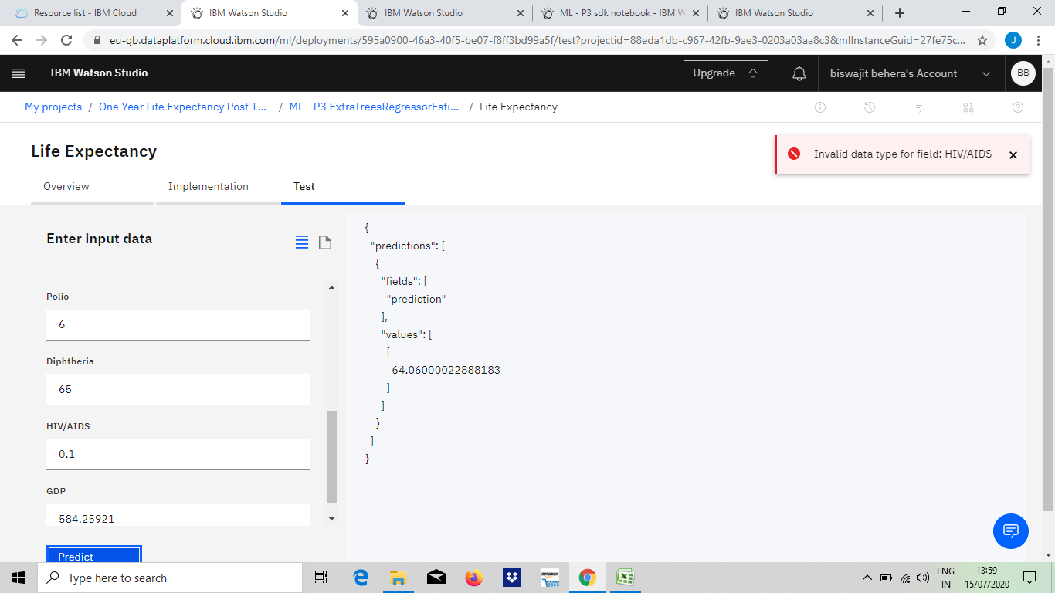



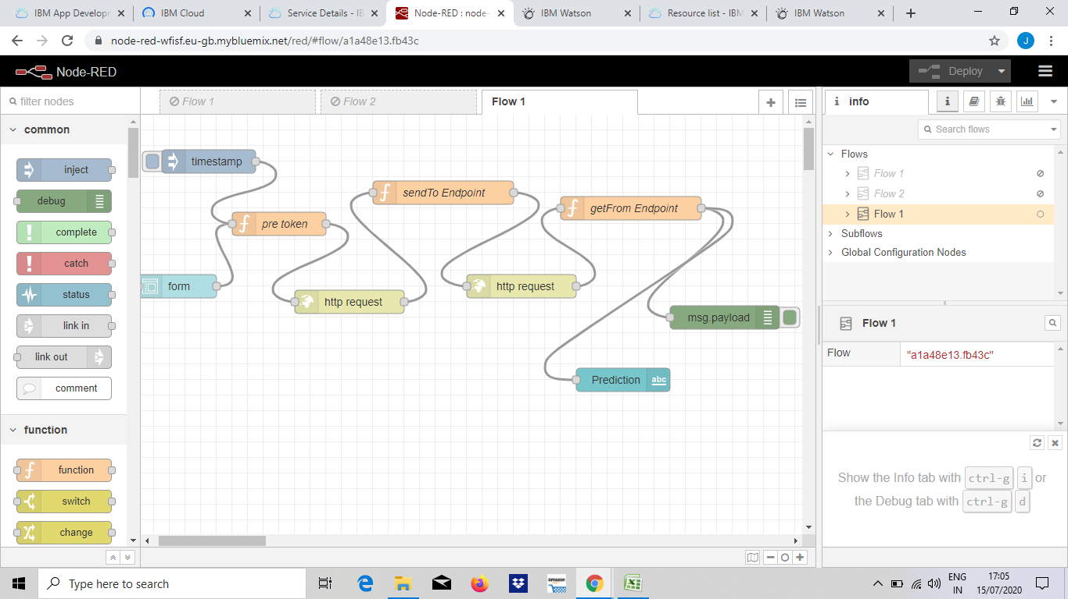

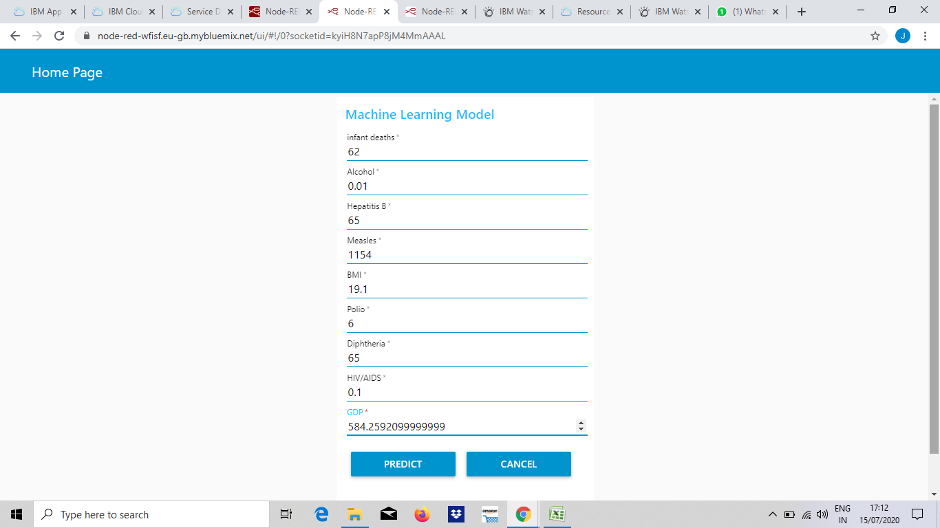

**CONCLUSION :**

Detection of lung cancer is one of the challenging problems in medical field due to structure of cancer cells, where most of the cells are overlapped to each other. Detection of lung cancer in the early stage is curable. The system contains two parts. One is Lung Cancer Detection part and the other is the Prediction of Life Expectancy Post Thoracic Surgery. Both the parts can run independently. The system is provided as a web application where anyone can upload a CT scan image of the lung in the front end and check out whether that image is infected with Lung Cancer. At the backend the image uploaded is preprocessed, segmented and predicted using the CNN model which is already trained. Also, the system provides a form requesting for the 14 attributes required to predict the survival span post Thoracic Surgery. Once the form is submitted, the form inputs are run on the LDA model and a response of whether the patient will survive or not is produced. CNN model used to detect lung cancer gave an accuracy of 95% and the LDA classifier gave the highest accuracy of 83.76% compared to other 3 algorithms used. The system considers only CT lung images as input, but further the system can be enhanced to take MRI (Magnetic Resonance Imaging) or PET (Position Emission Tomography) as input. Also, in the prediction of survival part, higher accuracies of the classifier can be achieved by considering large amount of dataset.

**FUTURE SCOPE :**

Thoracic surgery is living an enthusiastic era of thriving innovations. The changes in the fields of diagnostics, in the therapeutic options, the development of surgical techniques and the adoption of novel technologies has radically changed the horizons of our specialty. We must embrace the innovations, learn navigational bronchoscopy, understand the multiple targeted therapies, and learn new ways to operate on advanced cases. We will not be able to stay complacent with our current 3 ports video-assisted thoracoscopic surgery (VATS) technique with open instruments, therefore every surgeon needs to be watching for each latest development as it happens. In this brief manuscript we will summarize some of the most important development over the recent years and forecast how this will impact on the patients affected by thoracic malignancies. As thoracic surgeons we have to embraces these developments in order to redefine our specialty.

**Bibliography**

* Hendrix RJ, Lee C, Friedrich AK, Rouanet E, Larkin AC, LaFemina J. [Prophylactic VersusTherapeutic Mastectomy: A Contemporary Analysis of the ACS-NSQIP Database.](https://www.ncbi.nlm.nih.gov/pubmed/30876714)ClinBreastCancer. 2019 Jun;19(3):e428-e432.

* Hendrix RJ, Martins PN, Stoff JS, Ahearn A, Bozorgzadeh A, Movahedi B. [Successful RenalTransplantation after Presumed Cyanide Toxicity Treated with Hydroxocobalamin and Review ofthe Literature.](https://www.ncbi.nlm.nih.gov/pubmed/30271651)CaseRep Transplant. 2018 Sep 9;2018:3753479.

* McKie K, McLoughlin RJ, Hirsh MP, Cleary MA, Aidlen JT. [Risk Factors for VenousThromboembolism in Children and Young Adults With Inflammatory Bowel Disease.](https://www.ncbi.nlm.nih.gov/pubmed/31181463)JSurg Res.2019 Jun 7;243:173-179.

* McLoughlin RJ, Green J, Nazarey PP, Hirsh MP, Cleary M, Aidlen JT. [The risk of snow sportinjury in pediatric patients.](https://www.ncbi.nlm.nih.gov/pubmed/29884589)AmJ Emerg Med. 2019 Mar;37(3):439-443.

* Hoang CM, Alavi K, Flahive JM, Sturrock PR, Maykel JA, Davids JS. [Impact of the "WeekendEffect" for Hospital Discharges on Readmissions After Elective Colectomy.](https://www.ncbi.nlm.nih.gov/pubmed/30451755)DisColon Rectum.2019 Apr;62(4):476-482.

* Sarani B, Paspulati RM, Hambley J, Efron D, Martinez J, Perez A, Bowles-Cintron R, Yi F, Hill S, Meyer D, Maykel J, Attalla S, Kochman M, Steele S. [A multidisciplinary approach to diagnosisand management of bowel obstruction.](https://www.ncbi.nlm.nih.gov/pubmed/30526888)

* Curr Probl Surg. 2018 Oct;55(10):394-438.

* [Davids JS, Lyu HG, Hoang CM, Daniel VT, Scully RE, Xu TY, Phatak UR, Damle A, MelnitchoukN. Female Representation and Implicit Gender Bias at the 2017 American Society of Colon andRectal Surgeons' Annual Scientific and Tripartite Meeting.](https://www.ncbi.nlm.nih.gov/pubmed/30451743)DisColon Rectum. 2019Mar;62(3):357-362.

* Min M, Noujaim MG, Green J, Schlieve CR, Vaze A, Cahan MA, Cave DR. [Role of MucosalProtrusion Angle in Discriminating between True and False Masses of the Small Bowel on VideoCapsule Endoscopy.](https://www.ncbi.nlm.nih.gov/pubmed/30934710)

* J Clin Med. 2019 Mar 27;8(4). pii: E418.

Murray CR, Balsam LB. [Commentary: Outliers-Salvage operations and the Society of Thoracic](https://www.ncbi.nlm.nih.gov/pubmed/30926197).