**Rocks Identification using Deep Convolution Neural networks**

Submitted by:

Pallavi Medicherla

1.) Introduction:

1.1. *Overview:*

A rock is a naturally occurring solid mass or aggregate of minerals or mineraloid matter. It is classified based on the chemical composition and the way it is formed. Generally rocks are grouped into three main groups: Igneous rocks, Metamorphic rocks, Sedimentary rocks. Rock type

Identification is a basic part of geological surveying, and research, and mineral resources exploration. The application used here is based on this intelligent type of identification for various types of rocks using deep convolution neural networks. Through this insightful approach it makes the task easier with more accurate results and hence reduces the difficulties in the automated identification of rocks in this field.

*1.2. Purpose:*

The principal idea of this project is to identify various kinds of rocks based on image analysis using deep convolution neural networks.

2.) Literature Survey:

*2.1. Existing Problem:*

Rocks are fundamental components of earth. There are three main types of rocks: Igneous, Metamorphic, and Sedimentary. Each of these rocks are formed by physical changes- such as melting, cooling, eroding, compacting, or deforming-that are part of the rock cycle. Visual inspection inspects properties such as colour, grain size and structure. The attribute of rocks reflects its chemical composition. But this analysis is time taken process to identify the rocks. The recognition method based on rock thin section leads to long recognition period and higher recognition cost, and the recognition cannot be guaranteed. Moreover, the above method cannot provide an effective solution in the field.

2.2. *Proposed Solution:*

To overcome the difficulties faced in the above method, a solution was proposed on deep convolution neural network is developed. So, this concept of convolutional neural networks presented a new solution for the rapid and accurate recognition of various rocks in the field of geological surveys, which provided the increase accuracy and efficiency in the identification hence, helps students and newly qualified geologists practice rock-type identification.

3.) Theoretical Analysis:

3.1. Block Diagram:

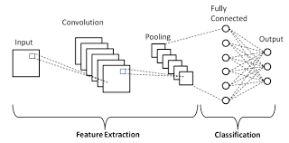

3.2. *Hardware / Software designing:*

While machine learning techniques have been increasingly applied to handle classification problems, these techniques have not focused on separating rock exposed bare neural network(CNN) to differentiate exposed bare rock from solid cover. The resulting CNN approach is likely scalable but dependent on high quality images and high performance algorithms using representative training sets informed by expert mapping. As image quality and quantity continues to increase globally, machine learning models that incorporate high-quality training informed by geologic, topographic, or other tropical maps may be applied to more effectively identify exposed rocks in large image collections.

4.) Experimental Investigations:

The various steps in the evaluation of experimental analysis of "Rock identification using deep convolution neural networks" are as follows:

A.)First take the dataset containing various types of images classified as Igneous, Metamorphic and Sedimentary and split them to trainset and testset.

B.)Next pre-process the images using ImageDataGenerator class

C.)Then import the libraries, and initialize the model

D.)Next add Convolution, Max pooling and flattening layers.

E.)Add hidden layers of ANN

F.)Add output layer of CNN.

G.)After performing image processing techniques, Compile the model.

H.)Save and predict the model.

i.)Build an html file and write the python code.

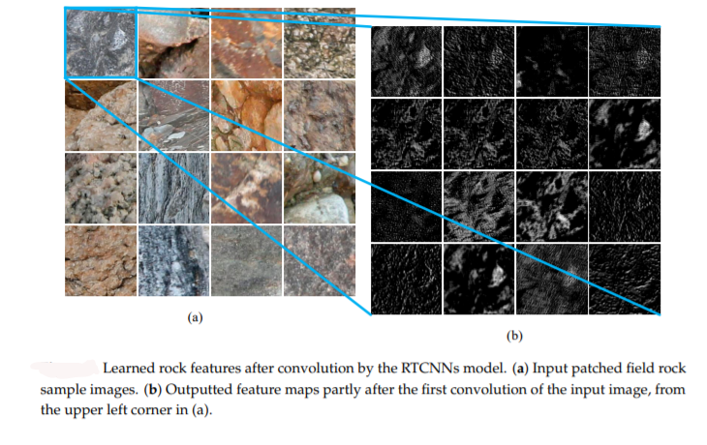

5.) Flowchart:

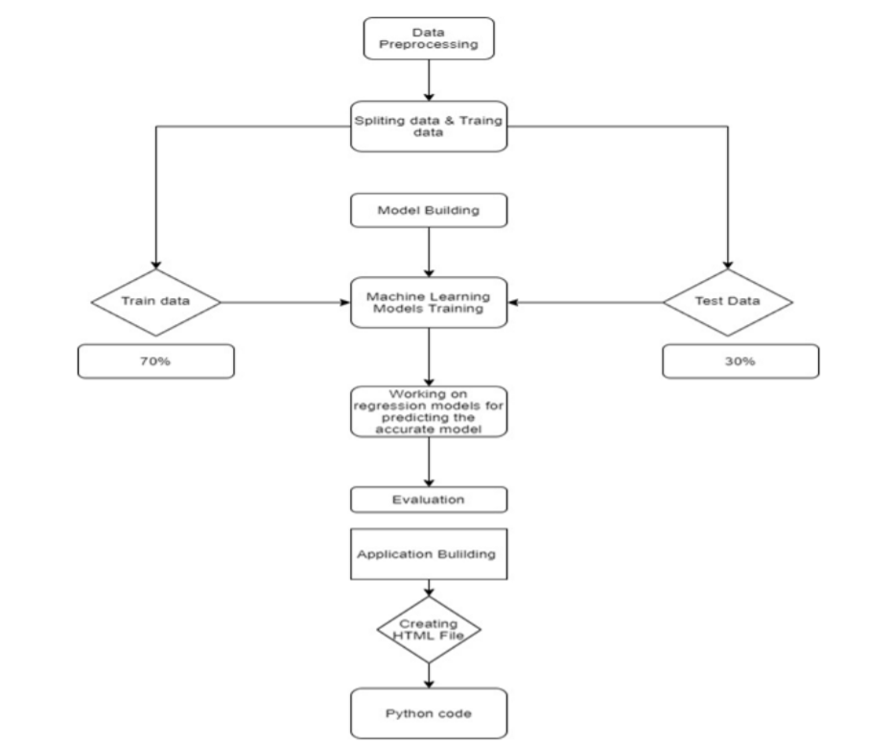

6.) Results:

We got an accuracy of 0.96 which is a good measure for convolution neural networks. When we give a rock image as input the model, it classifies them as - Igneous/Metamorphic/Sedimentary and gives the corresponding result.

7.) Advantages & Disadvantages:

Advantages:

A.)Reduces the waste of human resource for such busy work. Instead these people can be assigned with some other tasks to be completed.

B.)There is virtually no chance for error if their quality of image is high.

C.)Accurate output is obtained.

Disadvantages:

A.)There is obvious loss of jobs.

B.)There should be high pixel quality images present for the dataset.

C.)We should avail the whole database of rock characteristics.

8.) Applications:

Rocks are a natural solid substance. From building to highways-we can find applications of rocks everywhere. The robustness of rocks has played a significant role in everyday life. Some more applications of rocks are as follows:

A.)Rocks are used for masonry work, lintels, and vertical columns, covering floors of the building.

B.)Flags or thin slabs are used for paving, roofing etc.

C.)Broken or crushed rocks are also used as railway ballast.

D.)Stone screenings are used as a natural substitute for sand.

E.)Limestone is the basic material for the manufacture of lime concrete and cement.

9.) Conclusion:

In this project, we have made the application of deep convolutional neural network. Initially we have sliced and patched the original obtained photographic images to increase their suitability for training the model. The sliced samples clearly retain the relevant features of rock and augmented the dataset. Finally the proposed deep CNNs model was trained and tested the images dataset of images belonging to 3 classes and achieved an overall accuracy of 96.90%.Thus the developed project can be used in identification of rock types in order to get accurate results using deep convolutional neural network, without the need of any human intervention.

10.) Future Scope:

The application of CNNs to identify and classify various kinds of rock still faces some challenges. Firstly, regarding accuracy, it has to be improved still when we certain characteristics like small size, same color etc. In such cases this proposed approach delivers low accuracy. Therefore, our future work will combine the deep learning model with a knowledge library, containing more rock knowledge and relationships among various rock-type identification in the field.

11.) Bibliography:

1. Singh N., Singh T.N., Tiwary A., Sarkar M.K. Textural identification of basaltic rock mass using image processing and neural network.

2. Młynarczuk M., Górszczyk A., Ślipek B. The application of pattern recognition in the automatic classification of microscopic rock images.

3. Ślipek B., Młynarczuk M. Application of pattern recognition methods to automatic identification of microscopic images of rocks registered under different polarization and lighting conditions.

4. Thesmartbridgeteachable.com

12.) Appendix:

*A .Source Code:*

A.)Rocksmodel.h5:



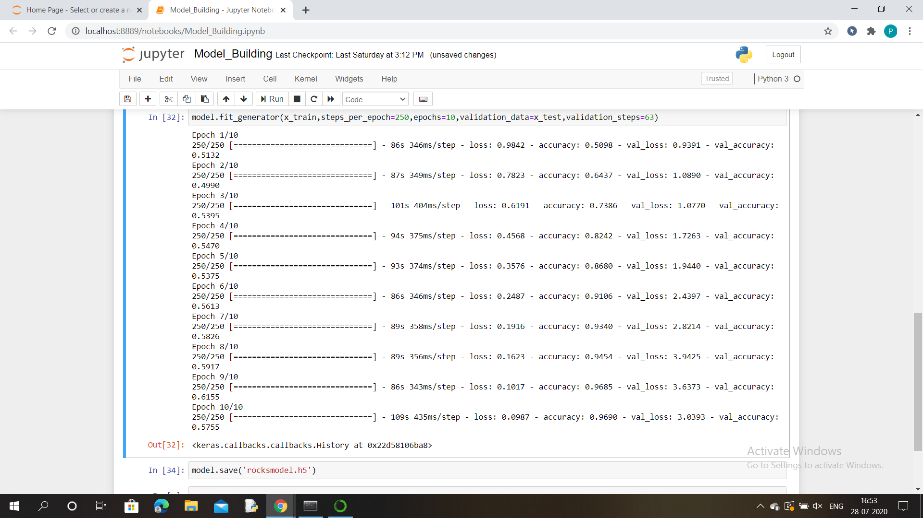

B.)Prediction:



C.)Flask:



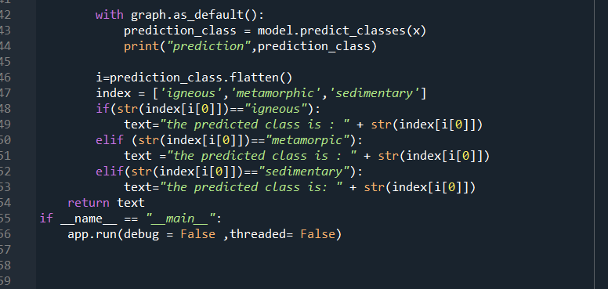

*B. UI output screenshots:*

