# Avalanche Forecasting Prediction Using Auto AI Service

SubmittedBy- Nikhil Rai

Email-ID: : :nikhilrai179@gmail.com

Submitted to : SmartInternz.com



**CONTENTS:**

**1.**Introduction……………………………………………………..3

1.1 Overview………………………………………………..3

1.2 Purpose………………………………………………….3

2. Literature Survey……………………………………………….4

2.1 Existing solution………………………………………...4

2.2 Proposed solution……………………………………….4

3. Theoretical Diagram……………………………………………5

3.1 Block Diagram…………………………………………..5

3.2 Hardware/software Designing…………………………..5

4. Experimental Investigation……………………………………..6-7

5. Flow chart……………………………………………………....8

6. Result…………………………………………………………...9

7. Advantages and Disadvantages………………………………...10

7.1 Advantages……………………………………………...10

7.2 Disadvantages…………………………………………...10

8. Applications…………………………………………………….11

9. Conclusion……………………………………………………...11

10. Future scope…………………………………………………...12

11. Bibliography…………………………………………………..12

12.Appendix……………………………………………………….13-15

**INTRODUCTION:**

**1.1 Overview:**

The word Avalanche refers to snow and ice. It means a mass of snow, ice, rocks, slush falling rapidly down a mountain. Snow avalanches are among the most destructive natural hazards threatening human life, ecosystems, built structures, and landscapes in mountainous regions.

Each year avalanche kills more than 150 people worldwide. The most common cause of death by avalanche is asphyxiation. If the person buried under an avalanche more than 15 minutes then there is no chance of survive. So, the life of the people in that region is difficult to live.

In order to predict Avalanche in a given region, we will be using Machine Learning algorithms to draw inferences from the given dataset and give an output. For better usability by the customer, we are also going to be creating a UI for the user to interact with using Node-Red. All the readings will be captured from different sensors for better forecasting.

**1.2 Purpose**

Avalanche considered under natural phenomenon which cost many life's from different region of the world. With some calculated measures atleast we can reduce the number of deaths which occurs across the world. So, main purpose of our project is to forecast the possibility of occurence of Avalanche . We will use our dataset to train our model using IBM auto AI and further nodeRed for developing interactive UI for making it user Friendly. We will use different sensors to measure Air temperature,wind,snow density,slope to predict the forecasting of Avalanche , so that atleast an alert will be circulated before Avalanche which will help people to decide about tracking whether to go or not.

**2. LITERATURE SURVEY**

**2.1 Existing Problem:**

The word Avalanche refers to snow and ice. It means a mass of snow, ice, rocks, slush falling rapidly down a mountain. Snow avalanches are among the most destructive natural hazards threatening human life, ecosystems, built structures, and landscapes in mountainous regions.

Each year avalanche kills more than 150 people worldwide. The most common cause of death by avalanche is asphyxiation. If the person buried under an avalanche more than 15 minutes then there is no chance of survive. So, the life of the people in that region is difficult to live.

**2.2 Proposed Solution:**

We were having a dataset which was having Date,Temperature,Humadity,Total snow depth and intermittent snow. We read this data using IBM watson auto AI machine learning functionality where it tested against different preprocessing steps and then further model get trained with best fitted regression model.Further we deployed the model in watson studio to test the prediction of values. Then we again created an interactive user interface using NodeRed to make this model more interactive. We will further modify this to take data directly from sensors time to time and then model will send an alert whenever it will predict Avalanche forecasting.

**3. THEORITICAL ANALYSIS**

**3.1 Block Diagram:**

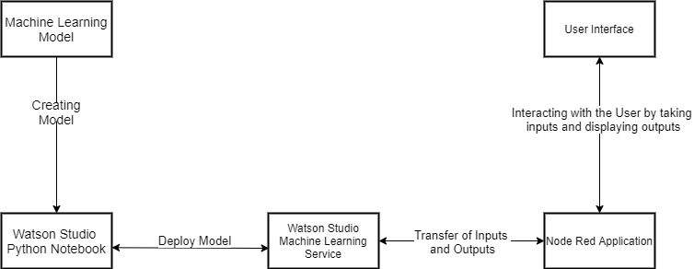

**3.2 Hardware/Software Designing:**

**Project Requirements:**

**i) Functional Requirements:**

To be able to predict the Avalanche forcasting using Machine Learning models.

**ii)Technical Requirements:**

Any working laptop/PC with minimum 2.2Ghz processor and at least 8GB of memory with an Internet connection.

**iii) Software Requirements:**

a) Python

b) IBM Cloud

c) IBM Watson

**4.EXPERIMENTAL INVESTIGATIONS**

Analyzing every feature in our dataset is very important which helps us to build a model which gives more accurate result.

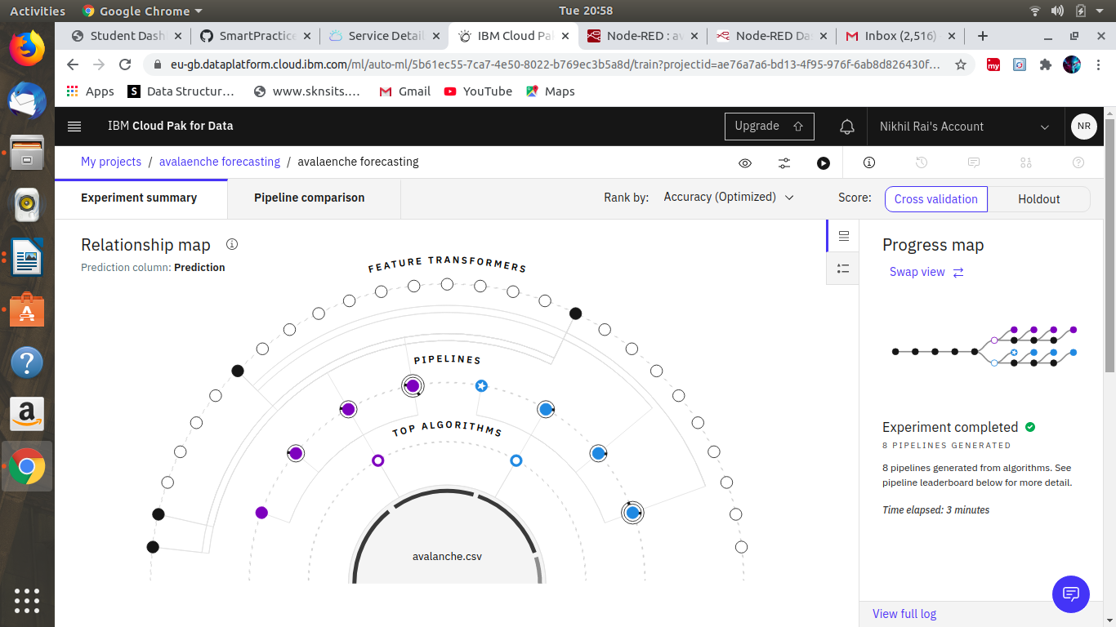

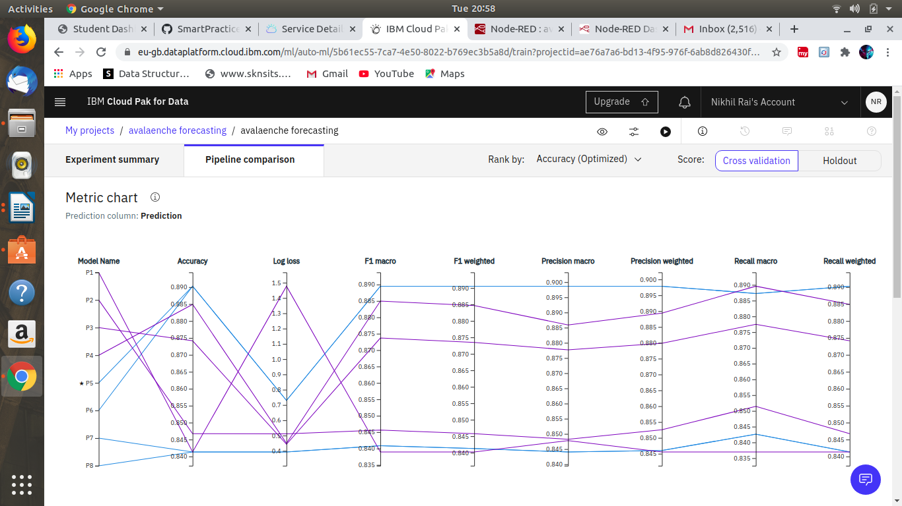

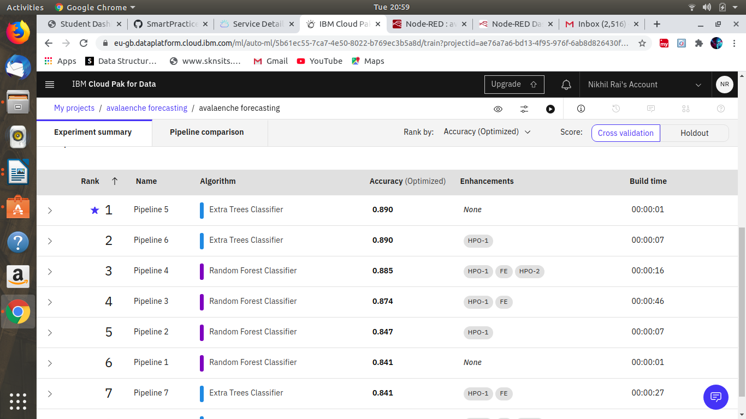

**6. RESULT**

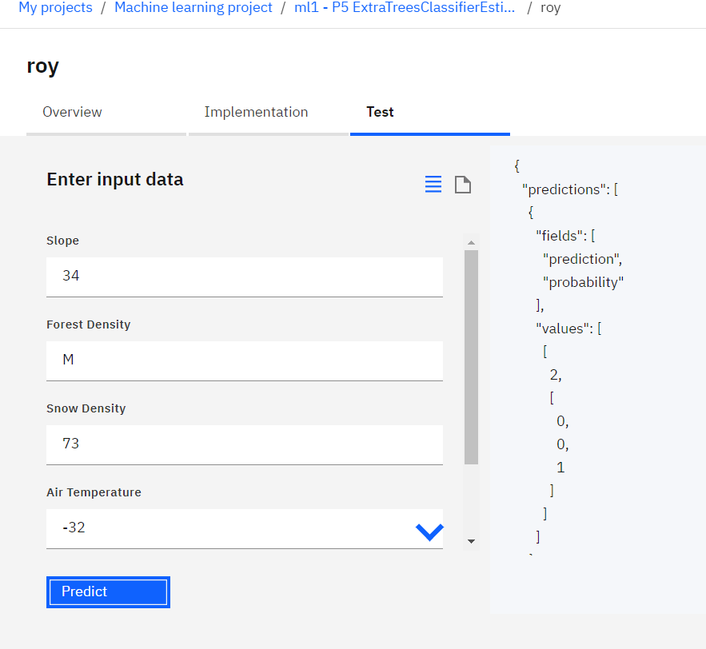

**7. ADVANTAGES AND DISADVANTAGES**

**7.1 Advantages:**

Model can easily forecast the Avalanche by getting proper data from different sensors which further helps to save the people from this natural clamity.

The application learns the patterns and trends hidden within the data without human intervention which makes predicting much simpler and easier. The more data is fed to the algorithm, the higher the accuracy of the algorithm is. It is also the key component in technologies for automation.

**7.2 Disadvantages:**

This model is developed using Machine Learning in which human involvement is very less and might cause some errors and if any error occurs it takes a lot of time for the developer to identify the root cause.

Also it can just forecast the Avalanche by using previous dataset but in extreme weather when sensors will start to behave differently than this model can also predict wrongly. That's why it can be used for Avalanche forecasting but can't be only one factor for forecasting.

**8. APPLICATIONS**

It will be very helpful in mountain areas where there is lack of even proper telecommunication means like Radio,Televisions etc so people can't depends totally on weather forecast.

That's why by learning from previously collected data model will be able to predict the Avalanche in real time. For input data we will be totally dependent on the different sensors like Temperature sensors which will give temperature data in real time whereas Humidity sensor will give humidity in real time and there will be a sensor to measure the depth of snow and with all together we will be able to forecast the Avalanche prediction locally which will be very helpful for the people of that region.

Whenever there will be any chances of Avalanche then UI will alert the people , so that people can take decision of going our or not during that time.

**9. CONCLUSION**

It will be like a great boon for the people of the region who face this Avalanche every year and many of them lost his or her life due to this.

Even this model can be easily fitted with Raspberrypi so that any people can use this who usually go on mountains for tracking purpose so they can be assure about Avalanche occurenece.

Many life's can be saved per year by using this model in those region where Avalanche occurs every years and cost many lives.

**10. FUTURE SCOPE**

One can plan to explore methods for gaining more insight in the nature of the patterns that are detected by neural networks, as well as making the determinants of a certain prediction transparent. For future use, one can integrate this model with different natural clamity like this also which will be a great benificiary for Humans's life.

The scalability and flexibility of the application can also be improved with advancement in technology and availability of new and improved resources. Also, with the growth in Artificial Neural networks and Deep learning, one can integrate that with our existing application.

**11. BIBLIOGRAPHY**

* <https://developer.ibm.com/tutorials/how-to-create-a-node-red-starter-application/>
* [https://bookdown.org/caoying4work/watsonstudio-workshop/jn.html#deploy-model-as-web-service](https://bookdown.org/caoying4work/watsonstudio-workshop/jn.html" \l "deploy-model-as-web-service)
* <https://www.ibm.com/watson/products-services>

**12. APPENDIX**

1. **WatsonAssistant:**

*Watson Assistant* is a conversation AI platform that helps you provide customers fast, straightforward and accurate answers to their questions, across any application, device or channel.

1. **WatsonStudio:**

Analysts prepare data and build models at scale across any cloud. Build models using images with IBM Watson Visual Recognition and texts with IBM Watson Natural Language Classifier. Deploy and run models through one-click integration with IBM Watson Machine Learning.

1. **IBM CloudFunction:**

IBM Cloud provides a full-stack, public cloud platform with a variety of offerings in the catalog, including compute, storage, and networking options, end-to-end developer solutions for app development, testing and deployment, security management services, traditional and open-source databases

1. **Node-Red:**

Node-RED is a flow-based development tool for visual programming developed originally by IBM for wiring together hardware devices, APIs and online services as part of the Internet of Things. Node-RED provides a web browser-based flow editor, which can be used to create JavaScript functions.

**UI OUTPUT:**



