## Created NODE-RED Application

->Now create a node red application to attach the python code to the node-red

->click on catalog in the ibm cloud account

-> Click on the software to find the application

->Search for node-red in the search bar provided.

-> Click on the node-red application to create.

->enter the details then u will get one page like

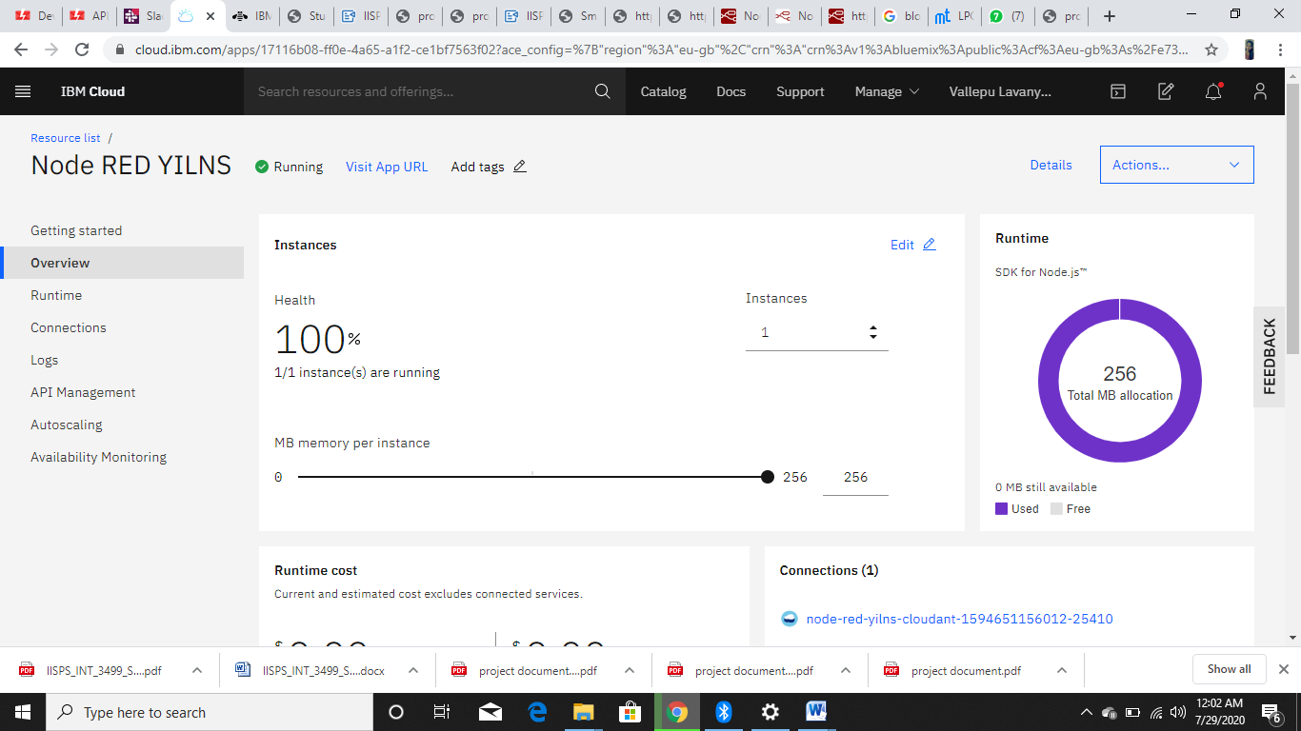

->Now click on Visit App url then node red application is created

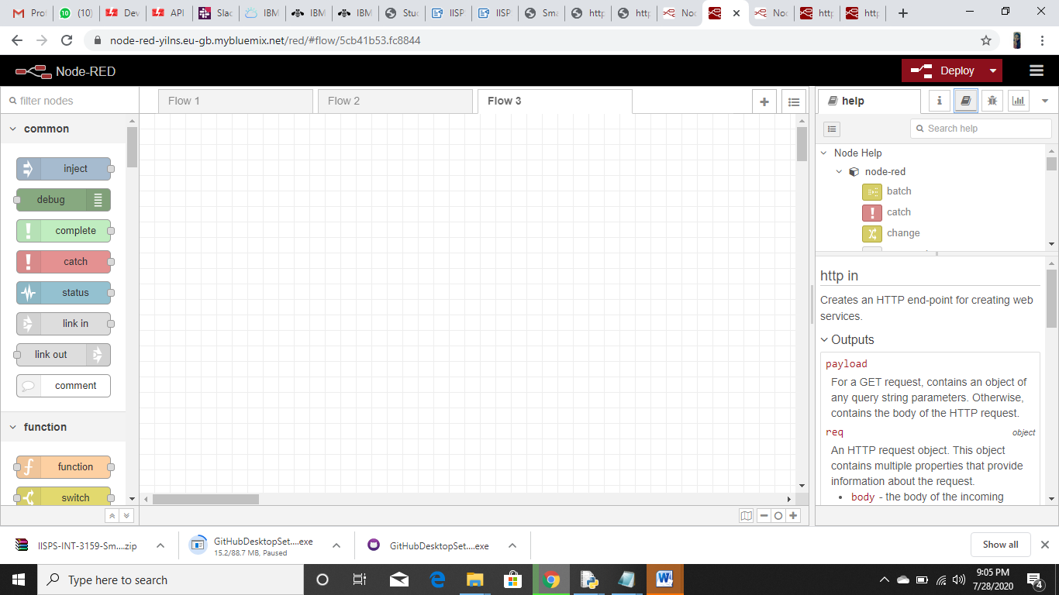

# CONFIGURE A WEB APP

CONFIGURE A WEB APP

Created A NODE-RED flow to get data from the Device

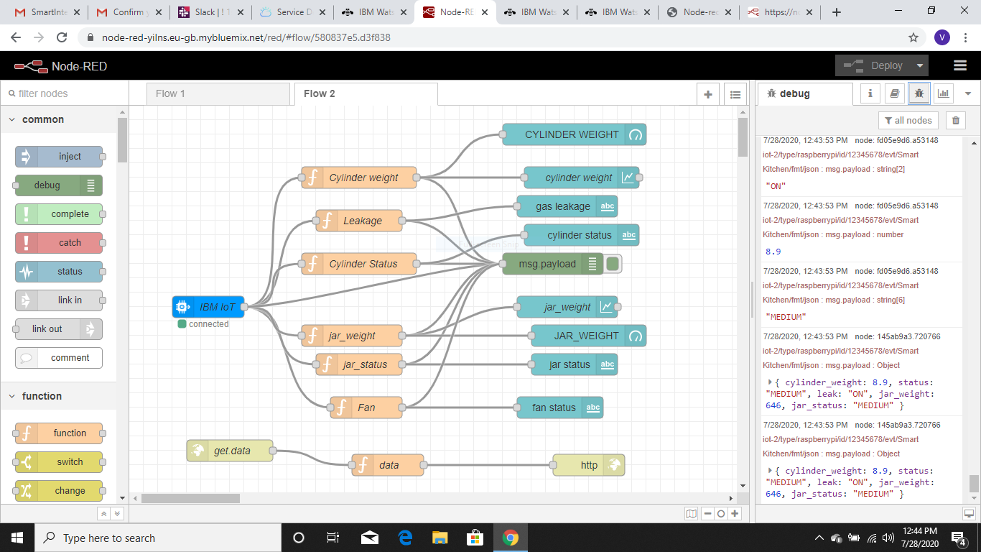

### OUTPUT OF THE NODERED AFTER EXCUTING THE PYTHON CODE

After creating nodered application

Copy the NodeRed URL till .net and paste in the new tab by typing /ui then u will get output like this

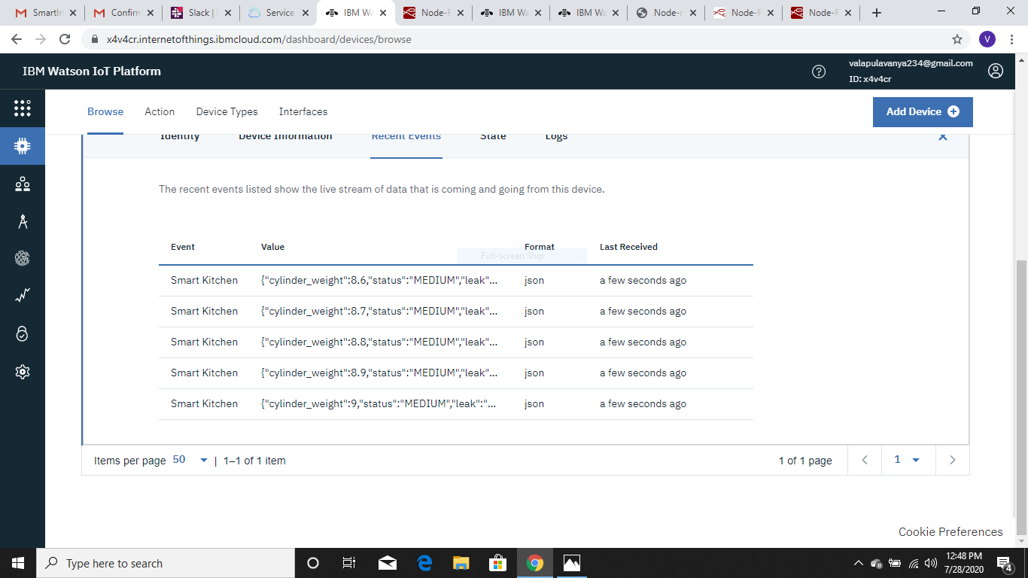

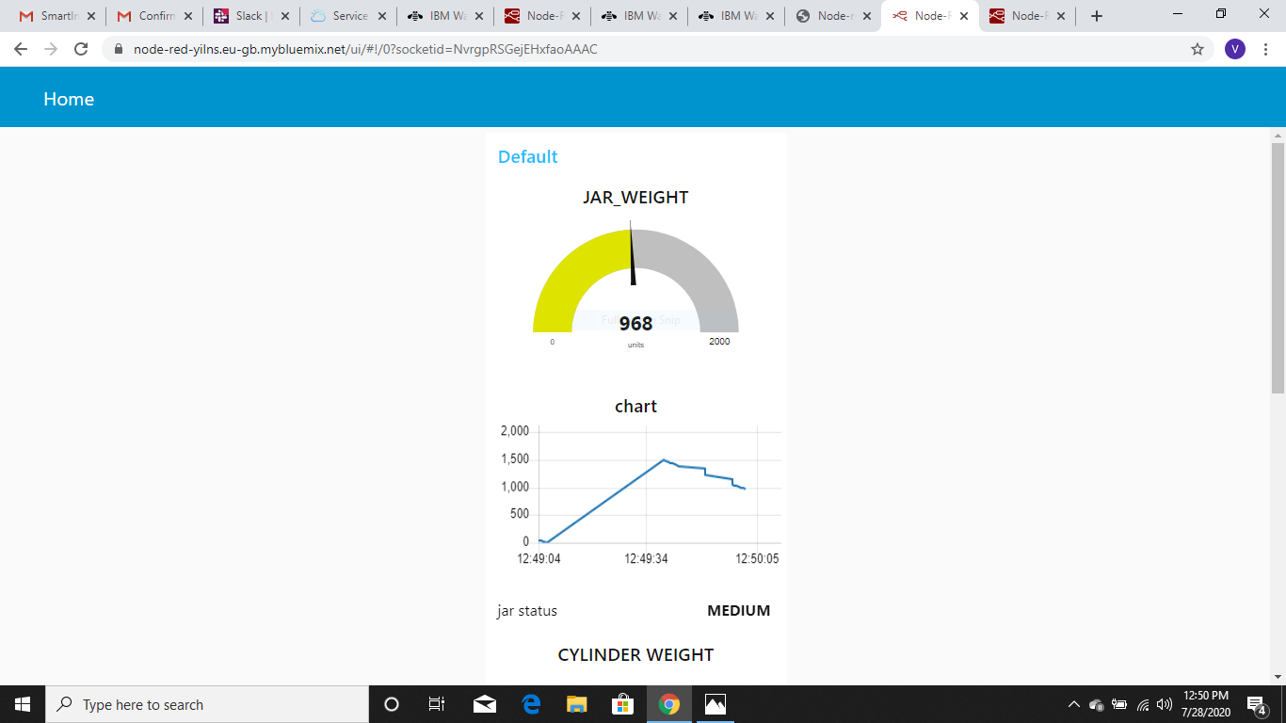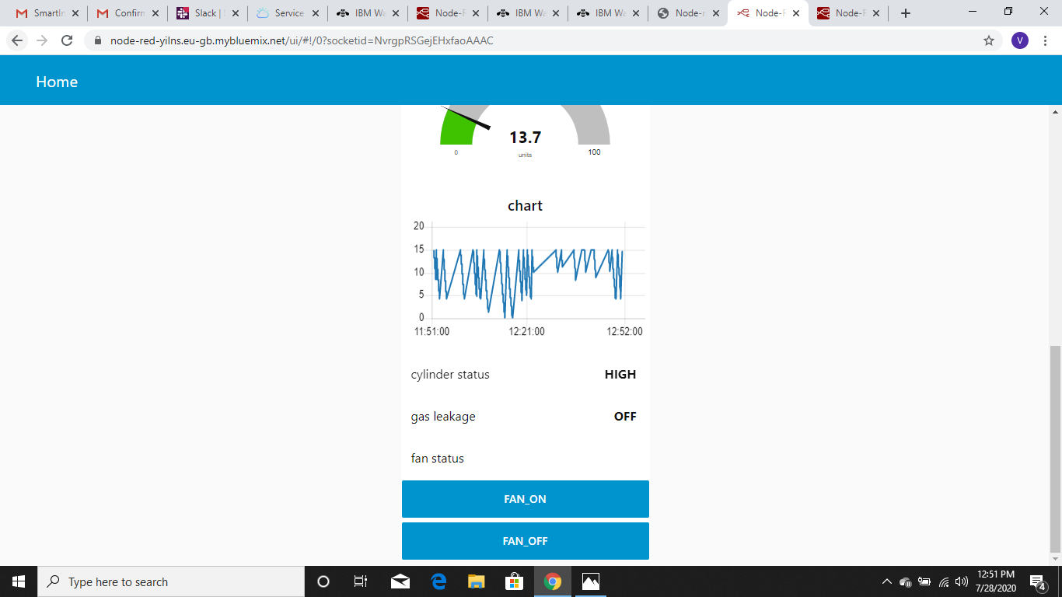

Creating an HTTP request for getting the values of gas cylinder weight,status ,jar weight,jar status and leakage status .

Display the values of gas cylinder in the webpage by dragging and placing the HTTP Input and HTTP Response node in the NodeRed flow editor.

Copy the URL in the NodeRed flow till .net and paste in the new tab by appending “/data” along with the URL and press Enter. cylinder values will be displayed on the webpage

### Open NodeRed flow editor to create an HTTP request to get command from the mobile app to device

##### OUTPUT: copy the URL of the NodeRed flow till .net and paste in the new tab and write [/command?command=lighton] for light on and [/command?command=lightoff] for light off to check whether URL is working properly or no

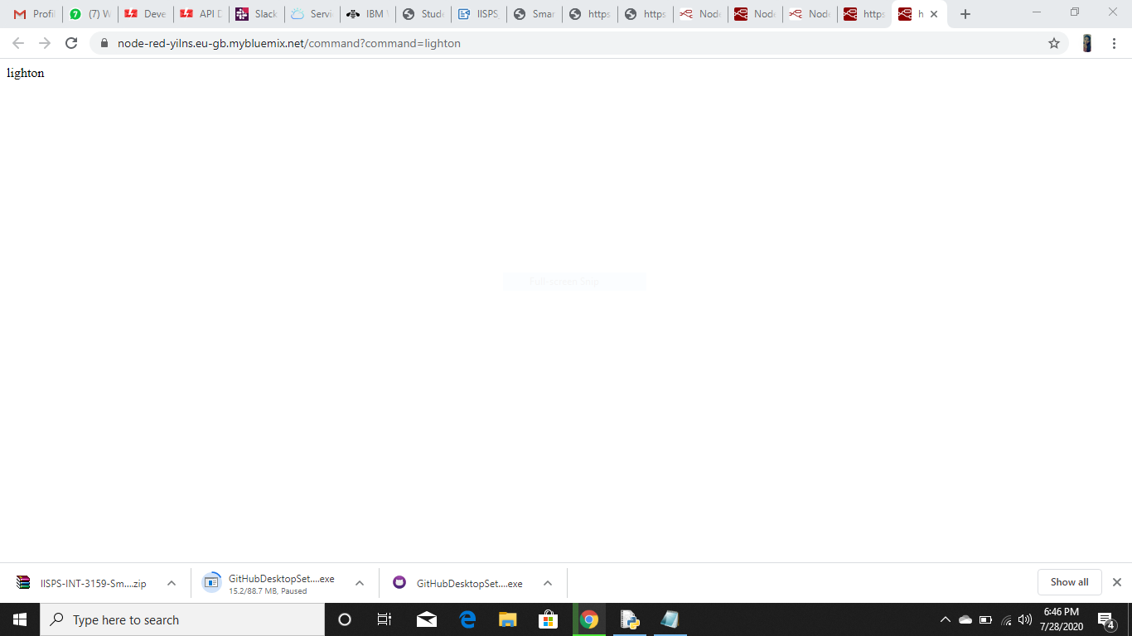

* then u will get LIGHTON message in the debug of NODE RED app

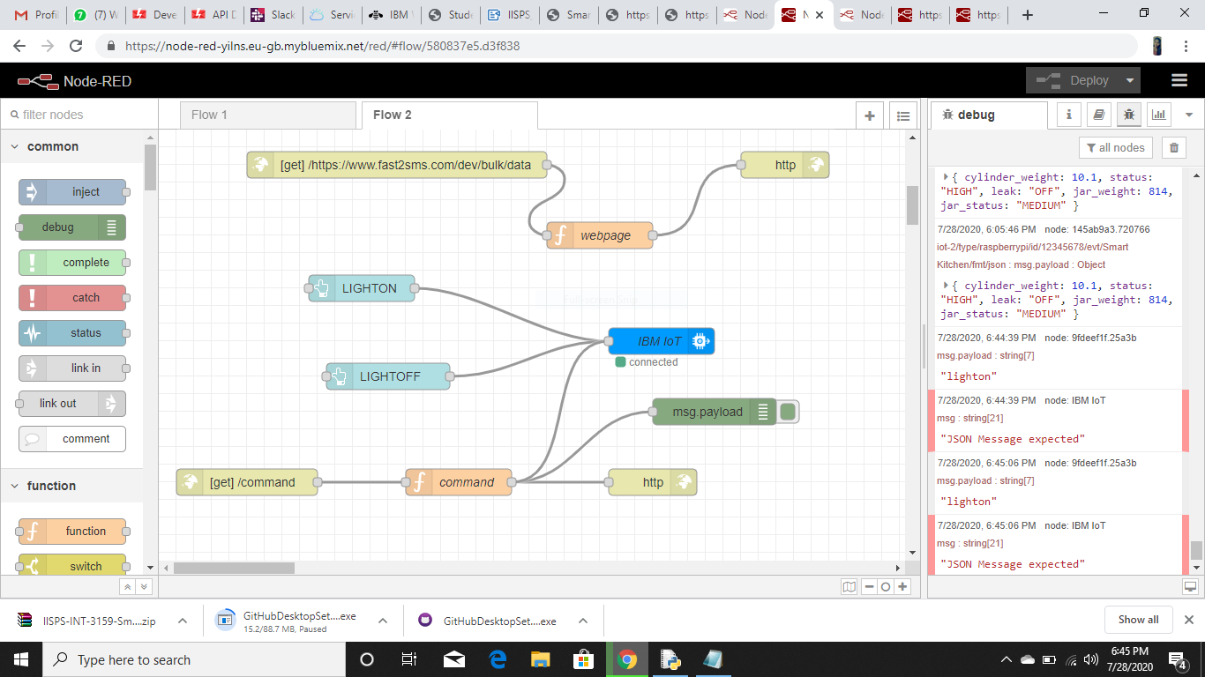

light off to check whether URL is working prope