Resale Value Prediction

(Using IBM Watson,Auto AI)

Introduction:

Overview:

With difficult economic conditions, it is likely that sales of second-hand imported  
(reconditioned) cars and used cars will increase.Because the production of new cars would be

difficult so it is advisable to re-use the car whose life is sustainable. My project illustrates how

a car can be evaluated and resale price can be determined and what are the factors invovled in

predicting the price for the resale of a car.

Purpose:

In many developed countries, it is common to lease a car rather than buying it outright. A lease is a binding

contract between a buyer and seller (or a third party – usually a bank, insurance firm or other financial institutions) in which the buyer must pay fixed instalments for a pre-defined number of months/years to the  
seller/financer. After the lease period is over, the buyer has the possibility to buy the car at its  
residual value, i.e. its expected resale value. Thus, it is of commercial interest to seller/financers  
to be able to predict the salvage value (residual value) of cars with accuracy.

Literature Survey:

Existing Problem:

The counundrum here is to find the factors on which the resale/lease price of a car depend on.

This depends on numerous parameters that describe the performance of the car. The prediction

made on the price varies heavily on the parameters used in the observed data. So fine tuning the parameters will give the accurate prediction.

Proposed Solution:

Considering the main factors which would affect the resale value of a vehicle a regression model is to be built that would give the nearest resale value of the  
vehicle. The main factors are the time in which vehicle got registered, number  
of kms it drove, power, type of gear box, model of the car, any damage or  
repair, fuel type etc. and the model processing is been done in Auto AI services  
in IBM cloud and then the deployment is been done in Watson studio.

Theoretical Analysis:

Software Requirement:

The whole model processing is done in IBM Watson Studio.

Watson Studio provides capabilities that empower businesses to simplify enterprise data science and AI, such as Automate AI lifecycle management with [AutoAI](https://dataplatform.cloud.ibm.com/docs/content/wsj/analyze-data/autoai-overview.html),Visually prepare and build models with Model, Build models using images with [IBM Watson Visual Recognition](https://www.ibm.com/cloud/watson-visual-recognition) and texts with Classifier, Deploy and run models through one-click integration with Learning, Manage and monitor models through integration with [IBM Watson Open Scale](https://www.ibm.com/cloud/watson-openscale)

For our project we will be using Auto AI to prepare the Regression model.

Experimental Investigations:

Firstly after getting into the Watson studio and starting a new project, We feed our processed dataset into the project workspace. Using the Auto AI, the experiment start the process by selecting the column which has to be predicted as the end product. Now Auto AI , Runs a series of Regression algorithms on the dataset Generating pipelines coupling them with Feature transformations

then it comes up with ranking through minimizing the RMSE value of the algorithms and presents the best algorithm at rank 1.

Process followed is illustrated by Relationship Map:

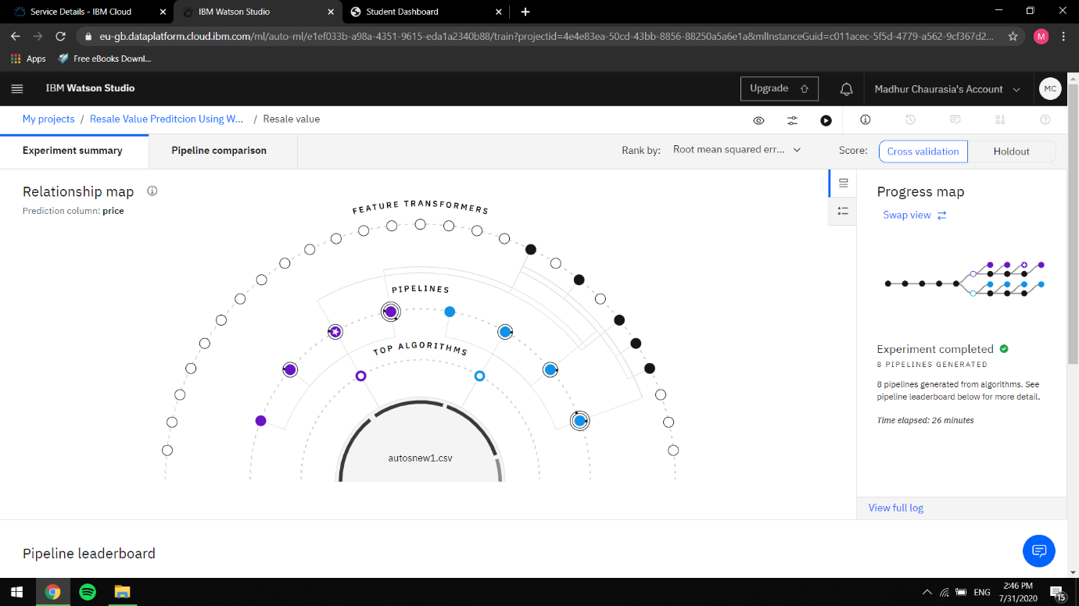

Ranked Algorithms:

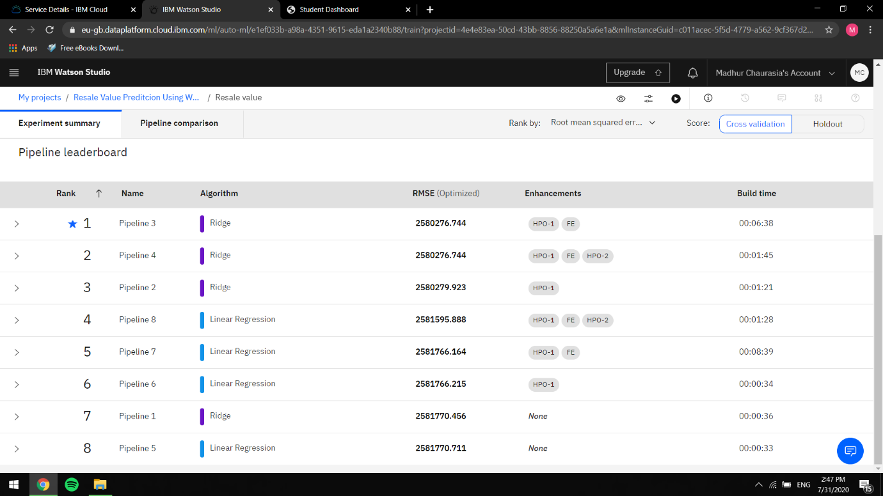

Pipeline Comparision:

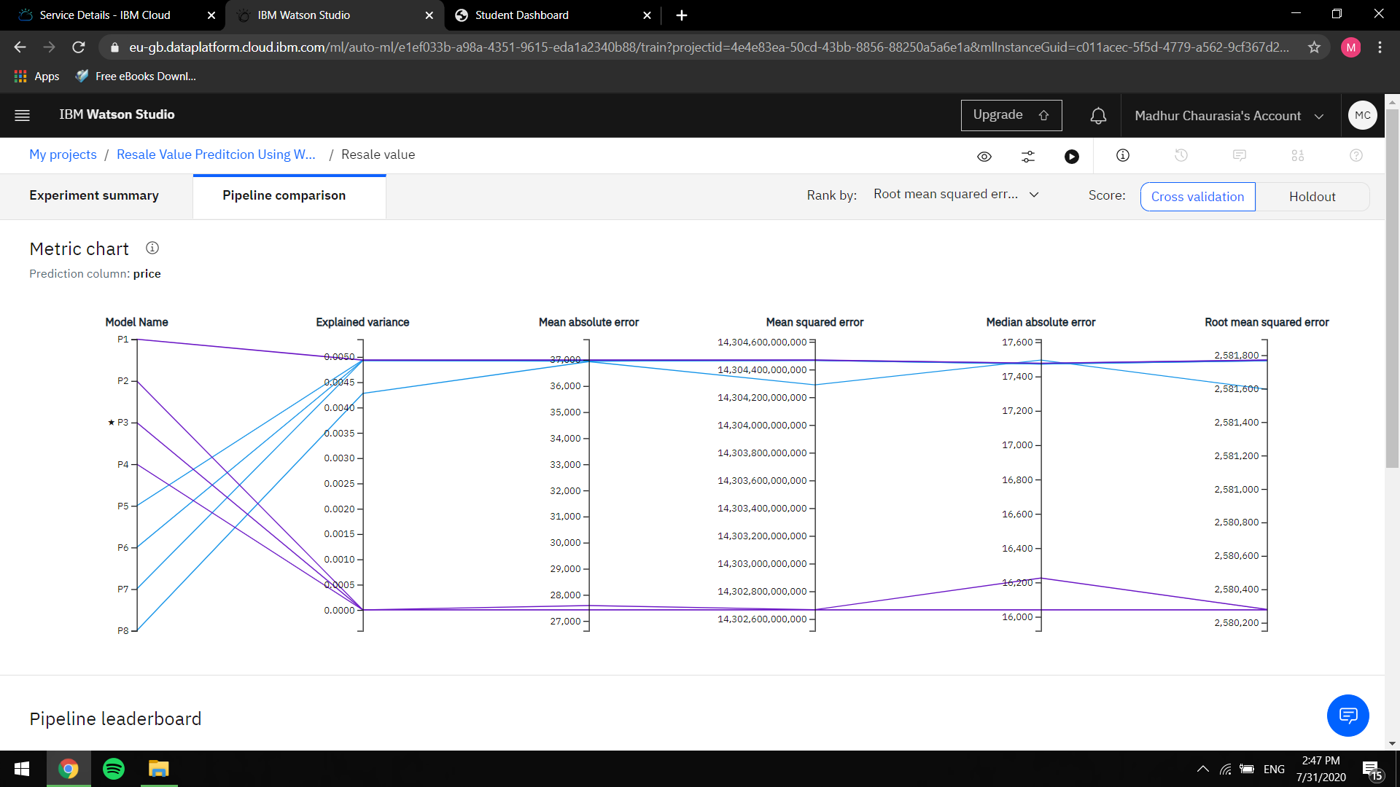

As shown pipeline 3 the Ridge Regression estimator with

RSME: 2580248.270 is the best pipeline for our prediction

experiment.

This model is fed into Web app created using Node Red through

API calls.

Thus creating a UI for the user end application to feed the

details of a car and predict the price.

Flow of the Web App:

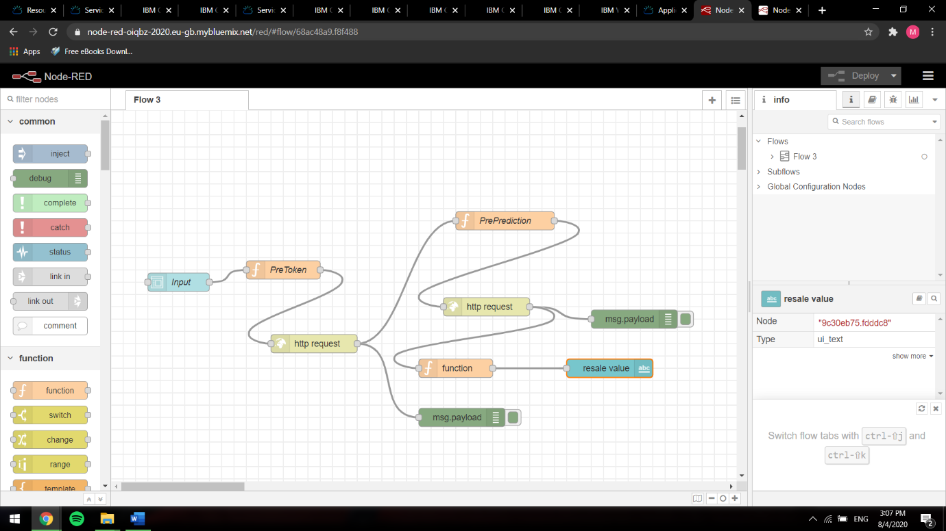

Flowchart:

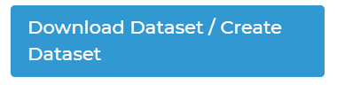

↓

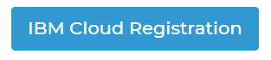

↓



↓

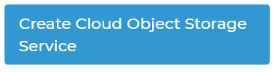

↓



↓

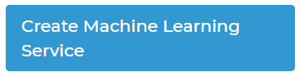

↓

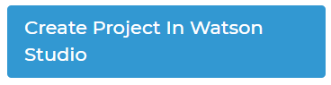

↓

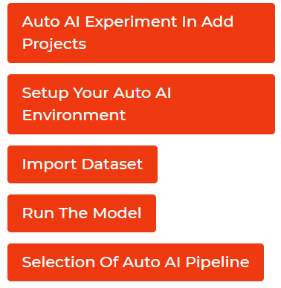

↓

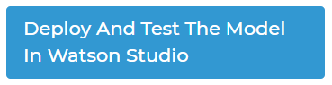

↓



↓



↓



Result:

After the implementation, deployment of project the result i.e. predicted price of vehicle can be seen in Node Red UI. This value depends on different parameters. The Node Red UI provide us simple way to get the result of Auto AI Experiment.

App built:

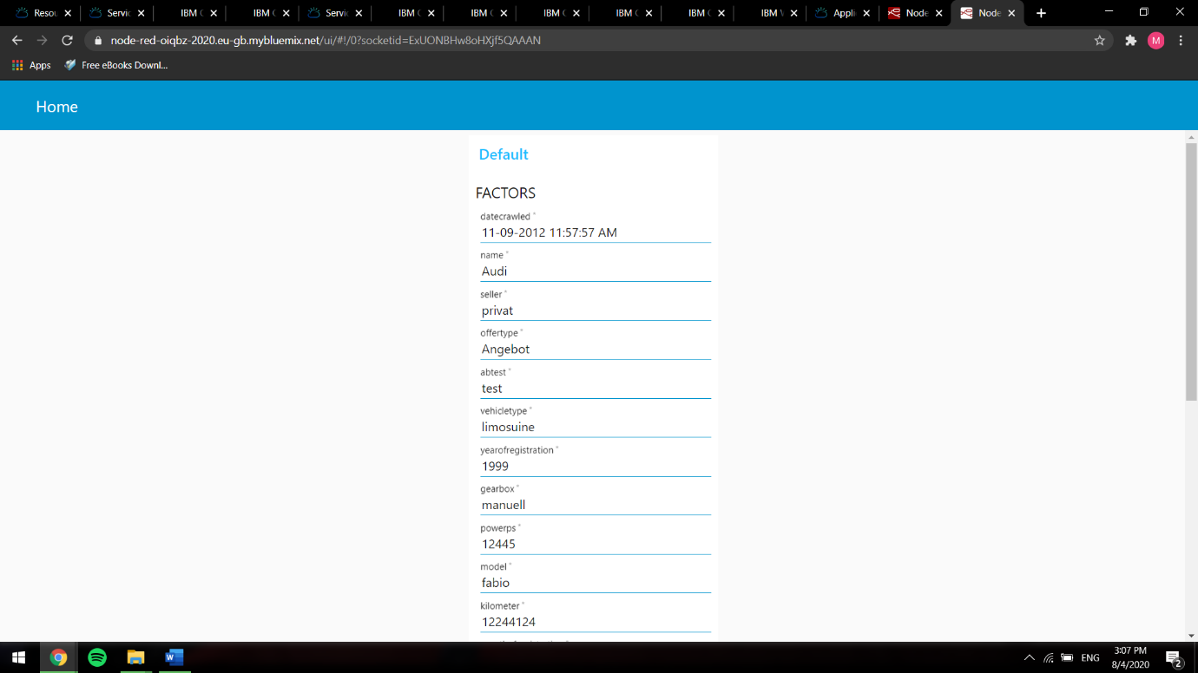

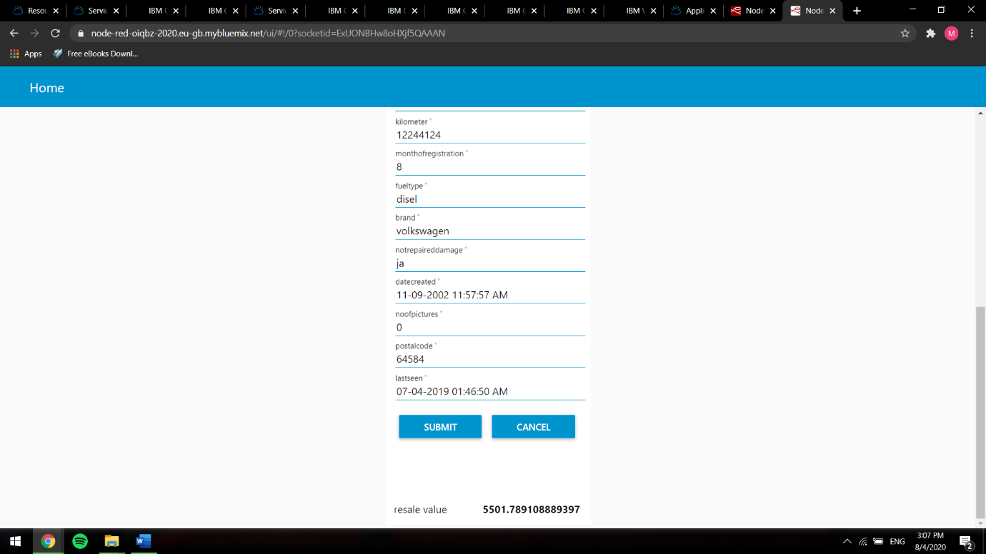

Thus the prediction model with a accuracy of 0.823 is built and deployed

the model using a web app built Node Red.

Advantages & Disadvantages:

The advantages are easy to implement ,

accessibility is fast,

we can handle multi-dimensional and multi-variety data,

Pretty Accurate,

Easy Deployment.

Where as the disadvantages are lack of security,

loss of control on data ,

dependence of network/providers,

Too many parameters to handle.

Applications :

Using The Auto AI Experiment,one can build and deploy a machine learning model with sophisticated training features . In the given project we can predict the price of the required vehicle by giving few input parameters.

CONCLUSION:

In this project by using IBM Cloud the model processing is been done in Auto AI services in IBM cloud and then the deployment is been done in Watson studio and application is build using Nodered service which has been successful as we are able to get the desired output.

Future Scope:

As we are developing day to day there is a continuous growth of Auto AI and Machine Learning.The web application can be used to predict the price of the vehicle accurately and efficiently instead of n number of people being involved directly or indirectly .

Even the parameters can be fine tuned and newer

techniques like Image Processing for a car pic can

be emplyoyed in increasing the performance of the

model.

Bibilography:

<https://www.kaggle.com/orgesleka/used-cars-database/kernels>

<https://www.ibm.com/cloud/watson-studio>

<https://www.ibm.com/in-en/cloud>

1. [{"id":"4361c698.a5b3d8","type":"tab","label":"Flow