OUTPUTS:

**#Load the data into the data frame**

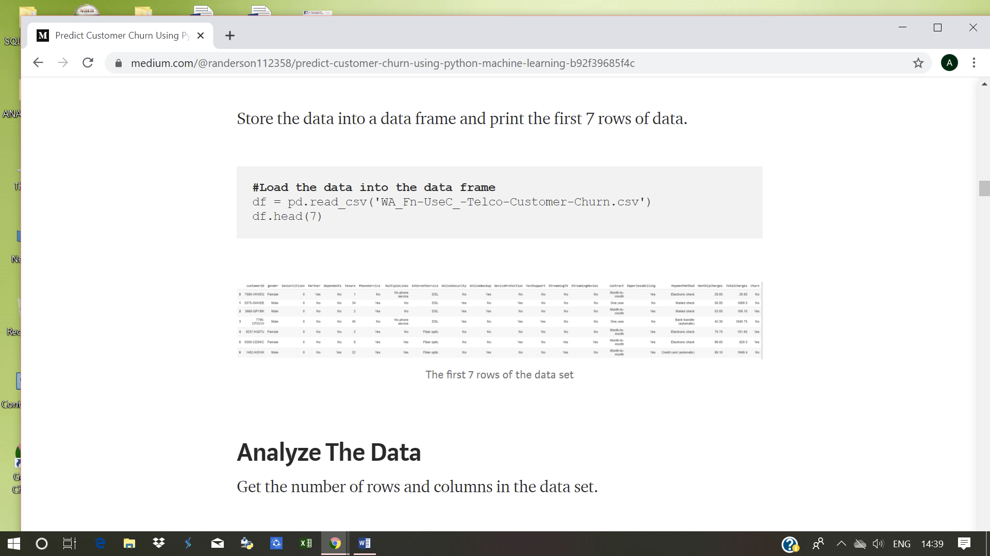

#Analyze the data

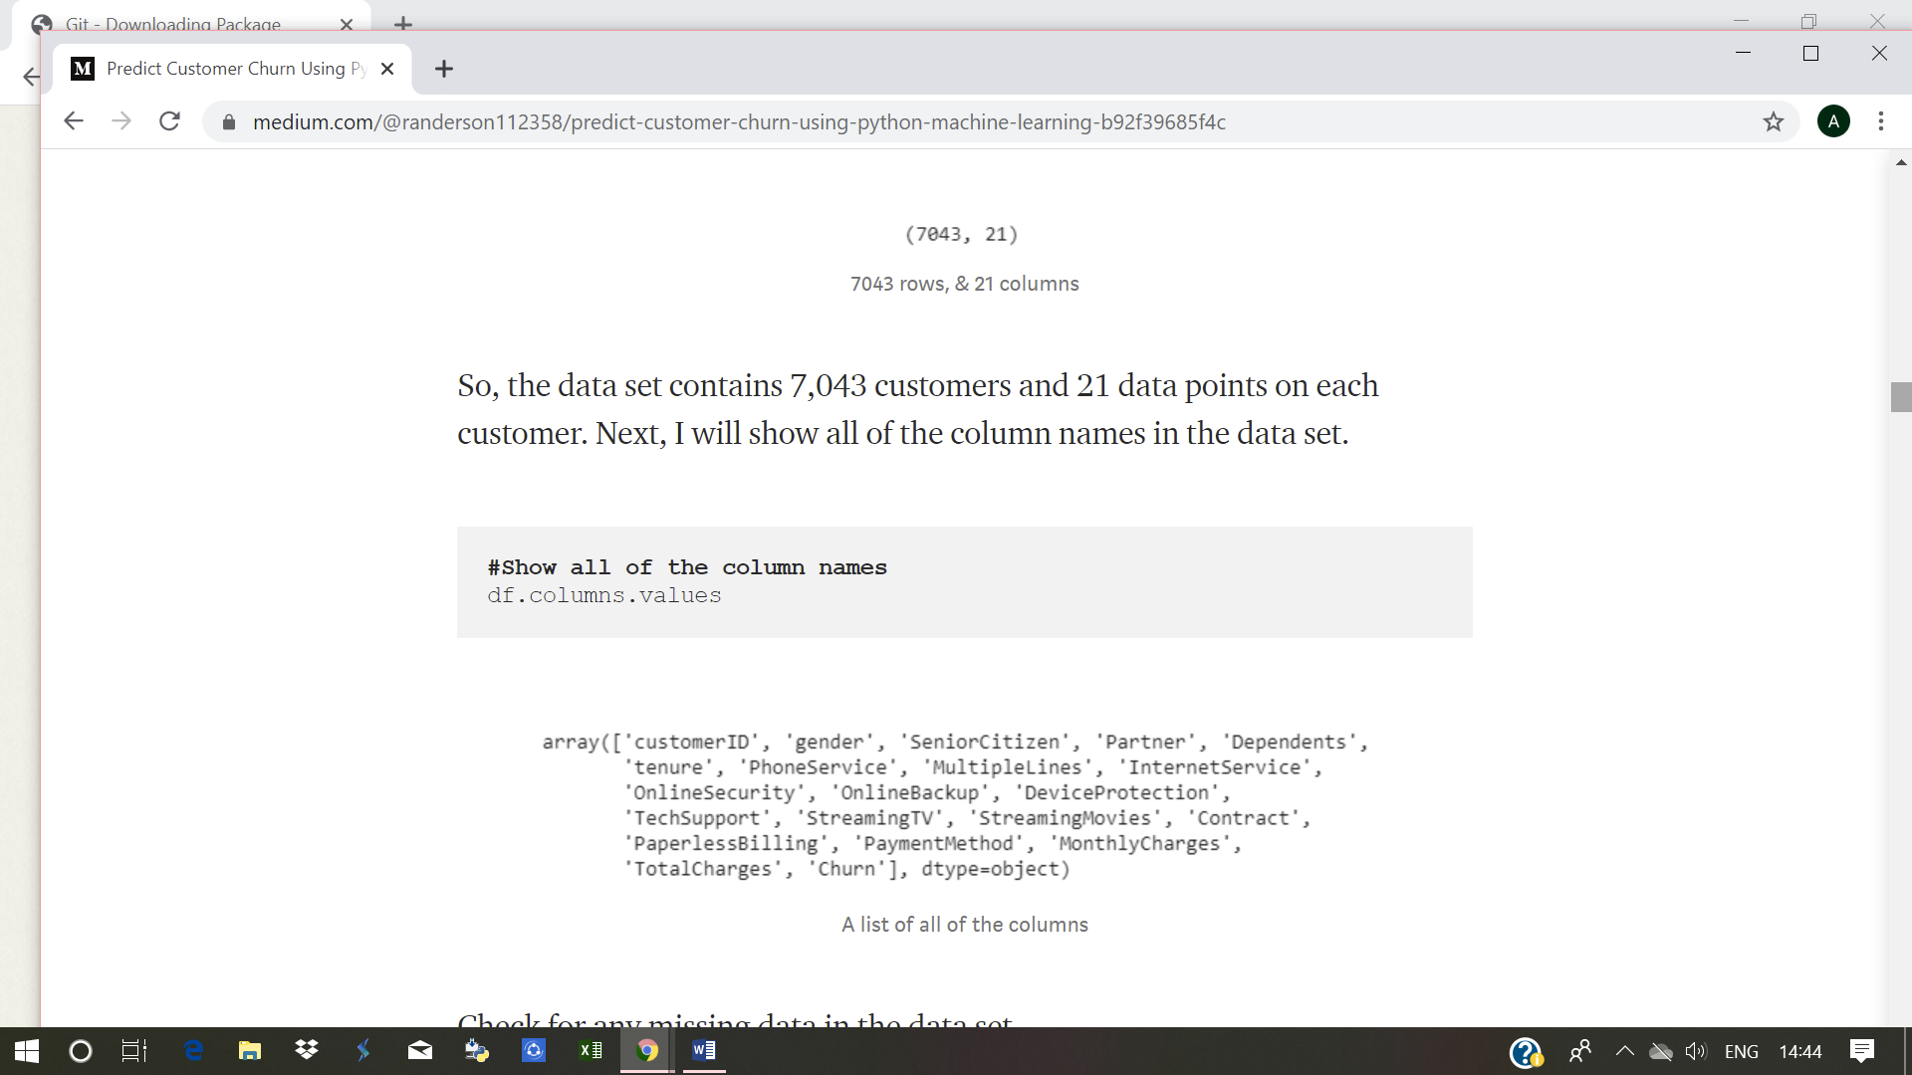

**#Show all of the column names**



**#Check for na or missing data**

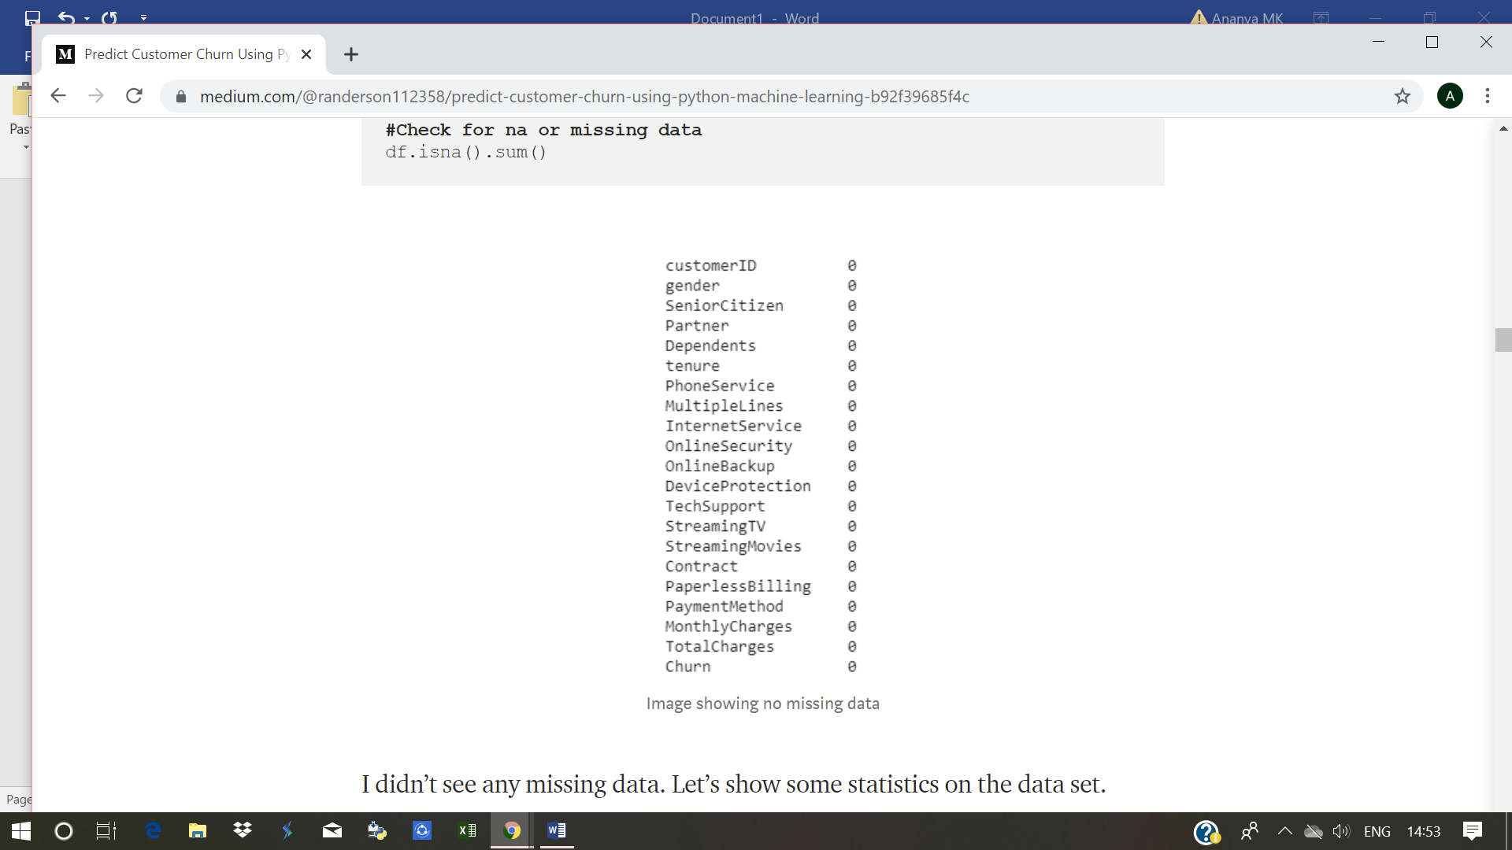

**#Show statistics on the current data**

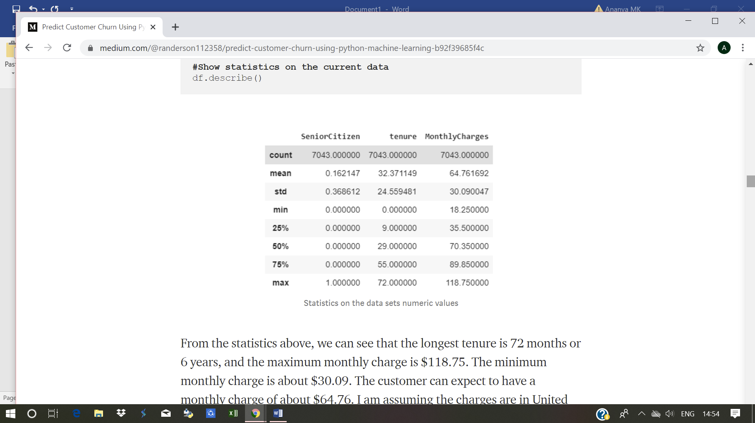

**#Get the number of customers that churned**

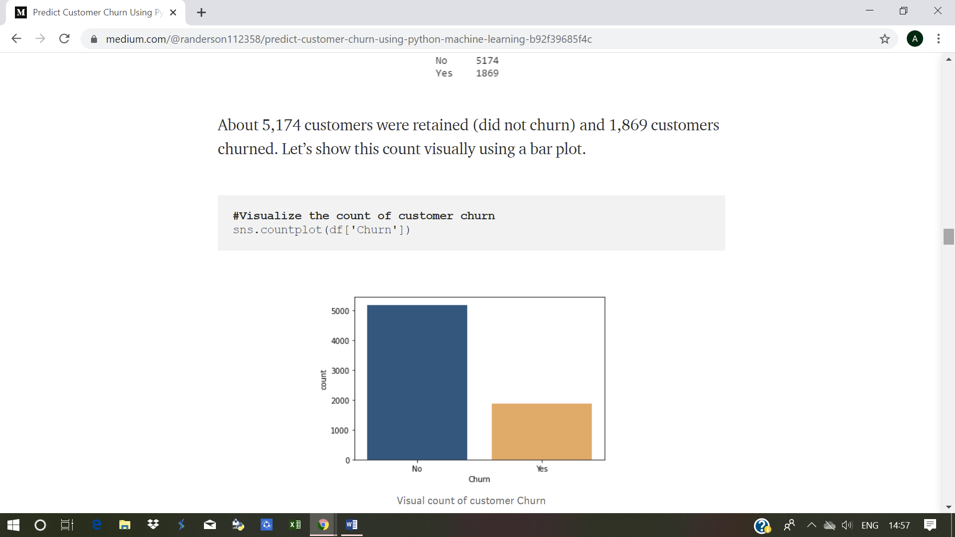

**#Visualize the count of customer churn**



**#Print the percentage of customers that stayed and left**

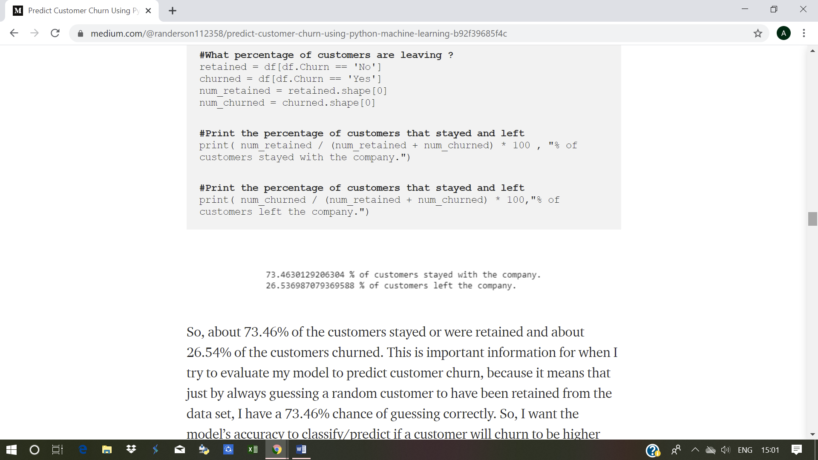

**#Visualize the churn count for both Males and Females**

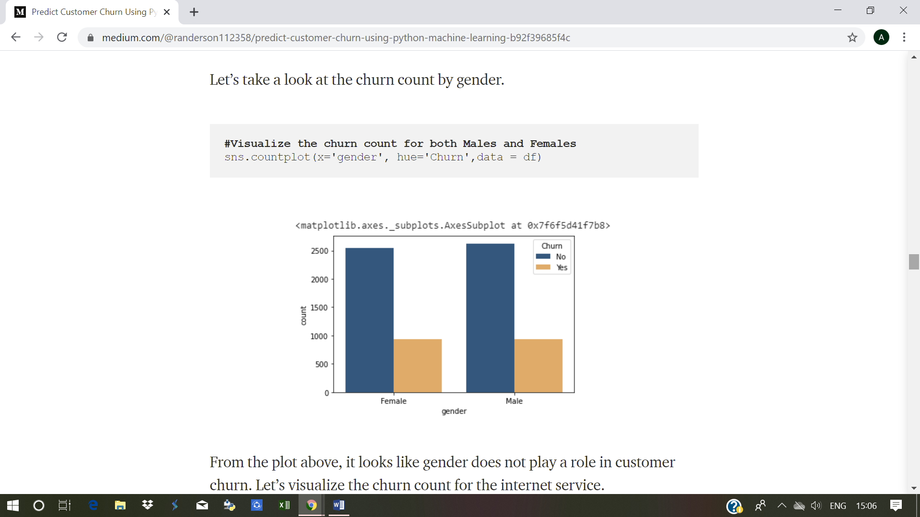

**#Visualize the churn count for the internet service**

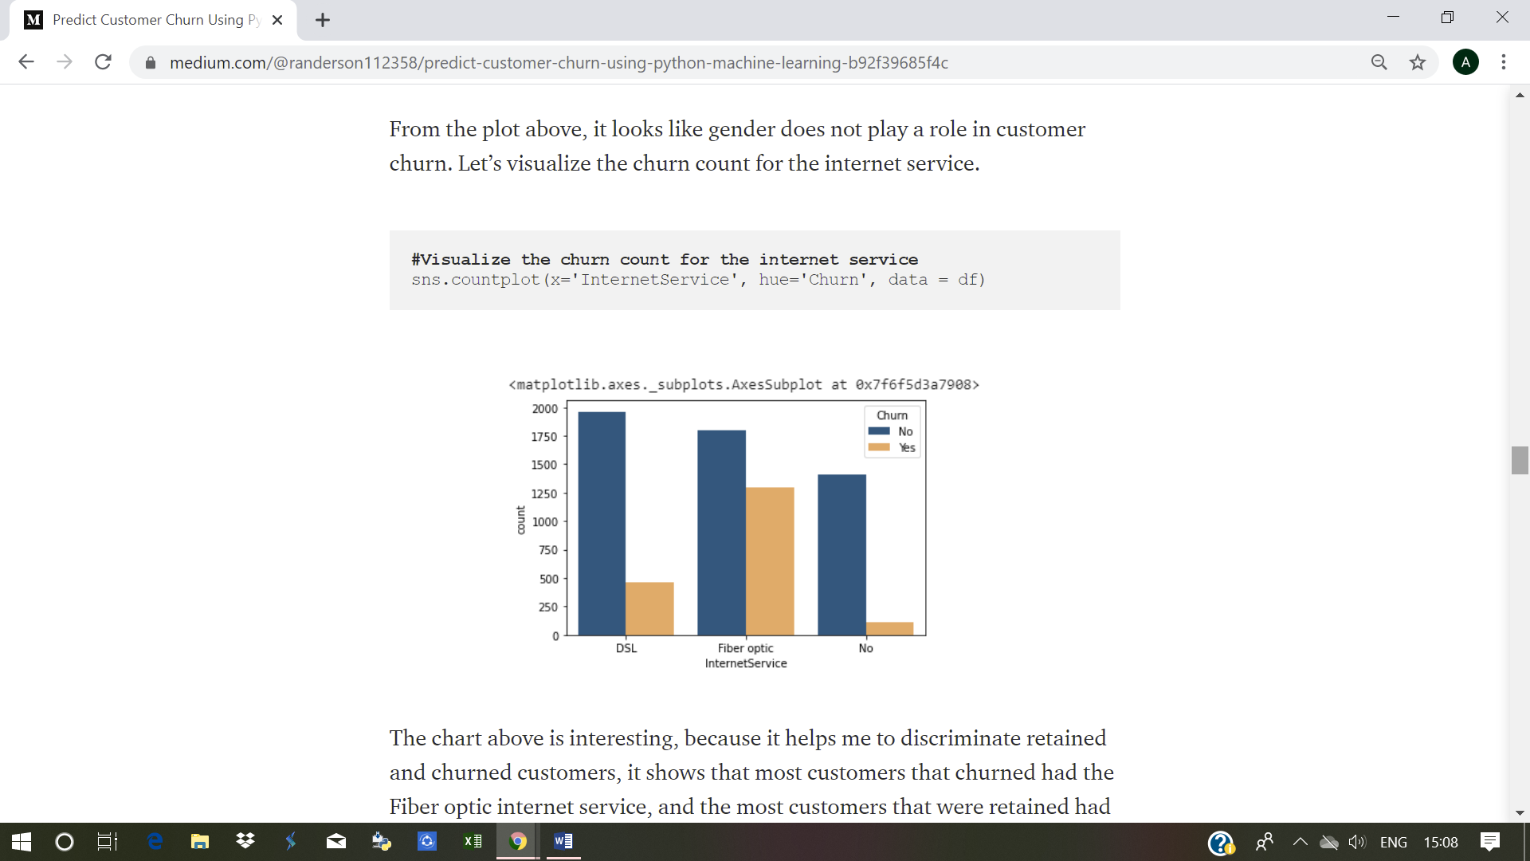

#description of data

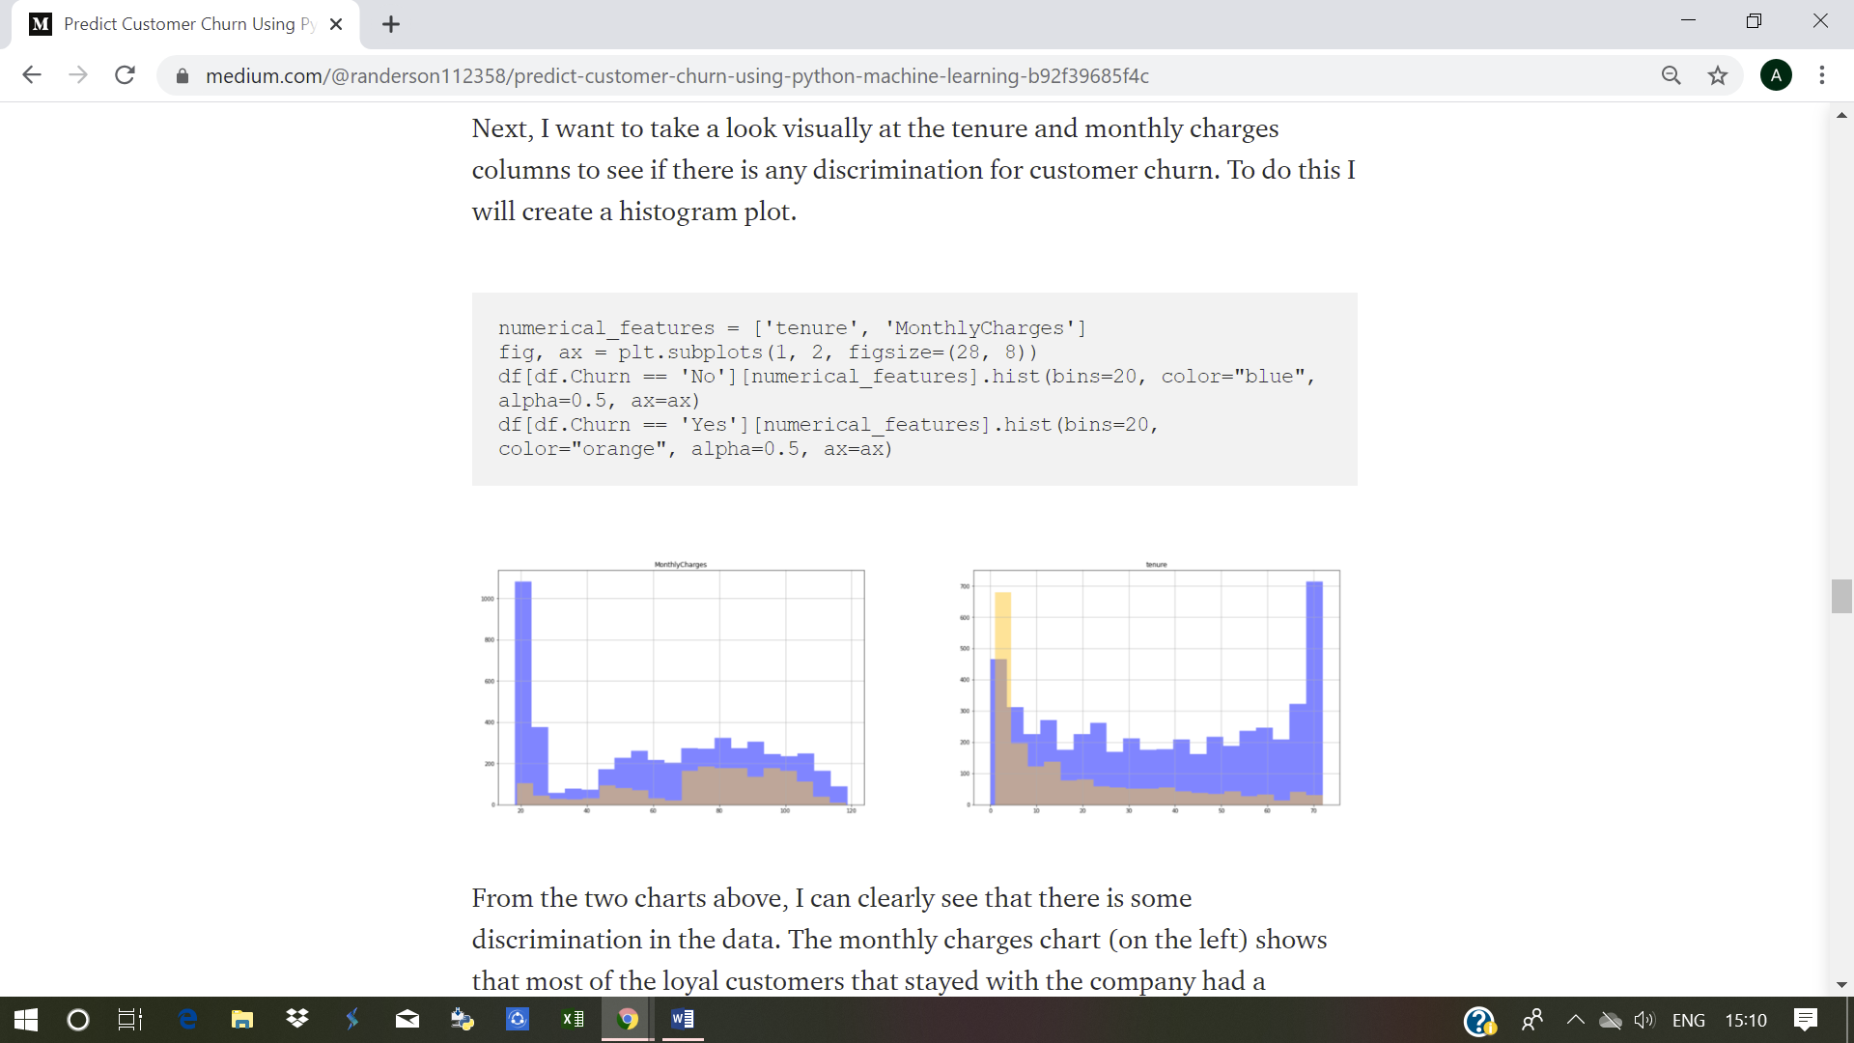**#Look at the number of rows and cols in the new data set**  
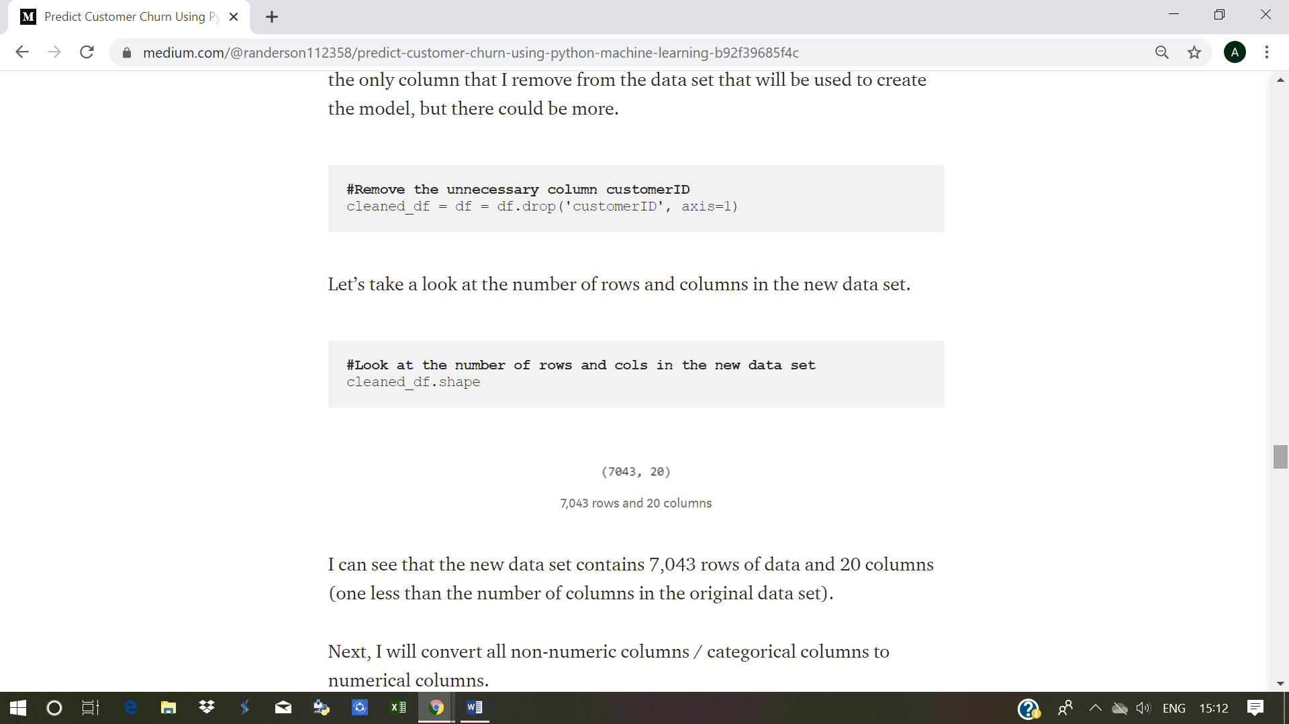

**#Check the new data set data types**

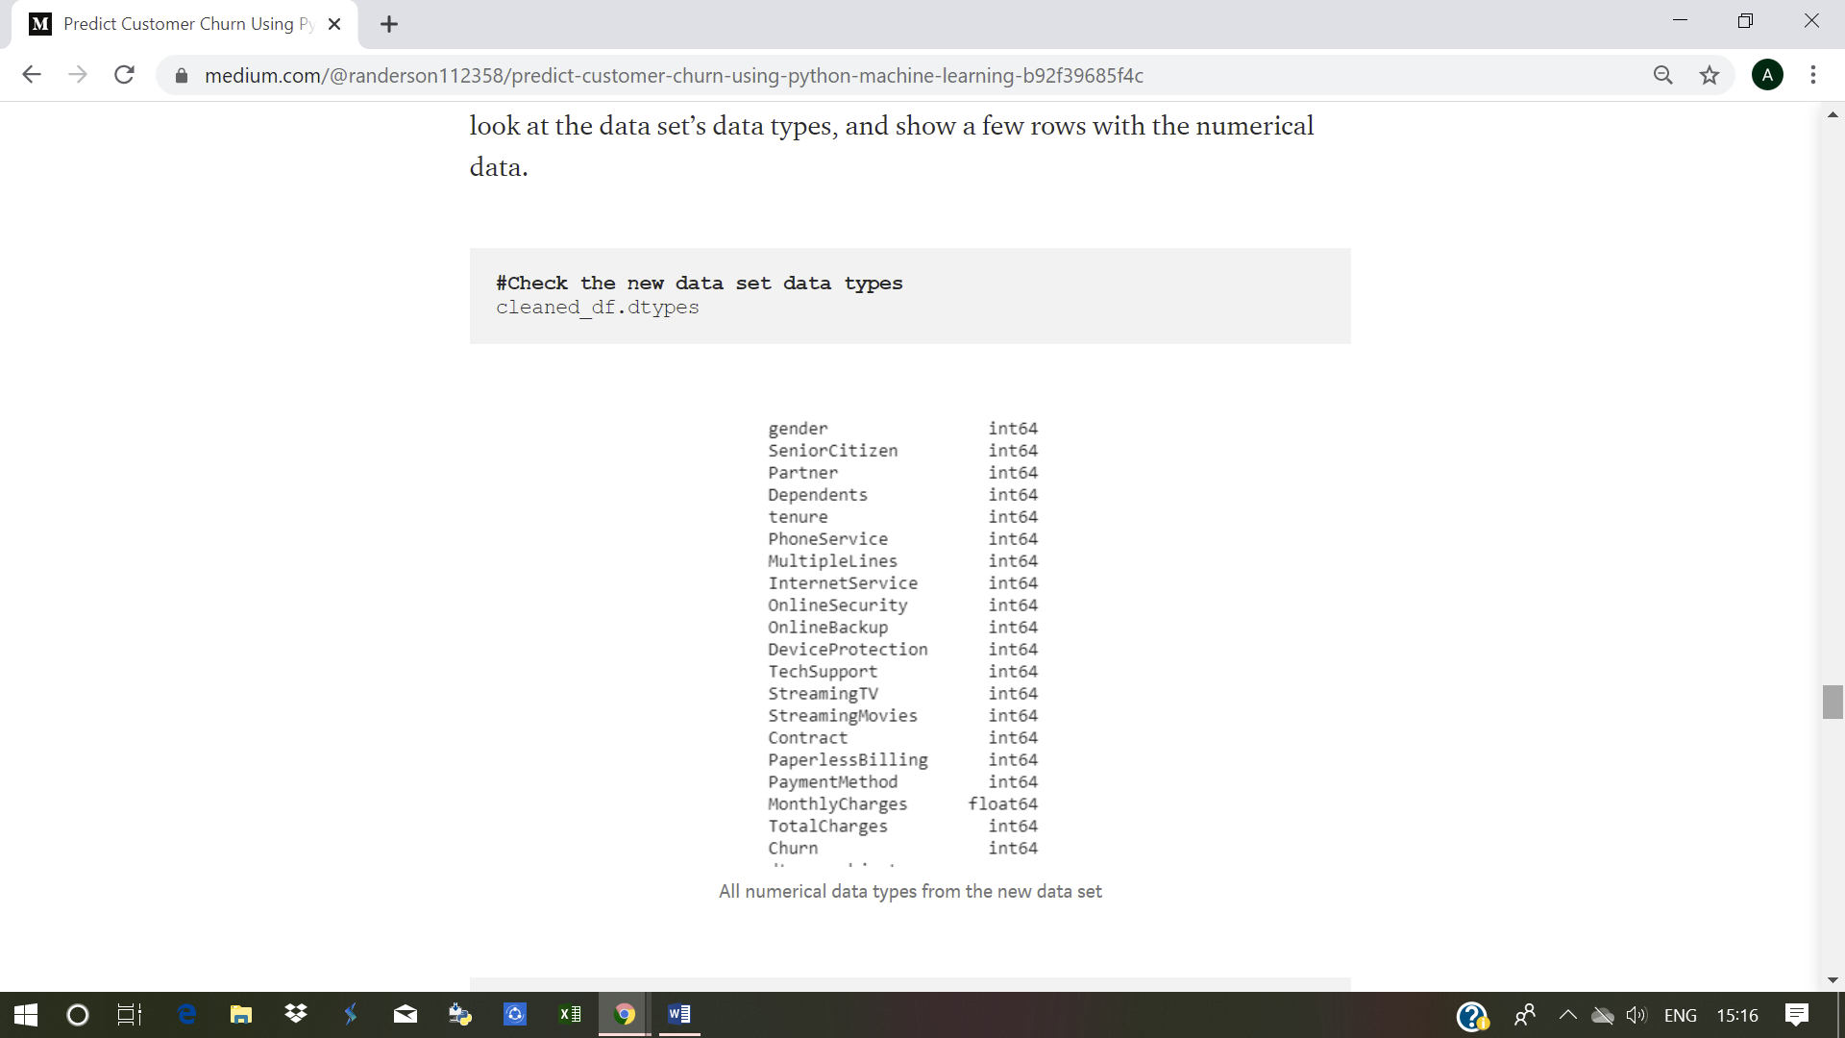

**#Show the first 5 rows of the new data set**

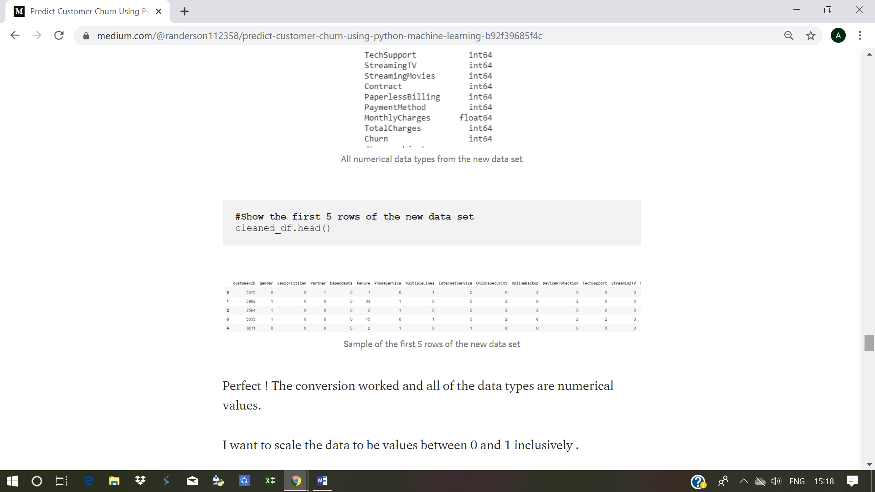

**#printing the predictions**

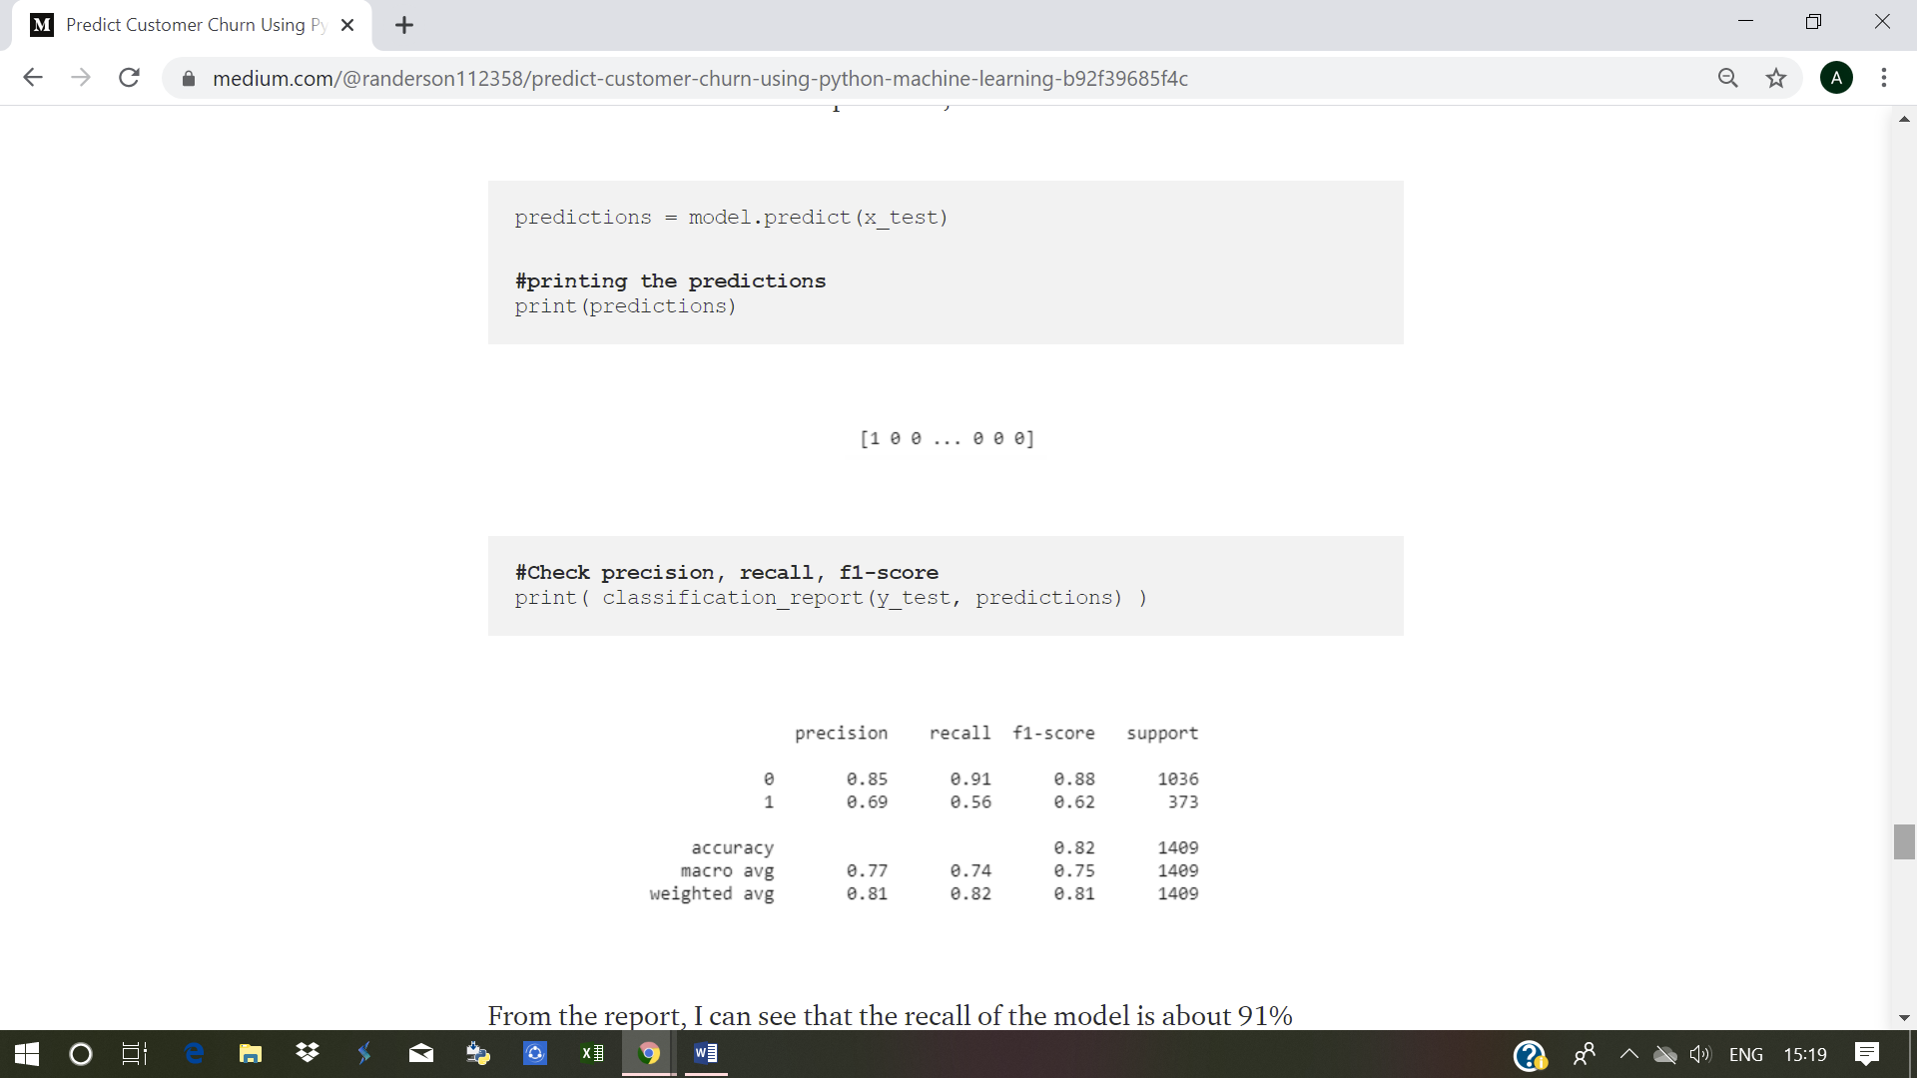

**#Check precision, recall, f1-score**



From the report, I can see that the recall of the model is about 91% meaning the model correctly identified about 91% of the customers that were retained and missed about 9%.