7/12/2020

IOT BASED SMART ENERGY METER

DONE BY,

DEIVEEGA RAAMAN.V

**INTRODUCTION  
    Overview**

Similar meters, usually referred to as [interval](https://en.wikipedia.org/wiki/Intervalometer) or time-of-use meters, have existed for years, but "Smart Meters" usually involve real-time or near real-time sensors, [power outage](https://en.wikipedia.org/wiki/Power_outage) notification, and power quality monitoring. These additional features are more than simple [automated meter reading](https://en.wikipedia.org/wiki/Automated_meter_reading) (AMR). They are similar in many respects to [Advanced Metering Infrastructure](https://en.wikipedia.org/wiki/Advanced_Metering_Infrastructure) (AMI) meters. Interval and time-of-use meters historically have been installed to measure commercial and industrial customers, but may not have automatic reading.care.

**Purpose**

Since the inception of electricity [deregulation](https://en.wikipedia.org/wiki/Deregulation) and market-driven pricing throughout the world, utilities have been looking for a means to match consumption with generation. Non-smart electrical and gas meters only measure total consumption, providing no information of when the energy was consumed.[]](https://en.wikipedia.org/wiki/Smart_meter#cite_note-21) Smart meters provide a way of measuring electricity consumption in near real-time. This allows utility companies to charge different prices for consumption according to the time of day and the season. It also facilitates more accurate cash-flow models for utilities. Since smart meters can be read remotely, labor costs are reduced for utilities.

**THEORITICAL ANALYSIS  
    Block diagram**

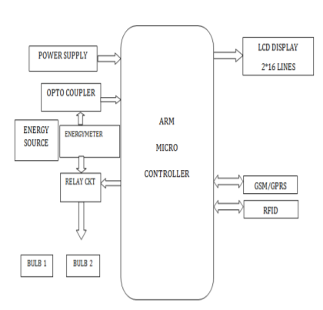

**Hardware / Software designing**  
Hardware components used are : 1.Arduino 2.micro controller 3.the power system 4.Connecting wires.

Software components used are : 1.IBM cloud 2.IBM IOT platform 3.IBM Watson 4.node-red 5.Tinker cad 6.Python IDLE 7.MIT app inventor

**FLOWCHART**

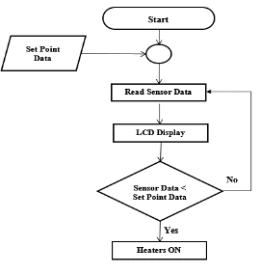

**ADVANTAGES & DISADVANTAGES**

**PROS:**

* Power outage notification (if you’re offsite)
* Power quality monitoring
* Real-time or near real-time sensors
* Consumers gain more control over electricity costs
* Better control over available power resources across the state and country
* Real-time monitoring of the grid (or electricity system) as a whole
* Reducing manual labor to determine meter readings
* **CONS:**  
  Introduction of change and new processes
* Managing new data collection and reading processes
* Ensuring the safety, privacy and protection of collected data
* Trying to convince customers to switch to a new product
* Additional fees

**APPLICATIONS**

More accurate settlement:

Smart metering improves settlement procedures by providing accurate and rather up to date consumption data for metering points. Thus most needs to estimate consumption data and correct the settlement and billing afterwards are removed. In other words DSOs may eliminate costly additional settlements procedures.

More frequent and cheaper switching of retail electricity suppliers:

One of the core functions in Smart Metering is a possibility to request metered data from a metering point at any time. Considering that regulators require steady shorter periods for changing of retail electricity suppliers (in Norway it is two weeks now and will be reduced even further) possibility to read data remotely at any moment of time, reduces costs for DSOs. In the future it will also provide a possibility to implement an automated supplierswitching procedure.

Correct and timely billing:

The EU Commission emphasises in its ESD Directive 2006/32/EC the importance of providing actual energy consumption data to customers and billing, based on actual consumption data. Smart Metering obviously enhances this possibility

**CONCLUSION**

The wide range of application makes smart energy meters to be used in all the private and public sectors. The usage of energy meter will reduce power consumption. This saving in power can be effectively used in other area, where there is scarcity of electricity.

**FUTURE SCOPE**

With more High-end hardware and software, the smart energy meter can be customized and can be upgraded for more accurate energy consumption readings

**BIBILOGRAPHY**

a.Github

b.ubuntupit

c.youtube

d.smart internz

**APPENDIX**

**A. UI output Screenshot.**

