**FINAL DOCUMENTION**

**TOPIC:**

**Pneumonia Prediction Using  X-Ray Images**

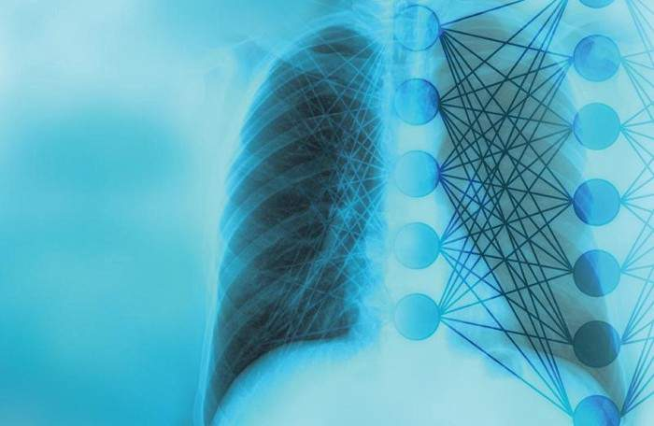

**SUBMITTED BY:**

R.SUHIRTHA

G.SHANTHINI

V.HARIPRIYA

J.ABINISHA

**INDEX**

1 INTRODUCTION

1.1 Overview

1.2 Purpose

2 LITERATURE SURVEY

2.1 Existing problem

2.2 Proposed solution

3 THEORITICAL ANALYSIS

3.1 Block diagram

3.2 Hardware / Software designing

4 EXPERIMENTAL INVESTIGATIONS

5 FLOWCHART

6 RESULT

7 ADVANTAGES & DISADVANTAGES

8 APPLICATIONS

9 CONCLUSION

10 FUTURE SCOPE `

11 BIBILOGRAPHY

APPENDIX

Source code

**1 .Introduction**

**1 .1. Overview**

Using Deep-Learning algorithm whether a human has pneumonia or not can be determined from an X-Ray image of the human lungs. The algorithm works in such a way that when an image is uploaded it predicts whether or not the given image is an X-Ray of lungs having pneumonia or normal.This is an example of binary classification.

[Pneumonia](https://www.medicinenet.com/pneumonia_facts/article.htm) Inflammation of one or both [lungs](https://www.medicinenet.com/image-collection/lungs_picture/picture.htm) with dense areas of lung inflammation.[Pneumonia](https://www.medicinenet.com/pneumonia_quiz/quiz.htm) is frequently but not always due to infection.The infection may be bacterial, viral, fungal or parasitic.Symptoms may include [fever](https://www.medicinenet.com/aches_pain_fever/article.htm), [chills](https://www.medicinenet.com/chills/symptoms.htm), [cough](https://www.medicinenet.com/chronic_cough/article.htm) with sputum production, [chest pain](https://www.medicinenet.com/chest_pain/article.htm) and shortness of breath.[Pneumonia](https://www.medicinenet.com/pneumonia_symptoms_and_signs/symptoms.htm) is suggested by the symptoms and confirmed by [chest X-ray](https://www.medicinenet.com/chest_x-ray/article.htm) testing. Treatment includes antibiotics. Through this  project we have tried to obtain accurate and precise models for detecting whether a  person  has Pneumonia through his Chest X- Rays. We have leveraged the use of CNN  (Convolutional Neural Networks) and ANN (Artiﬁcial Neural Networks) to obtain Deep  learning  Models with accuracy of ~91 % on test set and ~94 % on test set. The project Reposit ory is published on github as an open source project.

**1 .2. Purpose**

        The purpose of this project is pnemonia prediction using

x-ray images is to create a web application which users can

upload an image of their X-ray and ﬁnd  out  whether they have

pneumonia or normal by developping an accurate model  to

predict Pneumonia through X-Ray Images. This model could help mitigate the reliability and interpretability challenges often faced when dealing with medical imagery. Unlike other deep learning classification tasks with sufficient image repository, it is difficult to obtain a large amount of pneumonia dataset for this classification task; therefore, we deployed several data augmentation algorithms to improve the validation and classification accuracy of the CNN model and achieved remarkable validation accuracy.

**2 .Literature Survey**

**2.1. Existing Problem**

One of the following tests can be done for pneumonia diagnosis: chest X-rays, CT of the lungs, ultrasound of the chest, needle biopsy of the lung, and MRI of the chest . Currently, chest X-rays are one of the best methods for the detection of pneumonia . X-ray imaging is preferred over CT imaging because CT imaging typically takes considerably more time than X-ray imaging, and sufficient high-quality CT scanners may not be available in many underdeveloped regions. In contrast, X-rays are the most common and widely available diagnostic imaging technique, playing a crucial role in clinical care and epidemiological studies . There are several regions across the globe where there is a scarce availability of practiced healthcare workers and radiologists whose prediction on such diseases matter greatly . Computer-aided diagnosis using artificial intelligence based solutions is becoming increasingly popular these days . This facility can be made available to a large population at a minimal cost. Another issue with this disease is that sometimes, the features that describe the very existence of the disease often get mixed with other diseases, and hence, radiologists find it challenging to diagnose this disease.

**2.2.Proposed Solution**

Deep learning techniques solve all these problems, and their accuracy in the prediction of the disease is the same and sometimes even greater than an average radiologist . Among the deep learning techniques, convolutional neural networks (CNNs) have shown great promise in image classification and segmentation and therefore are widely adopted by the research community. Biomedical image diagnosis that uses the techniques of deep learning and computer vision has proven to be very helpful to provide a quick and accurate diagnosis of the disease that matches the accuracy of a reliable radiologist . Currently, deep learning based methods cannot replace trained clinicians in medical diagnosis, and they aim to supplement clinical decision making. In this model is presented based on the applications of deep learning and convolutional neural networks that are capable of classifying automatically that the patient has pneumonia or not. The proposed methodology uses a deep transfer learning algorithm that extracts the features from the X-ray image that describes the presence of disease automatically and reports whether it is a case of pneumonia.

**3 .Theoretical Analysis**

**3.1. Block diagram**

An external file that holds a picture, illustration, etc.
Object name is diagnostics-10-00417-g001.jpg

A series of convolution and pooling operations is performed on the input image, which is followed by a single or multiple fully connected layers. The output layer depends on the operations being performed. For multiclass classification, the output layer is a softmax layer. The main disadvantage with deeper CNNs is vanishing gradients, which can be solved by using residual networks introduced in the following section.  The main advantage of CNN compared to its predecessors is that it is capable of detecting the relevant features without any human supervision.

**3.2. Hardware/Software Designing**

For creating the CNN model we need:

keras 2.4.4 to import libraries for ImageDataGenerator  for  data

preprocessing and   sequential,dense,etc. for  building the model.

Numpy and tensorﬂow 1.14. For creating app.py python code  to

run the web application we require to import os,global graph,flask and WSGI Serve.

**4. Experimental Investigations**

First data preprocessing rescaling and transformation was performed on the images of the given dataset. Then libraries are imported and model was initialised. After initialising the model first convolution layer is created. 3x3 feature detecter is used. Then max pooling layer is added. 2x2 matrix is used. After that flatten layer is added and last hidden and output layers. After adding all the layers of the CNN model it is compiled and trained with 10 epochs. After training model was saved.

For prediction saved model is loaded, transformations takes place and the given image is predicted whether normal or pneumonia. X-ray image given here was normal and it predicted accurately as normal.

After saving cnn.h5 and deep learning algorithm file html file and corresponding styles.css and file.js are created. Css is for the layout of the web application and .js is neccesary for previewing the image uploaded in the web application.

Last python code is created app.py. This is to run the model in the web application. After importing the libraries model is loaded. Html file is rendered and uploaded image is saved to uploads folder. The image is resized, converted into array form then interpreted by the machine when running the application. Finally prediction is displayed.

Upon Conducting Experiments for tuning hyper parameters of our model to obtain better accuracy. We found that the best set of parameters were batch size =32,Input Image size =96 x 96. The model was rescaled to 1./255 of its values to obtain a fast convergence.

Two Dropout Layers were added when the model showed signs of overfitting. Dropout1 (0.2) was added after the Max Pooling 2d_1 and Dropout2(0.2) was added after flatten_1. The image data was augmented so that the machine can understand the features better. shear_range = 0.2, zoom_range rotation_range = 30, horizontal_flip = False,vertical_flip=False.

To Fit the Model different set of parameters were chosen

Epochs =10,steps_per_epoch = 163,epochs = 10,validation_data =

test_set,validation_steps = 20.

Epochs =8,steps_per_epoch = 50, epochs = 10, validation_data = test_set,validation_steps = 20.

The 1st model obtained an impressive figures :

Training Accuracy    :  0.9467 (Approx 94.67%)

Training Loss            :  0.1390 Validation Loss         :  0.0556

Test Accuracy           :  0.9167 (Approx 91.67%)

The results of the second model were :

Training Accuracy    :  0.8787 (Approx 87.87%)

Training Loss            :  0.2654 Validation Loss         :  0.2829

Test Accuracy           :  0.8798 (Approx 87.98%)

**5. Flowchart**

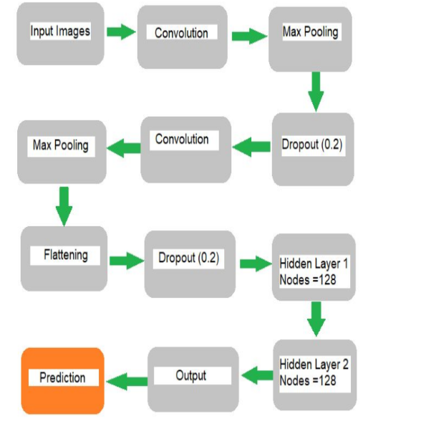

**6. Result**

To evaluate and validate the effectiveness of the proposed approach, we conducted the experiments 10 times each for three hours, respectively. Parameters and hyperparameters were heavily turned to increase the performance of the model. Different results were obtained, but this study reports only the most valid. As explained above, methods such as data augmentation, learning rate variation, and annealing were deployed to assist in fitting the small dataset into deep convolutional neural networks final results obtained are training loss 0.190, training accuracy 0.9467, validation loss: 0.0566, and validation accuracy of 0.9167. When app.py is running in the terminal in the web application image can be uploaded and the model will predict whether it is pnemonia or normal. The X-Ray image will also be previewed.

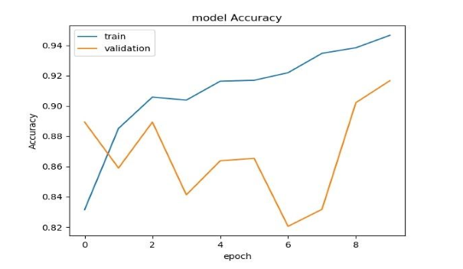

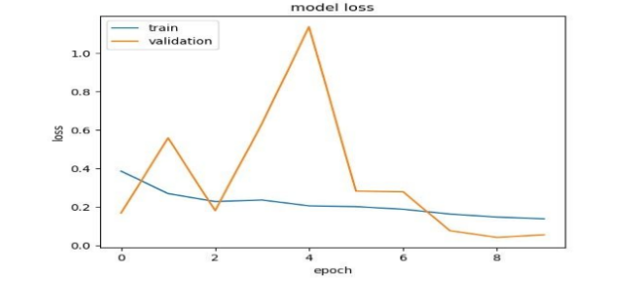

**7. Advantages and disadvantages**

The advantage of this cnn is it gives accurate prediction even when it is trained with less number of epochs. Generally accuarcy will be high only when more than 100 epochs are initialised.

Although the results were overwhelming, there were still some limitations in our model which we believe are vital to keep in consideration. The first biggest limitation is that there is no history of the associated patient considered in our evaluation model. Secondly, only frontal chest X-rays were used but it has been shown that lateral view chest X-rays are also helpful in diagnosis. Thirdly, since the model exercises a lot of convolutional layers, the model needs very high computational power otherwise it’ll eat up a lot of time in computations and spatial invarience is not possible.

**8. Applications**

The detection of pneumonia disease is commonly performed through the examination of the chest X-Ray radiograph (CXR). The examination involves the diagnosis of the manifestation of the areas of increased opacity, the further diagnosis is confirmed through clinical history, vital signs and various laboratory examinations. The pneumonia diagnosis on CXR is hectic due to the presence of other scenarios and conditions in the lungs, such as bleeding, fluid overload, loss in volume, post-radiation or post-surgical changes. There is a known difference or variability amongst radiologists in the interpretation or diagnosis of the chest radiographs. To improve the efficiency and accuracy of diagnosis, computer-aided systems for pneumonia detection has been widely exploited in the last decade. Deep learning approaches outperformed or outnumbered conventional machine learning methods in many medical imaging analysis tasks, including detection, classification and segmentation.

**9. Conclusion**

In this project deep learning cnn model and web application to predict pneumonia from an x-ray image has been created. An x-ray can be uploaded and the algorith will detect pneumonia.

Due to the importance of medical image classification and the particular challenge of the medical image-small dataset, this paper chose to study how to apply CNN-based classification to small chest X-ray dataset and evaluate their performance. We have demonstrated how to classify positive and negative pneumonia data from a collection of X-ray images In the future, this work will be extended to detect and classify X-ray images consisting of lung cancer and pneumonia. Distinguishing X-ray images that contain lung cancer and pneumonia has been a big issue in recent times, and our approach will tackle this problem.

**10. Future scope**

The web application can be used for identifying pneumonis in a patient. Currently it is a time consuming process to diagnos a patient with pneumonia but with this application it can identify in very less time and patients suffering from severe pneumonia can get treatment immediately.

Deep learning rose to its prominent position in computer vision when neural networks started outperforming other methods on several high-profile image analysis benchmarks. Most famously on the ImageNet Large-Scale Visual Recognition Challenge (ILSVRC) in 2012. when a deep learning model (a convolutional neural network) halved the second best error rate on the image classification task. Enabling computers to recognize objects in natural images was until recently thought to be a very difficult task, but by now convolutional neural networks have surpassed even human performance on the ILSVRC, and reached a level where the ILSVRC classification task is essentially solved (i.e. with error rate close to the Bayes rate).

**11. Bibilography**

[1] P. Rui, K. Kang, National Ambulatory Medical Care Survey: 2018 Emergency Department Summary Tables.

[2] E. Sayed, et. al, Computer-aided Diagnosis of Human Brain Tumor through MRI: A Survey and a new algorithm, Expert System with Applications (41): 2014.

[3] D.K. Das, M. Ghosh, M. Pal, A.K. Maiti, and C. Chakraborty, Machine learning approach for automated screening of malaria parasites using light microscopic images, Micron 45, 97106, 2013.

[4] M. Poostchi, K. Silamut, R. Maude, S. Jaeger, and G. Thoma, Image analysis and machine learning for detecting malaria, Translational Research, 2018.

[5] N.E. Ross, C.J. Pritchard, D.M. Rubin, and A.G. Duse, Automated image processing method for the diagnosis and classification of malaria on thin blood smears, Medical and Biological Engineering and Computing 44, 5, 427436, 2006.

[6] A.S. Razavian, H. Azizpour, J. Sullivan, and S. Carlsson, CNN features off-the-shelf: an astounding baseline for recognition, In Proceedings of the IEEE conference on computer vision and pattern recognition workshops, 806813, 2014.

[7] Fafi, Kusworo and Catur, Breast Tumor Detection using Haar-Like Feature Method on Ultrasonography (USG) Imaging, International Journal of Innovative Research in Advanced Engineering, Volume V, 154-157. doi://10.26562/IJIRAE.2018.MYAE10082. INTERNATIONAL JOURNAL OF SCIENTIFIC & TECHNOLOGY RESEARCH VOLUME 9, ISSUE 04, APRIL 2020 ISSN 2277-8616 1337 IJSER©2020 www.ijstr.org [8] Abiyev R. H., Maaitah M. K. S., Deep Convolutional Neural Networks for Chest Diseases Detection, Journal of Healthcare Engineering, 2018.

[9] A. Krizhevsky, I. Sutskever, & G.E. Hinton, ImageNet Classification with Deep Convolutional Neural Networks, Neural Information Processing Systems, 25. 10.1145/3065386, 2012.