**RSIP Career Basic AI 108**

**Project Report**

**on**

**Rock Identification using Deep Convolution Neural Network**

**Prepared by,**

**Lavkesh Madavi**

1. **Introduction:**

**Overview**:

Rock are a fundamental component of earth. The automatic identification of rock type in the field would aid geological surveying, education and automatic mapping. Visual inspection assesses properties such as color, shape, etc. It is a basic part of geological surveying, research and education. The traditional method of rock classification is a time- consuming process and has less accuracy rate.

So, this project basically aims on making a system using deep CNN which can detect the rock type and help people in knowing the types instantly.

## Purpose:

To get the type of rock within seconds or minutes (decrease time in detecting the type of rock.)

Detecting the type of rock plays a major role in geological surveying. Type of the rock reflects their chemical composition and in turn would be very useful if the time to predicting the type would be less. This model is also helpful for those who don't have that much geological knowledge but want to know the type of the rock.

# Literature survey:

This section summarises some of the scholarly and research works in the field of deep convolution neural network for classifying the type of rock.

### Existing problem:

The main aim of this project is to classify the rocks. So, I have to create a system that can identify rocks with high accuracy than the traditional method (less accurate and time consuming).

### Proposed solution:

First model is optimization model for minima and maxima values. Second module is for colour similarity measure. Third is for time complexity measure. Fourth is for collection of images. Fifth module is Deep learning CNN. Lastly, they have performance evaluation.

referred pdf[:https://ieeexplore.ieee.org/stamp/stamp.jsp?arnumber=9042306](https://ieeexplore.ieee.org/stamp/stamp.jsp?arnumber=9042306)

# Theoritical Analysis:

While machine learning techniques have been increasingly applied to handle classification problems, these techniques have not focused on separating rock exposed bare neural network(CNN) to differentiate exposed bare rock from solid cover. The resulting CNN approach is likely scalable but dependent on high quality images and high performance algorithms using representative training sets informed by expert mapping. As image quality and quantity continues to increase globally, machine learning models that incorporate high-quality training informed by geologic, topographic, or other tropical maps may be applied to more effectively identify exposed rocks in large image collections.

### Block diagram:

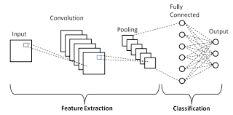

**Hardware/Software design:**

**Hardware tools:**

* Camera

### Software tools:

### Jupyter Notebook, Spyder IDE

* Tensor Flow, Keras, Flask
* Operating system for python, html, css, js

1. **Experimental Investigation:**

A convolution layer extracts the features of the input images and by convolution and outputs the feature maps. It is composed of series of fixed size filters, known as convolution kernels, which are used to perform convolution.

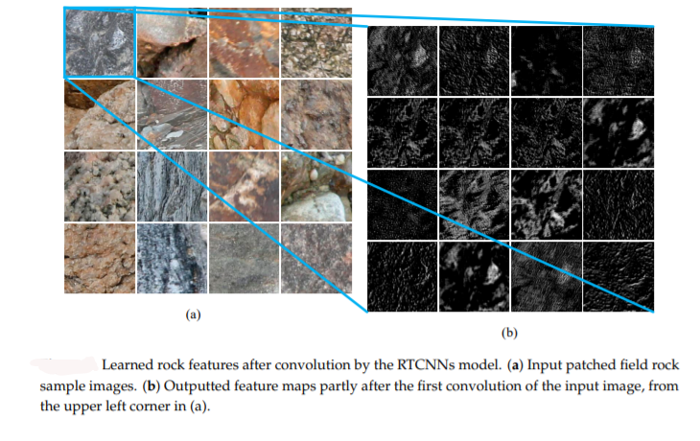

## Flowchart:

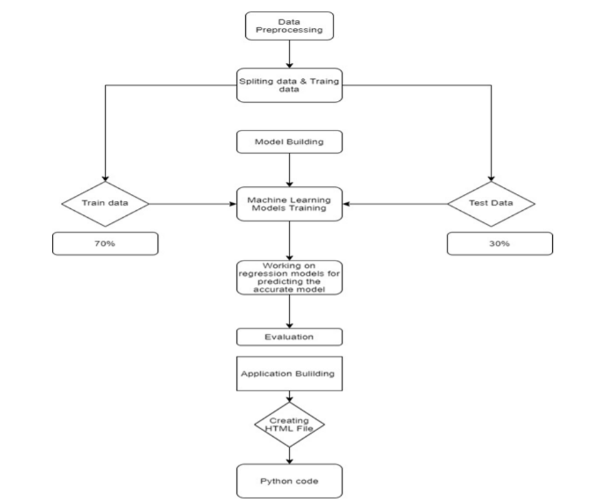

1. **Result**:

I got an accuracy of 0.93 which is a good measure for convolution neural networks.

When we give a rock image as input the model, it classifies them as the categorical output-

* Igneous Rock
* Metamorphic Rock
* Sedimentary Rock

## Advantages and Disadvantages:

### Advantages:

* High speed.
* Predicts the type just by having clear image
* Effective and predicts with 90 per or more accuracy.
* Efficiency can be increased by training the model.

### Disadvantages:

* Requires clear images.
* High computational cost.
* There is obvious loss of jobs.

## Application:

Can be used for geological research, even for education purpose.

The traditional method has many drawbacks such as less accuracy and time consuming so this can be used to overcome those drawbacks.

## Conclusion:

This project helps in identifying the rock type effectively using CNN. This experiment shows that this has high reliability whether in HSV or RGB color space. In RGB color space the efficiency acquired is 93 percent which is good. In view of using CNN for rock classification this can be considered a good way for classifying rocks.

## Future scope:

The application of CNNs to identify and classify various kinds of rock still faces some challenges. Firstly, regarding accuracy, it has to be improved still when we certain characteristics like small size, same color etc. In such cases this proposed approach delivers low accuracy. Therefore, our future work will combine the deep learning model with a knowledge library, containing more rock knowledge and relationships among various rock-type identification in the field.

## Biblography:

### Idea:

### [*https://www.researchgate.net/publication/319590805_Rock_images_classification_by_usin*](https://www.researchgate.net/publication/319590805_Rock_images_classification_by_using_deep_convolution_neural_network)[*g_deep_convolution_neural_network*](https://www.researchgate.net/publication/319590805_Rock_images_classification_by_using_deep_convolution_neural_network)[*https://ieeexplore.ieee.org/stamp/stamp.jsp?arnumb*](https://ieeexplore.ieee.org/stamp/stamp.jsp?arnumber=9042306)[*er=9042306*](https://ieeexplore.ieee.org/stamp/stamp.jsp?arnumber=9042306)

## Appendix: Dataset

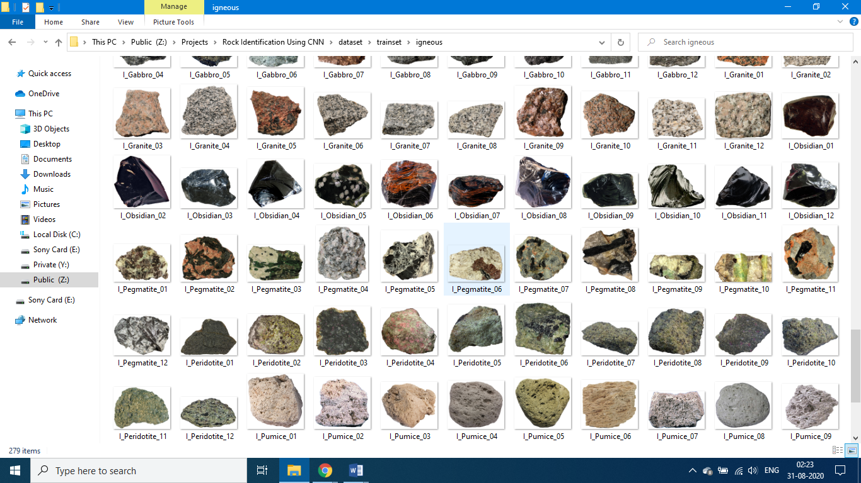

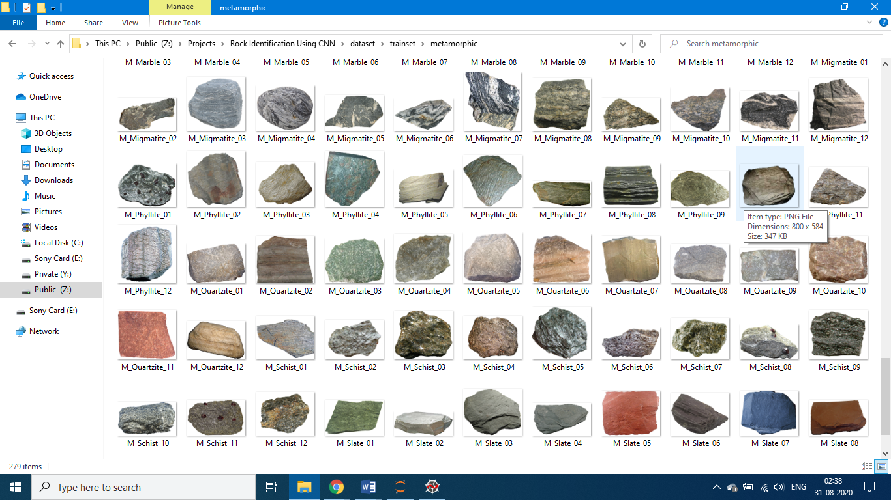

**Model training:**

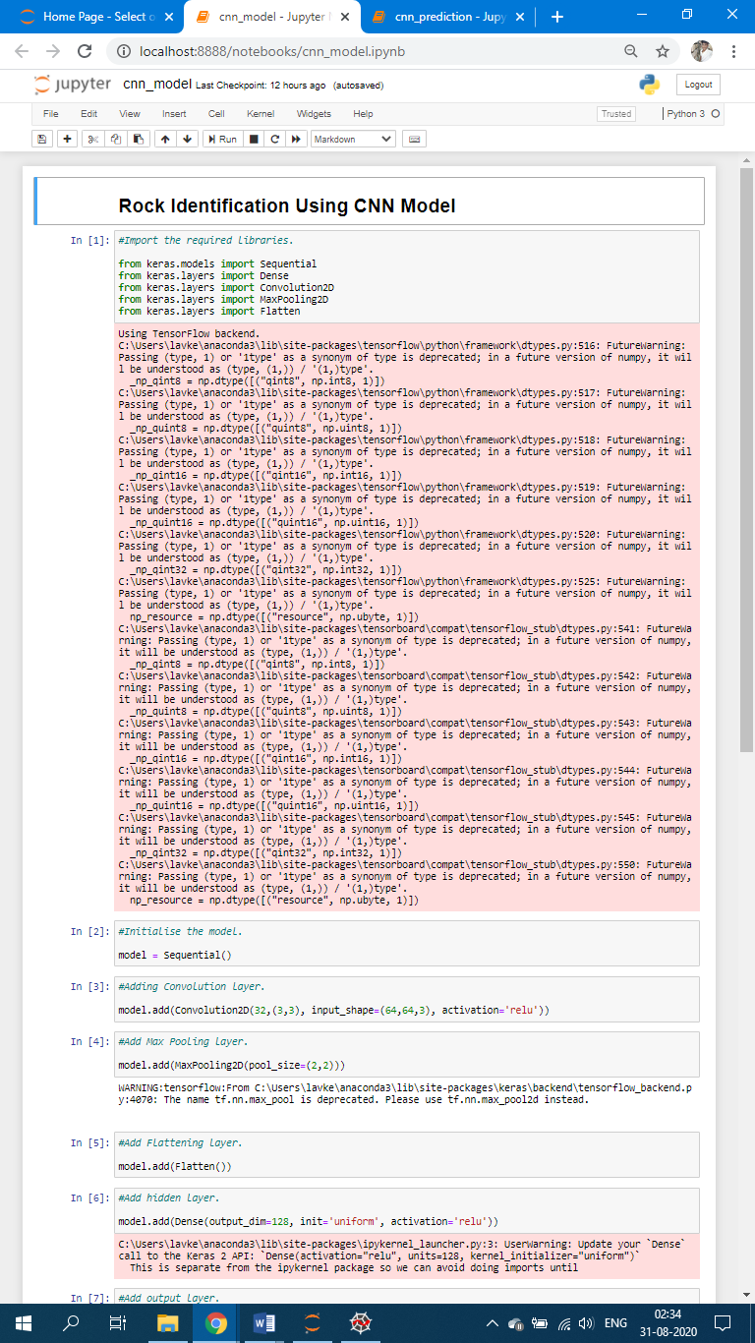

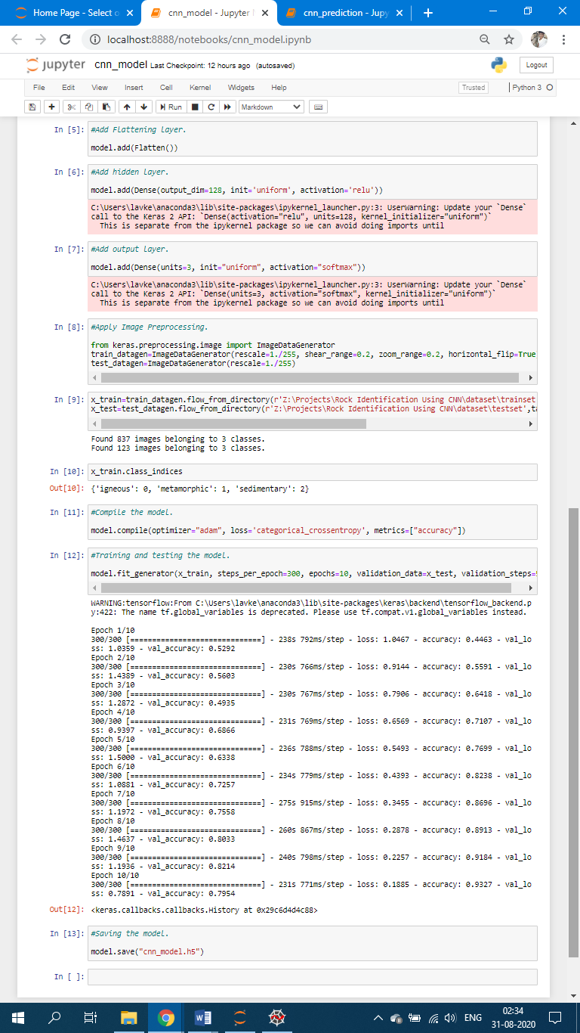

**Prediction:**

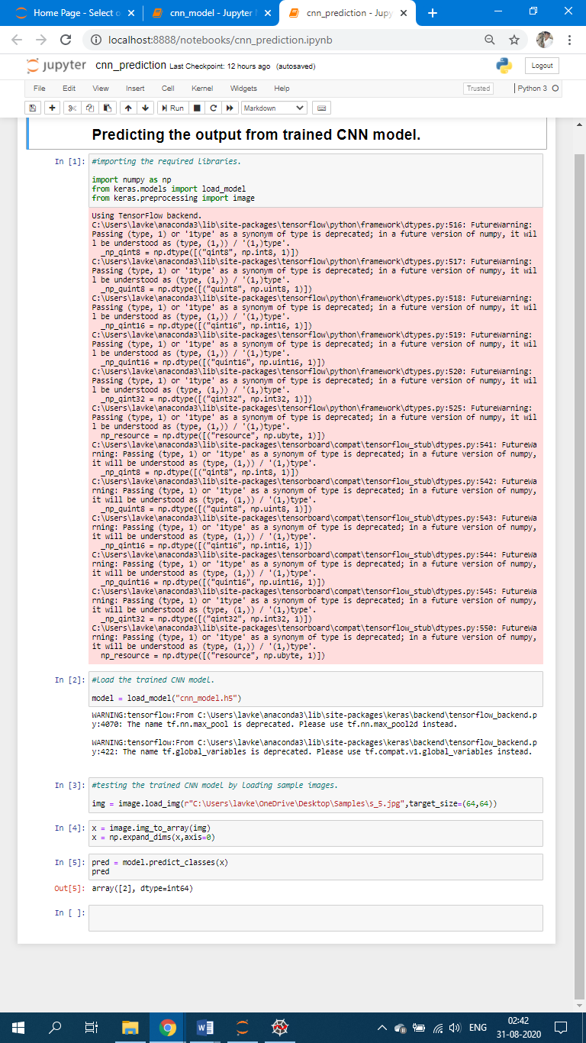

**Flask:**



**Output:**

